***Input file data set***

Hadoop is good subject

Hadoop is good subject

Hadoop is good subject

Hadoop is good subject for me

**Q. Run a map only job on the word count program using static configurations.**

***Driver***

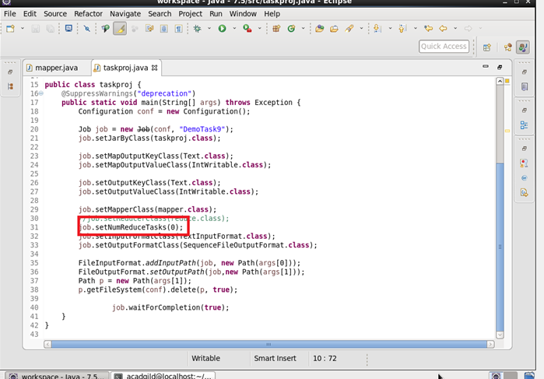

***Mapper***

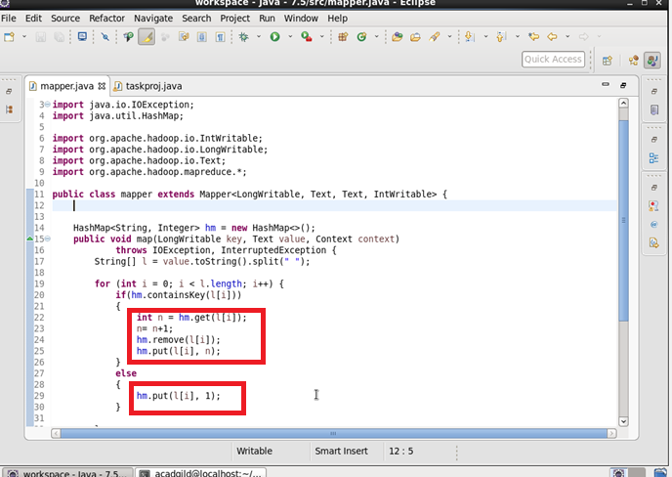

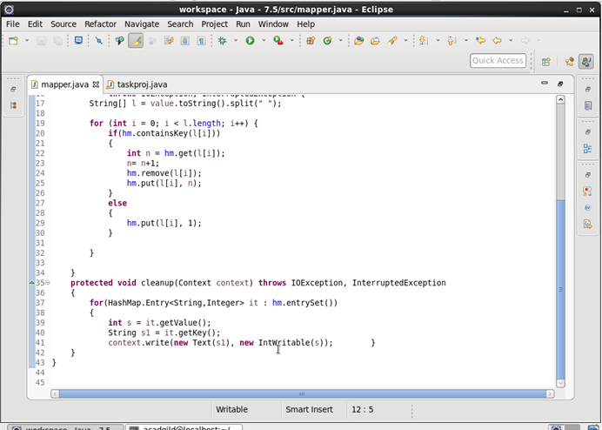

***Output***

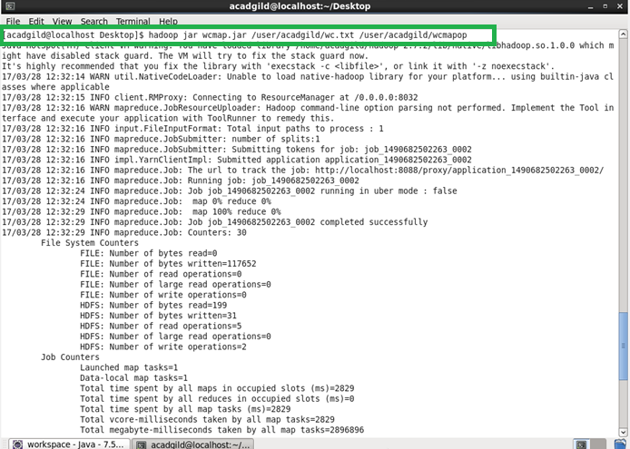

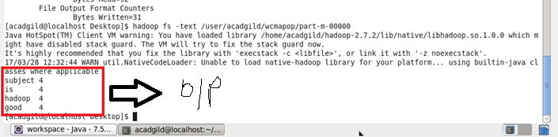

**Q. Run the mapreduce word count program and set the number of reducers to 2 using static configurations.**

***Driver***

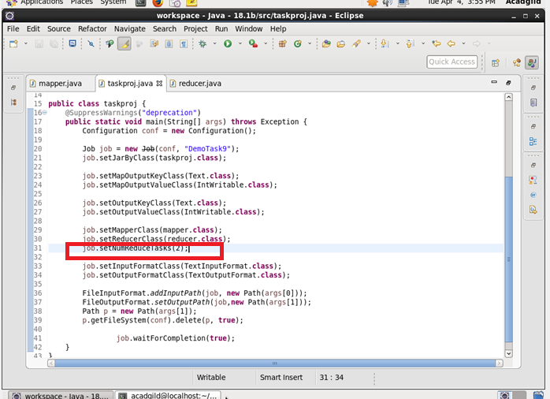

***Mapper***

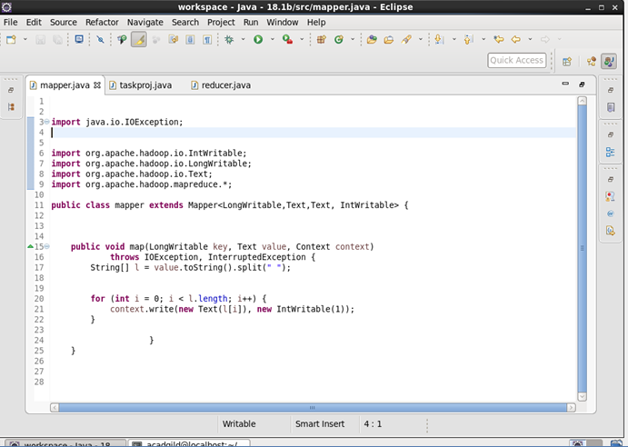

***Reducer***

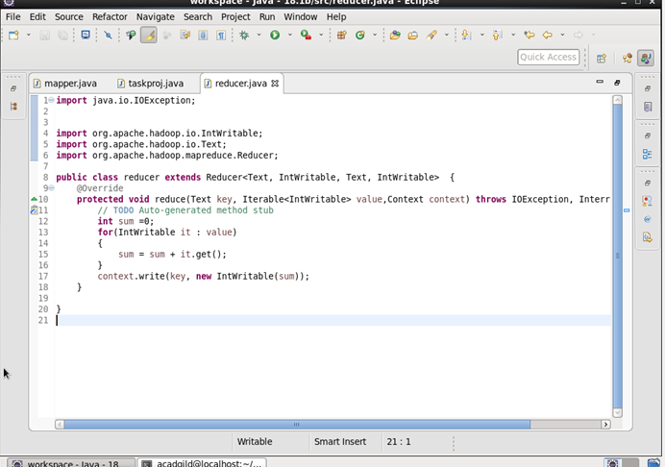

***Output***

