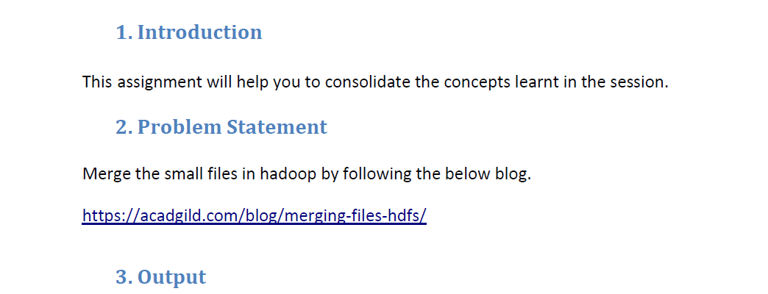

* **Merge the small files in hadoop**

We can merge the small files in Hadoop by using –getmerge command as

If we want to merge two or more files separated by line we will use **-nl**

**Hadoop fs -getmerge -nl <source file path> <local system destination path>**

**Input files :**

**file to be merged and its Content are displayed by cat**

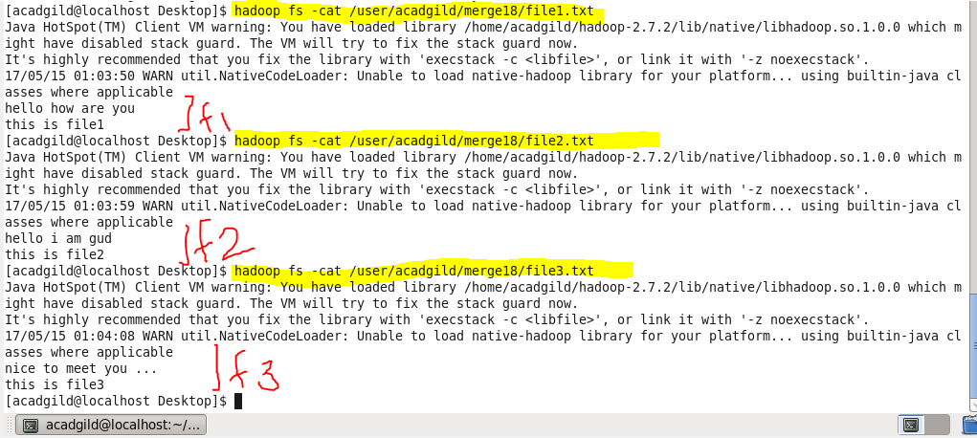

**File1, file2 and file3 are three different files we will use for merging.we will copy the files to HDFS for merge operation.**

**Now Executing Merge Command**

**Source path- /user/acadgild/merge18/**

Local system Destination path - /home/acadgild/Desktop/mergeout 🡪 without –nl (no line between files)

Local system Destination path - /home/acadgild/Desktop/mergeout1 🡪 with –nl (line between files)

* **Merging files without new line**

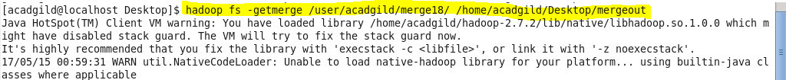

* **Merging files with new line between files**

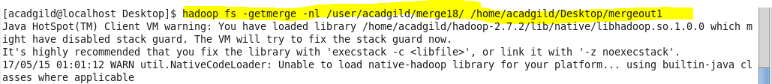

**-nl is Optional and is used for adding new line in result**

**Output**

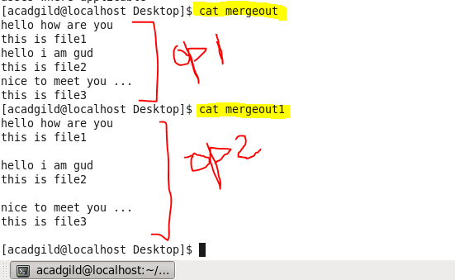

**Op1 -> merged output without –nl (new line)**

**Op2 -> merged output with –nl (new line)**

* **So the small files in Input are merged in the output folder**