**CREATING A TABLE**

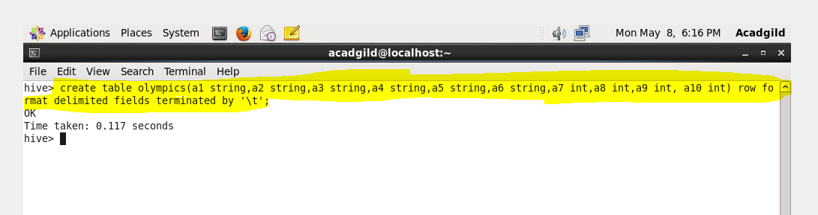

**LOADING A FILE IN THE TABLE**

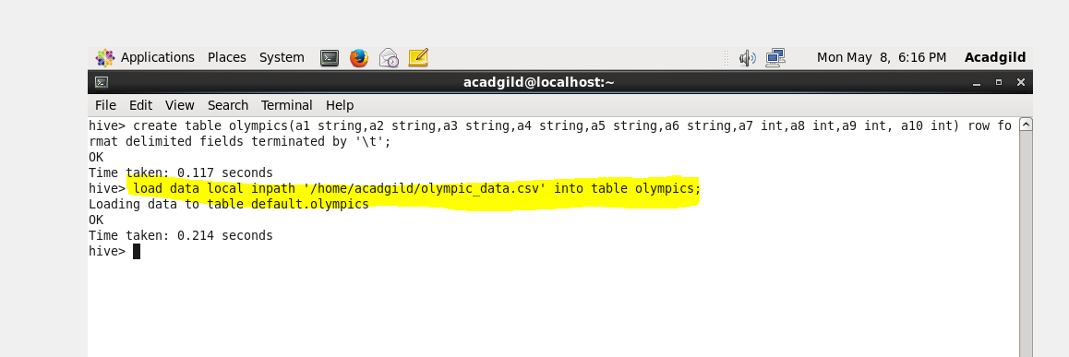

**INPUT DATA**

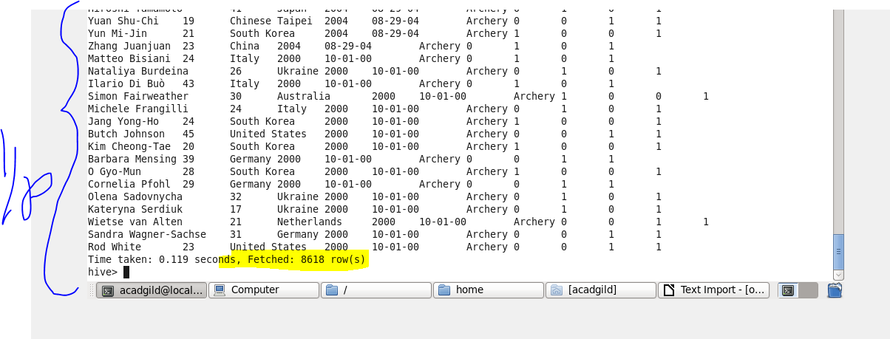

**Problem Statement:**

**Write a Hive Program to find the total number of medals each country won**

**COMMAND**

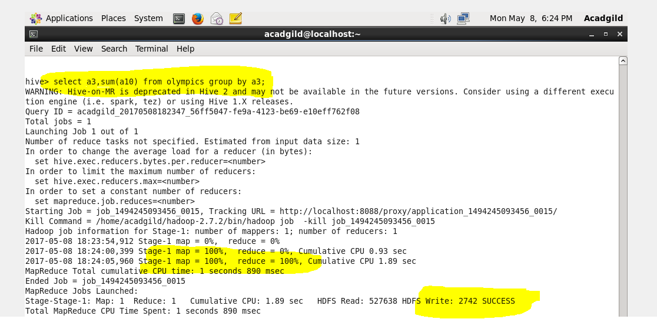

**OUTPUT**

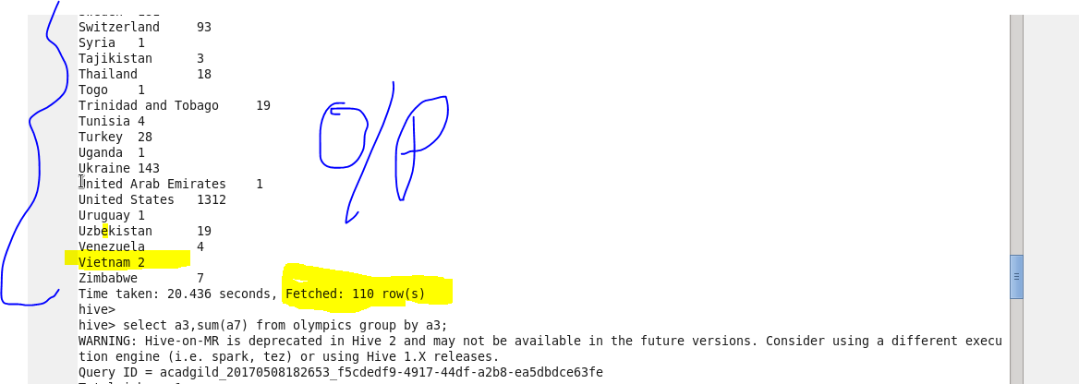

**Problem Statement:**

**Write a Hive program to find the number of gold medals each country won**

**COMMAND**

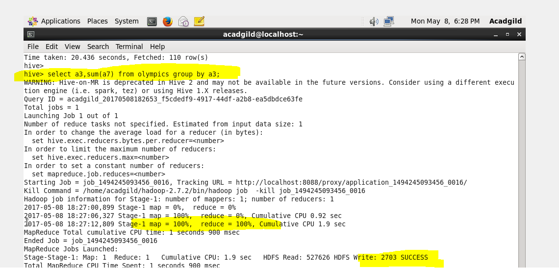

**OUTPUT**

