***TABLE CREATION***

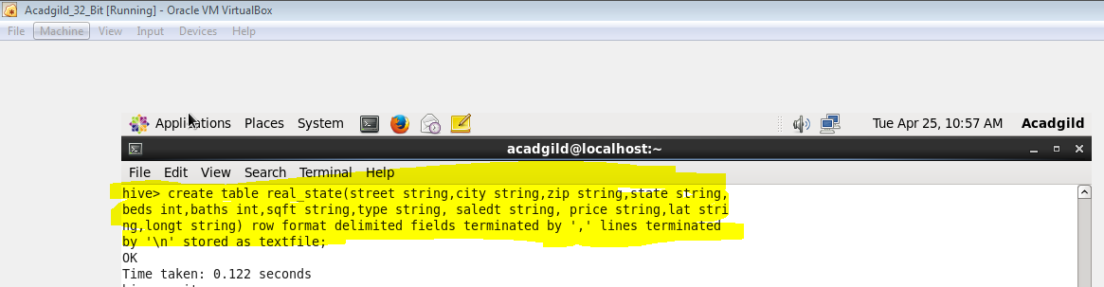

***LOADING THE FILE***

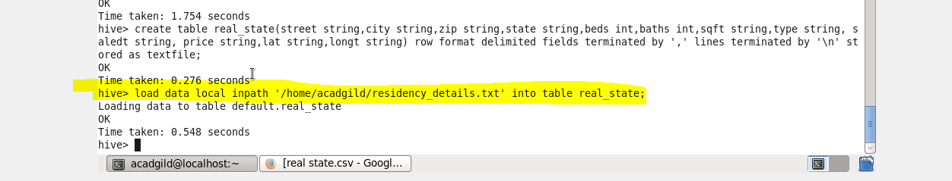

1. **Write a hive query to list top 5 residency details which lie in the budget of 60000-120000, an area more than 1450, sold after 17th may, min bedroom 3 and, min bathroom 2.**

***COMMAND***

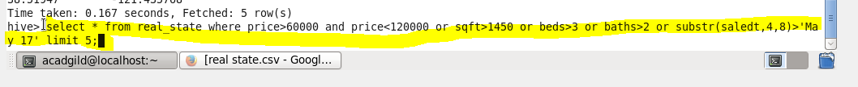

***OUTPUT***

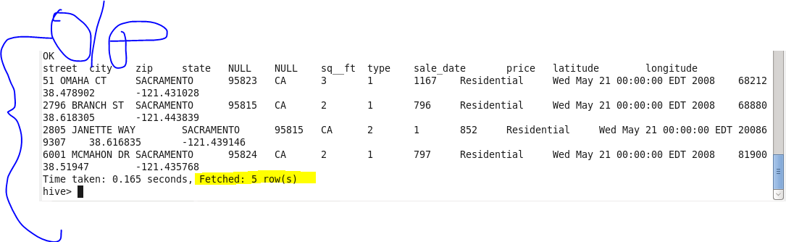

1. **Write a hive query to separate list of residential apartments with more than 2 beds. Also include columns in following order City, Baths, Sq_feet, Price, flat_type, Beds respectively.**

***COMMAND***

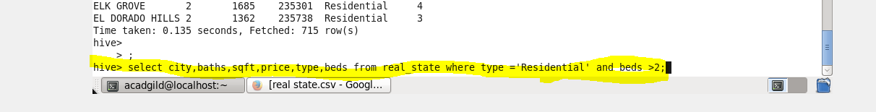

***OUTPUT***

