* **Create table RealEstate in Hive database, with all the columns present in dataset.**

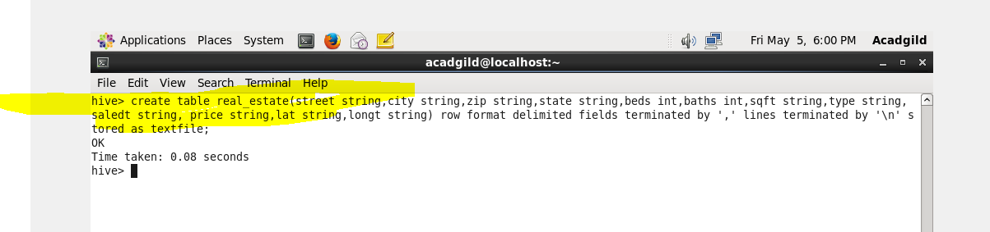

**Output**

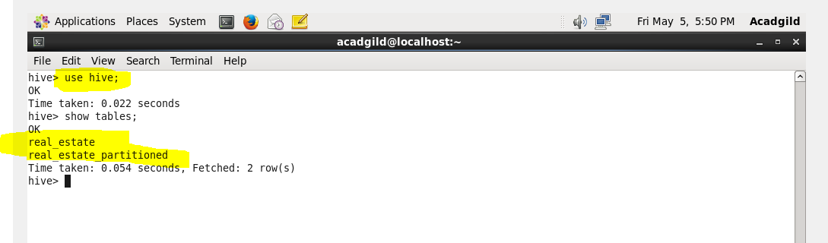

* **Load dataset into table realEstate.**

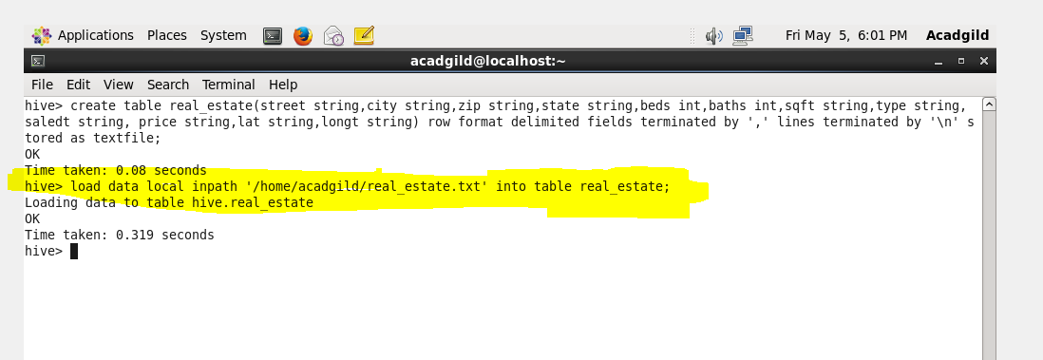

**Output**

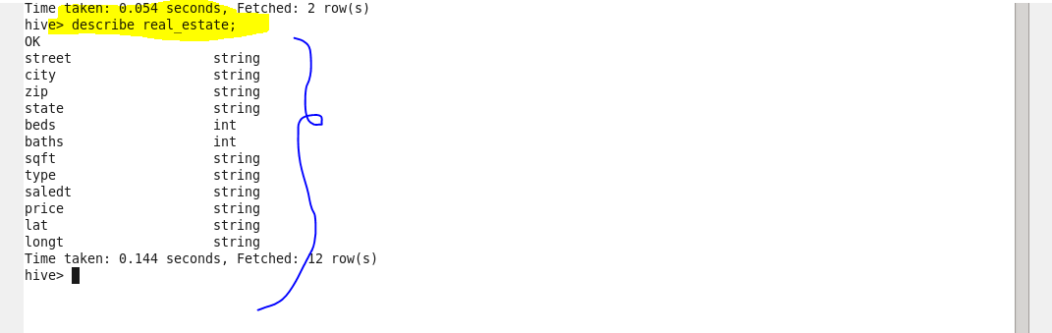

* **Using Dynamic partition get separate lists of residential apartments with more than 2 beds and include columns in following order City,Baths,Sq_feet,Price,flat_type,Beds respectively**

**Dynamic partitioning**

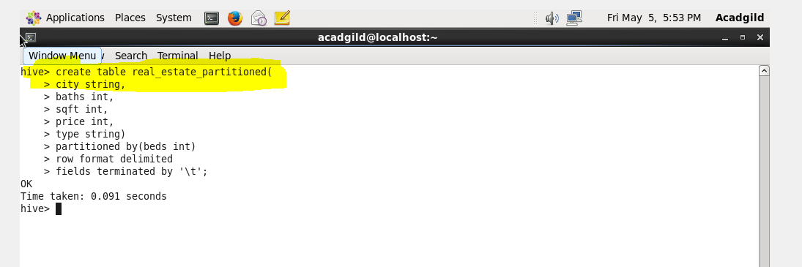

**Output**

