**Implement view**

**INPUT FILE-1**

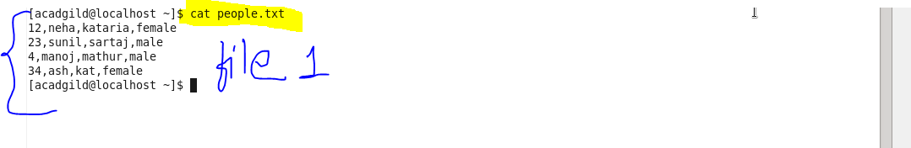

**INPUT FILE-2**

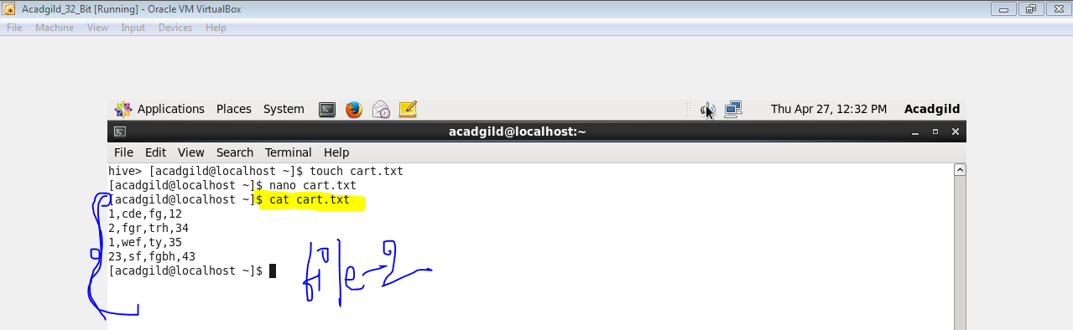

**CREATING & LOADING FILE-1**

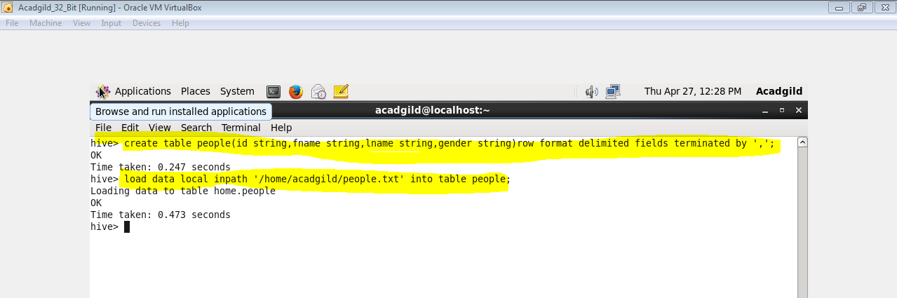

**CREATING & LOADING FILE-2**

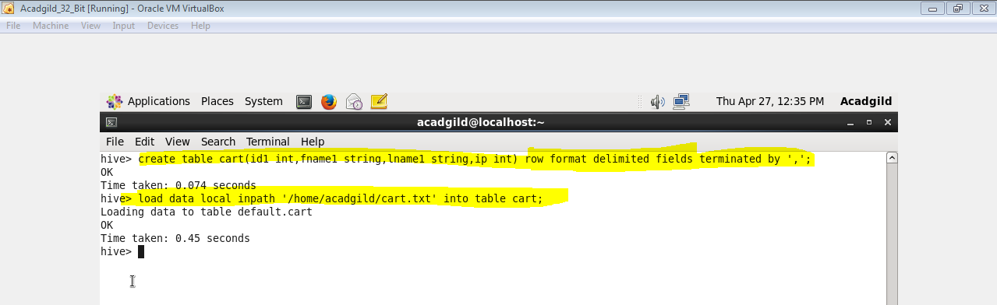

**CREATING VIEW**

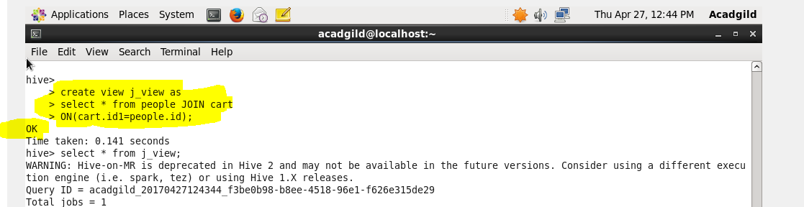

**OUTPUT**

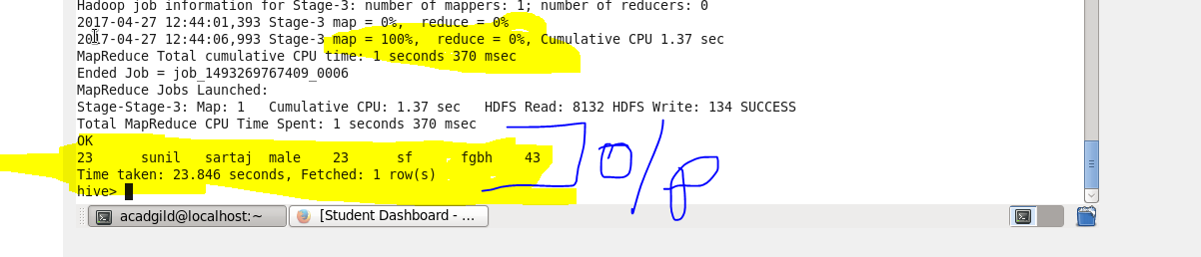

**QUERY**

