**Run parallel jobs in hive**

**Input files**

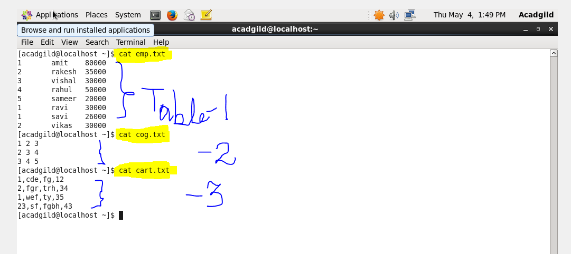

**Creating & loading the file emp**

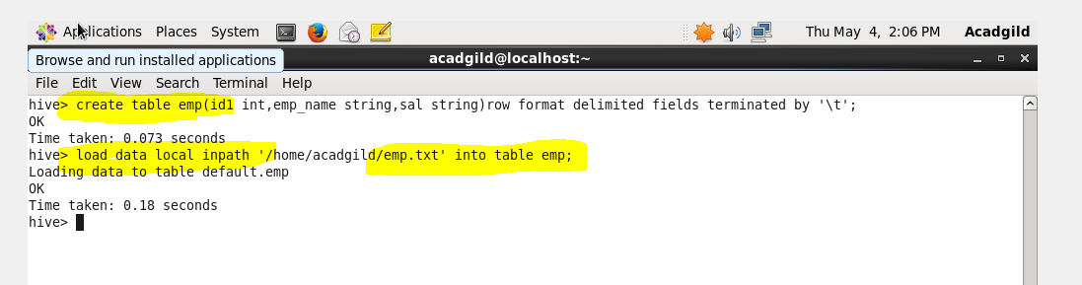

**Creating & loading the file cog**

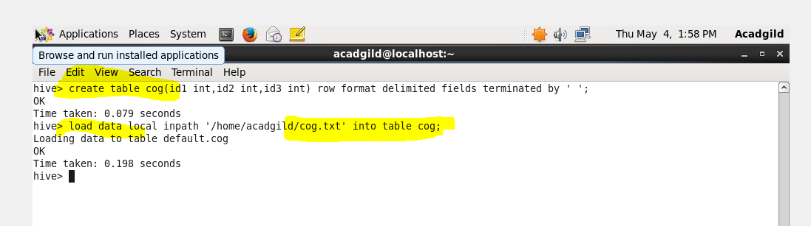

**Creating & loading the file cart**

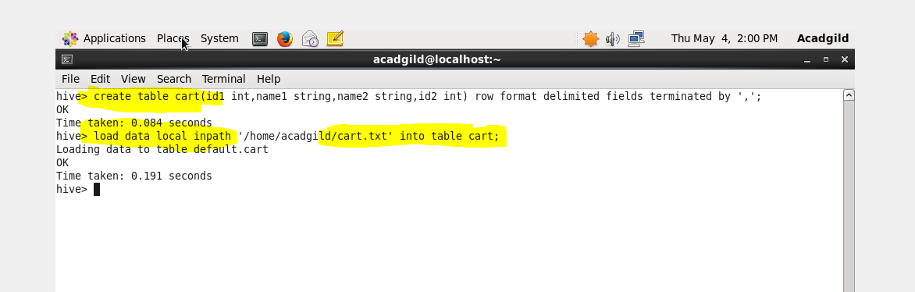

**Setting the parallel configurations in hive command line**

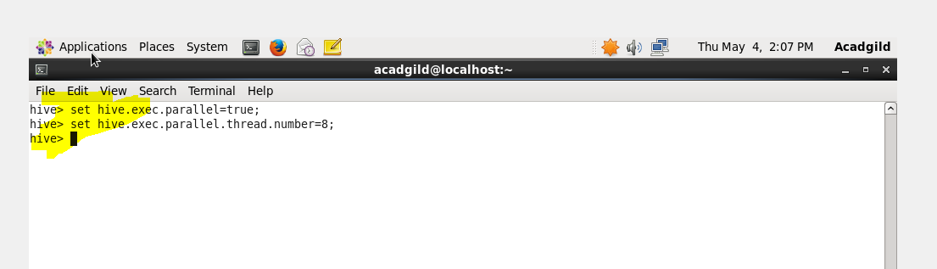

**Query**

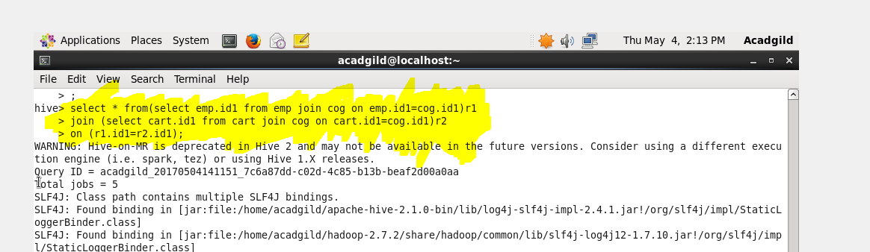

**Output**

