**Write a hive UDAF to find the largest integer in a column.**

**HIVE UDAF:**

It is used defined aggregate function .It works on a entire column and perform operation

Here we are finding the largest for example **I am having a employee dataset and I want to find a largest bus no**

**Input :**

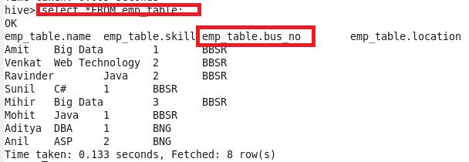

**Code**

Since we are creating Udf we create a **hivemax class** that extends UDAF where the output variable is defined

then we are creating static class maxIntUDAFEvalator implements UDAFEvaluator(The actual class for doing the aggregation. Hive will automatically look for all internal classes of the UDAF that implements UDAFEvaluator.) which has the following methods

**init() method**

where the output variable will be initialized

**Iterate methdod()**

**Iterate through one row of original data. The number and type of arguments need to the same as we call this UDAF from Hive command line. This function should always return true.**

Here we are actually checking for the first time when output contains null so we are getting maxvalue

Now when it already contains value a comparison is made using **Math.max()** and it is set to output

**TerminatePartial()**

Terminate a partial aggregation and return the state. If the state is a primitive, just return primitive Java classes like Integer or String.

**terminatePartial()**

Merge with a partial aggregation. This function should always have a single argument which has the same type as the return value of terminatePartial().

**Terminate()**

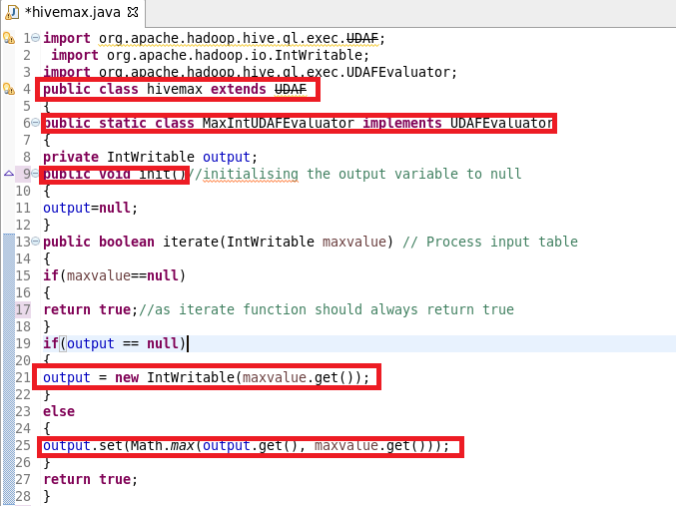

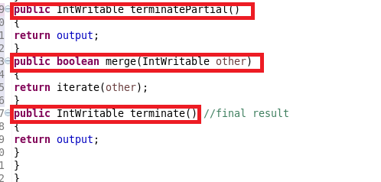

**Registering JAR:**

**ADDED THE JAR FILE AND CREATED A TEMPORARY FUNCTION AS SHOWN**

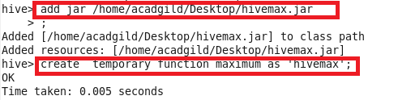

**OUTPUT**

