**ASSIGNMENT 32.3**

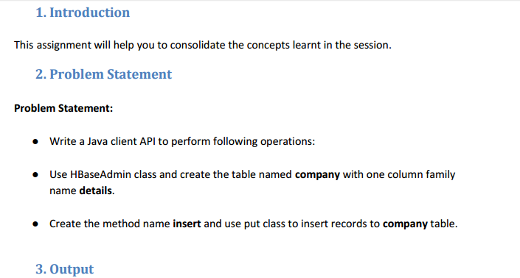

**WRITING A JAVA CODE TO CREATE A TABLE IN HBASE:**

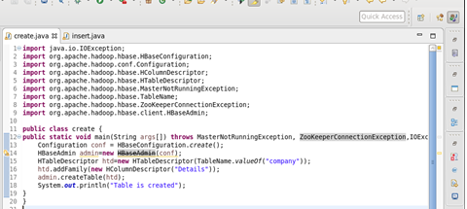

**TABLE IS CREATED IN HBASE BY RUNNING THE JAVA CODE (RUN AS APPLICATION) IN ECLIPSE**

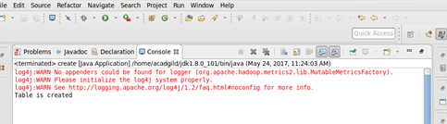

**USING ‘LIST’ COMMAND , SHOWING THE TABLES IN HBASE**

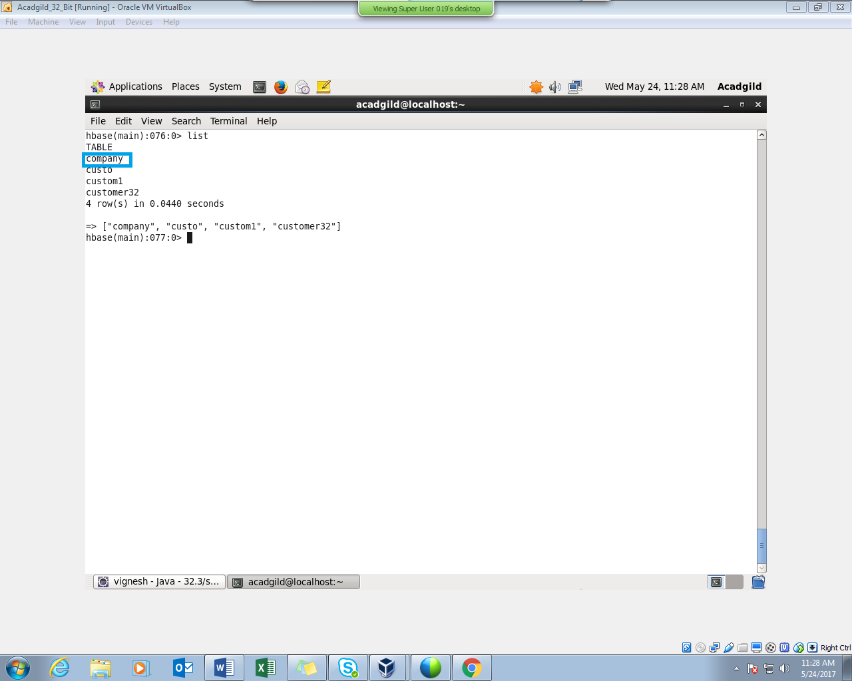

**WRITING A JAVA CODE TO INSERT DATA INTO THE TABLE “COMPANY”**

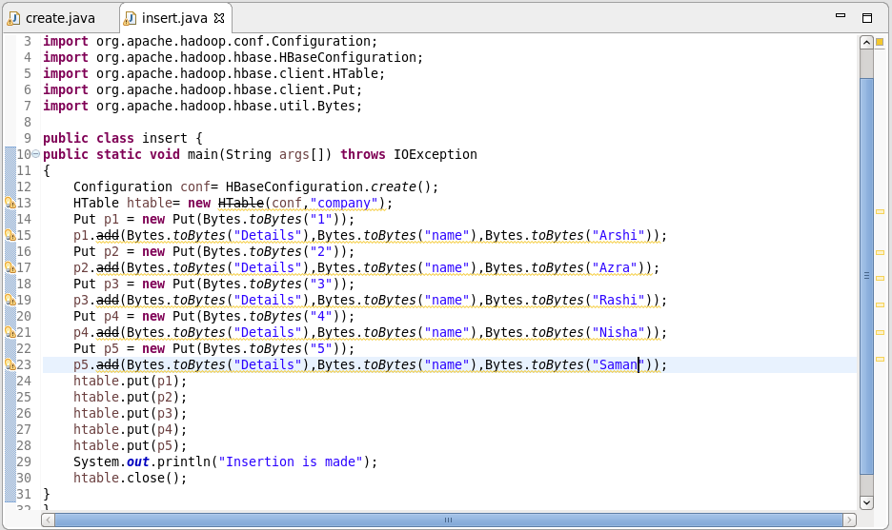

**INSERTION IS MADE BY RUNNING THE JAVA CODE IN ECLIPSE (RUN AS APPLICATION)**

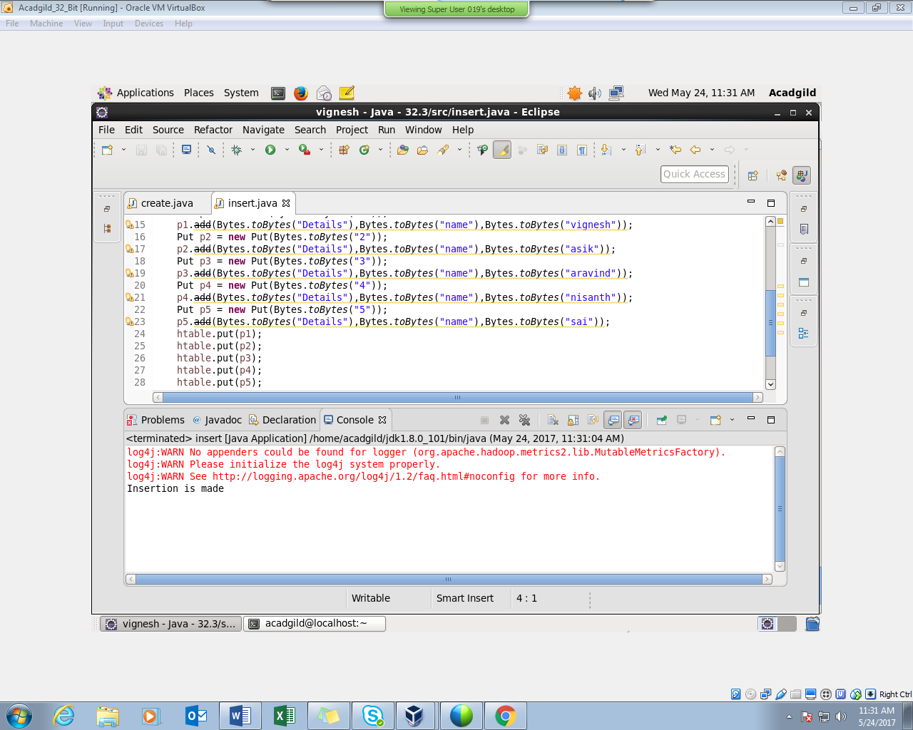

**HERE WE CAN SEE THAT INSERTION WAS SUCCESSFUL**

PERFORMING SCAN COMMAND :

