**Create the method name get record and use get class to retrieve one record at a time record from company table.**

**Step1:Created a method name getrecord() and passed tablename,columnfamily,rowkey,column as arguments**

**Step2: create a configuration object of Hbase**

**Step3: In getrecord() method, created a Htable object for Hbase configuration for the table “Company”**

**Step4:Created a object of get class for the given rowkey**

**Step5:Used Result object for storing the value for the given row**

**Step6:printed the value of the rowkey**

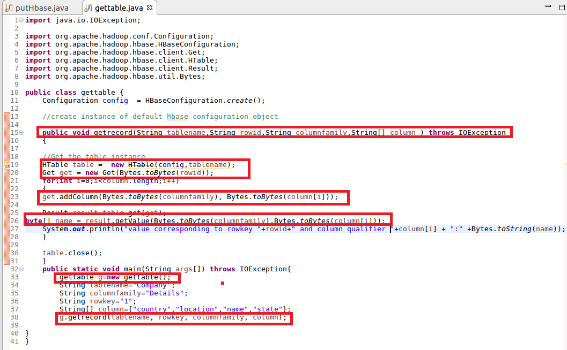

**Output**

**Output is Displayed in console corresponding to rowkey 1**

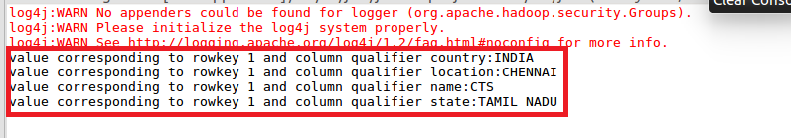

**2. Create the method name display and use scan class to display all records from company table.**

**Step1:Created a method name Display() and passed tablename,columnfamily,rowkey,column as arguments**

**Step2: create a configuration object of Hbase**

**Step3: In Display() method, created a Htable object for Hbase configuration for the table “Company”**

**Step4:Created a object of get class for the given rowkey**

**Step5:Used ResultScanner object for storing the value for the given row**

**Step6:printed the value of the rowkey**

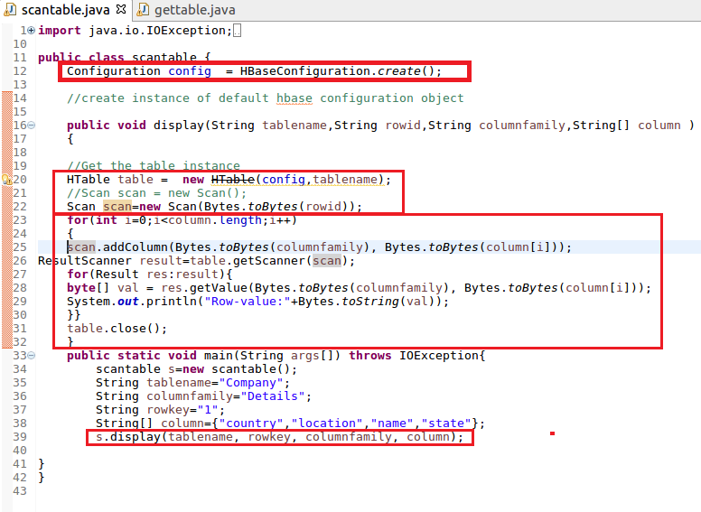

**Output**

