**Problem Statement:**

**● Create a employee table in Mysql and columns as Emo_id, Emp_name, Dept_name(Hadoop Developer), Emp_sal**

**Creating employee table**

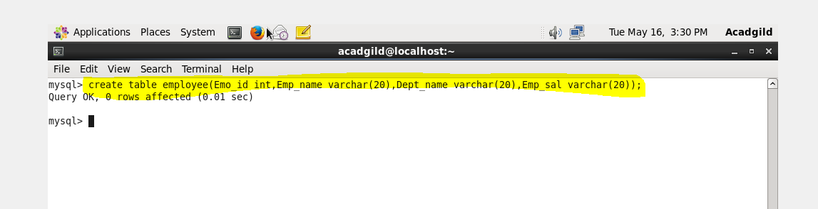

**Inserting values in table employee**

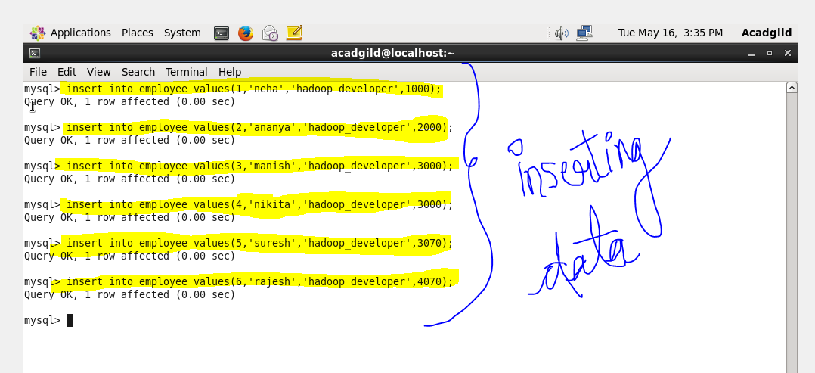

**● Import the employee table contents into the HDFS directory using Sqoop.**

**Creating a directory named sqoop**

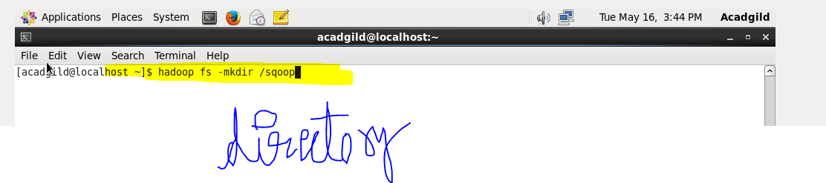

**At the browser**

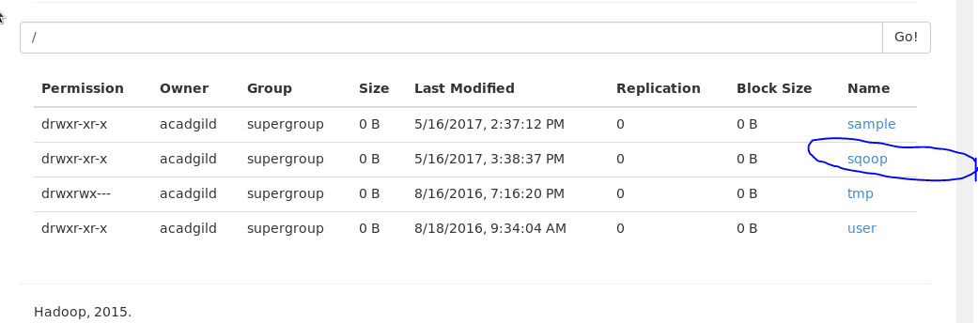

**Importing the data from mysql to hdfs directory using sqoop**

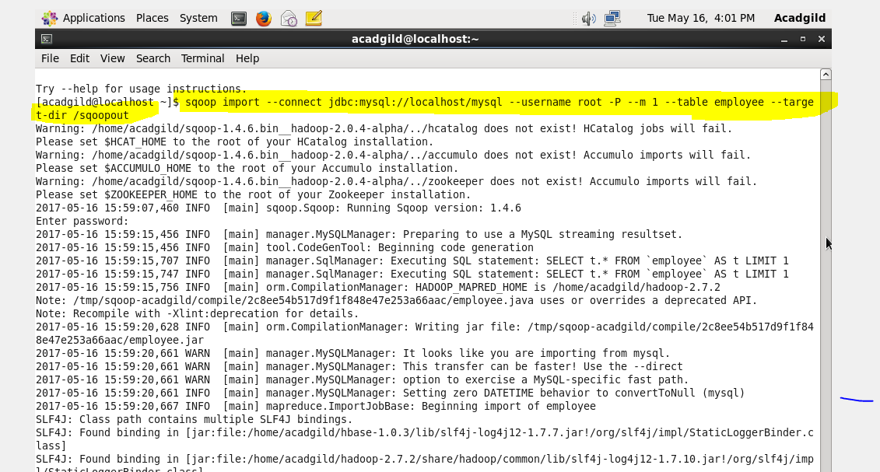

**Successfully imported**

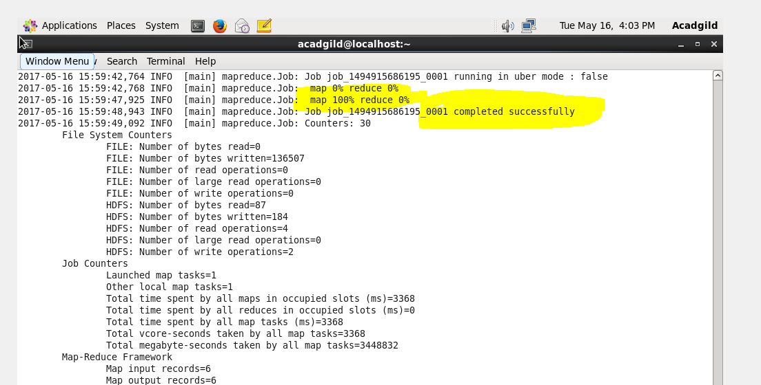

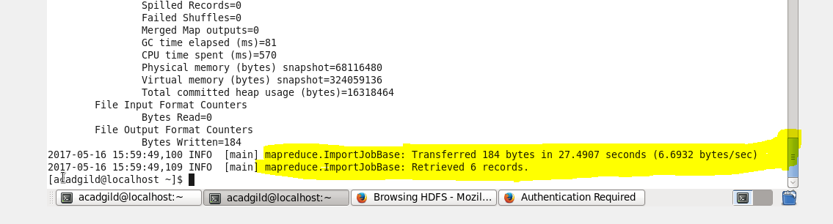

**Output**

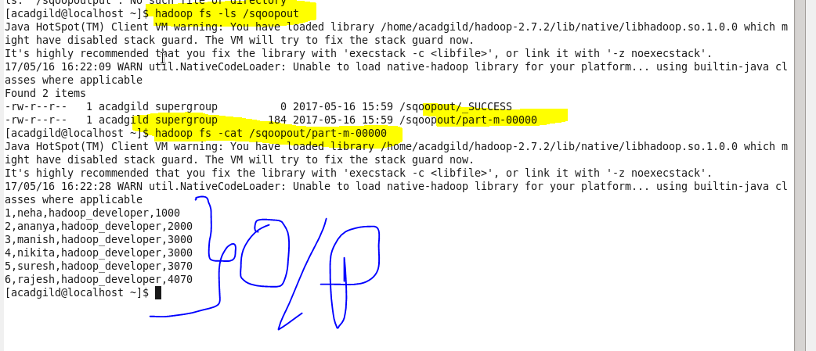

**● Create a employee2 table in Mysql and Export employee details file from HDFS directory to Mysql table employee2 using Sqoop**

**Creating table employee2**

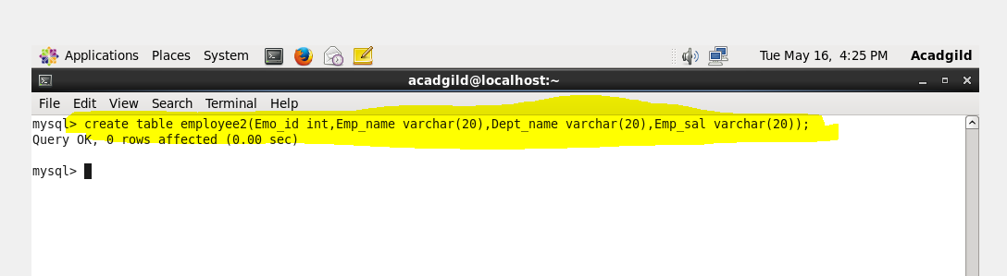

**Exporting data from hdfs to mysql**

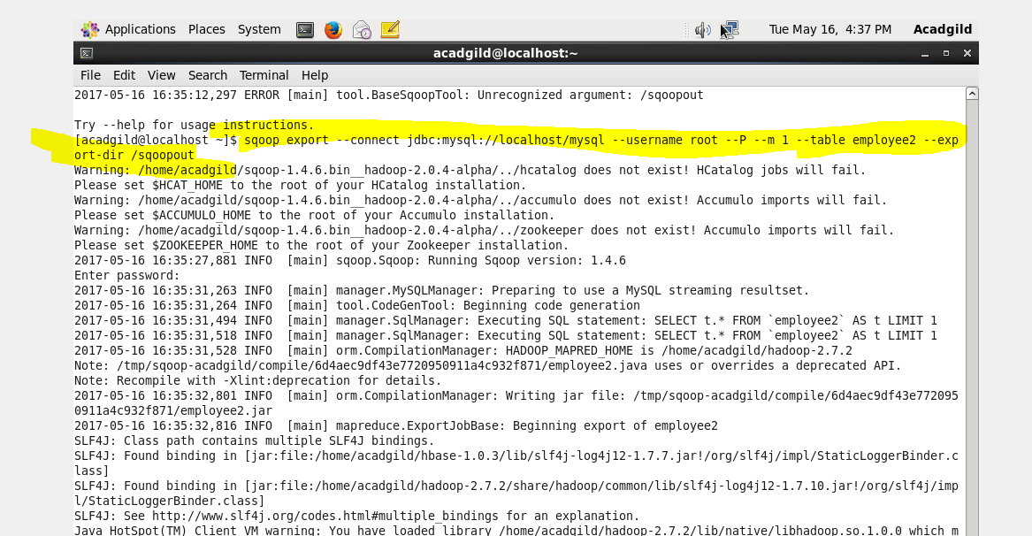

**Exported successfully**

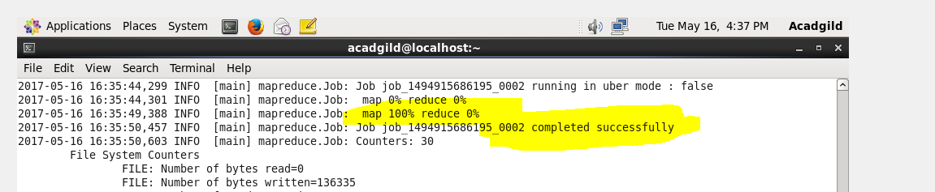

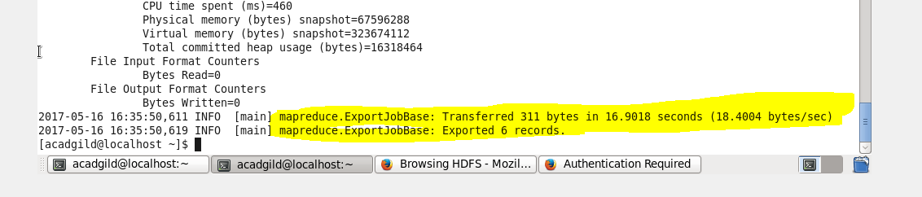

**Output**

