**● Explain and perform Sqoop Incremental Import operation to load data from Mysql To HDFS using Sqoop**

**Employee table**

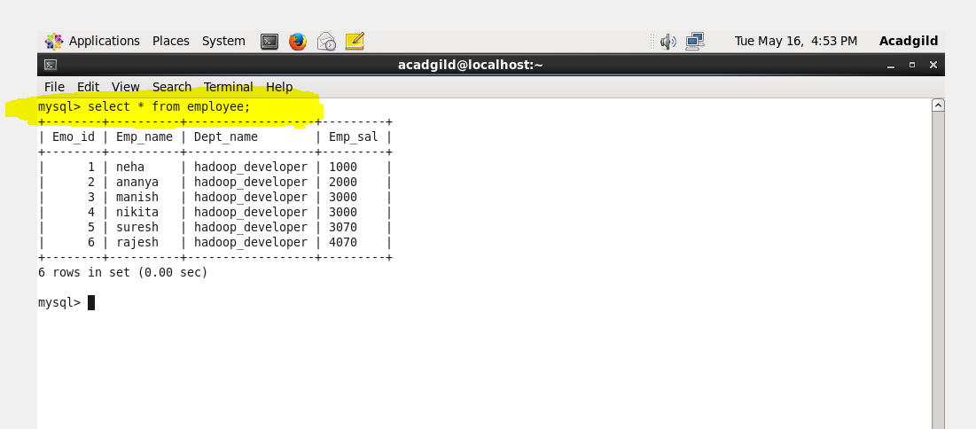

**Incrementing the rows in employee table**

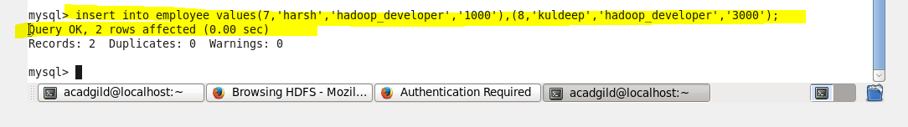

**Output of incrementing rows in mysql**

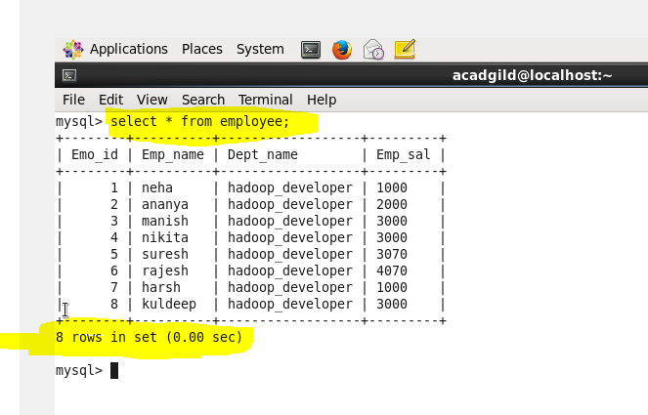

**Data already in hdfs**

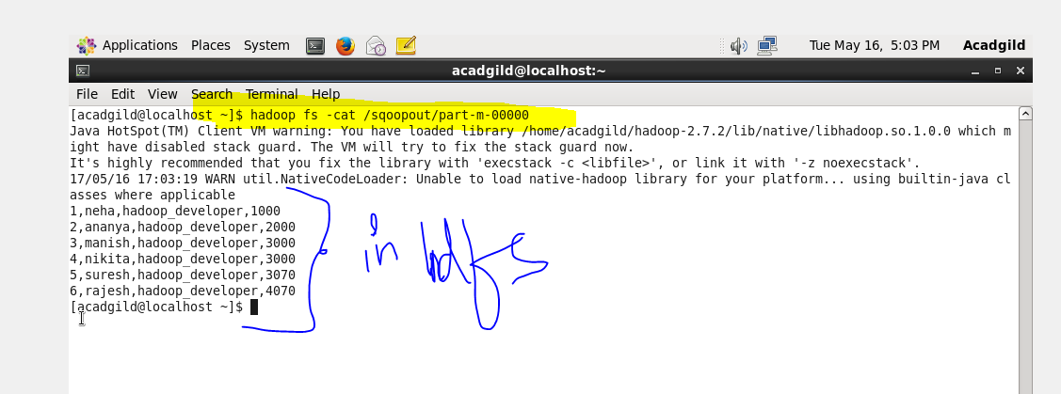

**Importing data from mysql to hdfs**

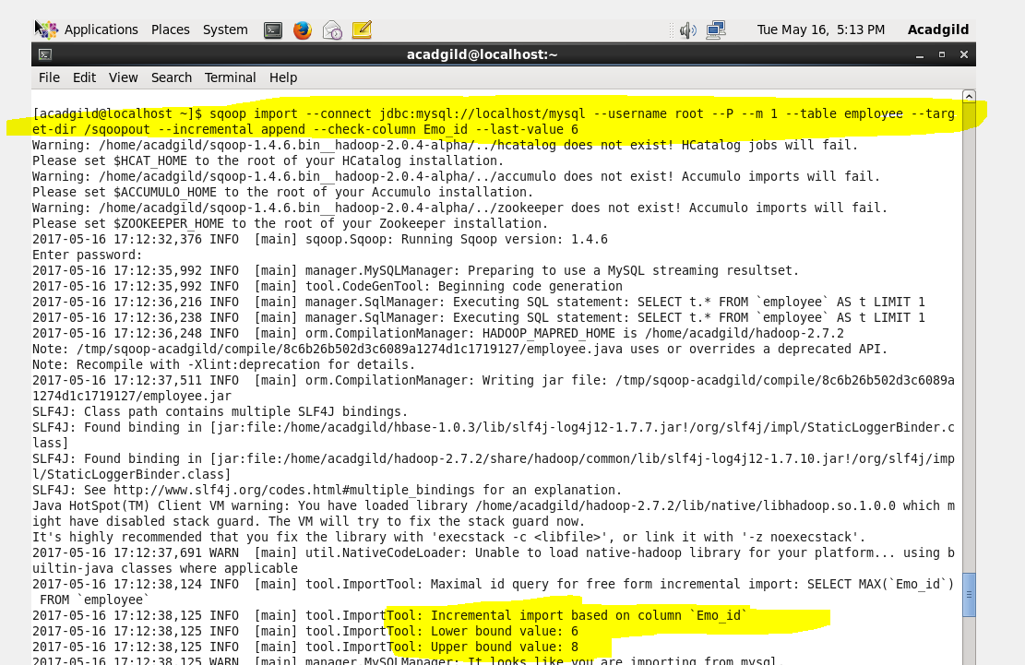

**Completed successfully**

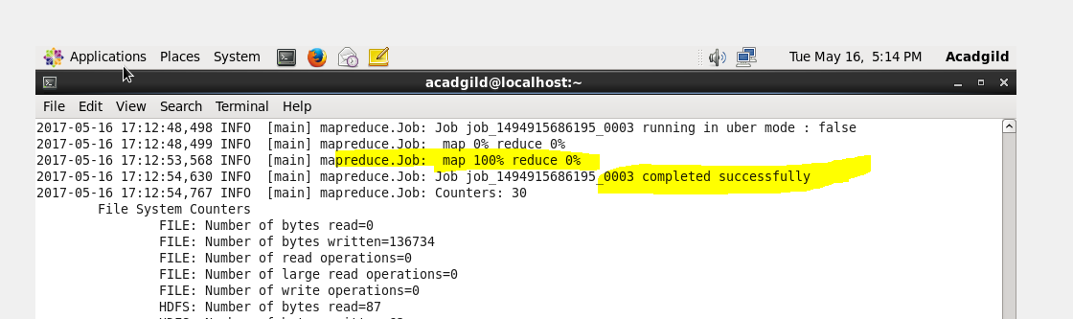

**Increment import completed**

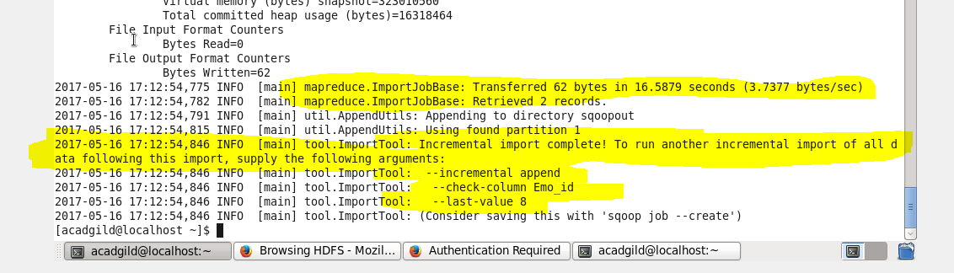

**Output (in hdfs)**

