**The advantage of using Sqoop is that we don’t want to have the table in Hive Instead sqoop will directly create a table and populate the data based on metadata**

● **Explain and perform Importing table contents from Mysql to Hive using Sqoop.**

**INPUT**

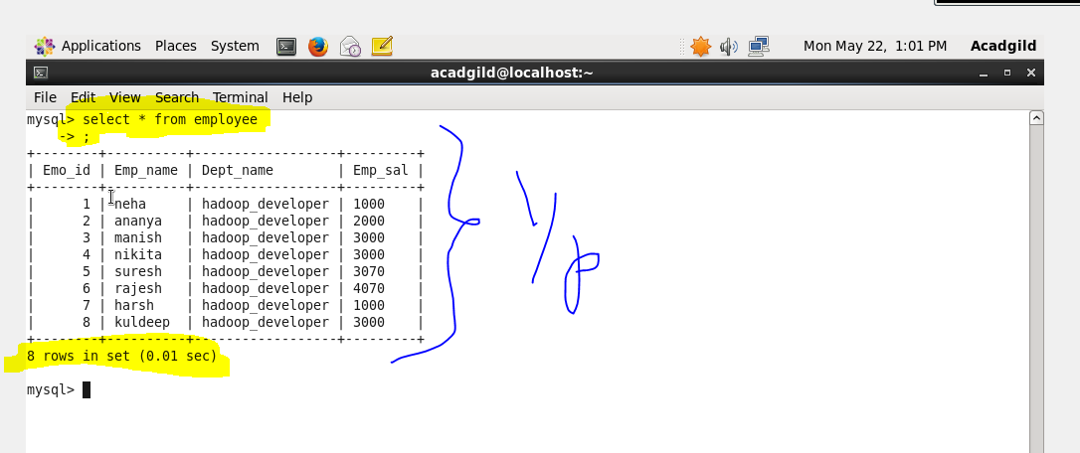

**SQOOP COMMAND TO DO IMPORT AND ITS EXPLANATION**

**Sqoop import-import is used when we are importing data from rdbms to Hadoop ecosystem**

**--connect -> It is used to give the JDBC Url of database**

**--Username🡪user name of database**

**--P🡪password of database**

**--table 🡪 give the table you want to copy from MySql**

**--target-dir🡪 temporary target directory used by Sqoop for transferring which will be deleted after the import is finished**

**--hive-import🡪 Indicating a hive import**

**--hive-table🡪table which will be created and on which data will be written(in our case employee-mysql)**

**-m1🡪number of mappers that should run**

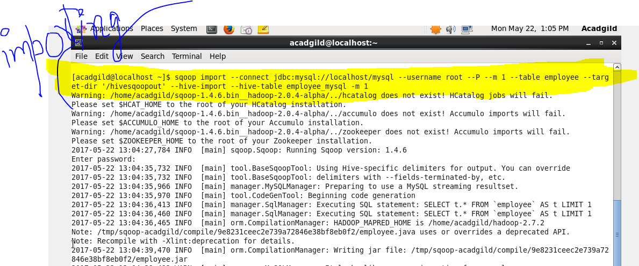

**From the below picture the table is successfully imported to HIive**

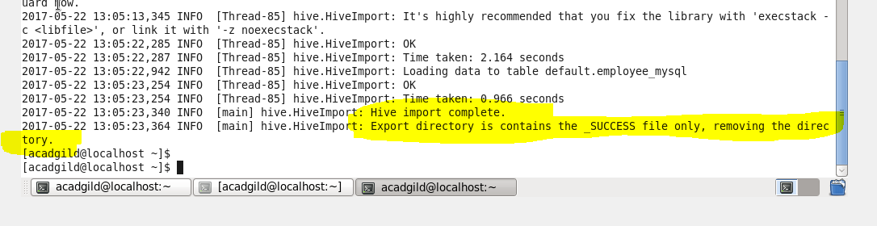

**OUTPUT**

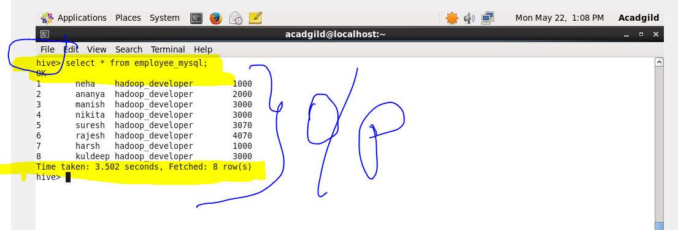

**● Explain and perform Importing table contents from Mysql to HBase using Sqoop.**

**INPUT**

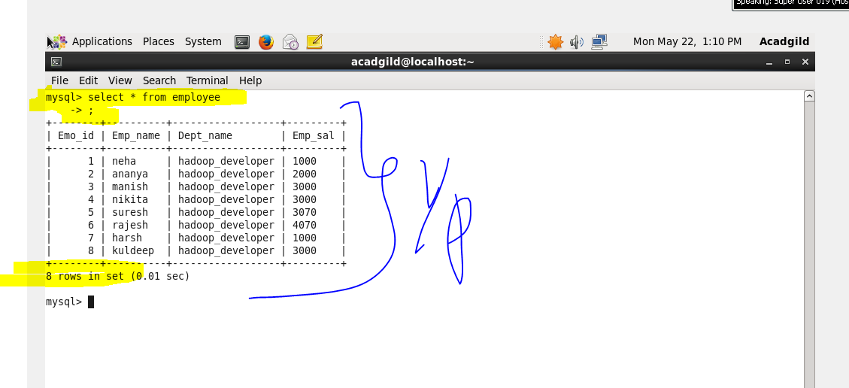

**First I will create the target table in Hbase as mysql_employee and give column family as employee details so that It can be imported to that table**

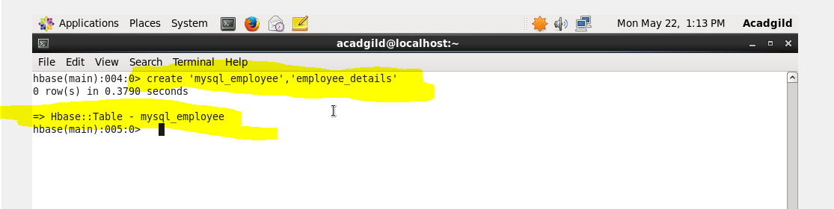

**SQOOP COMMAND TO DO IMPORT AND ITS EXPLANATION**

**Sqoop import-import is used when we are importing data from rdbms to Hadoop ecosystem**

**--connect -> It is used to give the JDBC Url of database**

**--Username🡪user name of database**

**--P🡪password of database**

**--table 🡪 give the table you want to copy from MySql**

**--hbase-table🡪 the table in Hbase where It should be copied(here it is Mysql_employee)**

**--column family🡪given the column family as employedetails**

**--hbase-rowkey 🡪which column should be taken as rowkey**

**-m1🡪number of mappers that should run**

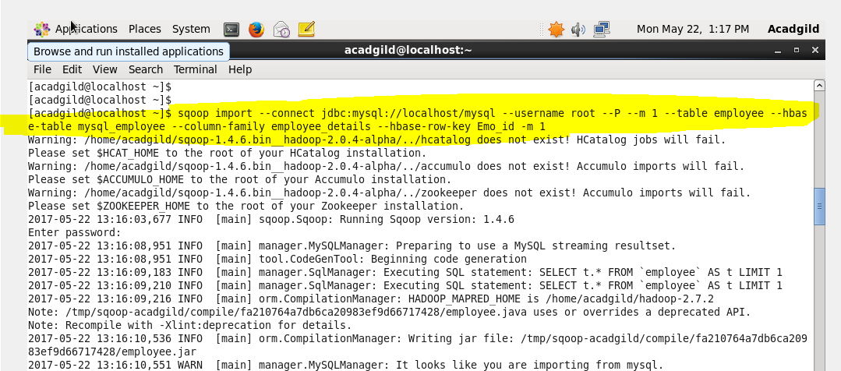

**From the above picture the table is successfully imported to Hbase**

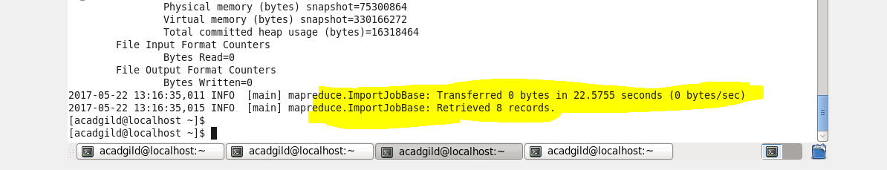

**OUTPUT**

