**Problem Statement**

**We have a dataset of travel data analysis**

**Input File-**

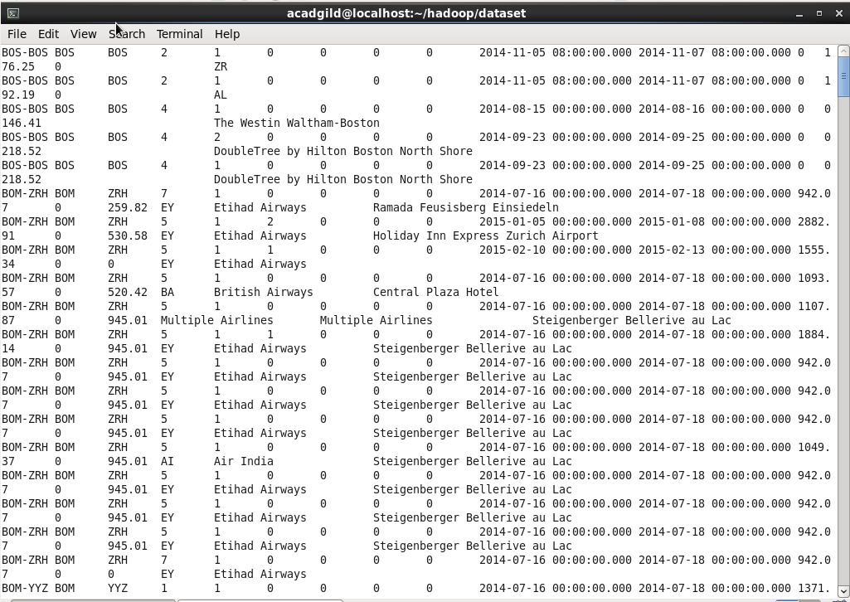

1. **Find out how many people has chosen their destination as MIA and MCO**

**Driver Code-**

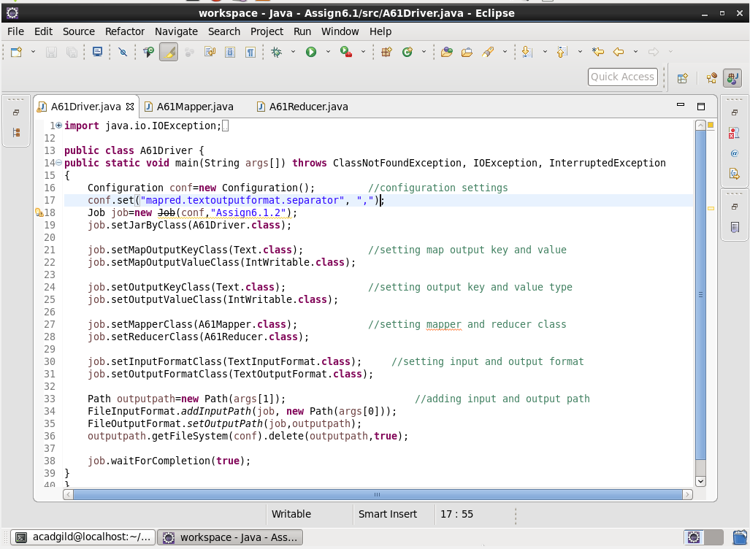

**Mapper Code-**

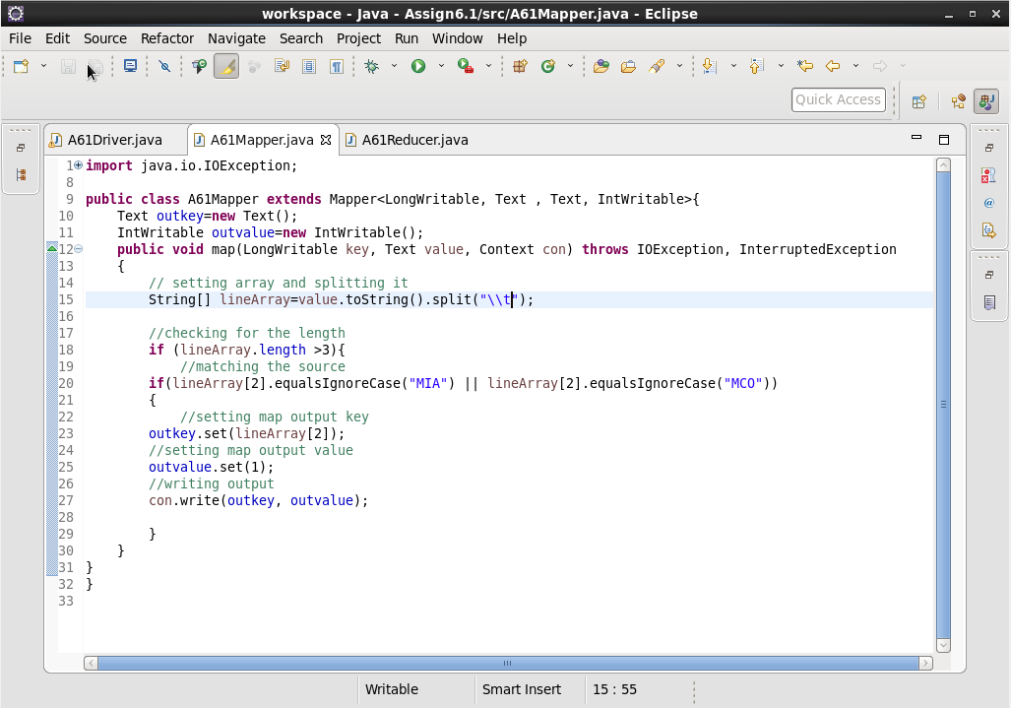

**Reducer Code-**

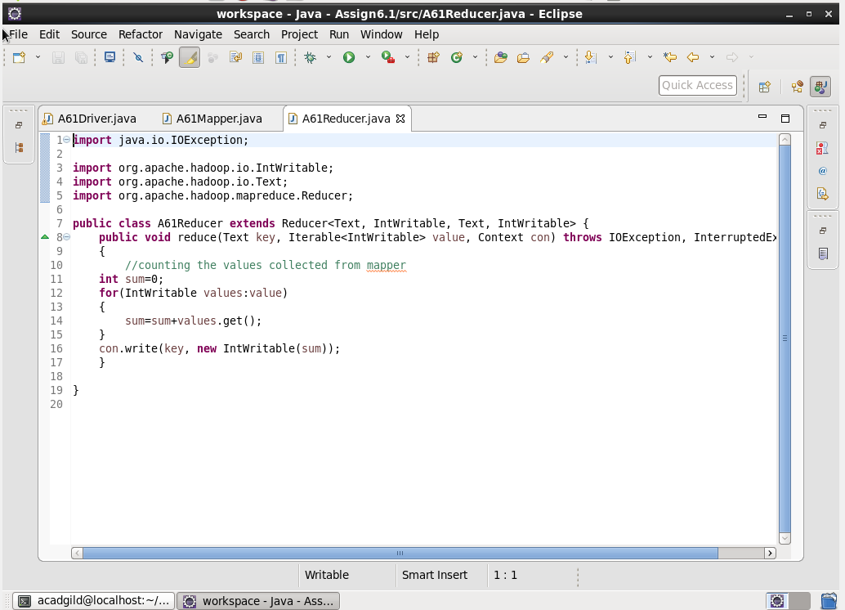

**Output-**

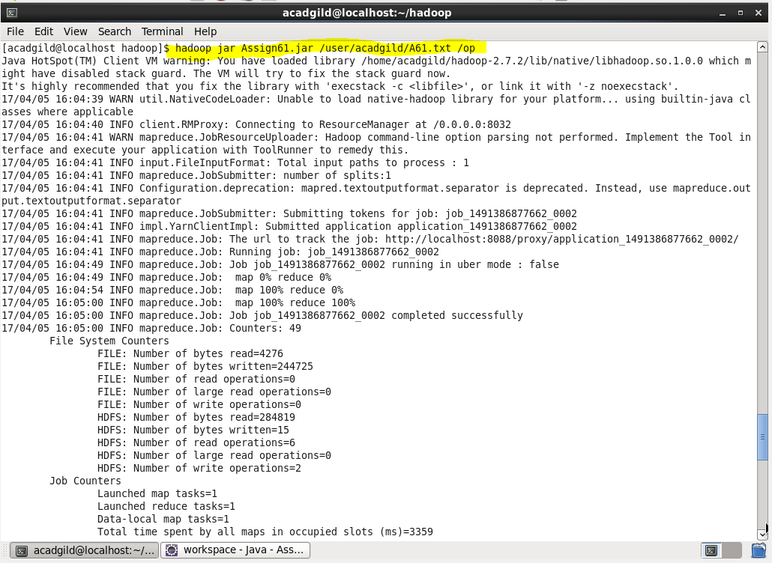

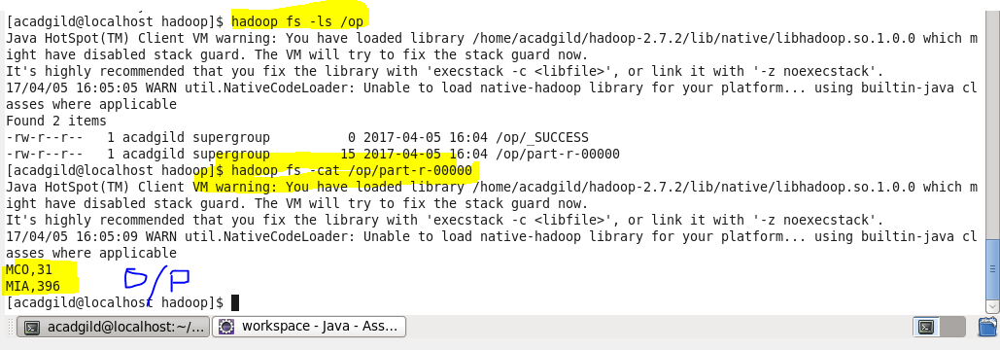

**Problem statement 2: Find out the number of people undertaken the trips from the places MIA and HOU**

**Driver Code-**

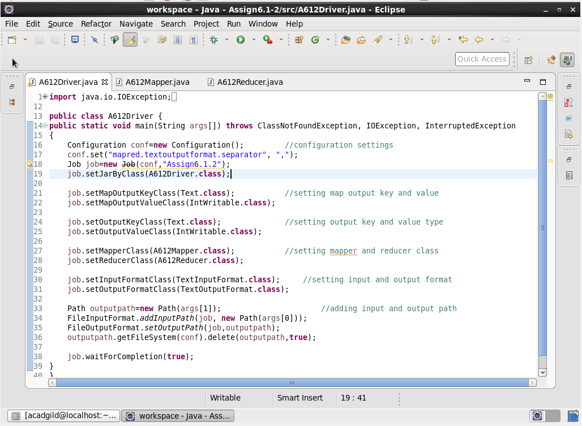

**Mapper Code-**

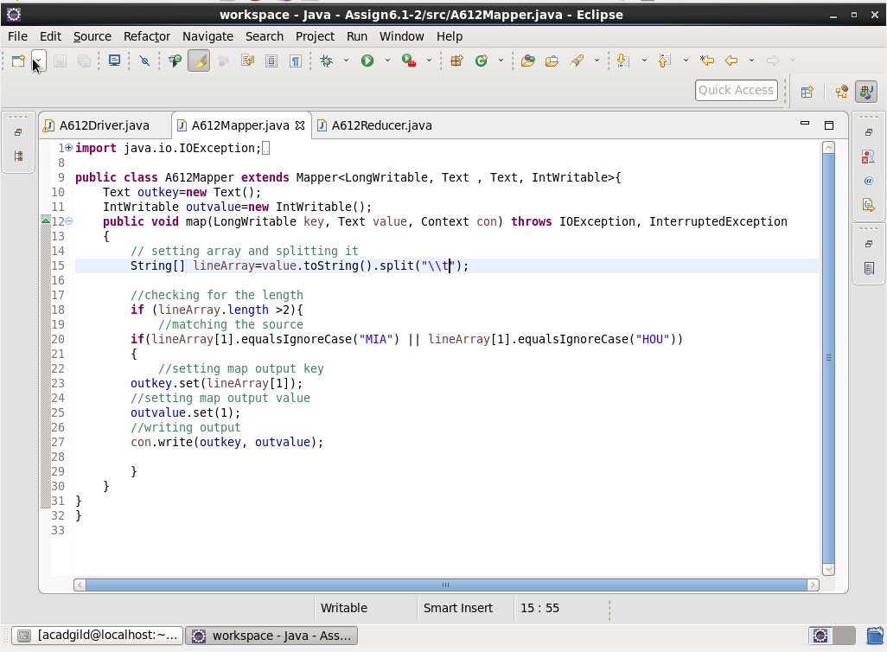

**Reducer Code-**

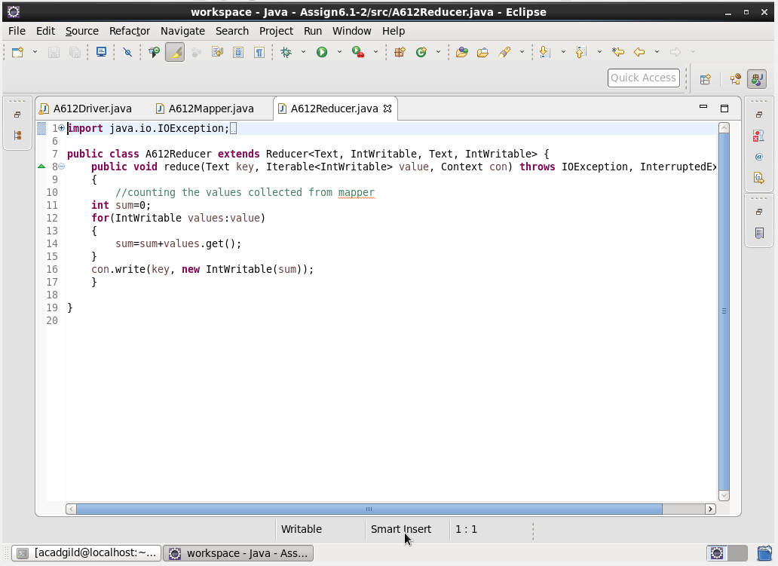

**Output File-**

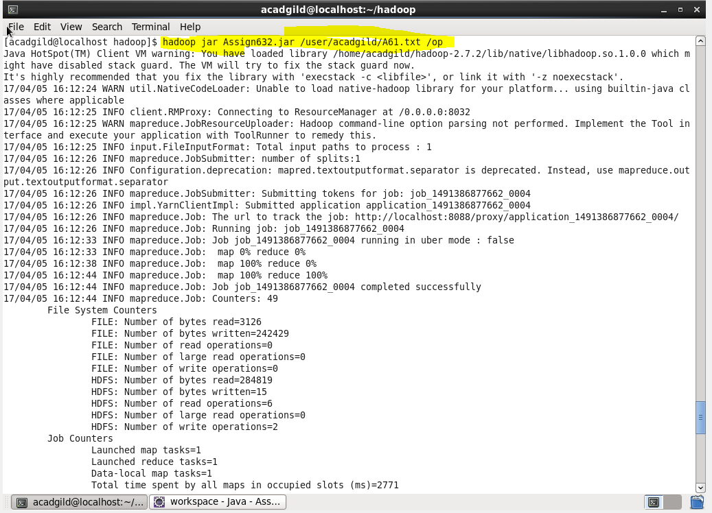

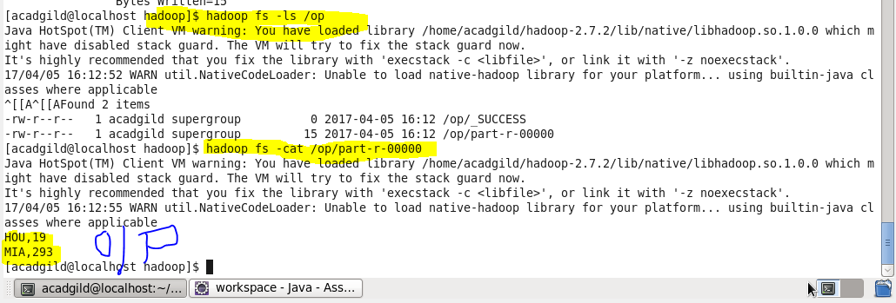

**Problem statement 3: Find out how many people has chosen airline mode of travel for the places LAS and LAX**

**Driver Code-**

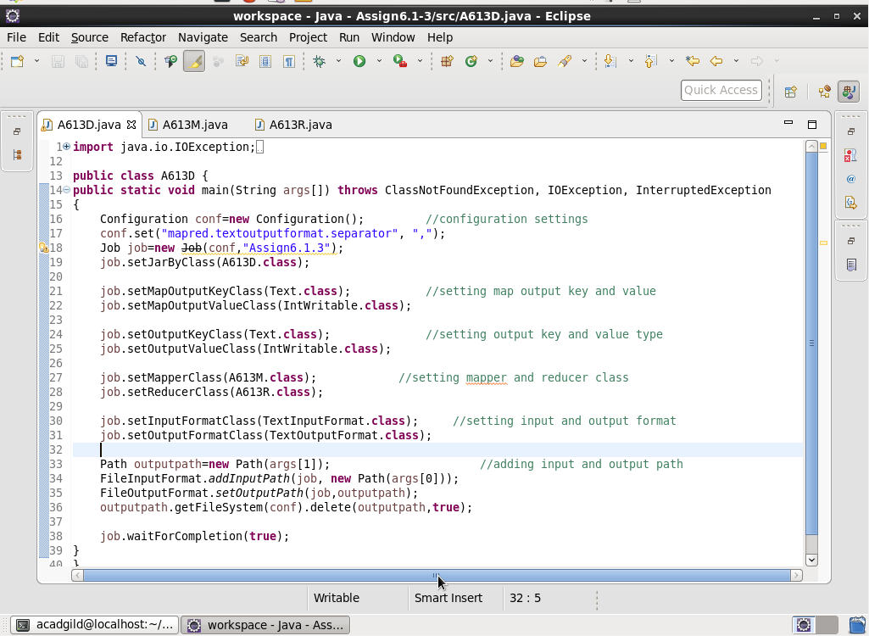

**Mapper Code-**

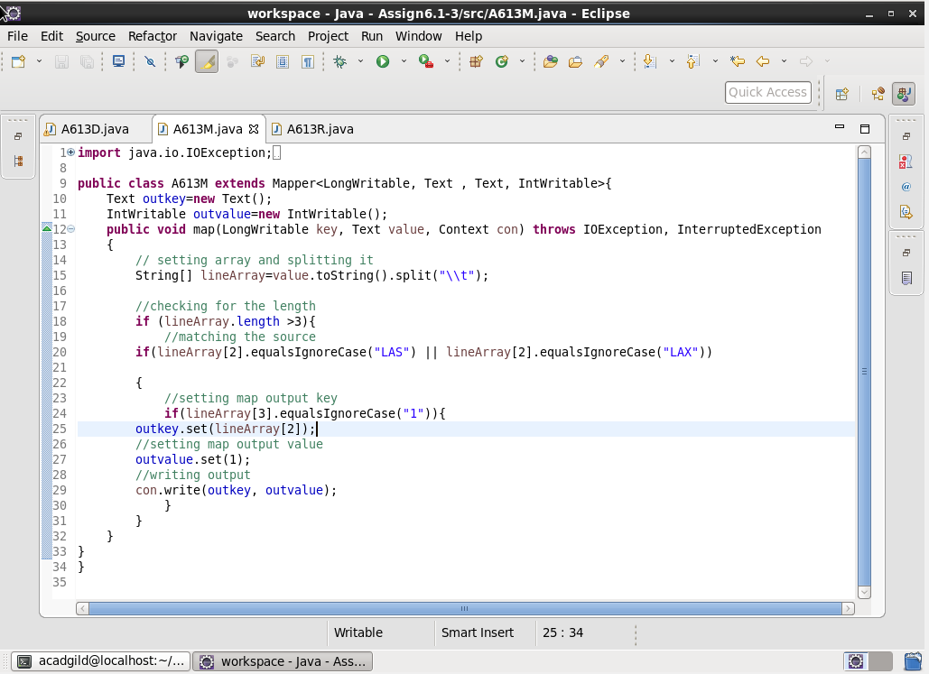

**Reducer Code-**

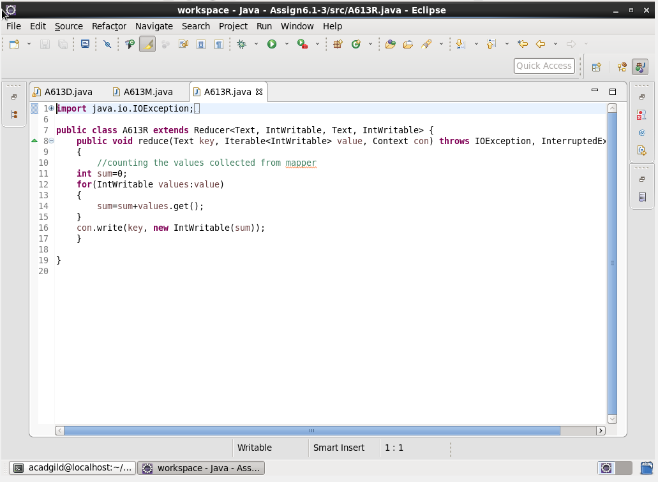

**Output File-**

