**Problem Statement**

The Daily show data analysis

**Input File-**

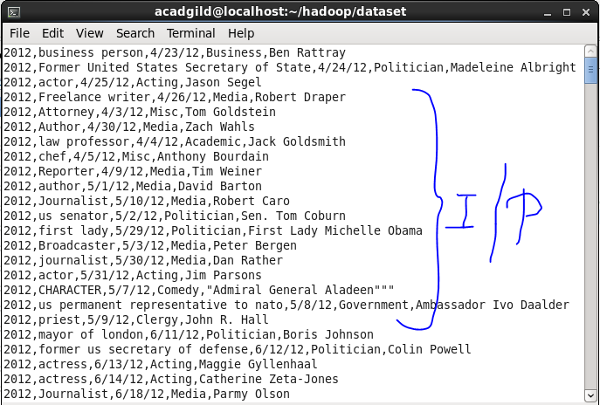

**Problem statement 1: Find the number of GoogleKnowlege_Occupation people who were guests in the show, in a particular time period. Take the time period as 1/11/99 to 6/11/99 i.e., 6 months.**

**Driver Code-**

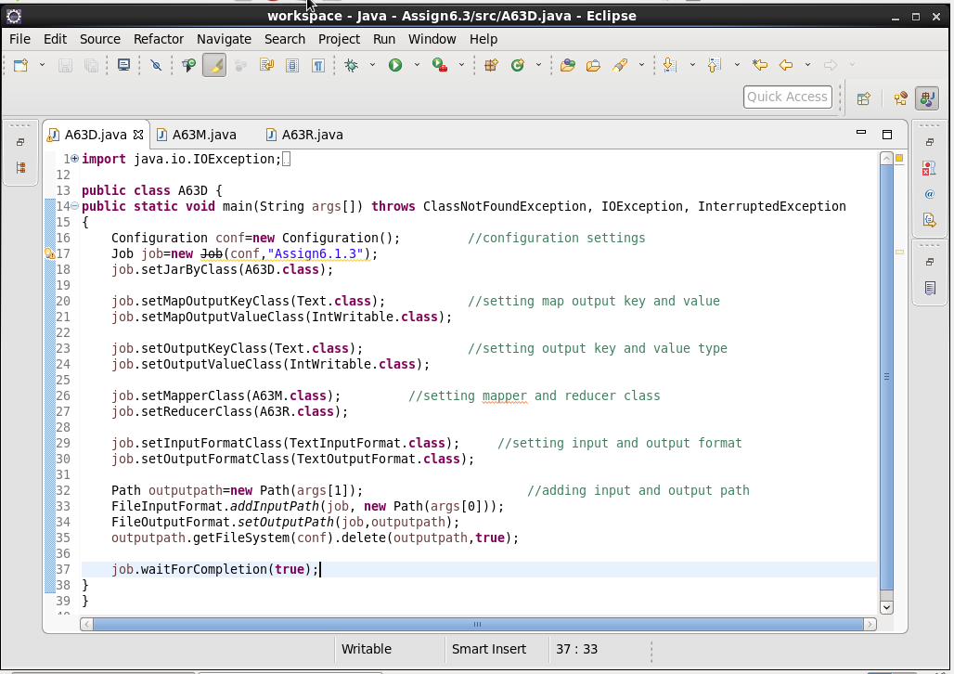

**Mapper Code-**

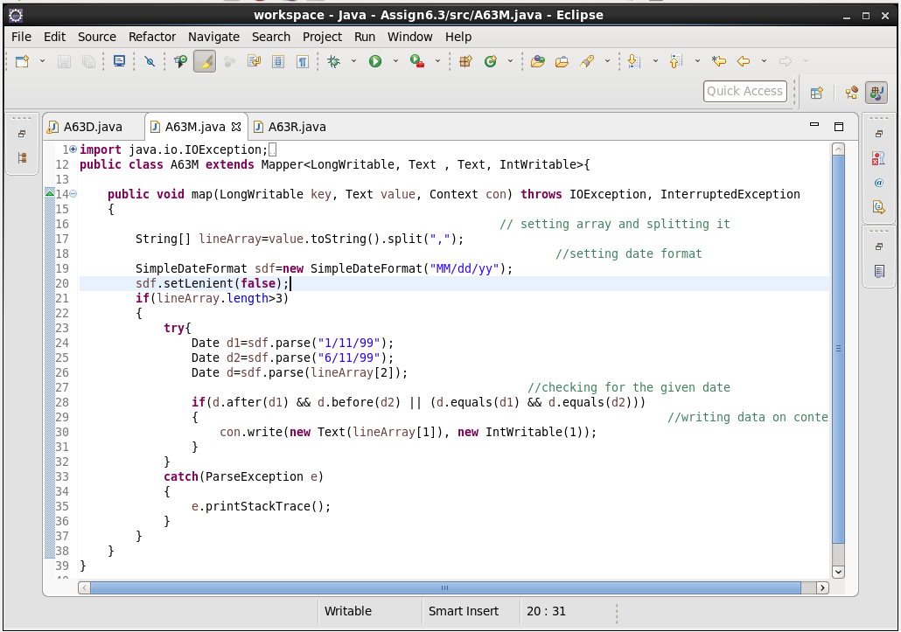

**Reducer Code-**

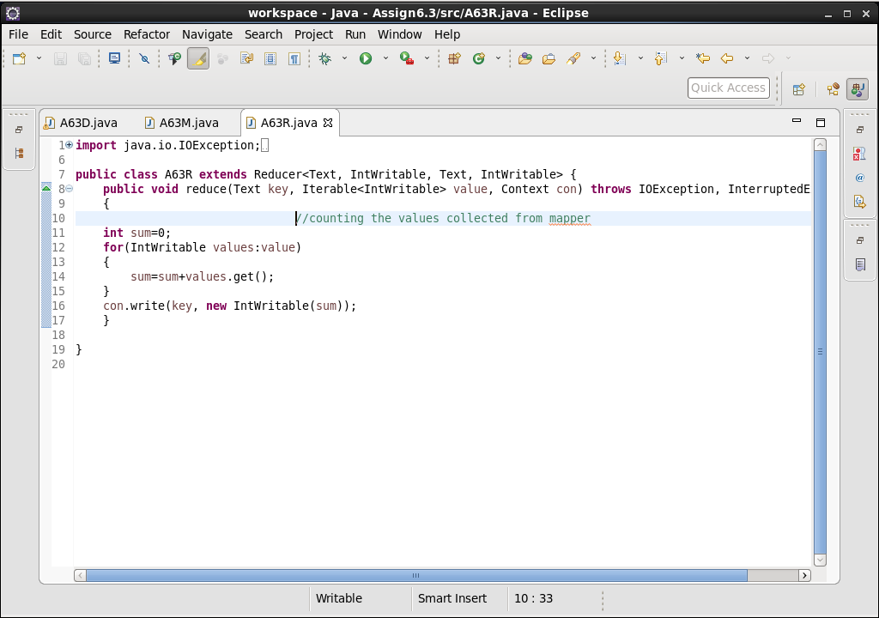

**Output-**

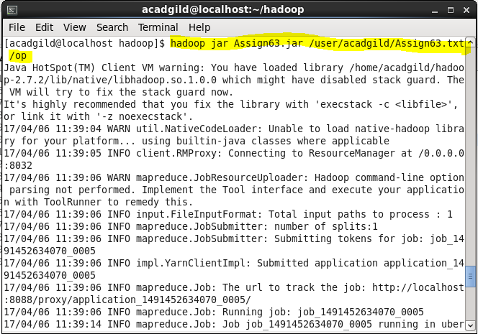

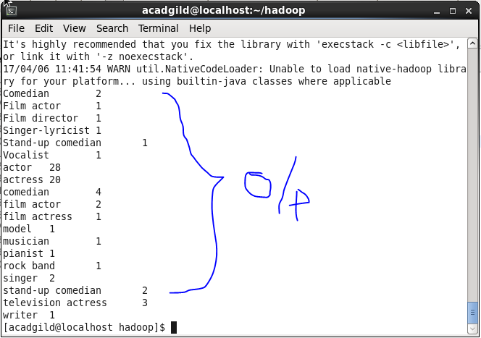

**Problem statement 2: Find the number of GoogleKnowledge occupation types in each group, who have been guests on the show.**

**Driver Code-**

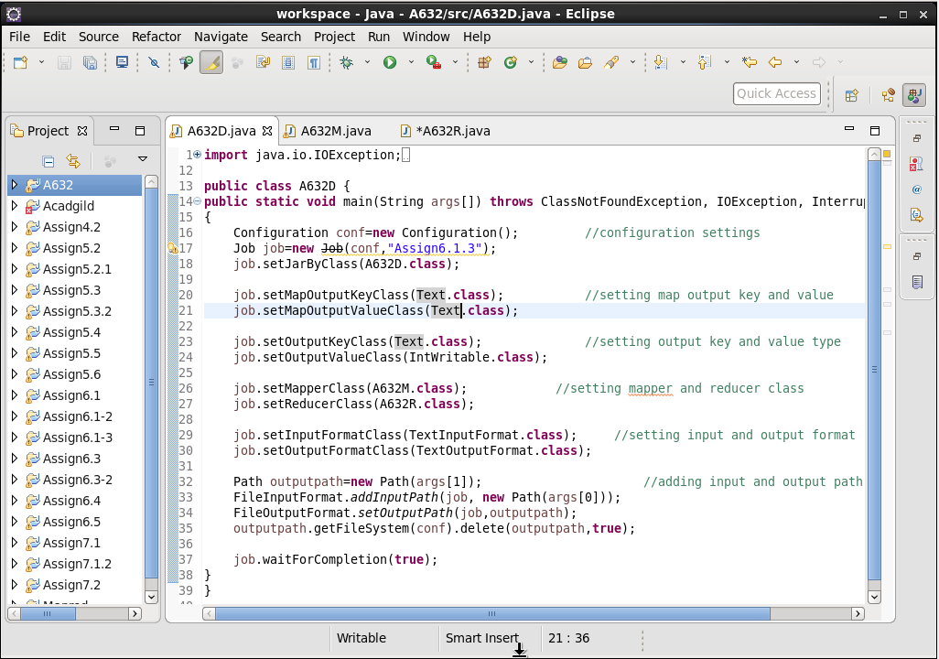

**Mapper Code-**

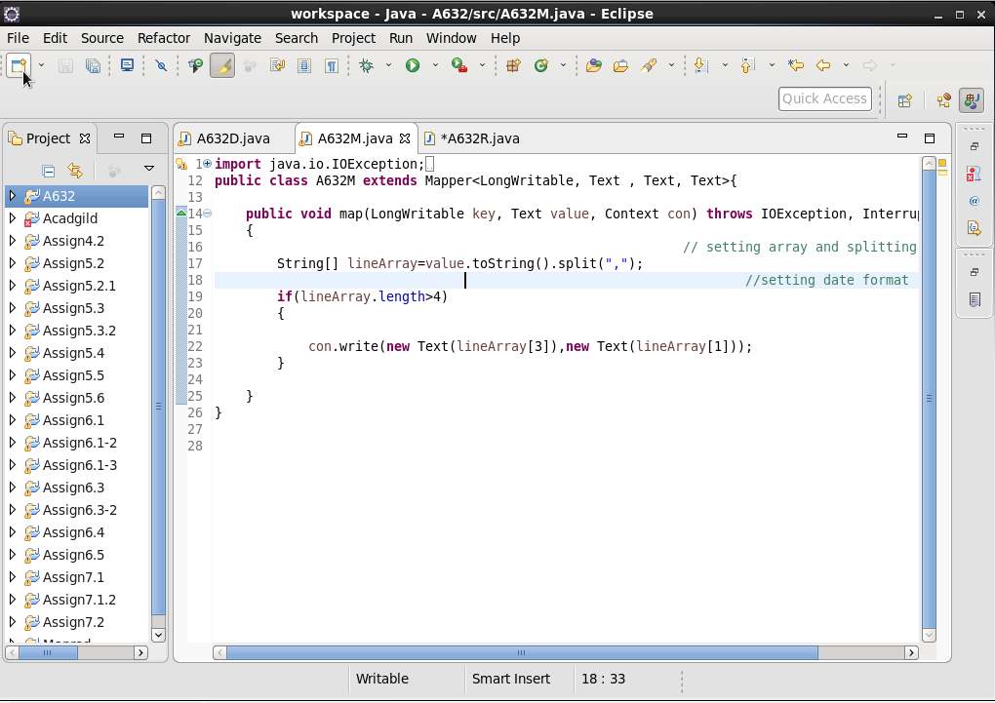

**Reducer Code-**

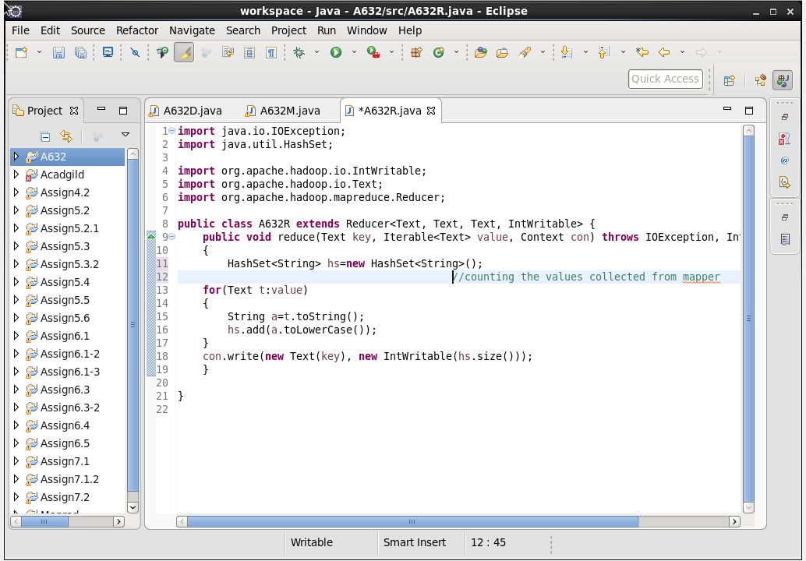

**Output**

