**Problem Statement**

**Write a map reduce program to use Sequence file as input and save the output in key value output format.**

**Driver Code-**

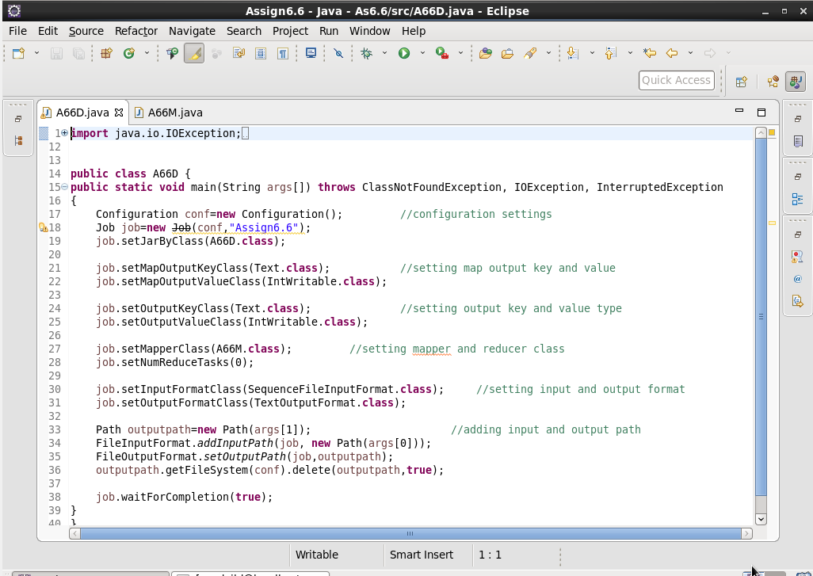

**Mapper Code-**

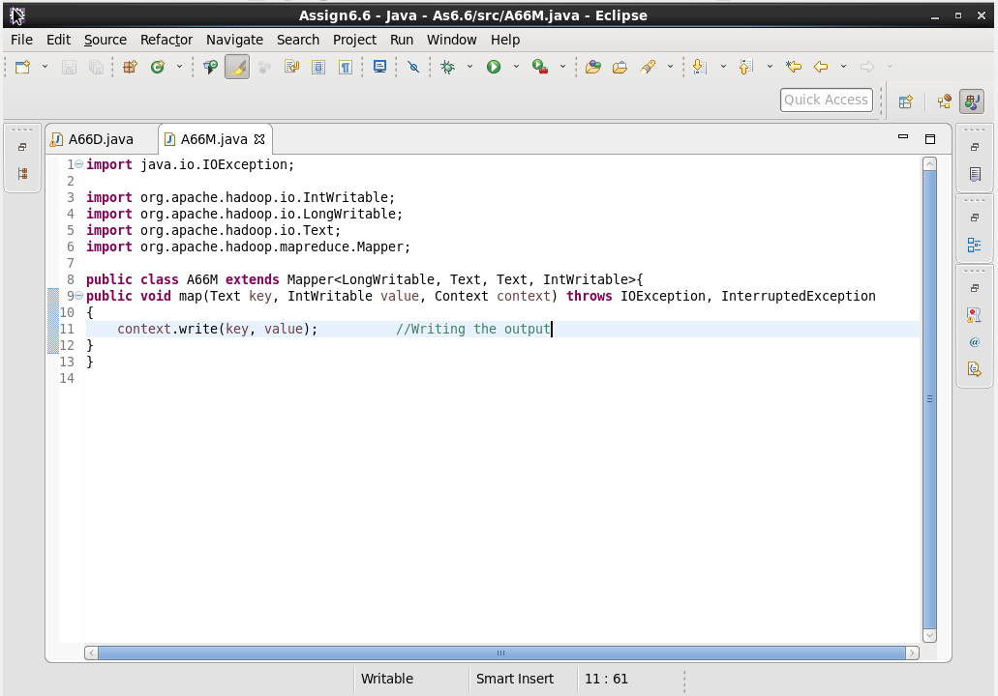

**Output-**

