**INPUT**

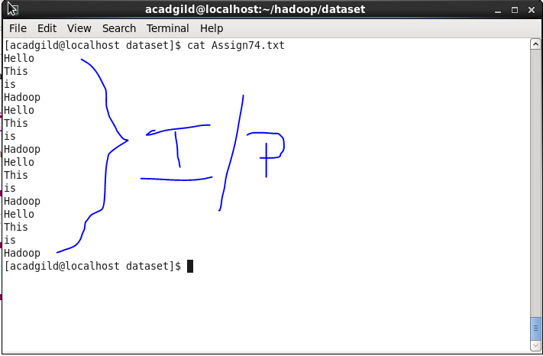

**Write a word count program using partitioner and implement the following logic in the partitioner words with length 5 should go into reducer 1 and words with length 6 should go into reducer 2 and the rest of the words should go into reducer 3.**

**Driver Code**

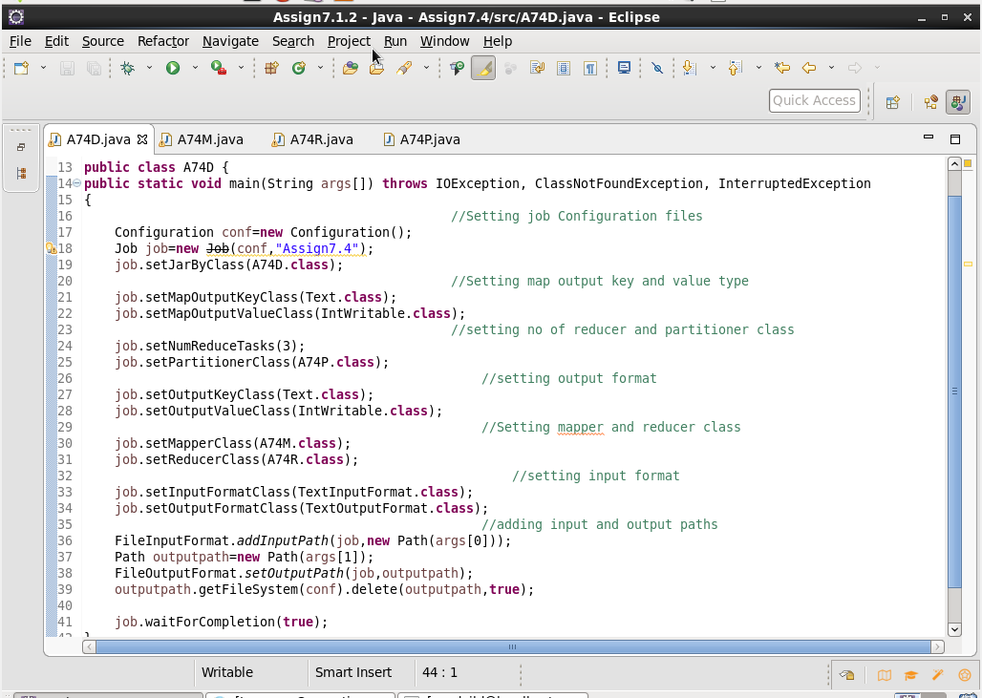

**Mapper Code**

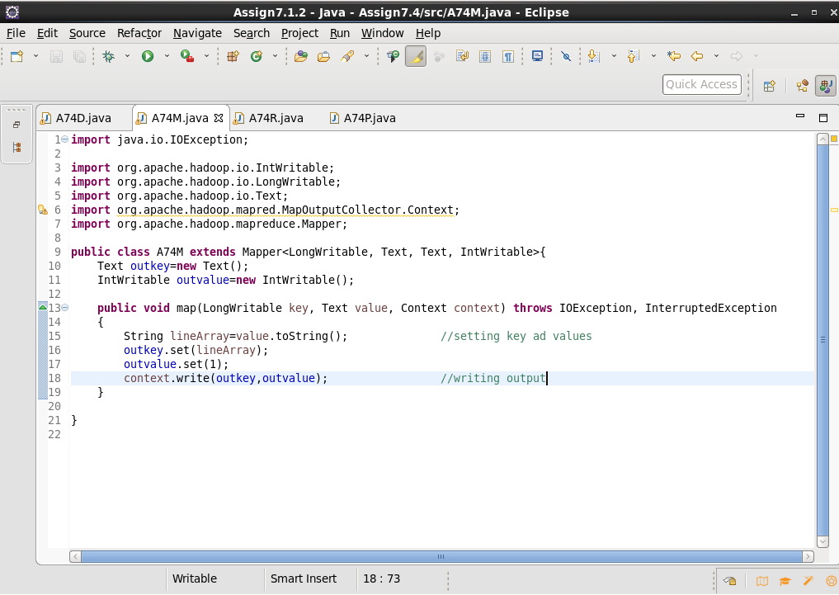

**Reducer Code**

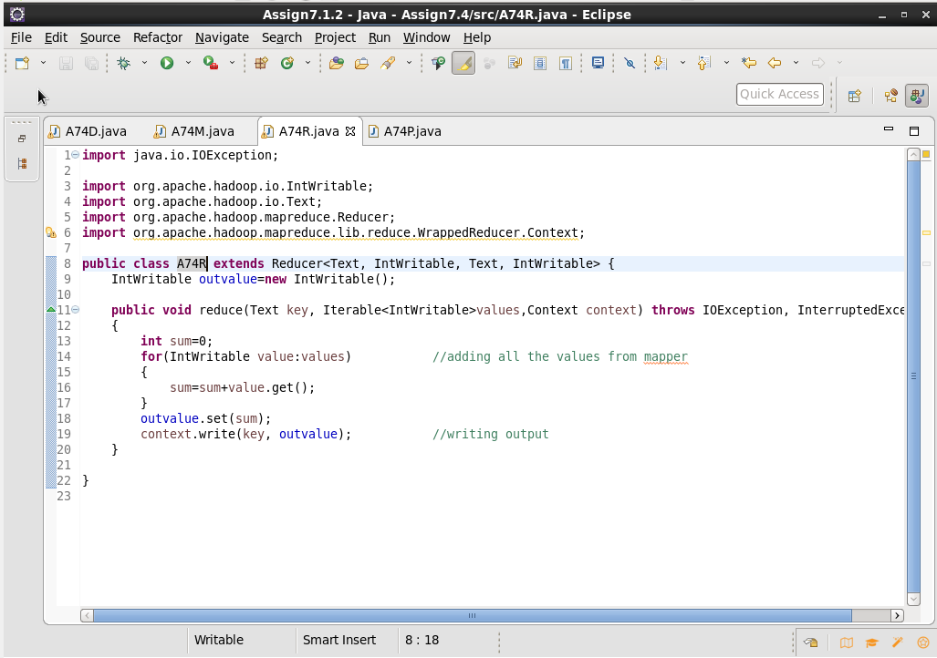

**Partitioner Class**

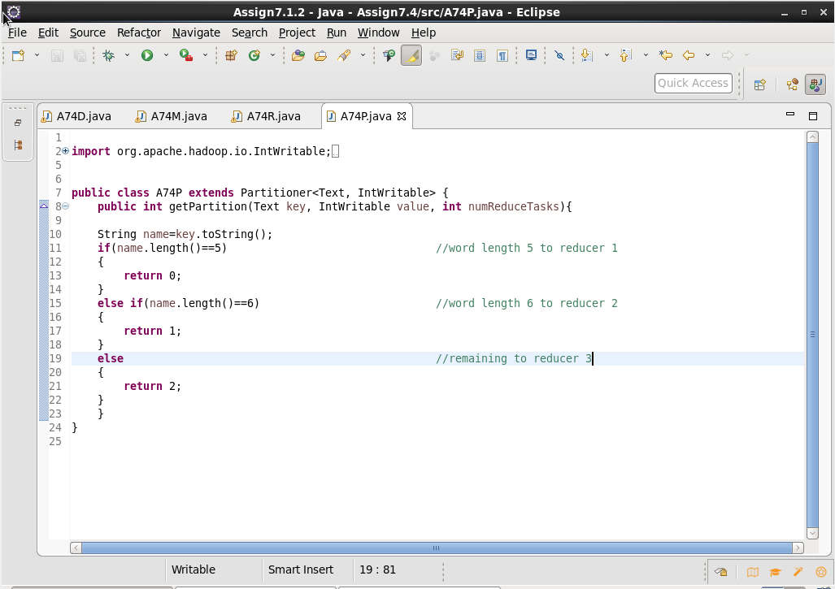

**Output**

