**Write a map only job for the word count program and set the output format as sequence file. Note : You can use the dataset of your choice**

**Driver Code**

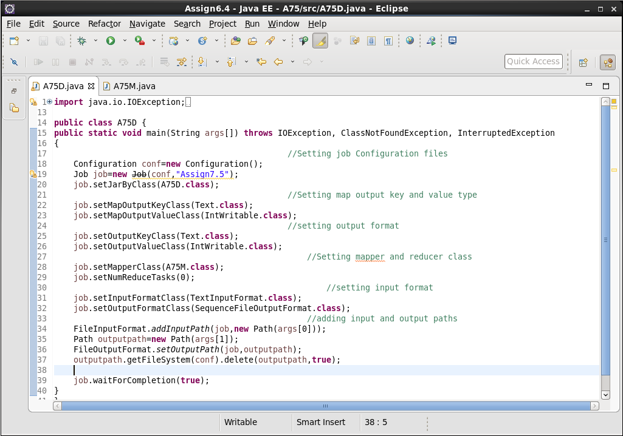

**Mapper Code**

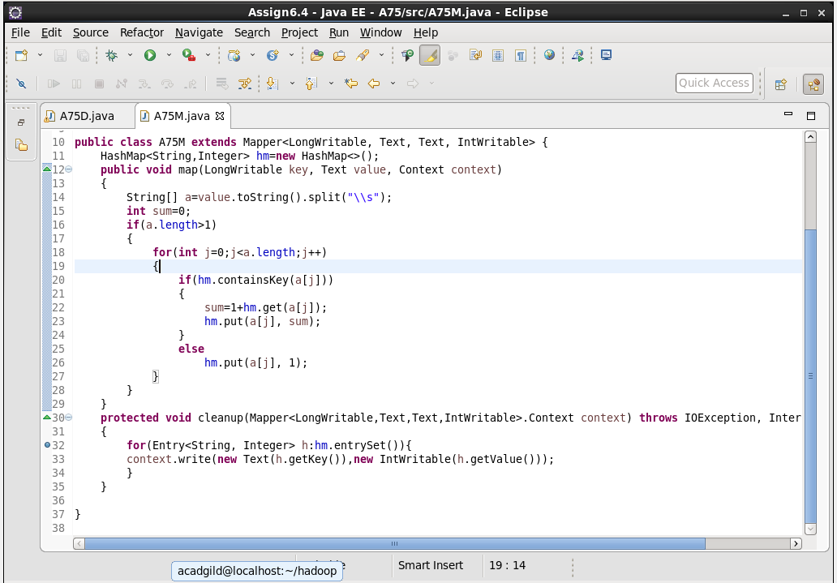

**Output**

