**Write a map reduce program save the output of the word count program in XML format. You need to write a custom writable to save the output in XML format.**

**Note : You can use any data set of your choice for executing this program**

**Driver Code**

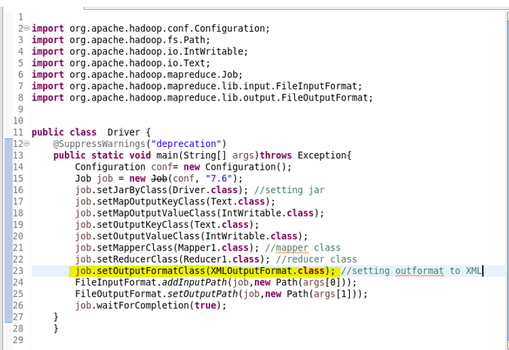

**Mapper Code**

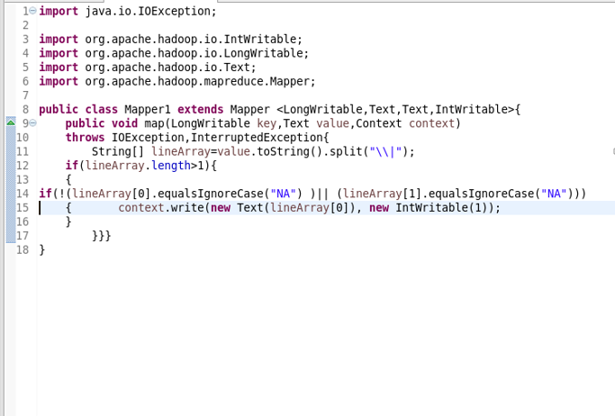

**Reducer Code**

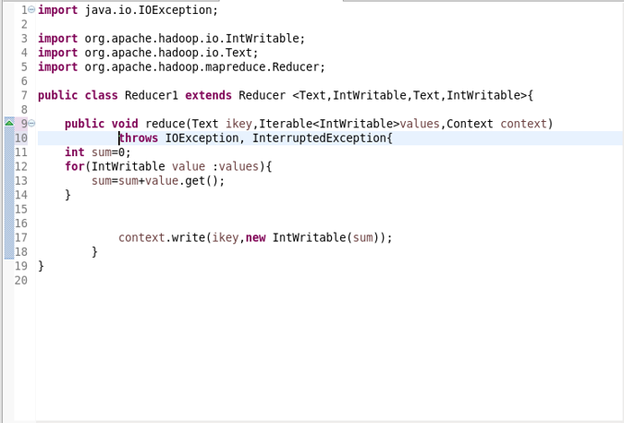

**XML Output Format**

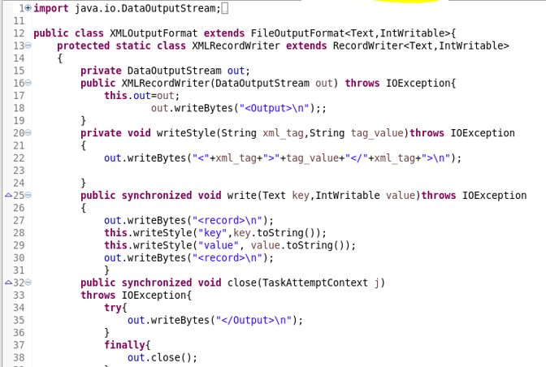

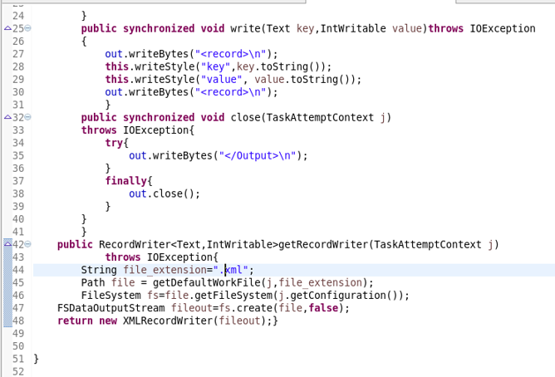

**Output**

