**Assignment 9.5**

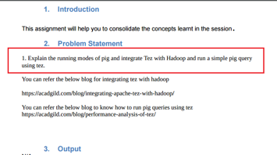

**RUNNING MODES IN PIG:**

**1. MapReduce/Hadoop Mode:**

-Here Pig jobs run as a series of MapReduce jobs picking the input and output paths from HDFS.

-Input file has to be copied in HDFS in case of Map reduce mode. Type the command pig or pig –x mapreduce to run Pig in MapReduce Mode.

**2. Local Mode:**

-Here the entire Pig job runs as a single JVM picking the local Unix path for execution.

-Input file has to be kept in local file system in case of local mode.

-Type the command pig or pig -x local to run Pig in Local Mode.

**DATASET:**

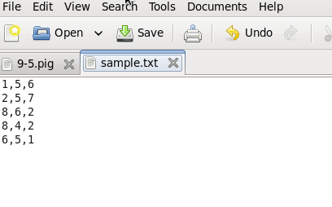

**PROGRAM:**

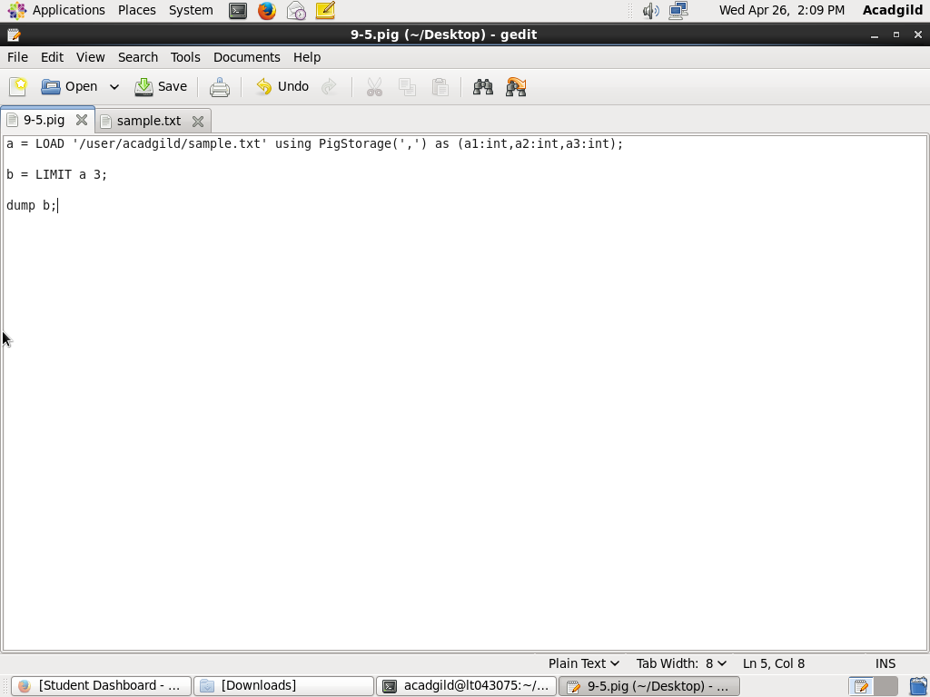

**EXECUTION COMMAND:**

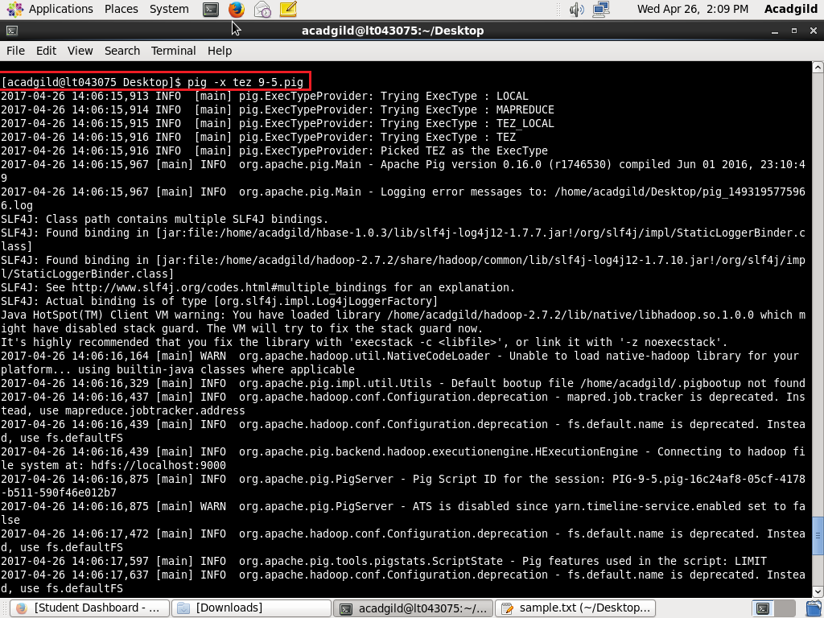

**OUTPUT:**

