Write a program to implement wordcount using Pig.

**LOAD DATA FROM LOCAL**

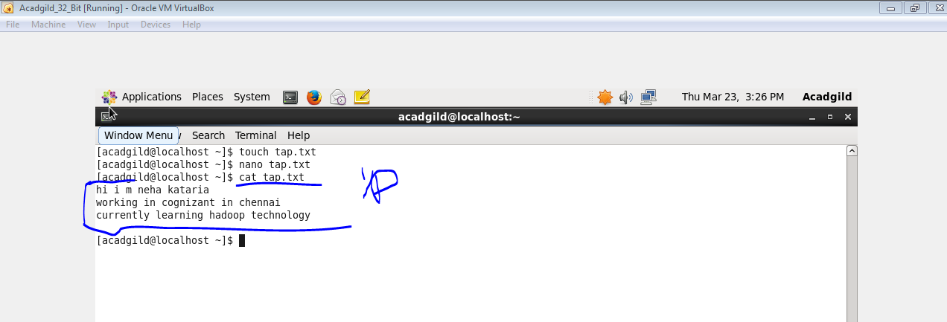

**SENTENCE INTO WORDS**

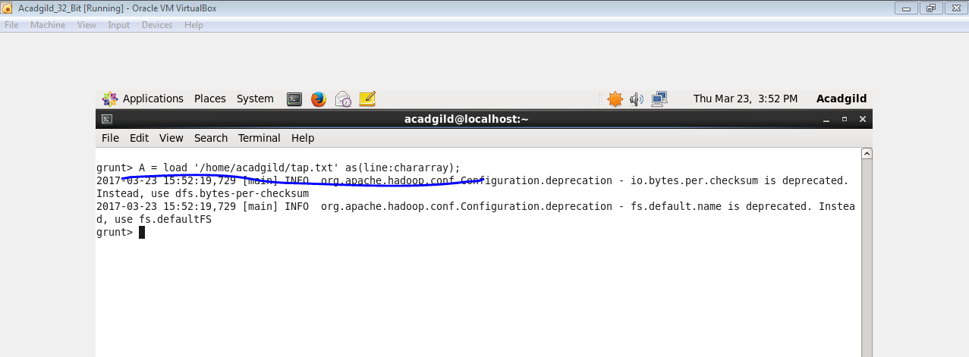

**COLUMN INTO ROWS**

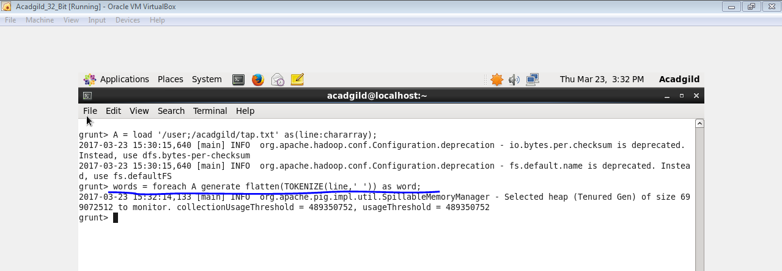

**GROUP BY COMMAND**

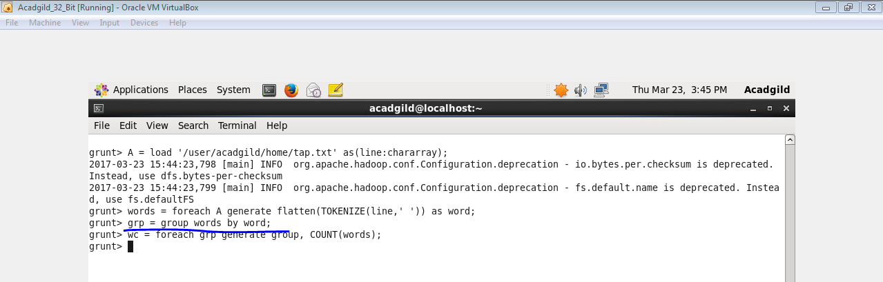

**GENERATE WORDCOUNT**

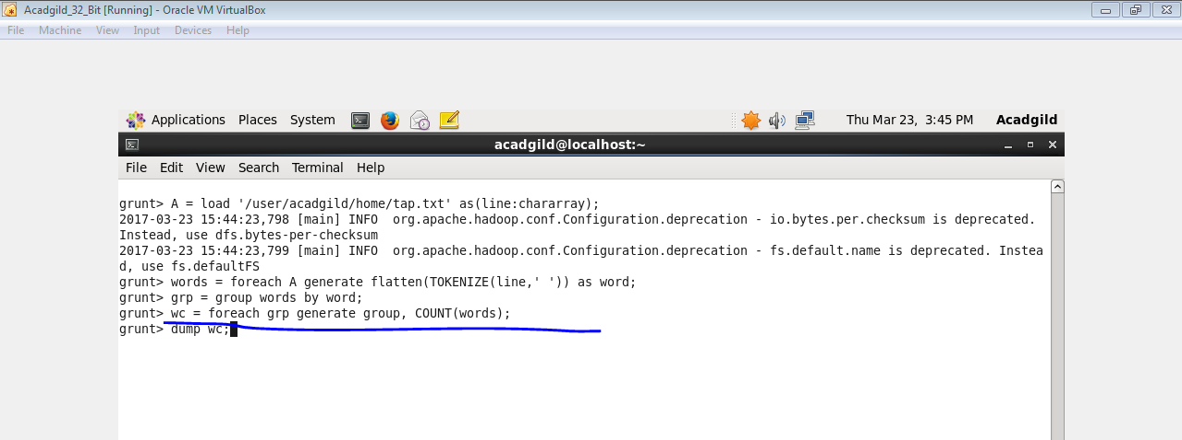

**OUTPUT**

