**Problem statement 1:**

Find the number of ratings given by each user.

**INPUT**

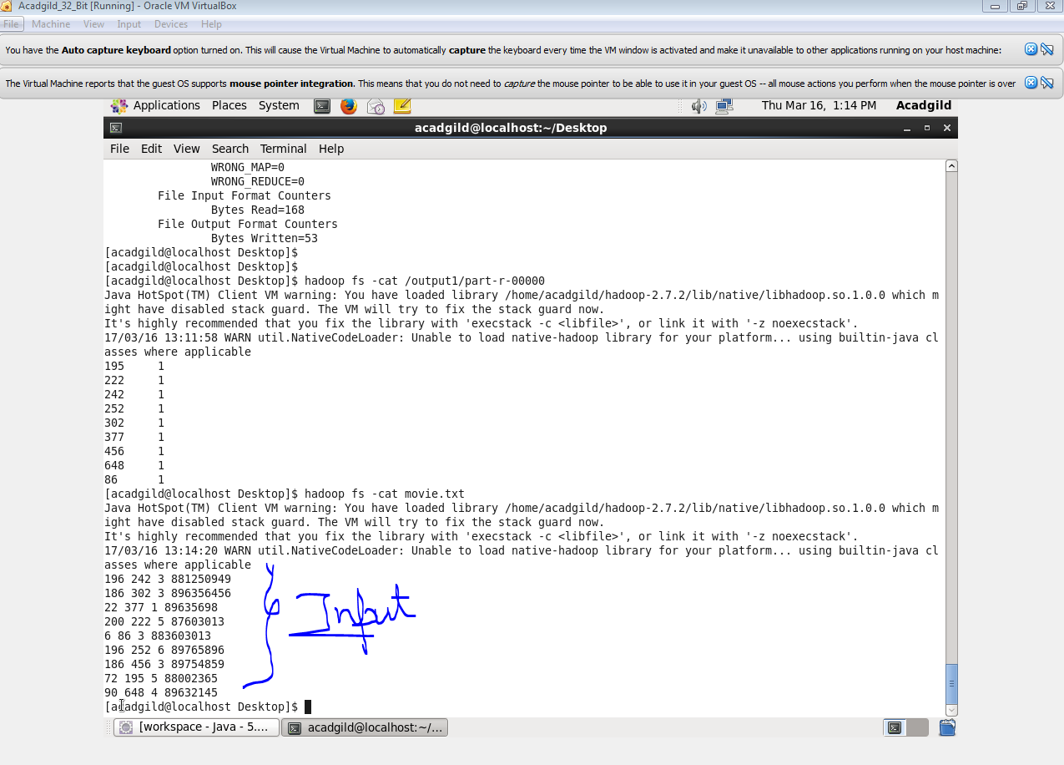

**CODE**

**DRIVER**

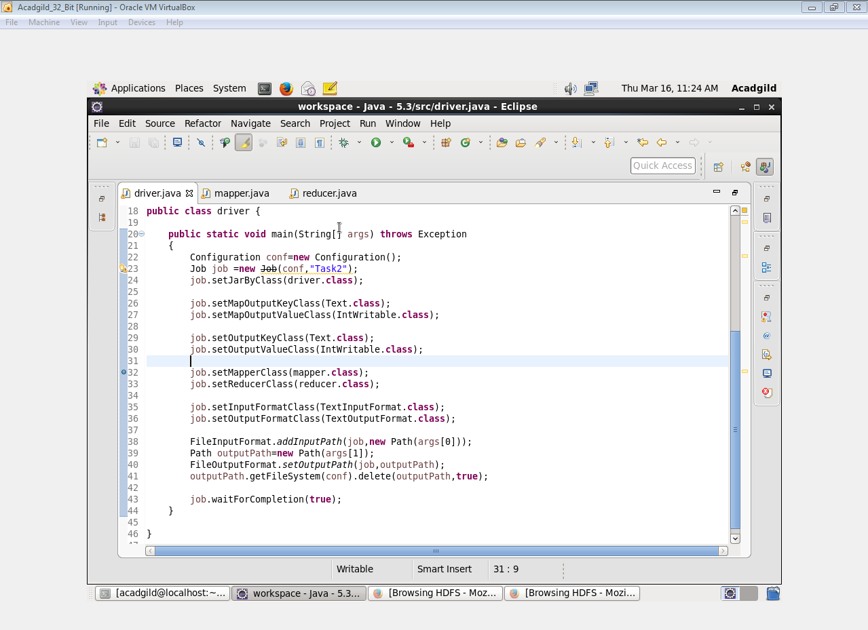

**MAPPER**

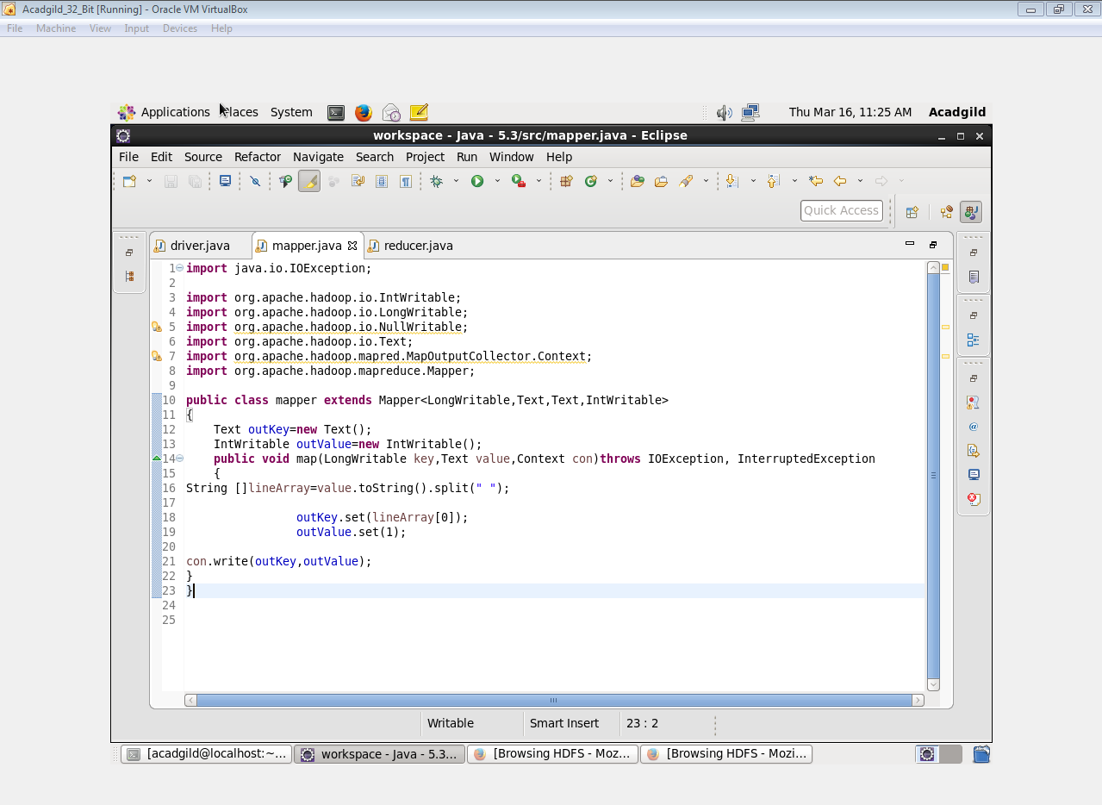

**REDUCER**

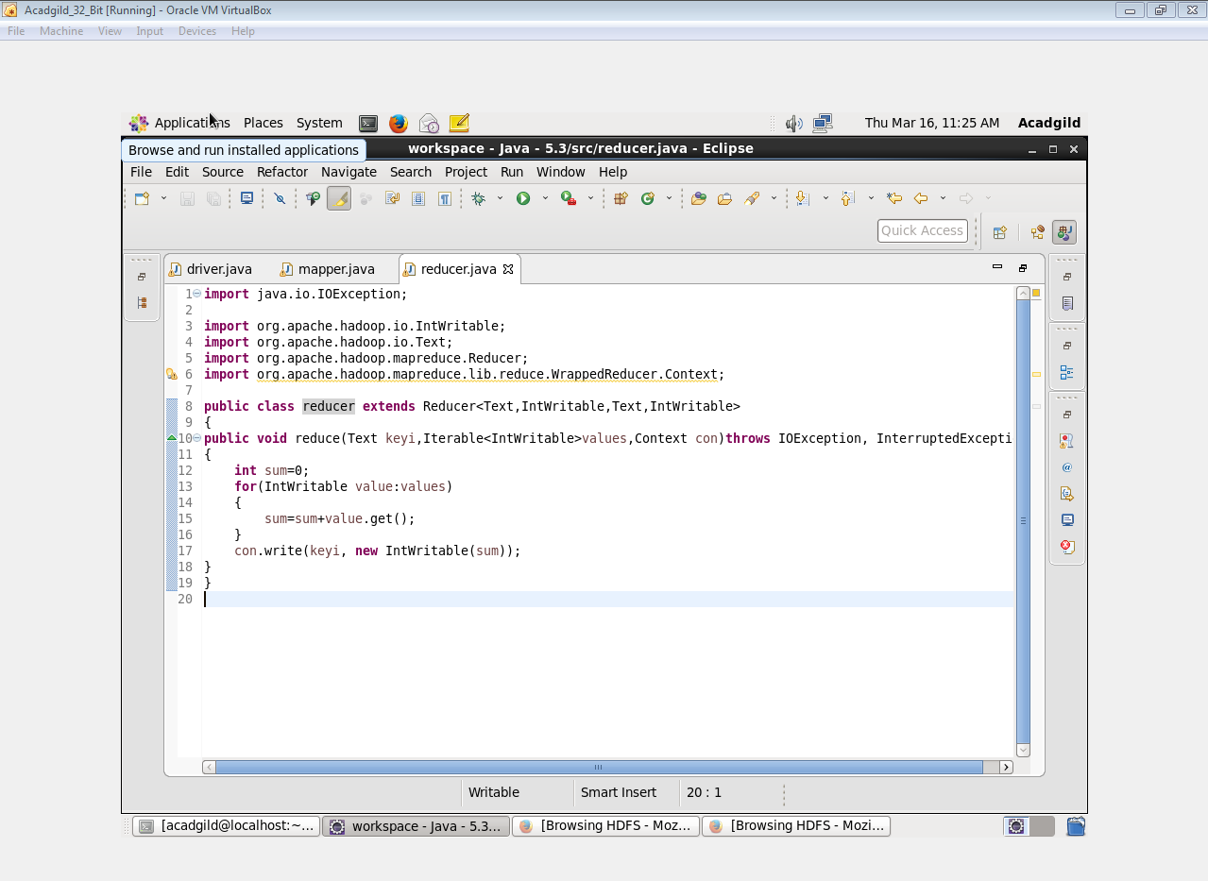

**OUTPUT**

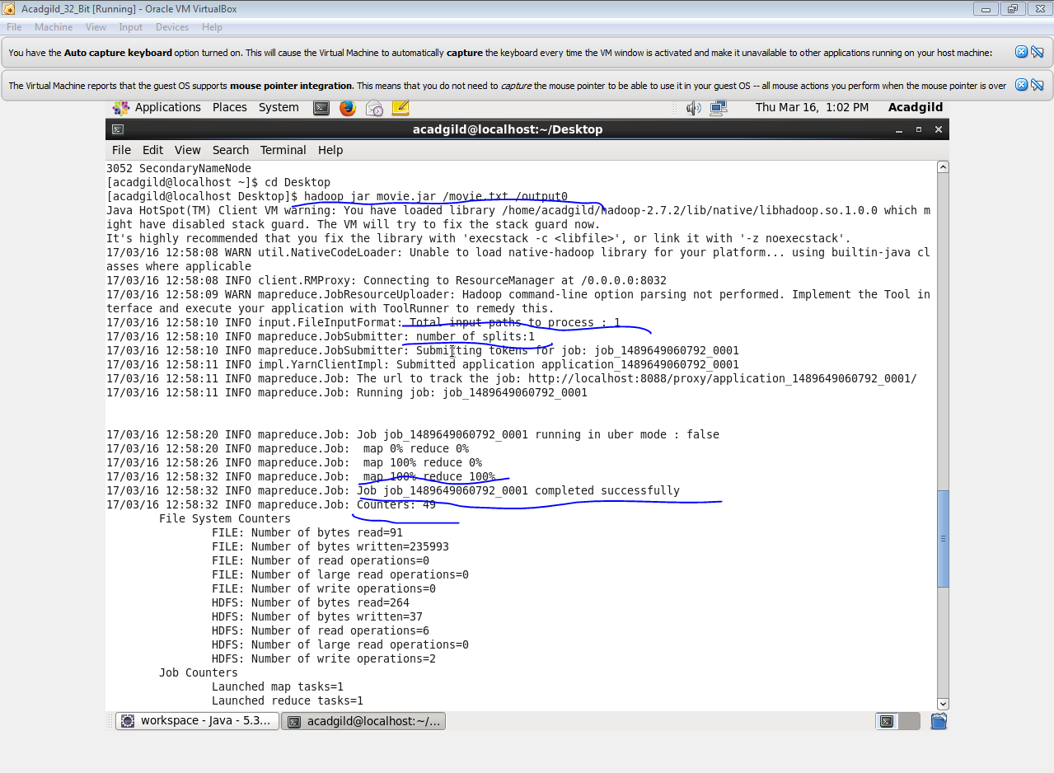

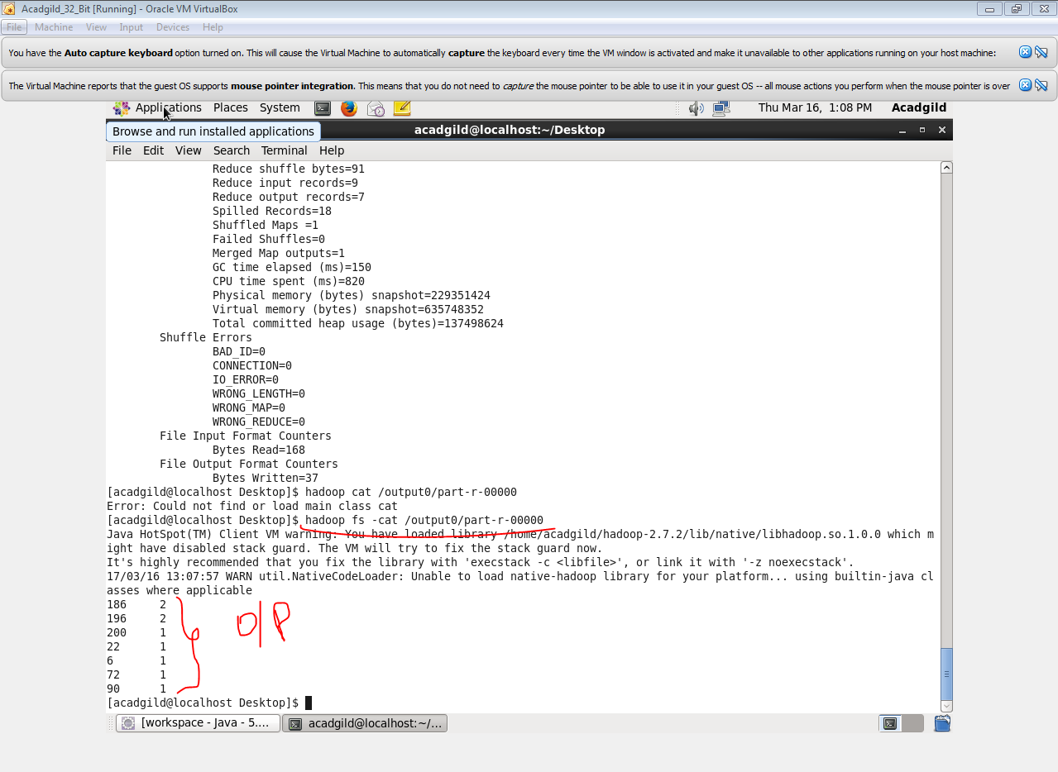

**Problem statement 2:**

Find the number of ratings received by each movie

**INPUT**



**DRIVER**



**MAPPER**

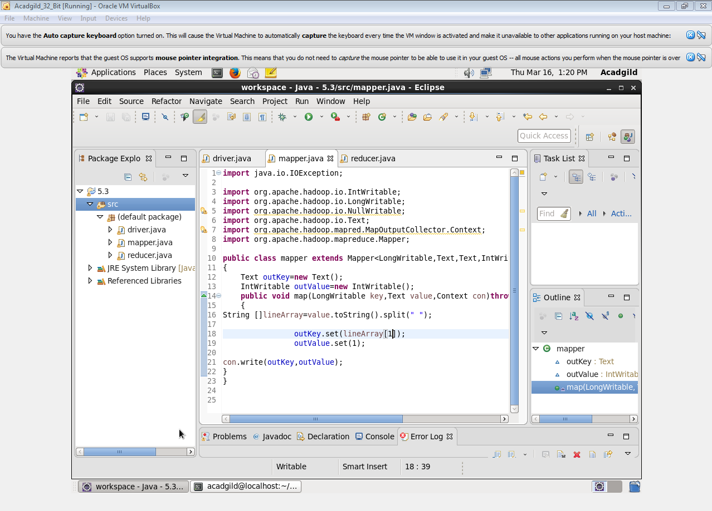

**REDUCER**



**OUTPUT**

