Write the Pig codes to analyze the petroleum data set.

**Q1What is the total amount of petrol in volume sold by every distributor?**

**A1 steps:**

1. Load the data from petrol_data.txt file.
2. Group the data by name;
3. Sum of total volume sold.
4. Dump the data.

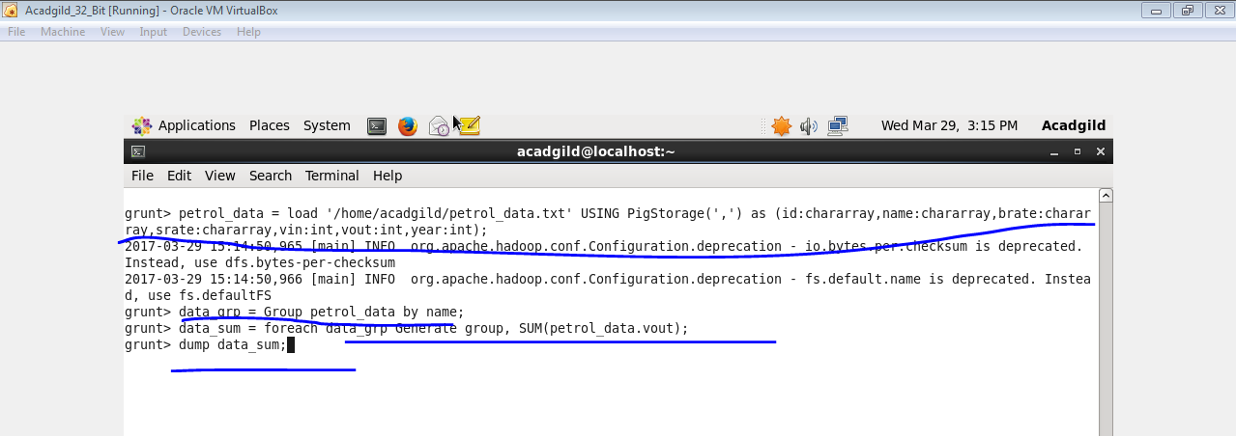

**OUTPUT**

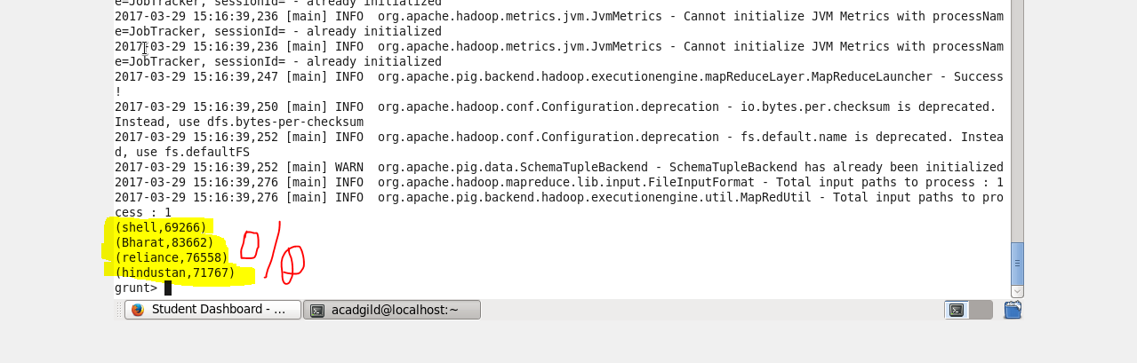

**Q2. Which are the top 10 distributors ID's for selling petrol? Also display the amount of petrol sold in volume.**

**A2**

1. Load the data from petrol_data.txt file.
2. Group the data by id and volume out.
3. Order by volume out in descending order.
4. Limit by 10.
5. Dump the data.

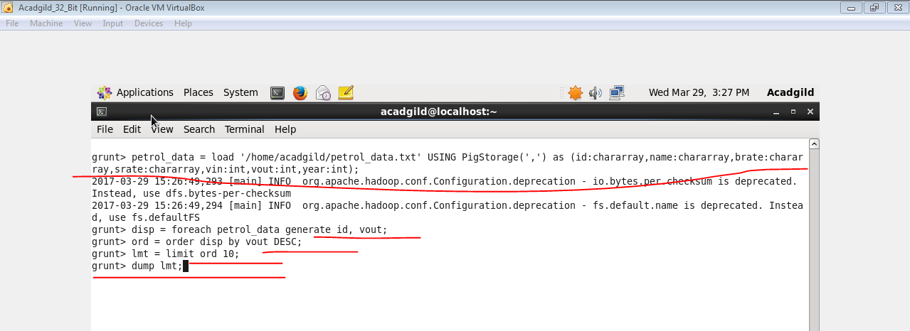

**OUTPUT**

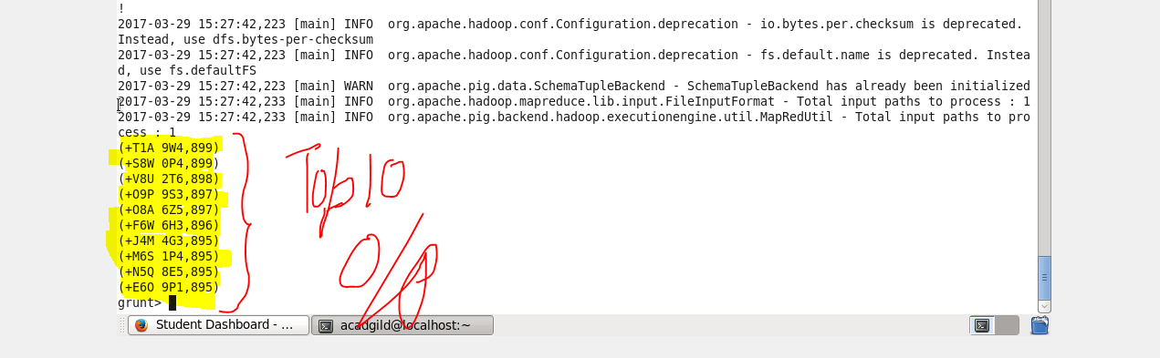

**Q3. List 10 years where consumption of petrol is more with the distributer id who sold it.**

**A3**

1. Load the data from petrol_data.txt file.
2. Order by volume out in descending order.
3. Display year and id.
4. Limit by 10.
5. Dump the data.

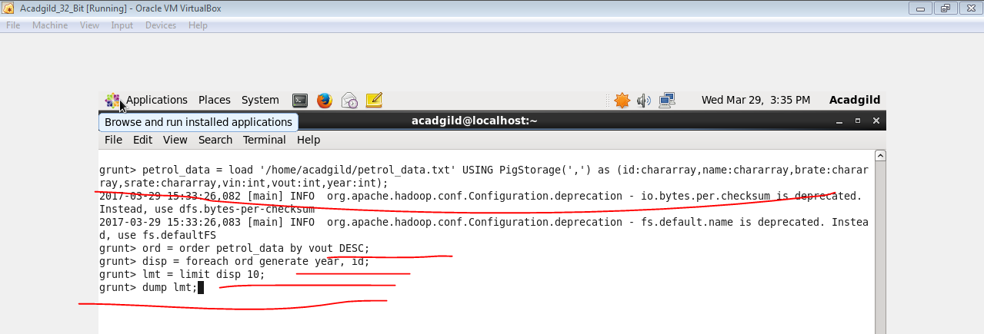

**OUTPUT**

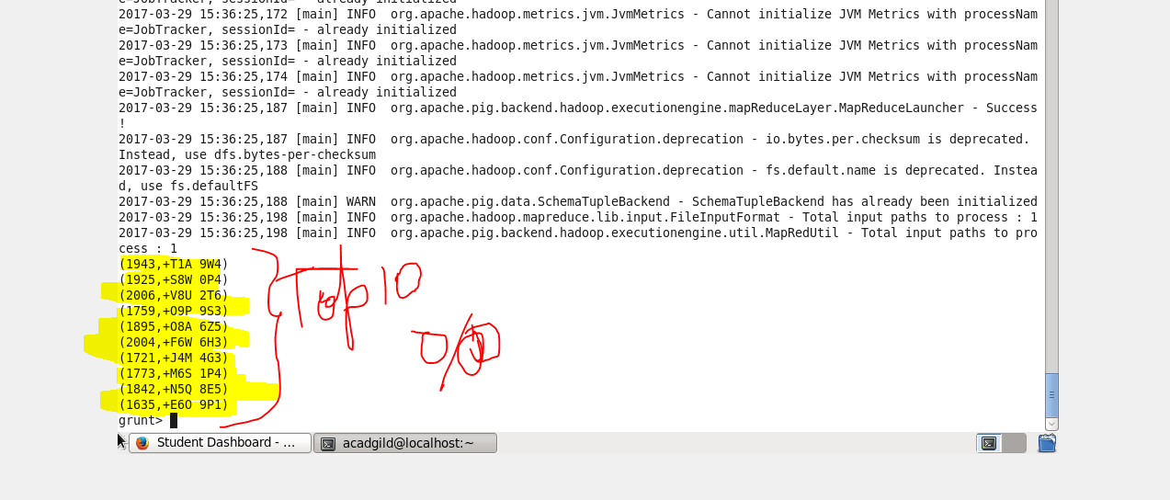

**Q4. Find the distributer name who sold petrol in least amount.**

**A4**

1. Load the data from petrol_data.txt file.
2. Order by volume out in ascending order.
3. Display name.
4. Limit by 1.
5. Dump the data.

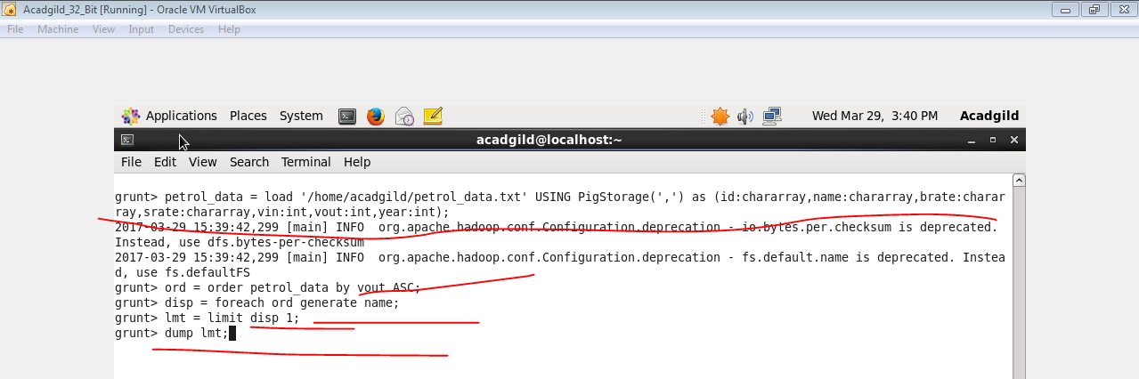

**OUTPUT**

