1. **Find the number of students who scored less than 5(50%).**

**Commands**

1. Load the student data into local.
2. Filter the student data with grade <5.
3. Group filtered data by all
4. Count the number of students.

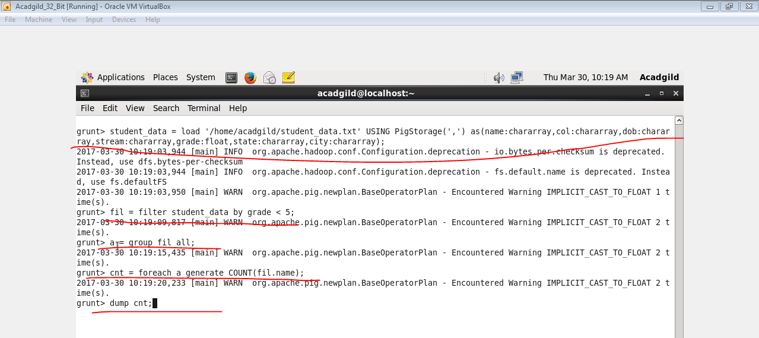

**OUTPUT**

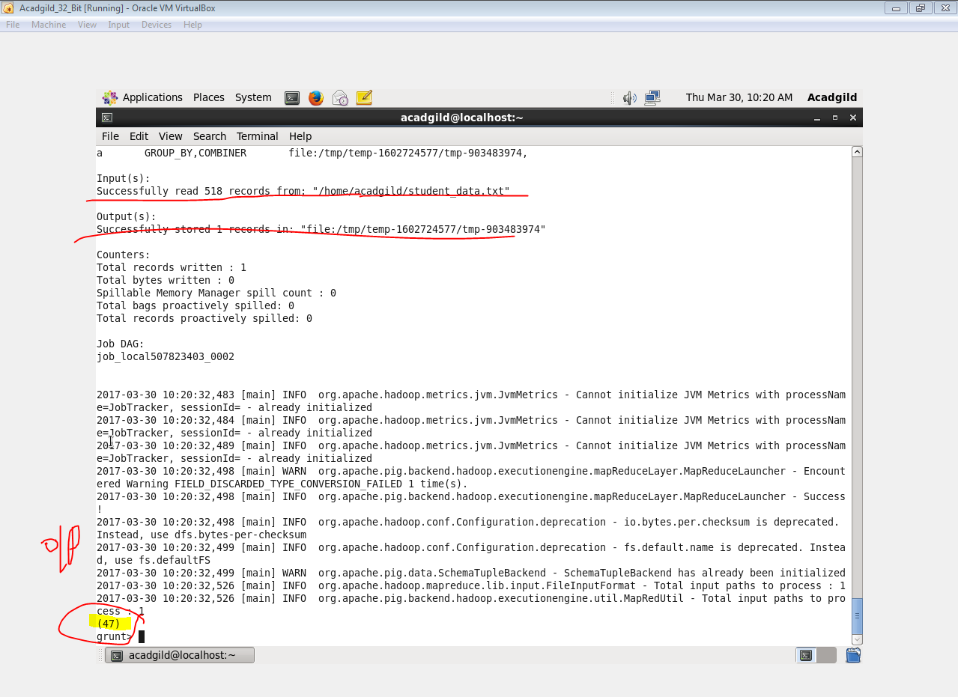

1. **List the name of students who are from Alaska.**

**Commands**

1. Load the student data into local.
2. Filter the student data with state alaska
3. Display the students name.

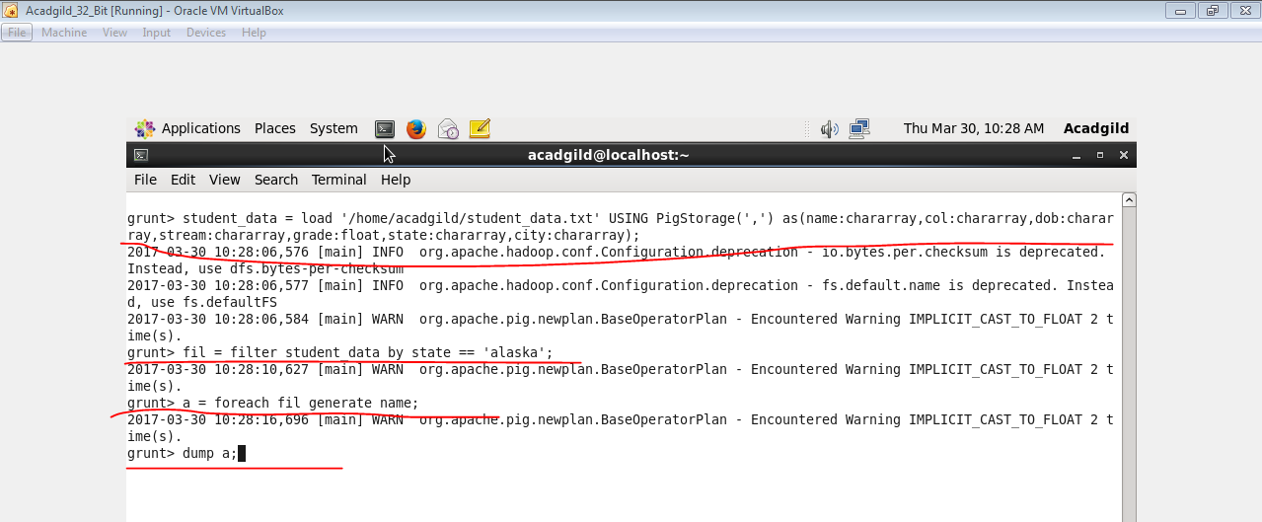

**OUTPUT**

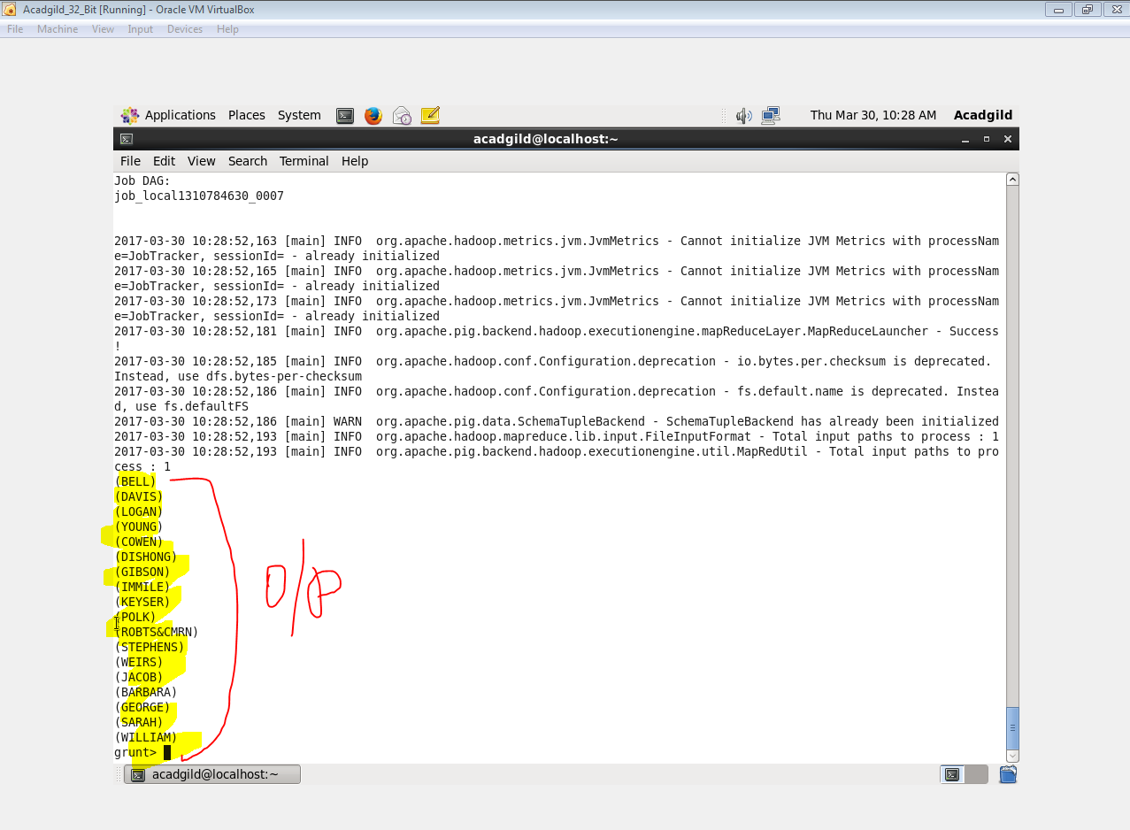

1. **How many government colleges are there in Alabama?**

**Commands**

1. Load the student data into local.
2. Filter the student data with state Alabama and Government College.
3. Group filtered data by all.
4. Display the count.

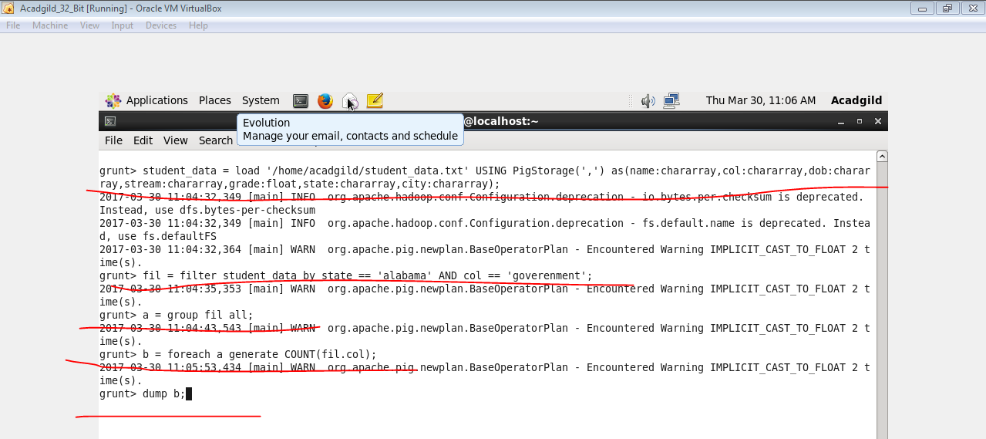

**OUTPUT**

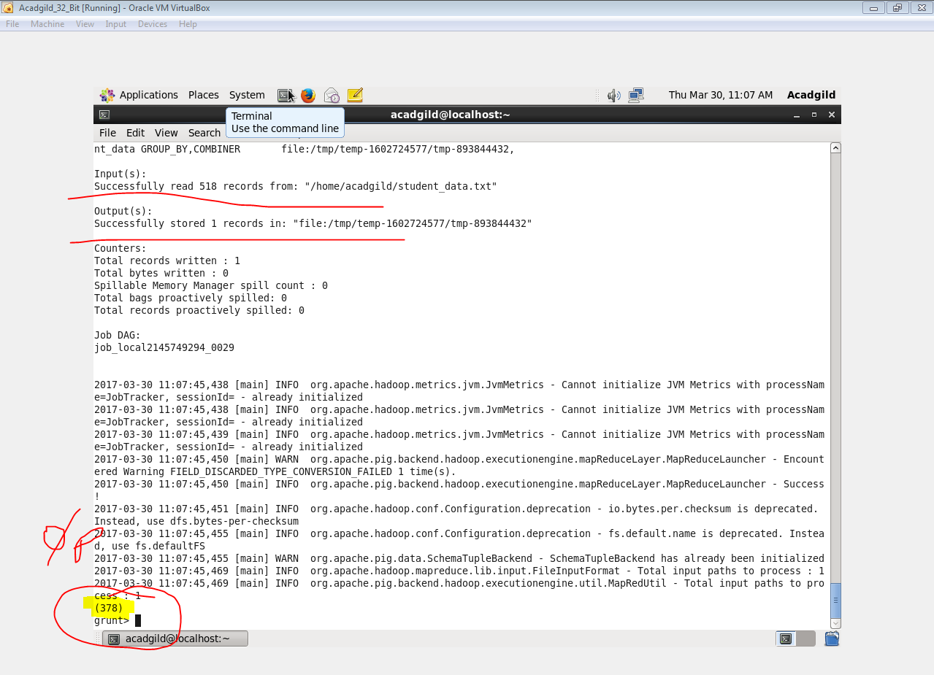

1. **List the name of students who are from Oregon and persuing BE.**

**Commands**

1. Load the student data into local.
2. Filter the student data with state Oregon and stream BE.
3. Display students name.

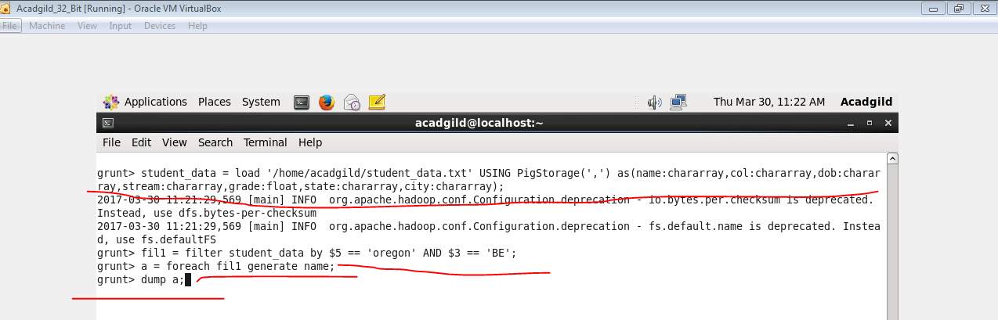

**OUTPUT**

