**Create a database named 'custom'.**

**Create a table named temperature_data inside custom having below fields: 1. date (mm-dd-yyyy) format 2. zip code 3. temperature**

**The table will be loaded from comma-delimited file. Load the dataset.txt (which is ',' delimited) in the table.**

***INPUT FILE:***

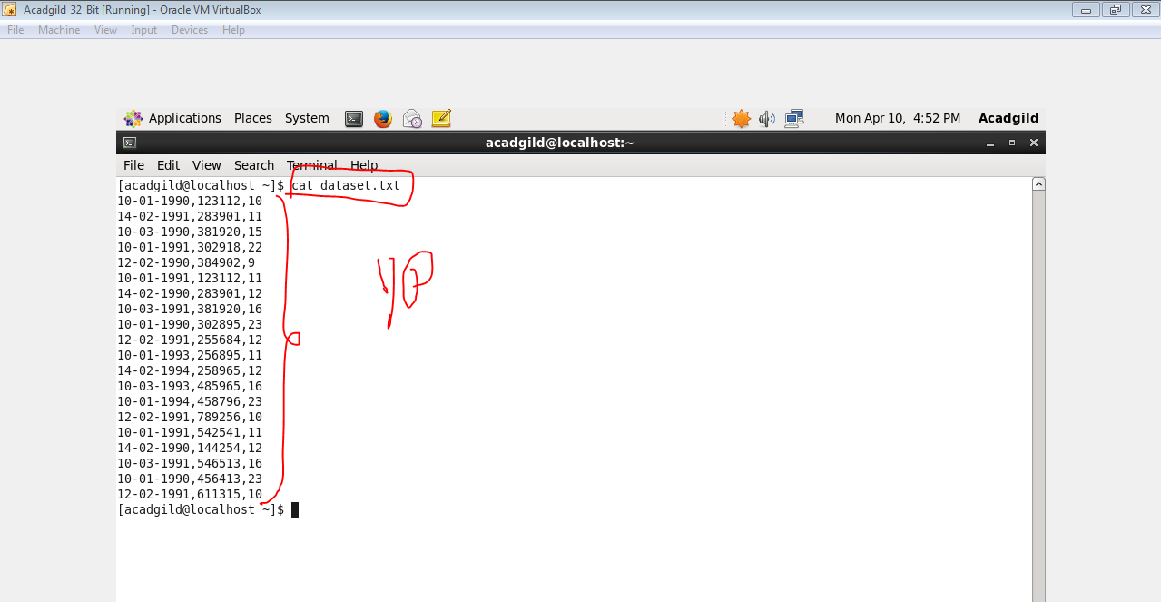

***COMMANDS:***

* Create database
* Use database
* Create table
* Load the data into table created
* Display the output

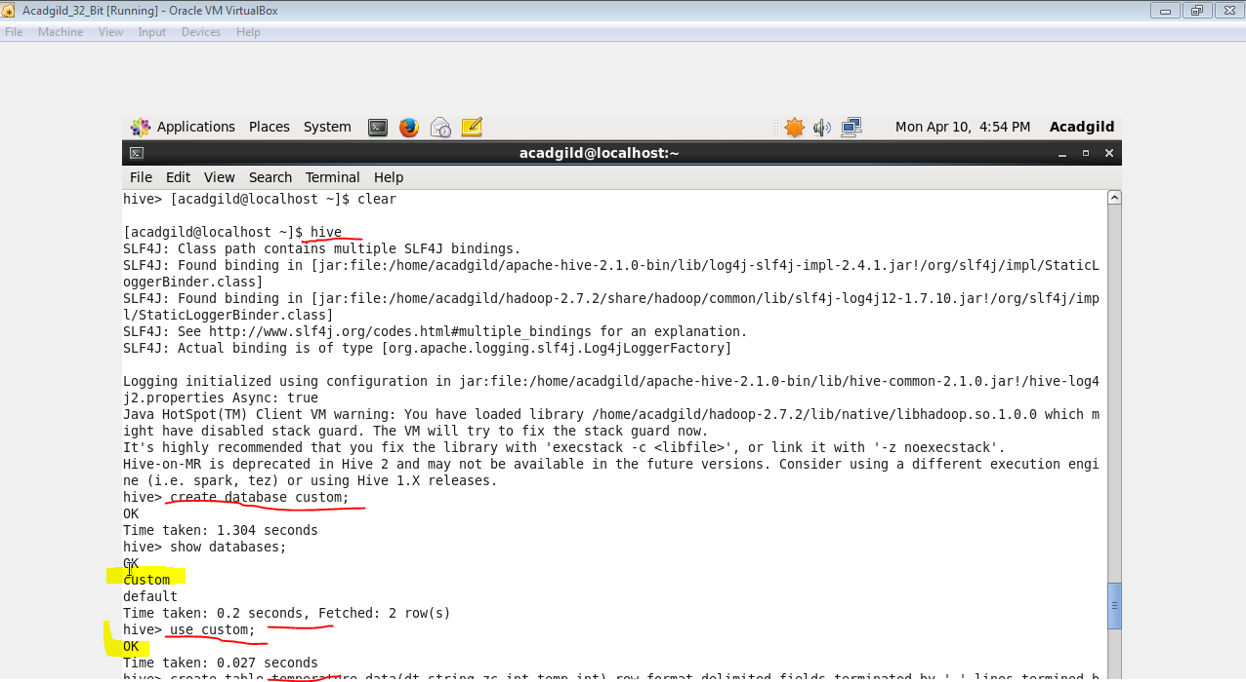

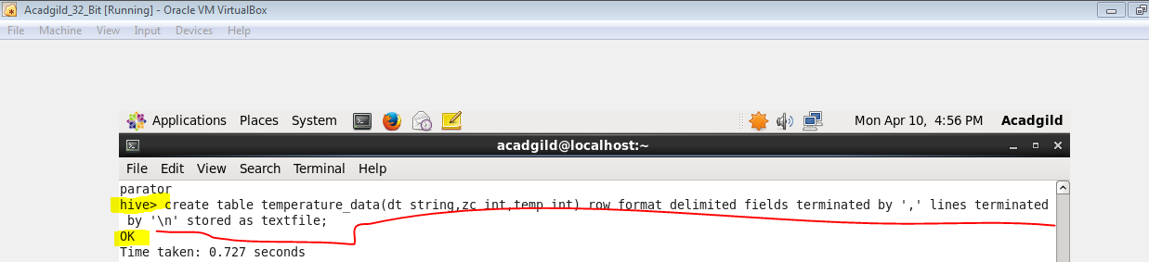

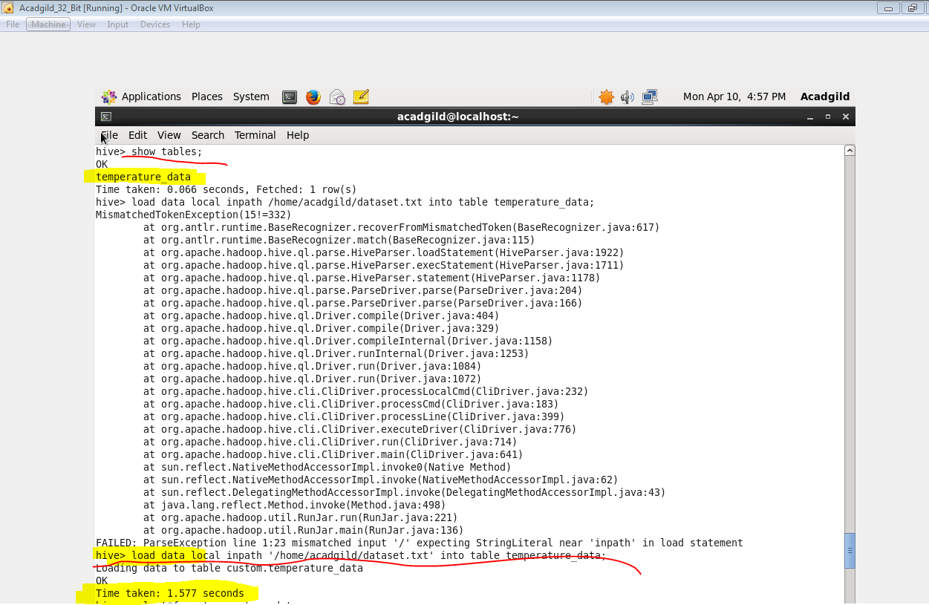

***OUTPUT:***

