**Explain Primary data types and complex data types in Hive with an example in brief.**

**Primary data types:**

Primary Data Types are further classified into four categories. They are:

• **Numeric Types**

**• String Types**

**• Date/Time Types**

**• Miscellaneous Types**

***Numeric Data Types***

• **Integral types are** – TINYINT, SMALLINT, INT & BIGINT

• **Floating types are** – FLOAT, DOUBLE & DECIMAL.

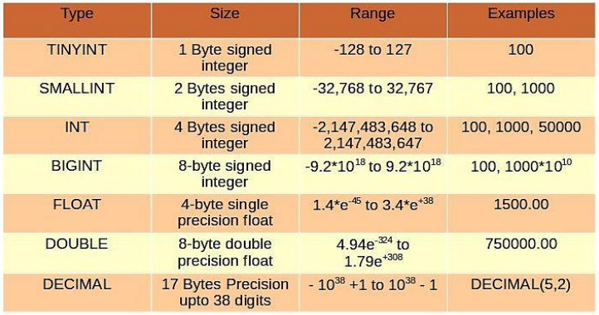

***String Data Types***

* **STRING**

String literals can be expressed with either single quotes (') or double quotes (")

* **VARCHAR**

Varchar types are created with a length specifier (between 1 and 65355), which defines the maximum number of characters allowed in the character string.

* **CHAR**

Char types are similar to Varchar but they are fixed-length meaning that values shorter than the specified length value are padded with spaces but trailing spaces are not important during comparisons.

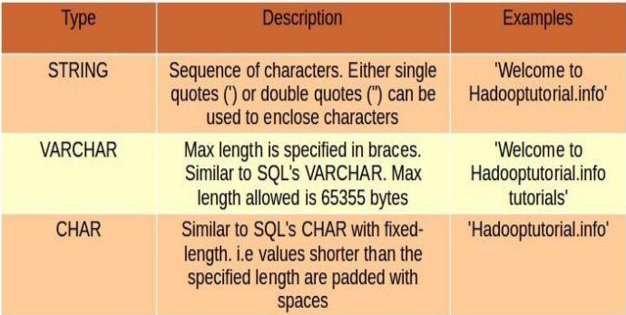

***Date/Time Types***

• Hive provides DATE and TIMESTAMP data types in traditional UNIX time stamp format for date/time related fields in hive.

• DATE values are represented in the form YYYY-MM-DD. Example: DATE ‘2014-12-07’. Date ranges allowed are 0000-01-01 to 9999-12-31.

• TIMESTAMP use the format yyyy-mm-dd hh:mm:ss[.f...].

• We can also cast the String, Time-stamp values to Date format if they match format.

***Miscellaneous Types***

• Hive supports two more primitive data types, BOOLEAN and BINARY. Similar to Java’s Boolean, BOOLEAN in hive stores true or false values only.

• BINARY is an array of Bytes and similar to VARBINARY in many RDBMSs

**Complex data types:**

Currently Hive supports four complex data types. They are:

**ARRAY**

**MAP**

**STRUCT**

**UNIONTYPE**

**ARRAY**

* ARRAY<datatype>
* An Ordered sequences of similar type elements that are indexable using
* zero-based integers.
* It is similar to arrays in Java.
* Example – array (‘siva’, ‘bala’, ‘praveen’);
* Second element is accessed with array [1 MAP]

**MAP**

* MAP<primitive_type,data_type>
* Collection of key-value pairs.
* Fields are accessed using array notation of keys (e.g., [‘key’]).

**STRUCT**

* STRUCT <col_name:data_type[COMMENT col_comment]
* It is similar to STRUCT in C language.
* It is a record type which encapsulates a set of named fields that can be any primitive data type.
* Elements in STRUCT type are accessed using the DOT (.) notation.
* Example – For a column c of type STRUCT {a INT; b INT} the a field is accessed by the expression c.a

**UNIONTYPE**

* UNIONTYPE <data_type,data_type,….>
* It is similar to Unions in C.

• At any point of time, an Union Type can hold any one (exactly one) data type from its specified data types.