**Calculate the number of employees corresponding to each skill from the table 'employee' which is loaded in the Demo.**

***TABLE CREATION***

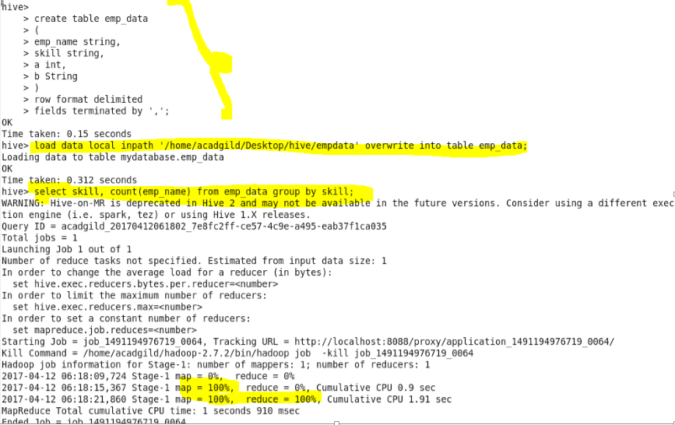

***OUTPUT***

