1. **Write a hive query find the average age of male and female persons died in the titanic tragedy**

***TABLE CREATION***

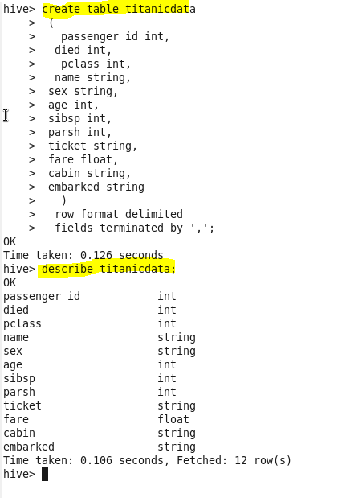

***LOADING THE DATA***



***OUTPUT***

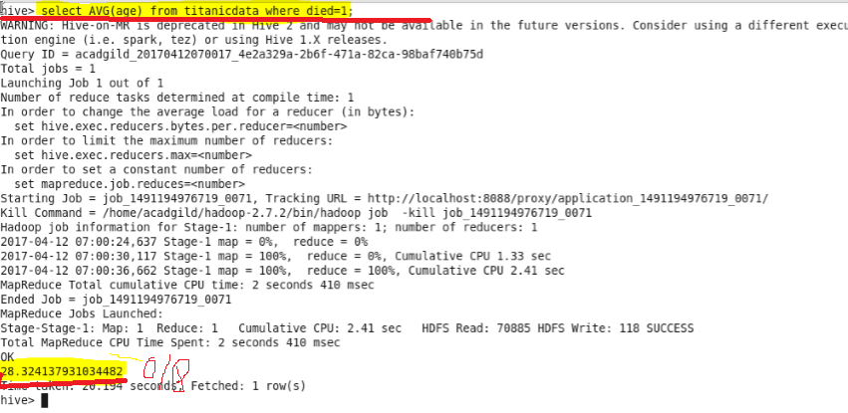

1. **Write a hive query to find the number of people died and survived in each class**

***OUTPUT***

