***TABLE CREATION***

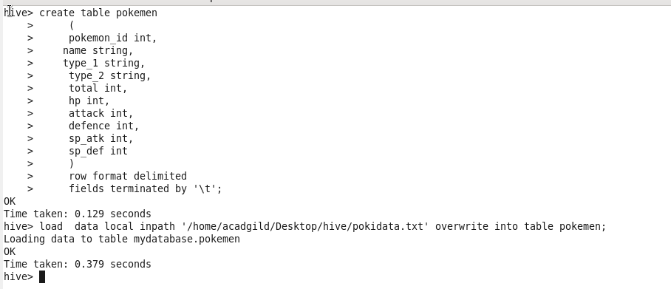

1. **Find out the average HP (Hit points) of all the Pokémons**

***CREATING VIEW***

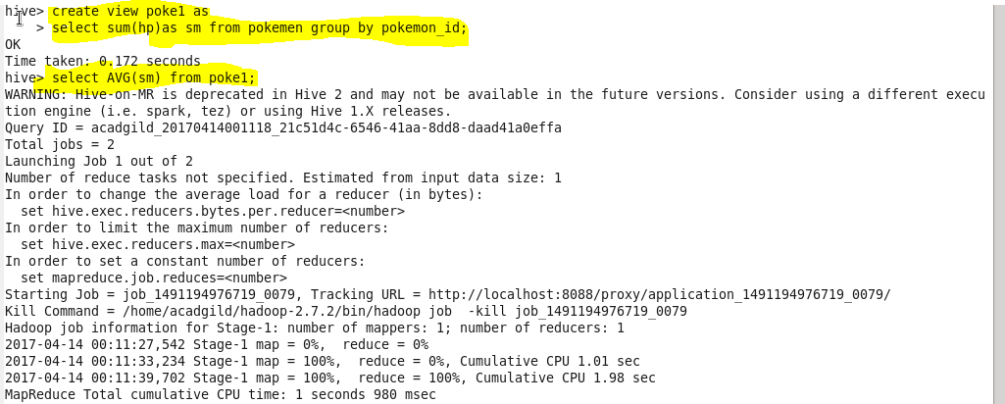

***OUTPUT***

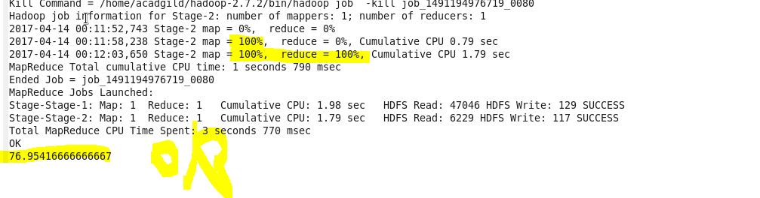

1. **Find out the average Defense of all the pokemon**

***CREATING VIEW***



***OUTPUT***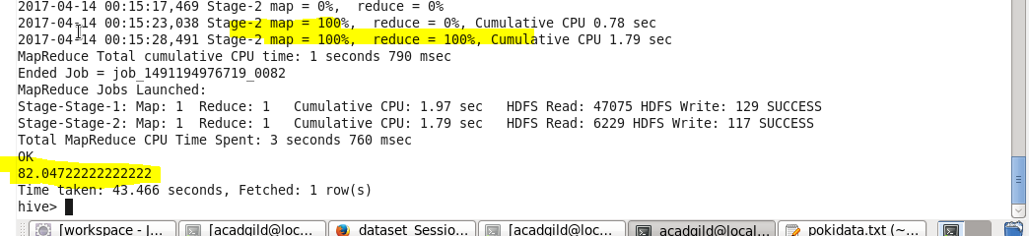

**3. Find out the average Sp.Atk of all the pokemons**

***CREATING VIEW***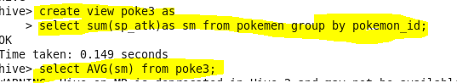

***OUTPUT***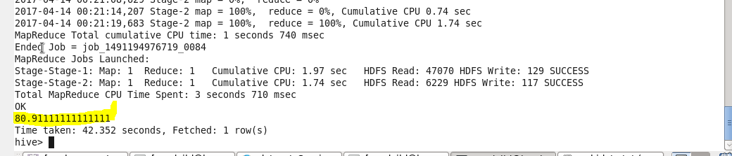

4. **Find out the average sp.Def of all the pokemons**

***CREATING VIEW***

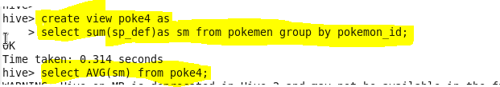

***OUTPUT***

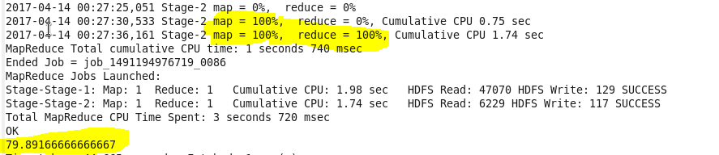

5. **Find out the average Speed of all the pokemons**

***CREATING VIEW***



***OUTPUT***

