***TABLE CREATION AND LOADING THE FILE***

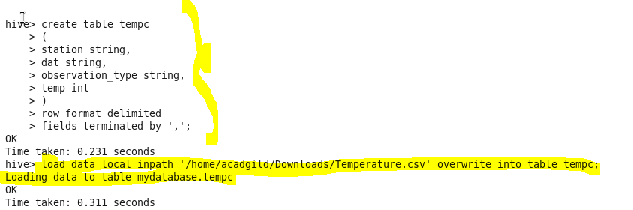

1. **Write a hive query to find the minimum temperature observed in a given weather station in a particular year.**

***QUERY***

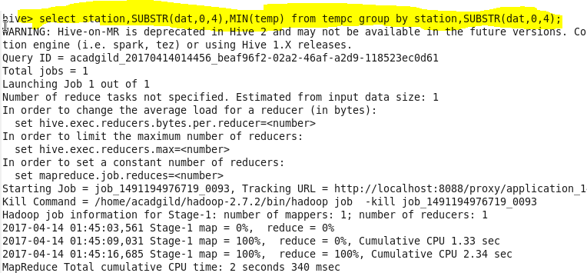

***OUTPUT***

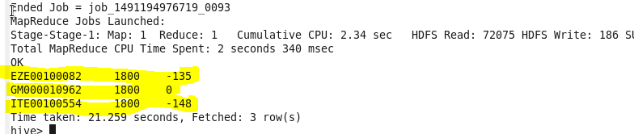

1. **Write a hive query to find the maximum temperature observed in a given weather station in a particular year.**

***OUTPUT***

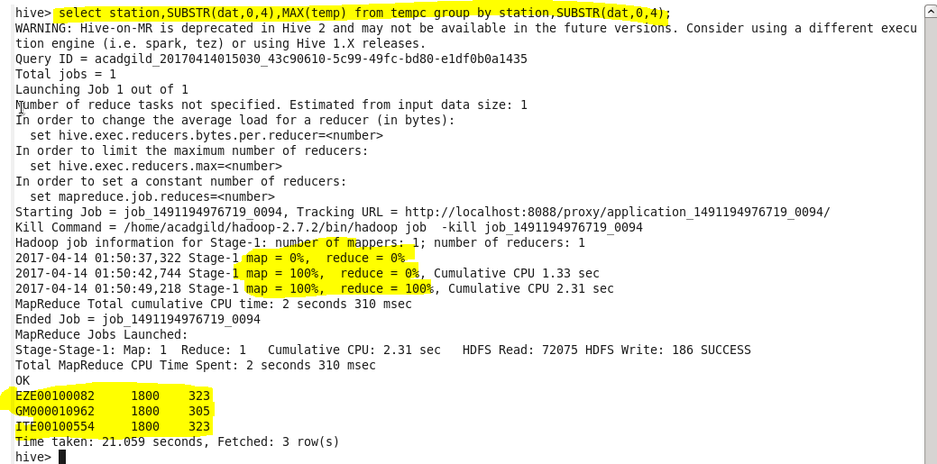

1. **Write a hive query to find the number of readings given by each weather station according to the dataset.**

***OUTPUT***

