Q1.Write a Java program, to take a HDFS Path as input and display all the files and sub-directories in that HDFS path.

A1

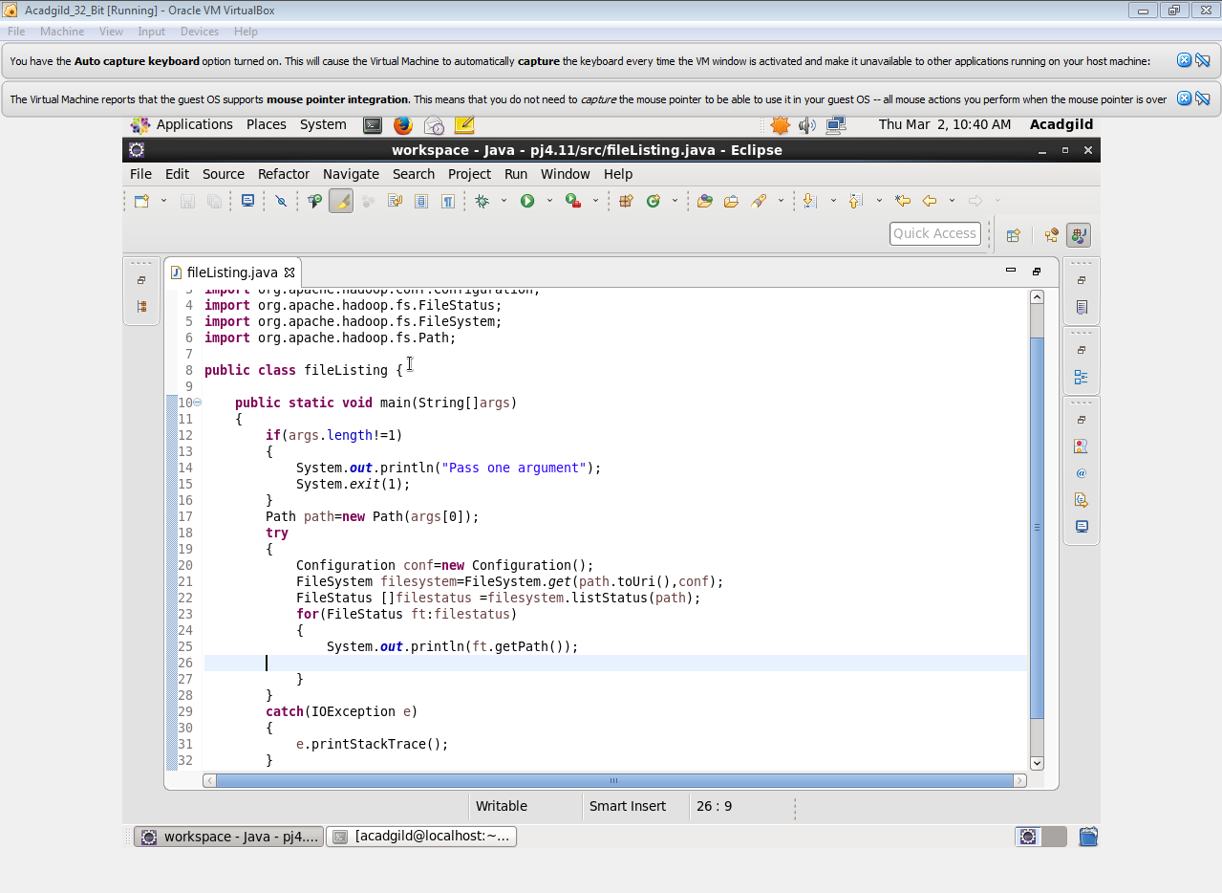

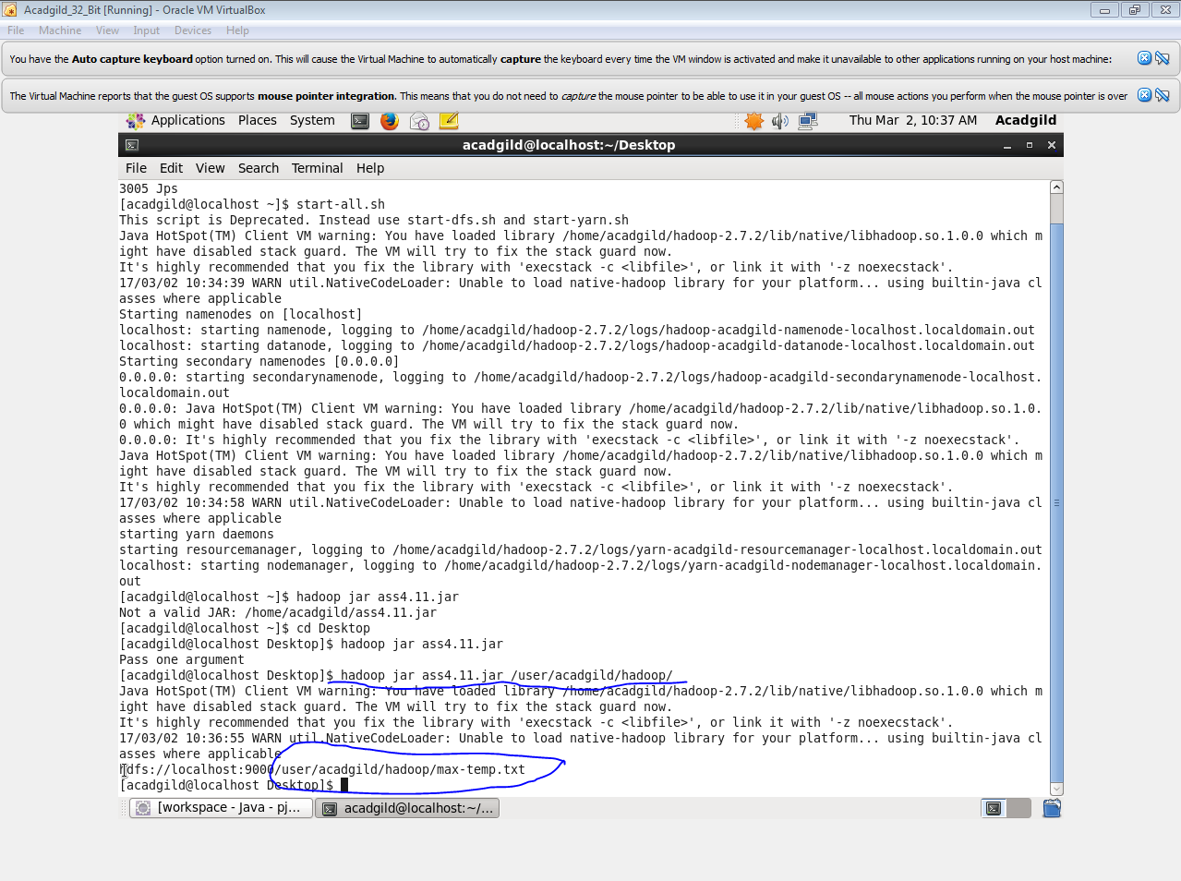

Q2.Modify the previous program to list all the files and sub-directories in the HDFS path recursively.

A2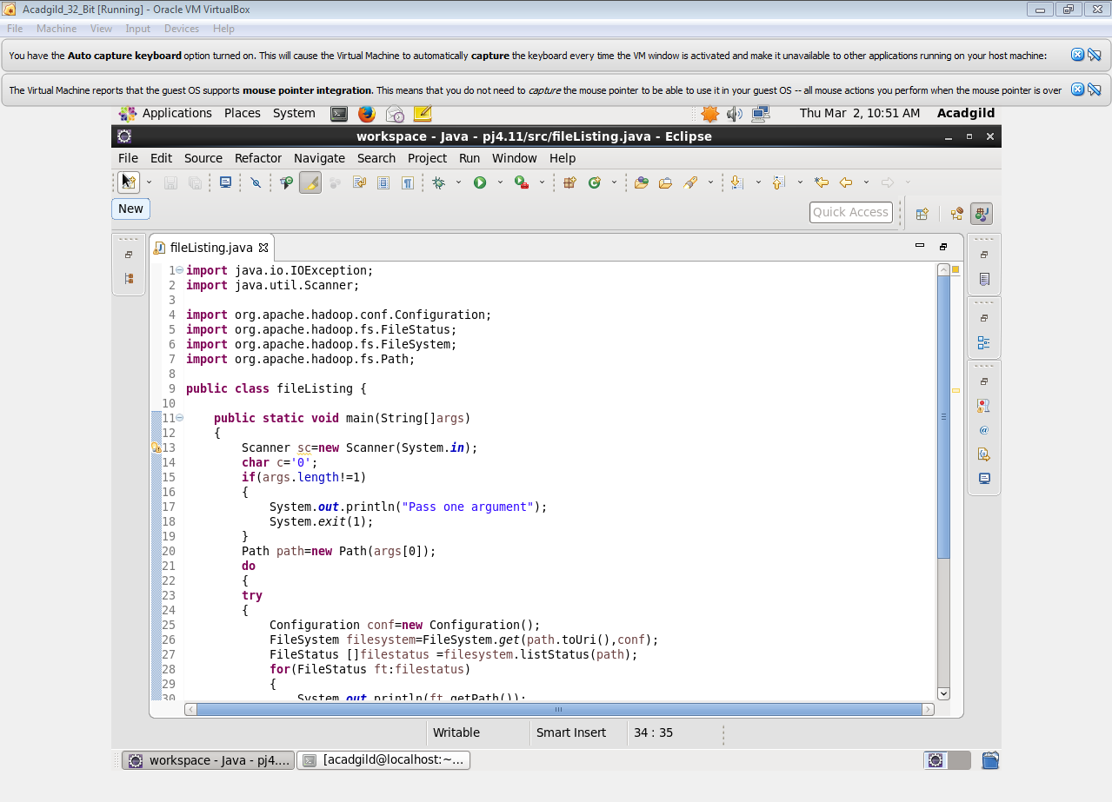

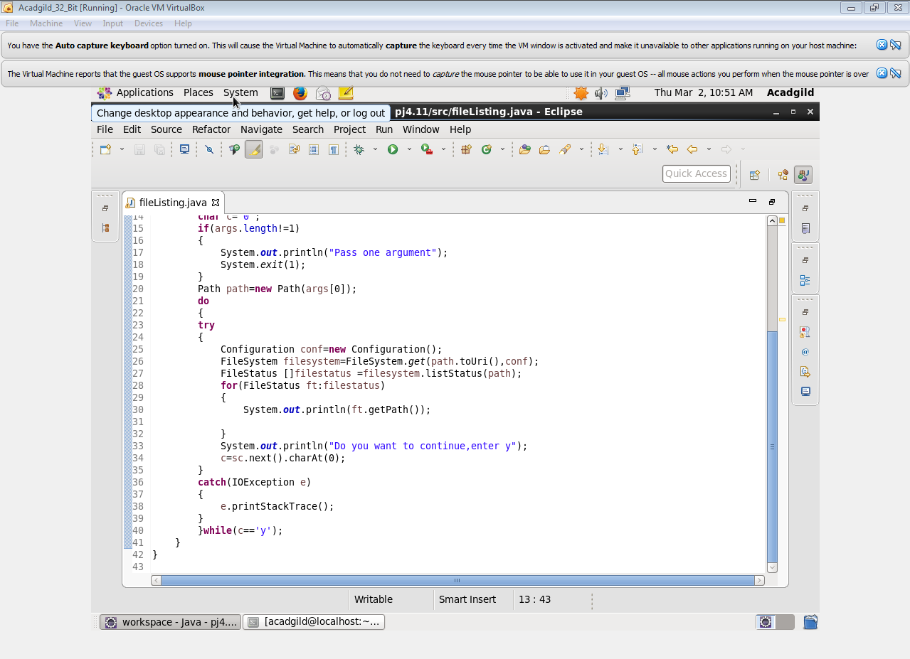

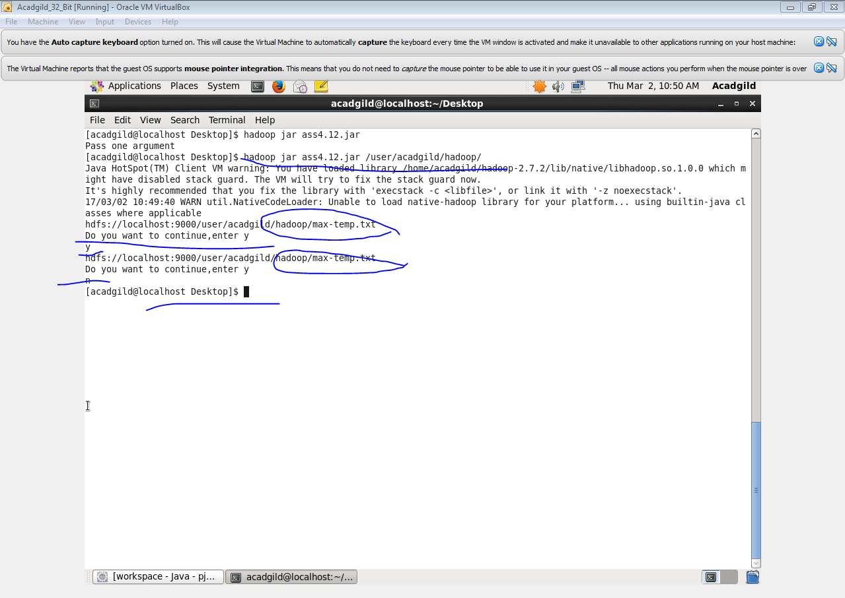

Q3.Modify the previous program to take multiple HDFS paths (separated by space) and list all the files and sub-directories in those HDFS paths recursively

A3

