Q1.Write a Java program to copy a file from HDFS to LFS.

A1.

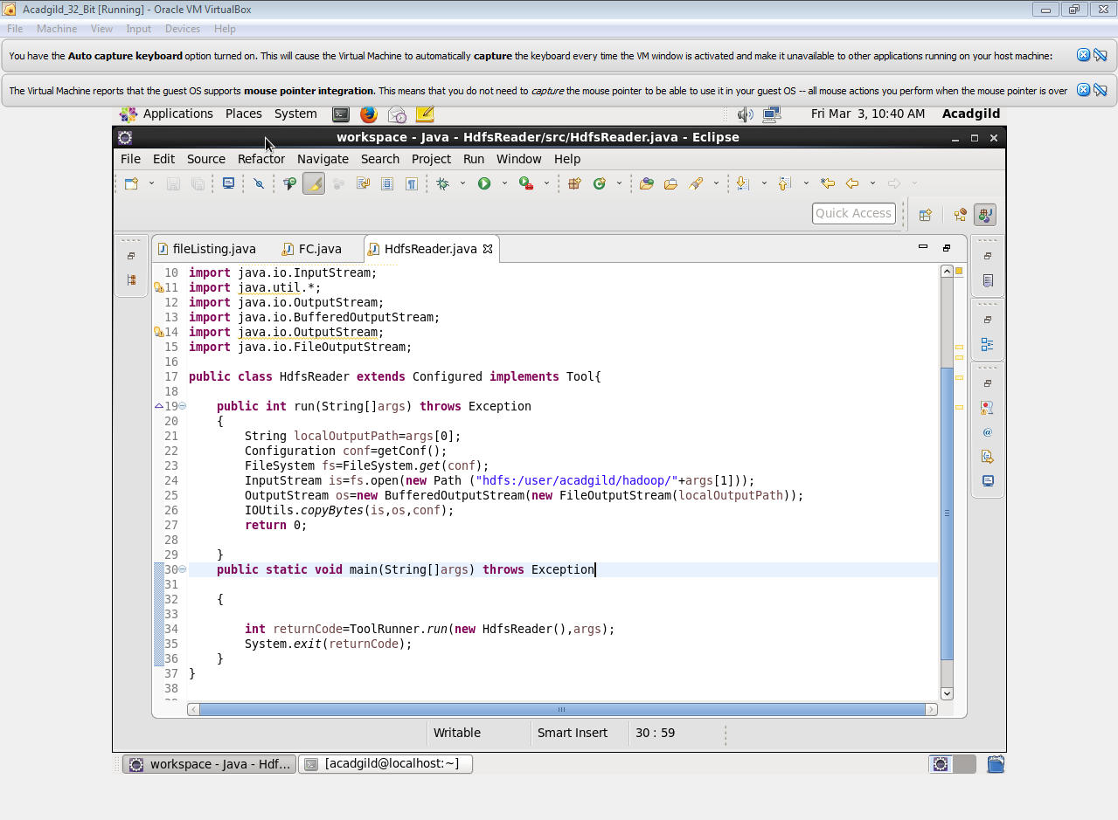



Q2. Explain the importance and usage of the below terms in details.

A2

1. **DFSInputStream:**

* Handles communication of the namenode with various datanodes.
* Handles integrity of data contained by the blocks.
* Manages data read activity in case of datanode failure.
* Called internally by FSDataInputStream.

**2. FSDataInputStream:**

* Provides stream (channel) for reading data.

**Open (Path path)**

Opens an FSDataInputStream at the indicated Path.

FileSystem fs = FileSystem.get(URI.create(uri), conf);

**FSDataInputStream**

Let the application read from a file FSDataInputStream

in = null; in = fs.open(new Path(uri));

1. **DFSOutputStream:**

* Handles communication of the namenode with various datanodes.
* Called internally by FSDataOutputStream.

1. **FSDataOutputStream:**

* Provides stream (channel) for writing data.

**Create (Path path)**

Creates an FSDataOutputStream at the indicated Path

InputStream in = new BufferedInputStream(new FileInputStream(localSrc)); Configuration conf = new Configuration();

FileSystem fs = FileSystem.get(URI.create(dst), conf);

**FSDataOutputStream**

Let the application write a file

OutputStream out = fs.create(new Path(dst)); IOUtils.copyBytes(in, out, 4096, true);