**Titanic Data set**

Problem statement

**Write a custom key to evaluate the number of people who died and the number of people who survived, along with their genders.**

**INPUT FILE**

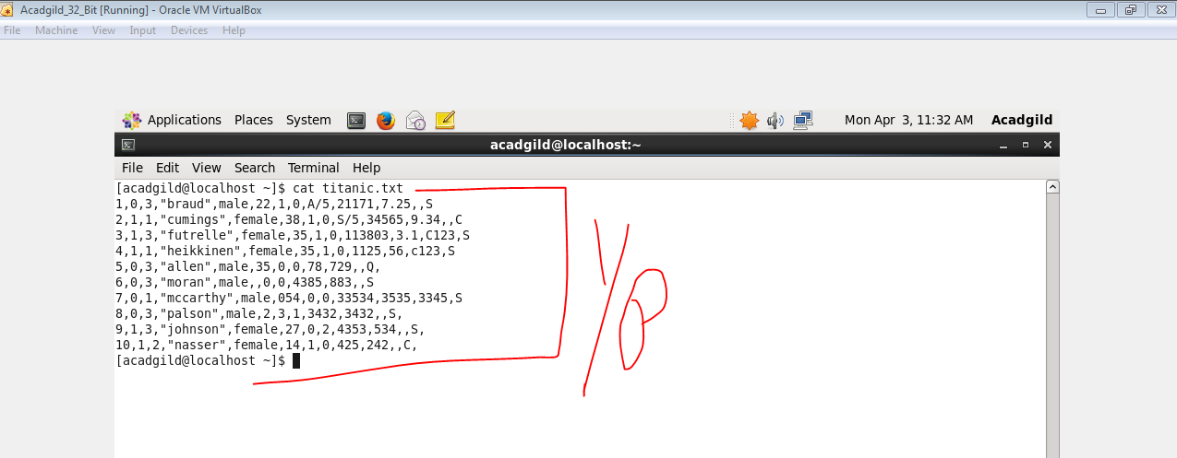

**CODE**

**DRIVER**

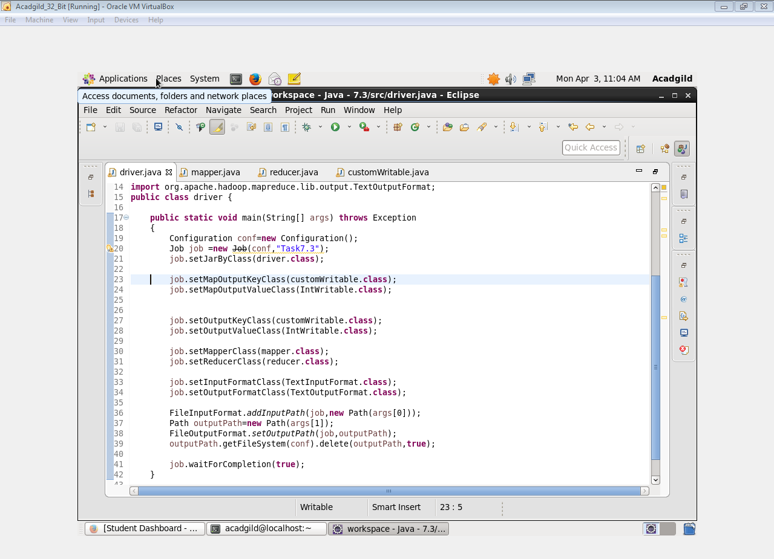

**MAPPER**

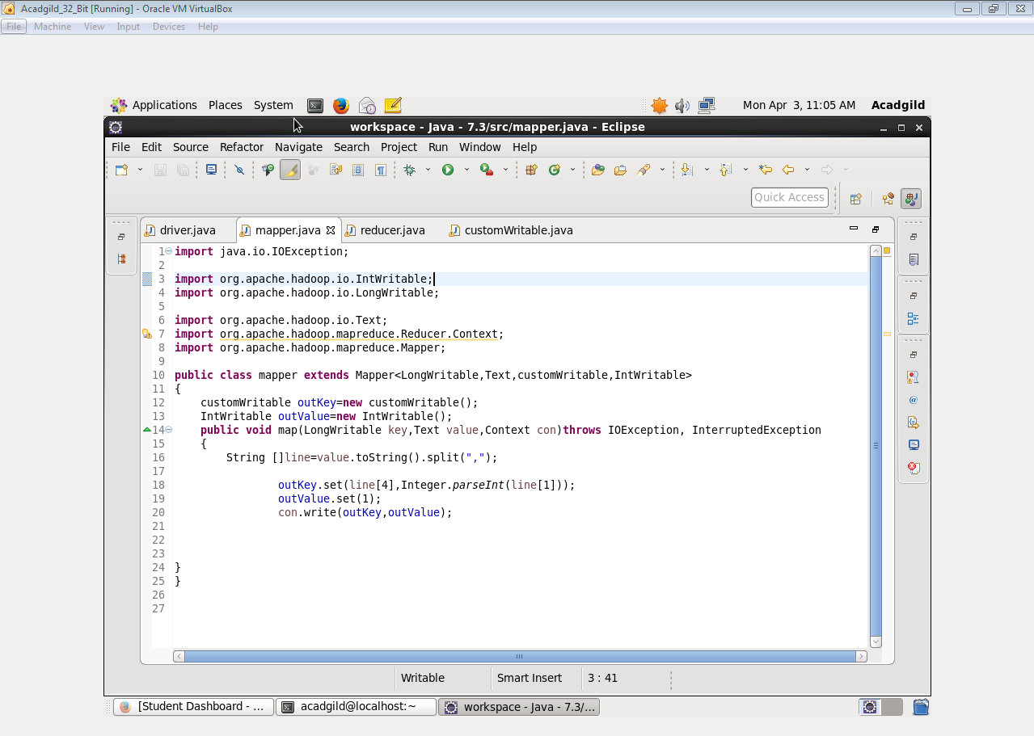

**REDUCER**

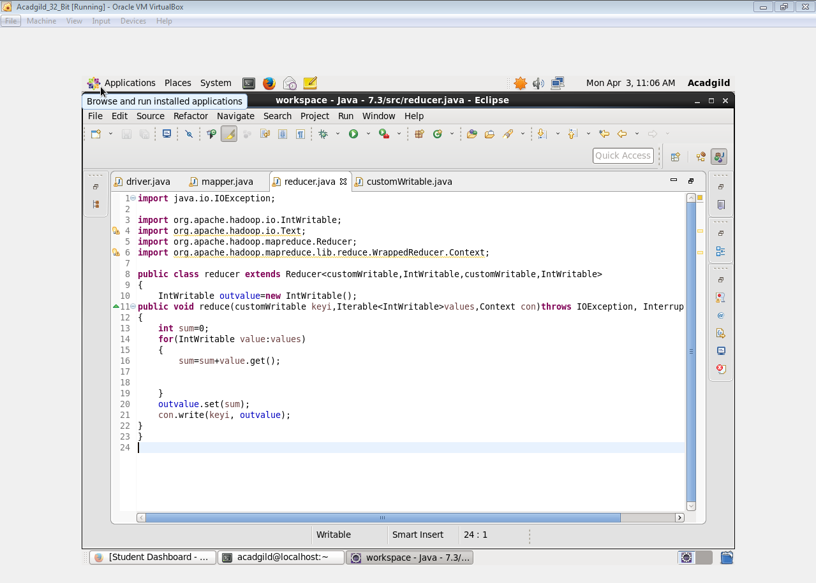

**COMPARABLE WRITABLE**

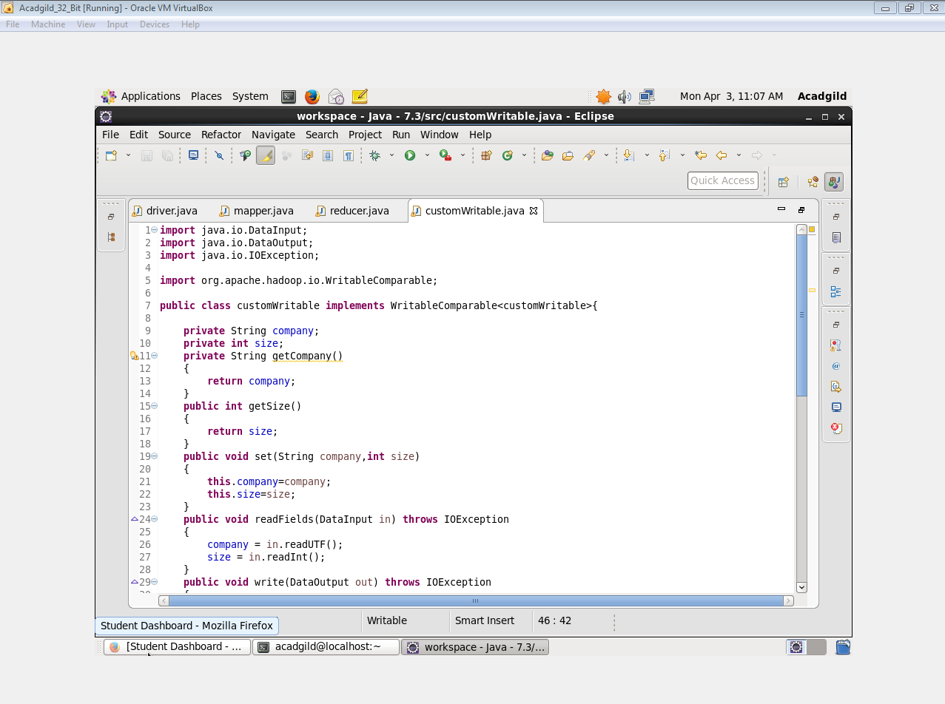

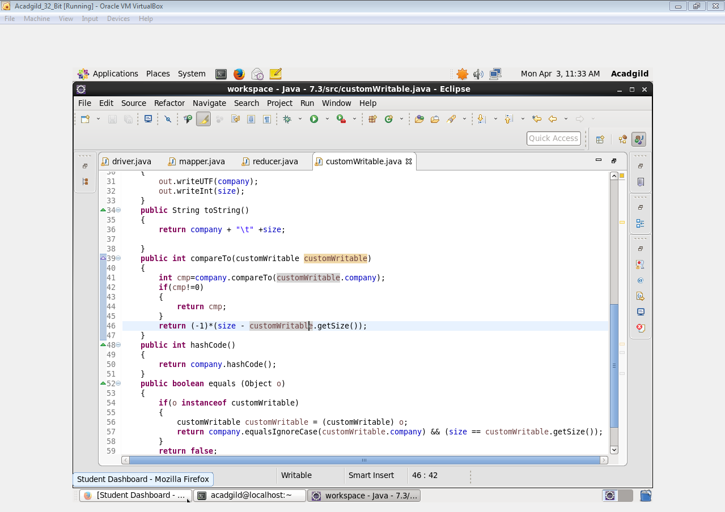

**OUTPUT**

