Create two datasets employee and department of file type text where the columns are delimited by tab ( ‘\t’ ), and use these datasets to perform below Join operations :

**INPUT FILE**

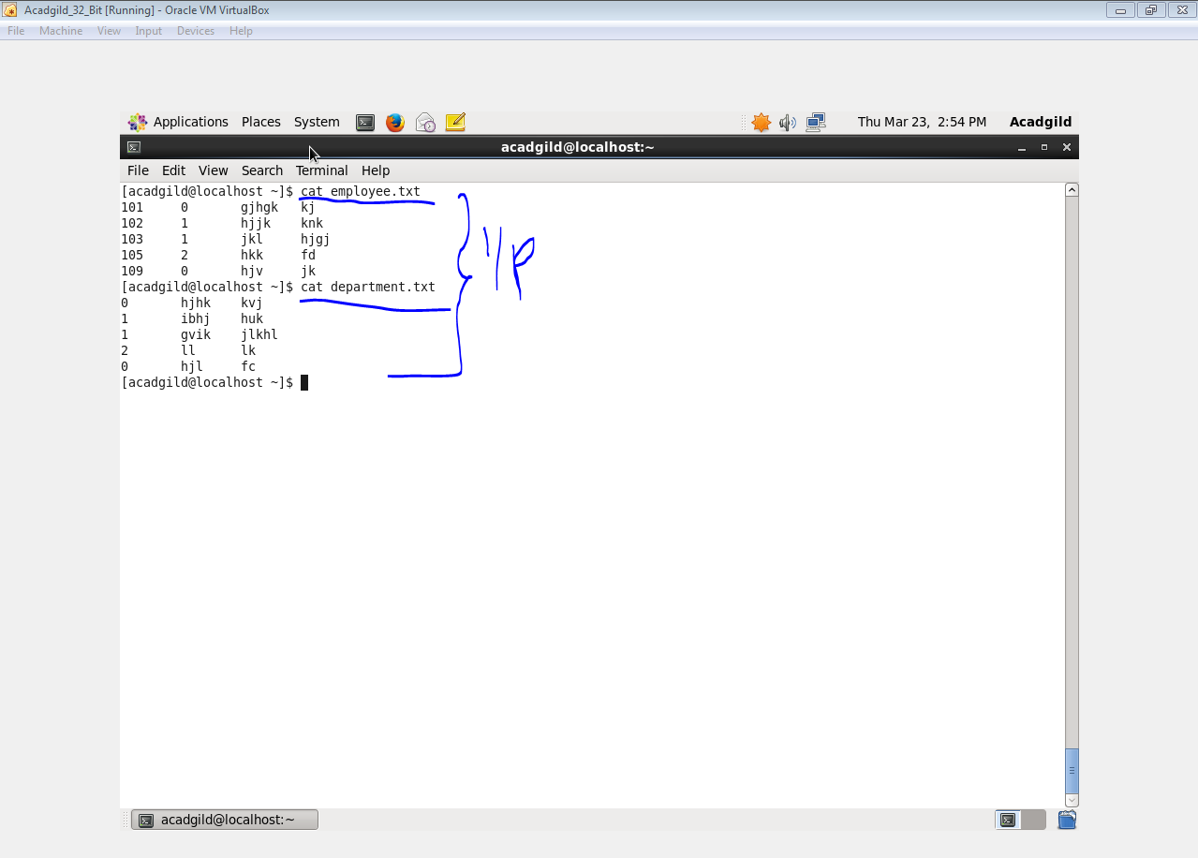

**● SELF JOIN**

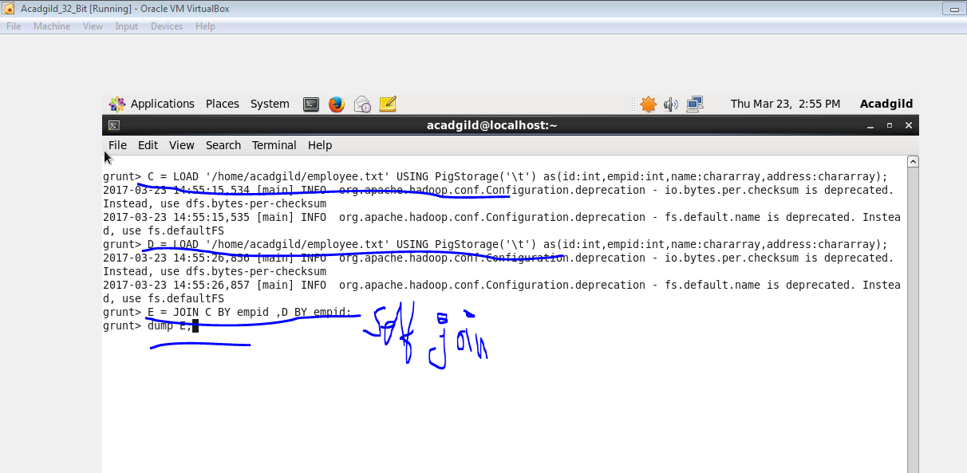

**Output**

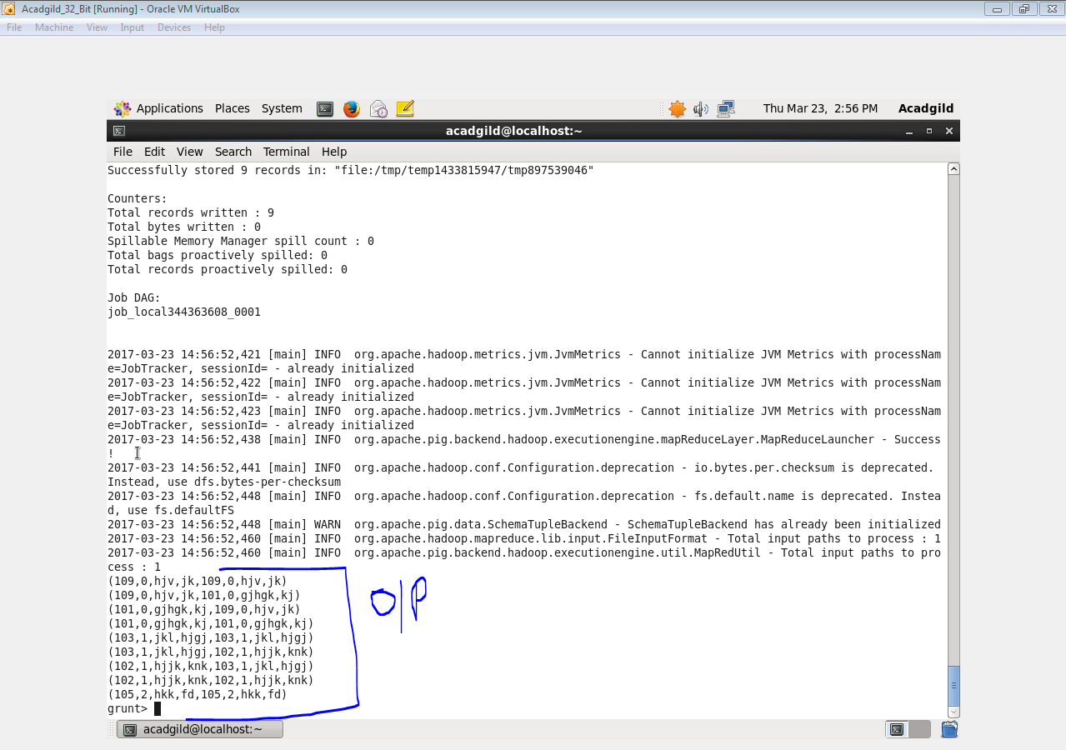

**● INNER JOIN**

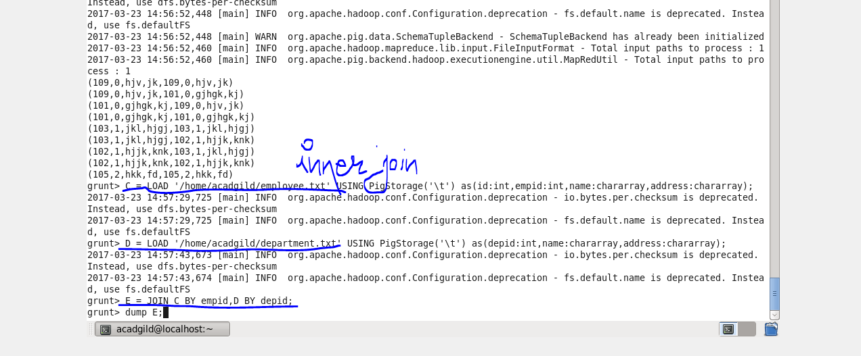

**Output**

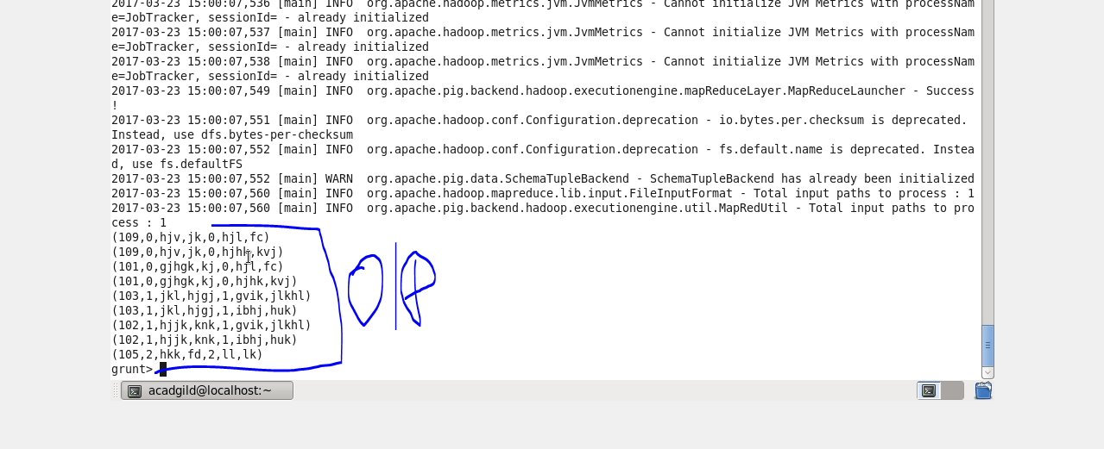

**● LEFT OUTER JOIN**

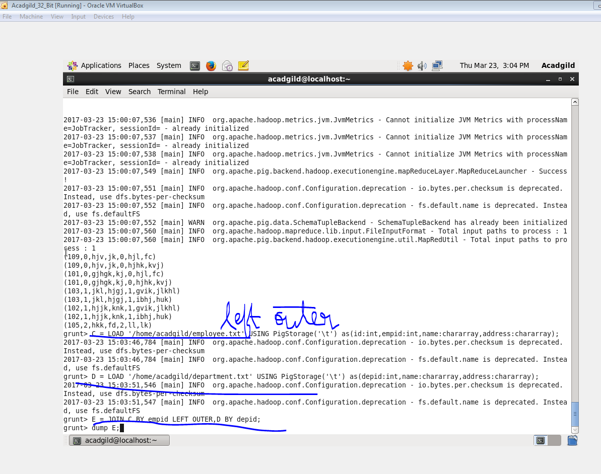

**Output**

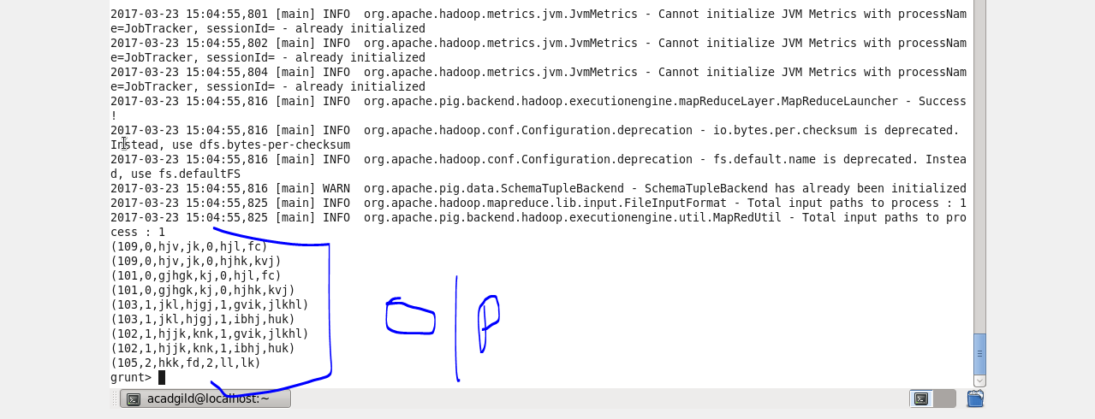

**● RIGHT OUTER JOIN**

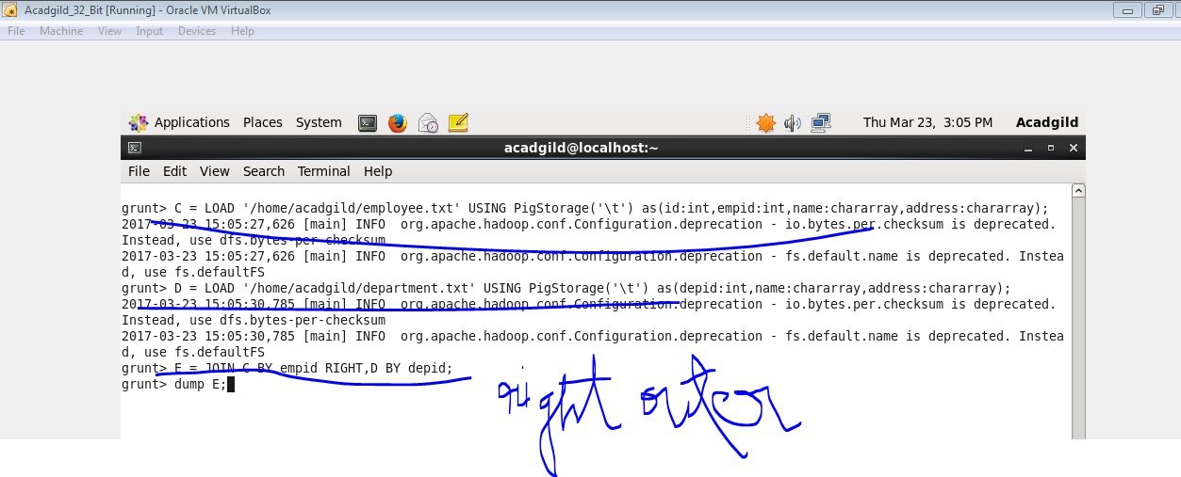

**Output**

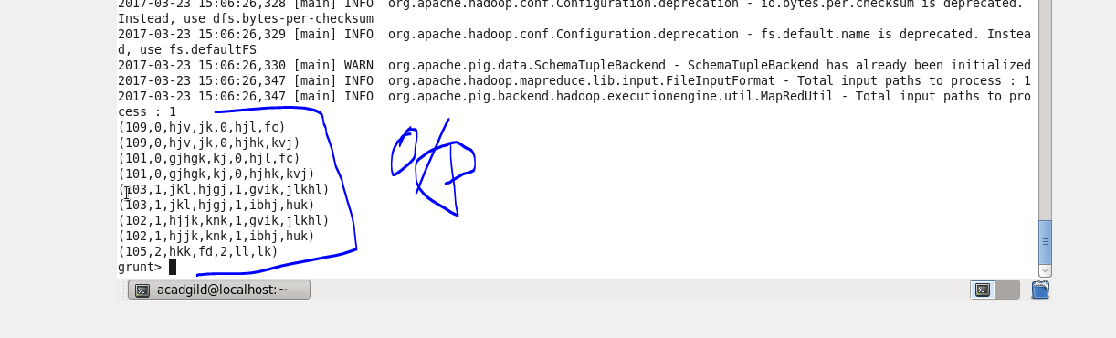

**● FULL OUTER JOIN**

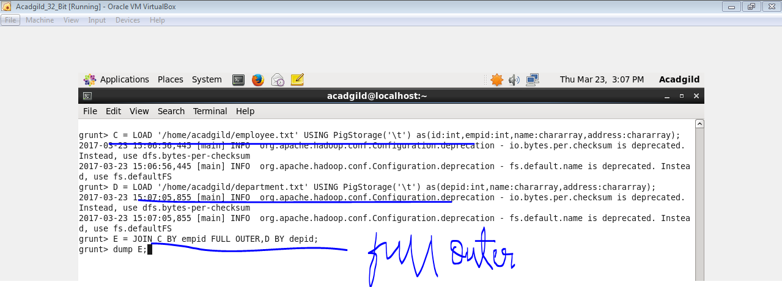

**Output**

