Practice the relational operators in pig:

**INPUT**

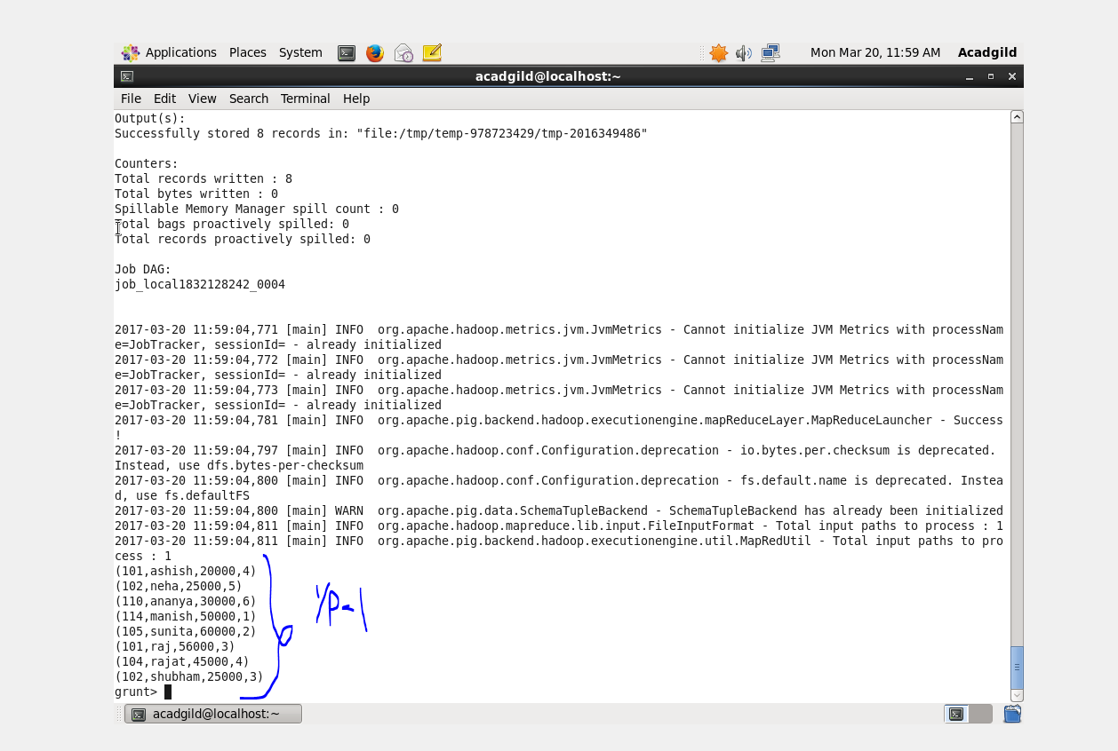

COMMANDS:

**Load:**

**Command**

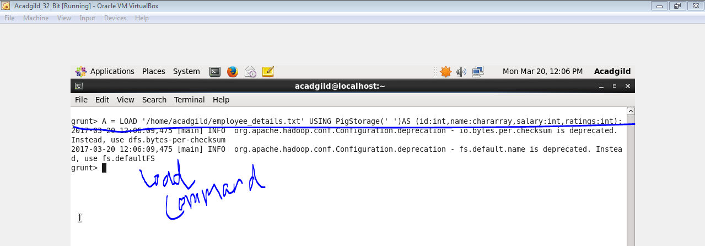

**Output**

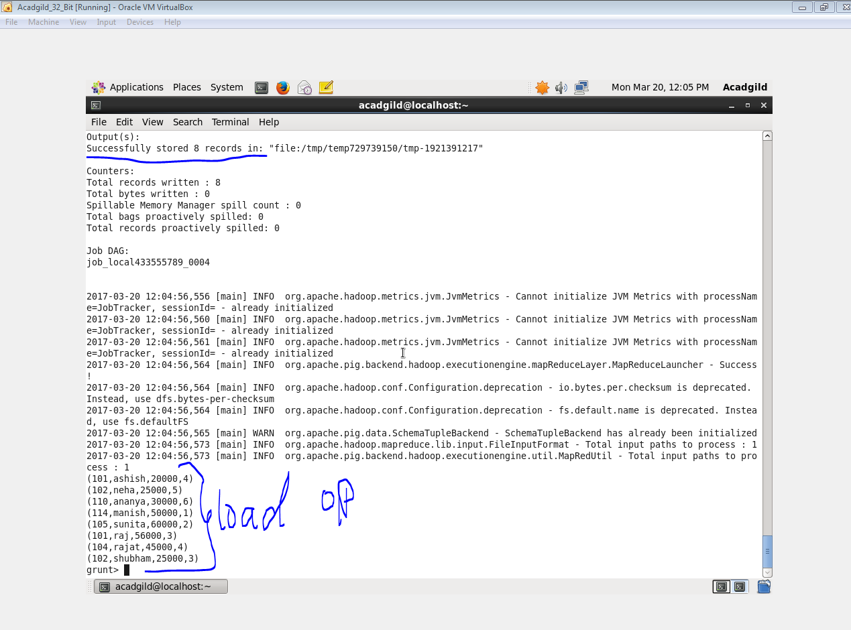

### Limit:

### Command & Output

### C:\Users\613044\Desktop\9.3limit.PNG

### Order:

### Command

### C:\Users\613044\Desktop\9.3sortin.PNG

### Output

### C:\Users\613044\Desktop\9.3sortout.PNG

### Group

### Command

### C:\Users\613044\Desktop\9.3groupin.PNG

### Output

### C:\Users\613044\Desktop\9.3groupout.PNG

### Foreach

### Command

### C:\Users\613044\Desktop\9.3foreachin.PNG

### Output

### C:\Users\613044\Desktop\9.3foreachout.PNG

### Filter

### Command

### C:\Users\613044\Desktop\9.3filterdin.PNG

### Output

### C:\Users\613044\Desktop\9.3filteredout.PNG