**INPUT**

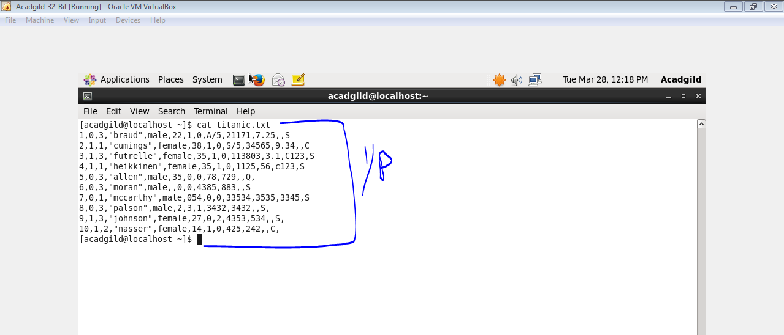

1. **Write a pig script find the average age of male and female persons died in the titanic tragedy.**

**CODE**

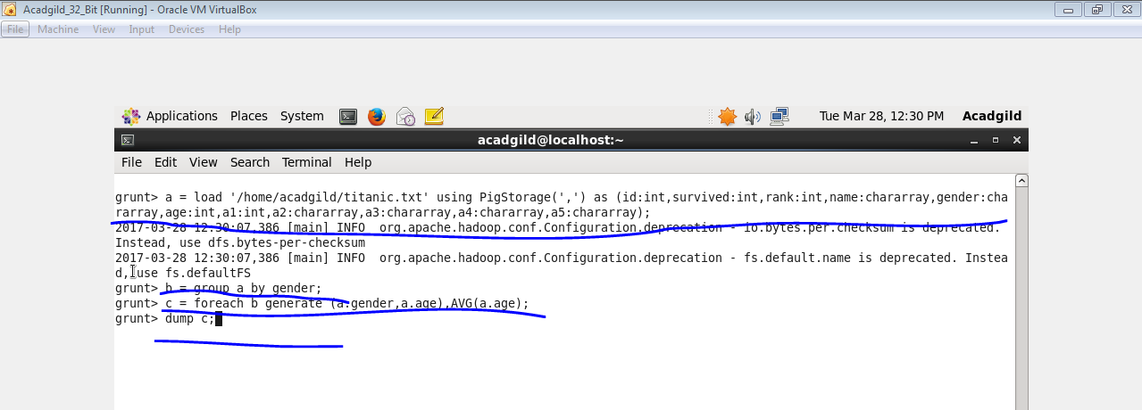

**Output**

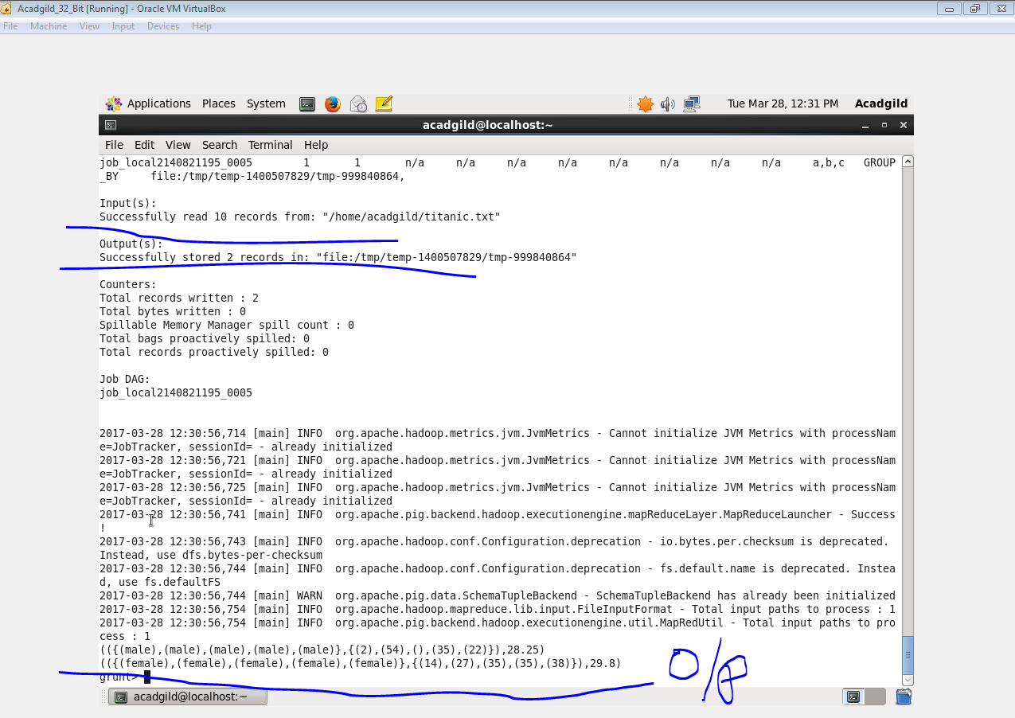

1. **Write a pig script to find the number of people died and survived in each class.**

**CODE**

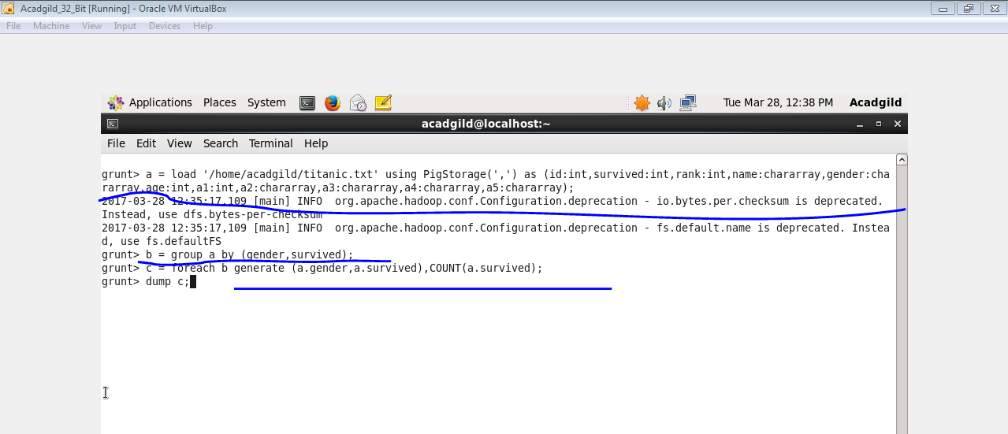

**OUTPUT**

