Q1 Explain what is a cluster and what is a hadoop cluster?

A1.**Cluster:**

1. In a computer system, a cluster is a group of servers and other resources that act like a single system and enable high availability and, in some cases, load balancing and parallel processing.

2. In personal computer storage technology, a cluster is the logical unit of file storage on a [hard disk](http://searchstorage.techtarget.com/definition/hard-disk); it's managed by the computer's [operating system](http://searchcio-midmarket.techtarget.com/definition/operating-system). Any file stored on a hard disk takes up one or more clusters of storage. A file's clusters can be scattered among different locations on the hard disk. The clusters associated with a file are kept track of in the hard disk's file allocation table ([FAT](http://searchexchange.techtarget.com/definition/file-allocation-table)). When you read a file, the entire file is obtained for you and you aren't aware of the clusters it is stored in.

3. Since a cluster is a logical rather than a physical unit (it's not built into the hard disk itself), the size of a cluster can be varied. The maximum number of clusters on a hard disk depends on the size of a FAT table entry. Beginning with DOS 4.0, the FAT entries were 16 bits in length, allowing for a maximum of 65,536 clusters. Beginning with the Windows 95 [OSR2](http://searchwinit.techtarget.com/definition/IOS) service release, a 32-bit FAT entry is supported, allowing an entry to address enough clusters to support up to two [terabyte](http://searchstorage.techtarget.com/definition/terabyte)s of data.

**Hadoop cluster:**

Normally any set of loosely connected or tightly connected computers that work together as a single system is called Cluster. In simple words, a computer cluster used for Hadoop is called Hadoop Cluster.   
  
**Hadoop cluster is a special type of computational cluster designed for storing and analyzing vast amount of unstructured data in a distributed computing environment. These clusters run on low cost commodity computers.** Hadoop clusters are often referred to as "shared nothing" systems because the only thing that is shared between nodes is the network that connects them.   
  
Large Hadoop Clusters are arranged in several racks. Network traffic between different nodes in the same rack is much more desirable than network traffic across the racks.

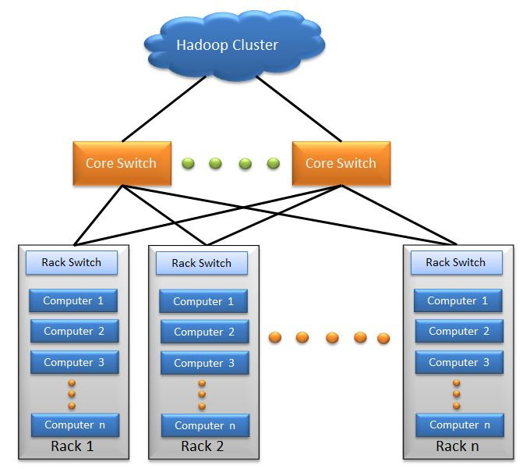

Core Components of Hadoop Cluster:

Hadoop cluster has 3 components:

* 1. Client
  2. Master
  3. Slave

The role of each components are shown in the below image.

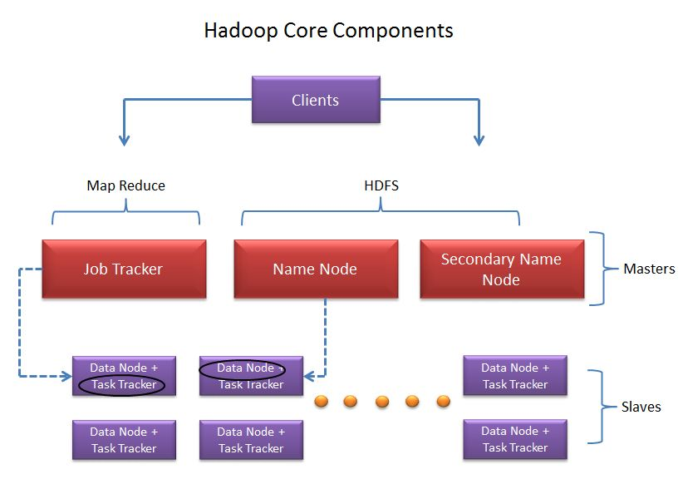

Q2.What is meant by a Rack and explain the rack arrangement in a hadoop cluster?

A2. For small clusters in which all servers are connected by a single switch, there are only two levels of locality: “on-machine” and “off-machine.” When loading data from a DataNode’s local drive into HDFS, the NameNode will schedule one copy to go into the local DataNode, and will pick two other machines at random from the cluster.

For larger Hadoop installations which span multiple racks, it is important to ensure that replicas of data exist on multiple racks. This way, the loss of a switch does not render portions of the data unavailable due to all replicas being underneath it.

HDFS can be made rack-aware by the use of a script which allows the master node to map the network topology of the cluster. While alternate configuration strategies can be used, the default implementation allows you to provide an executable script which returns the “rack address” of each of a list of IP addresses.

The network topology script receives as arguments one or more IP addresses of nodes in the cluster. It returns on stdout a list of rack names, one for each input. The input and output order must be consistent.

To set the rack mapping script, specify the key topology.script.file.name in conf/hadoop-site.xml. This provides a command to run to return a rack id; it must be an executable script or program. By default, Hadoop will attempt to send a set of IP addresses to the file as several separate command line arguments. You can control the maximum acceptable number of arguments with the topology.script.number.args key.

[**CONFIGURING RACK AWARENESS IN HADOOP**](http://huntingcheetah.wordpress.com/2013/02/21/configuring-rack-awareness-in-hadoop/)

## SAMPLE 1: SCRIPT WITH DATAFILE: FILE NAMED AS RACK-AWARENESS.SH

### TOPOLOGY SCRIPT

A sample Bash shell script:

HADOOP_CONF=/usr/local/hadoop/conf

while [ $# -gt 0 ] ; do  
nodeArg=$1  
exec< ${HADOOP_CONF}/topology.data  
result=””  
while read line ; do  
ar=( $line )  
if [ “${ar[0]}” = “$nodeArg” ] ; then  
result=”${ar[1]}”  
fi  
done  
shift  
if [ -z “$result” ] ; then  
echo -n “/default/rack “  
else  
echo -n “$result “  
fi  
done

### TOPOLOGY DATA FILE NAMED AS : TOPOLOGY.DATA

hadoopdata1.ec.com     /dc1/rack1  
hadoopdata1            /dc1/rack1  
10.1.1.1               /dc1/rack2