***BY MAPREDUCE***

1. **Write a mapreduce and pig program to calculate the number of cases investigated under each FBI code.**

**CODE**

**DRIVER**

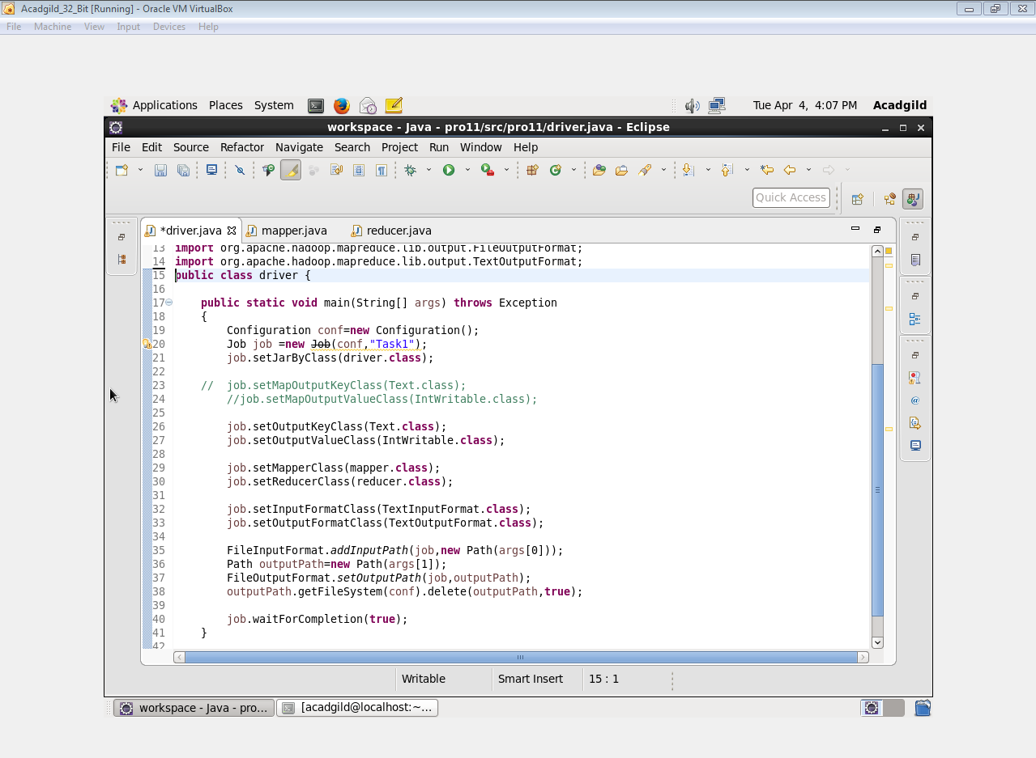

**MAPPER**

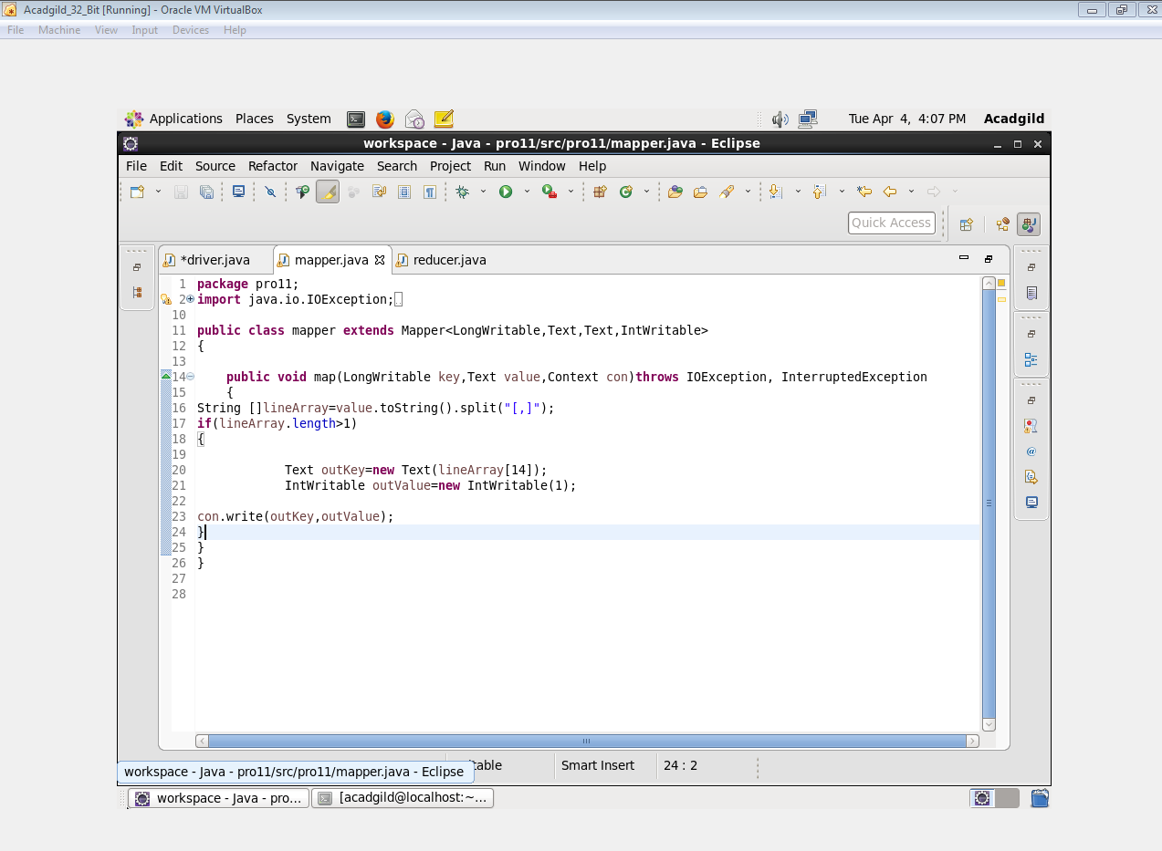

**REDUCER**

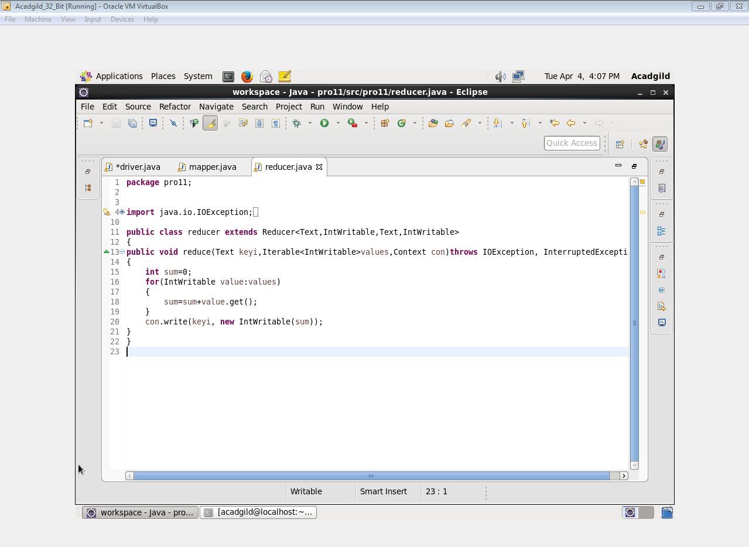

**OUTPUT**

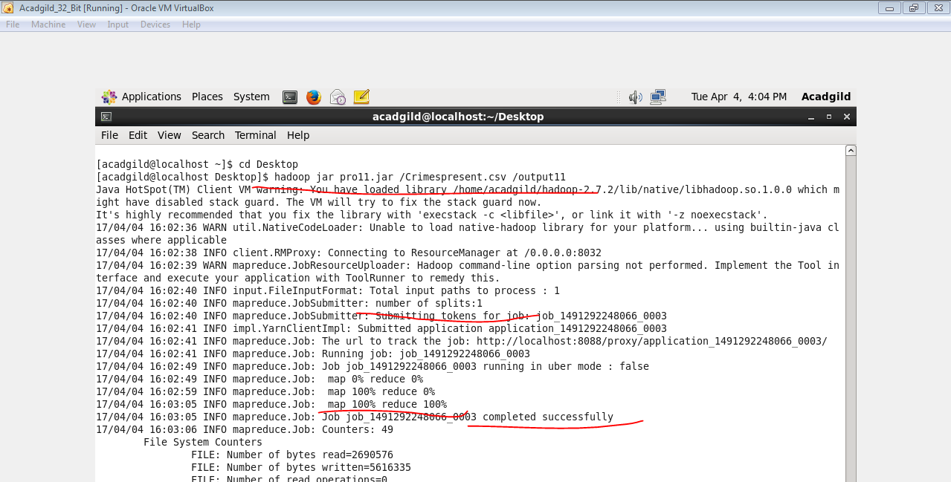

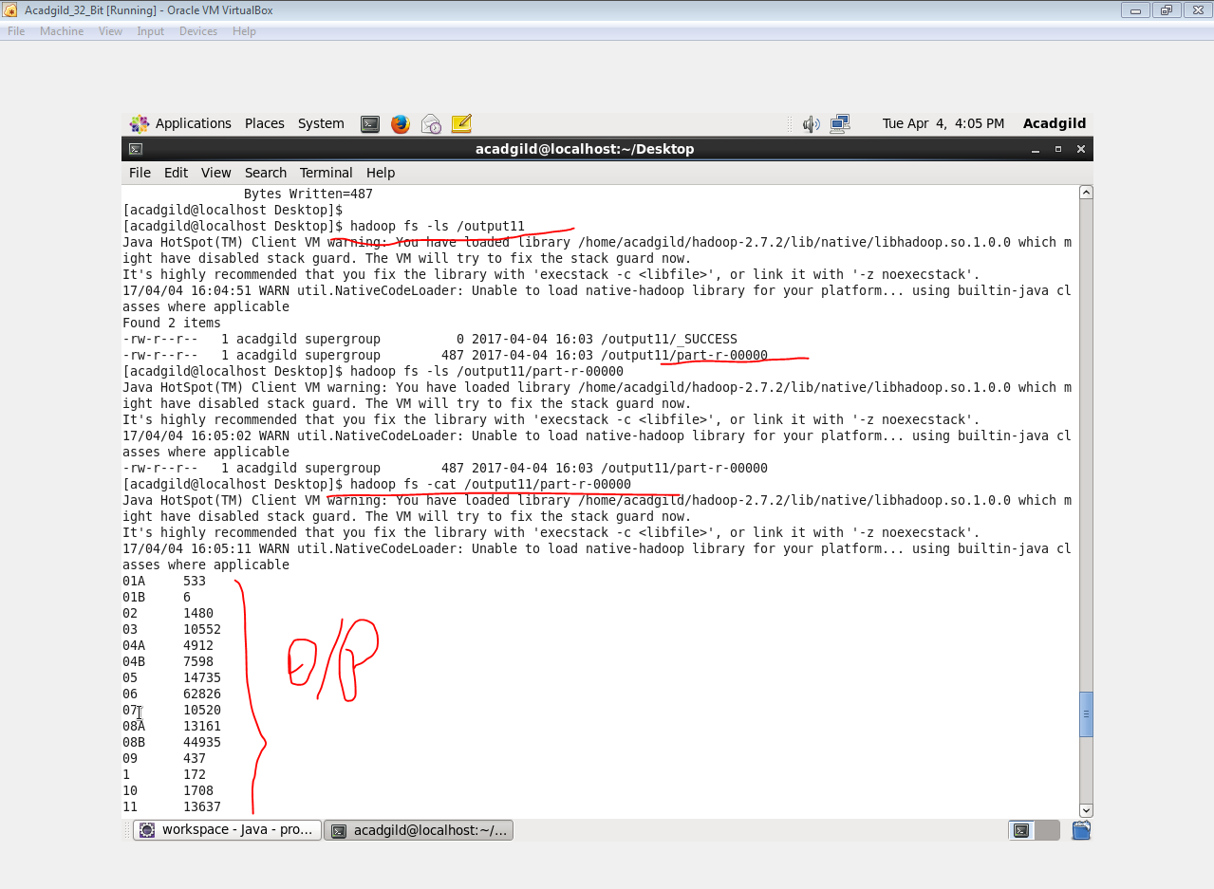

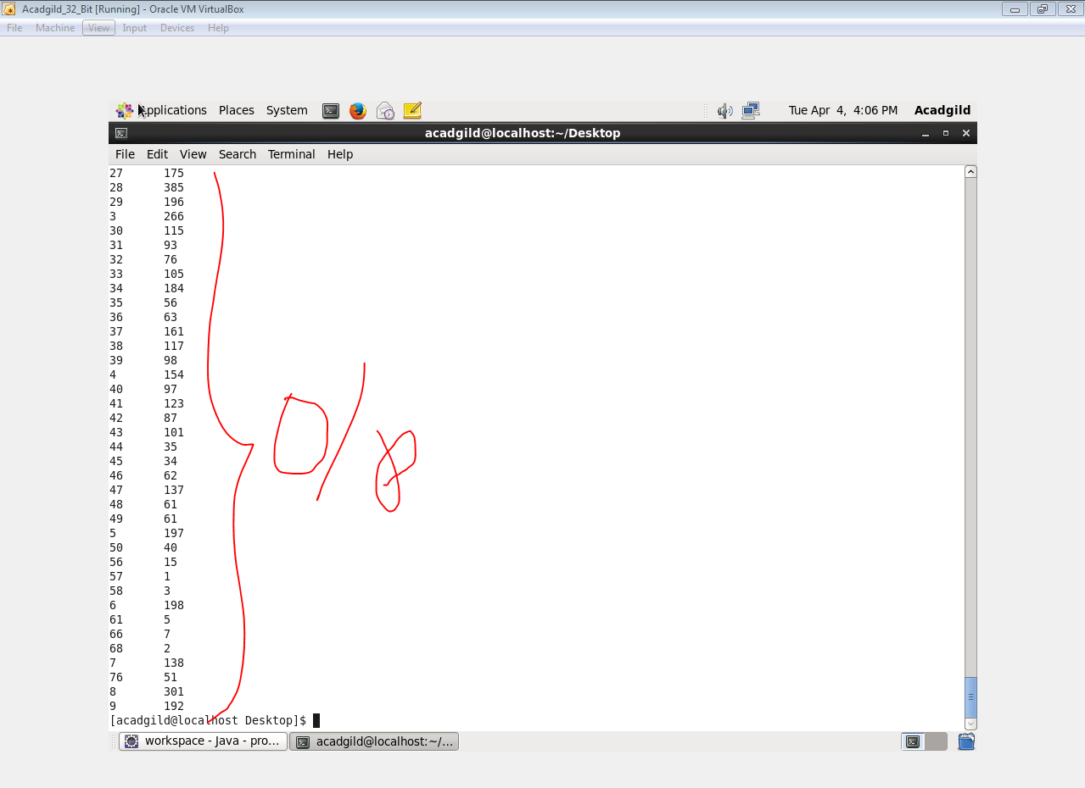

1. **Write a mapreduce and pig program to calculate the number of cases investigated under FBI code 32.**

**CODE**

**DRIVER**



**MAPPER**

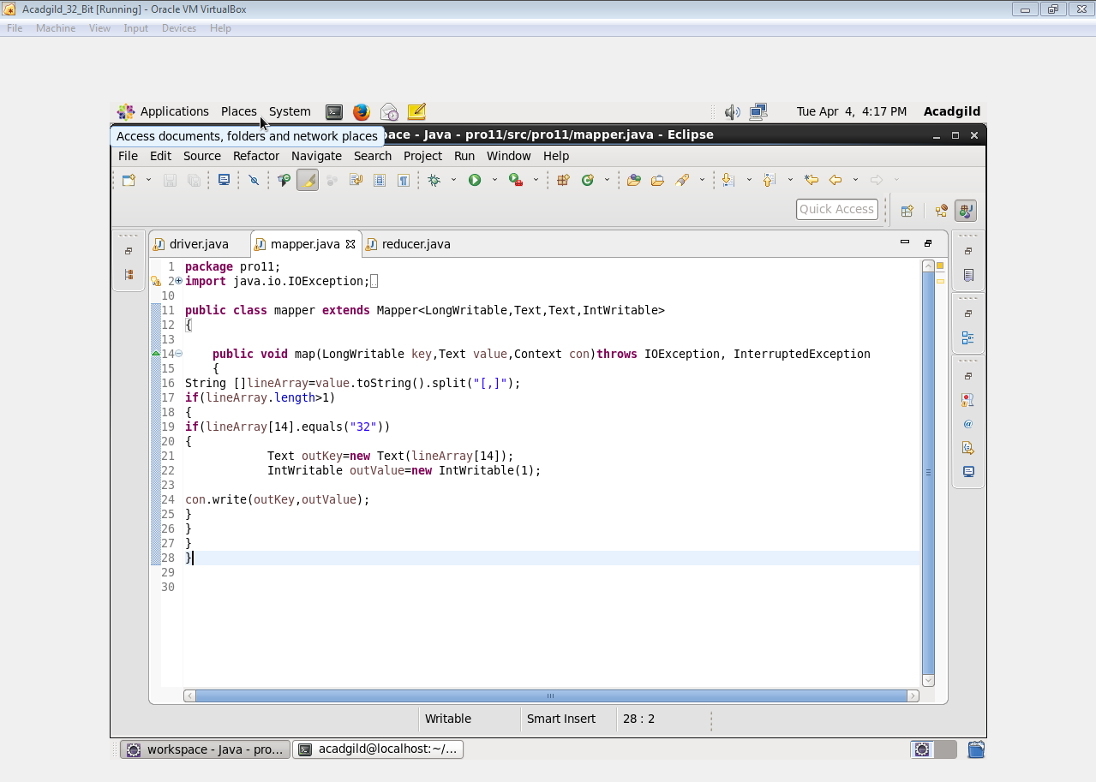

**REDUCER**



**OUTPUT**

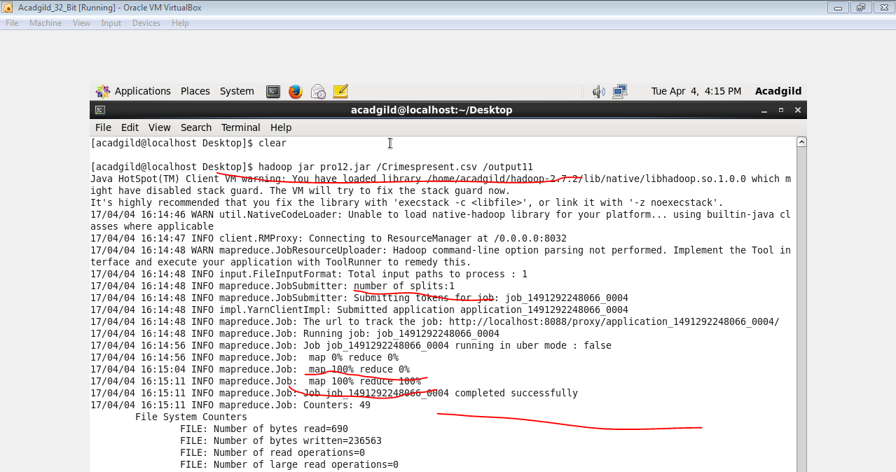

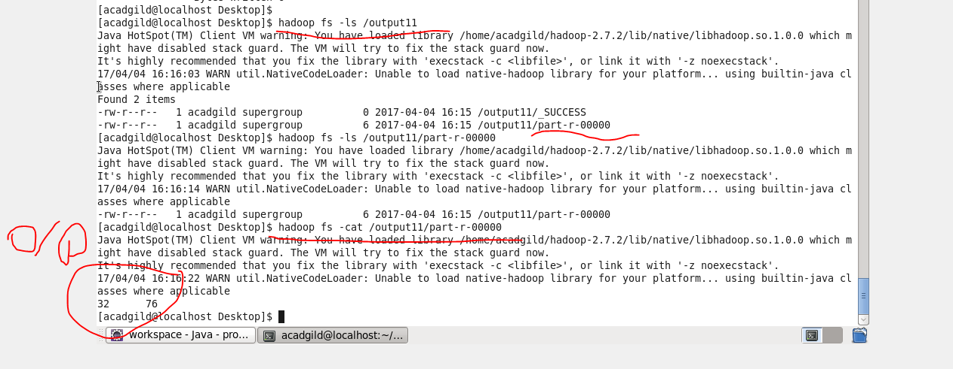

1. **Write a mapreduce and pig program to calculate the number of arrests in theft district wise.**

**CODE**

**DRIVER**



**MAPPER**

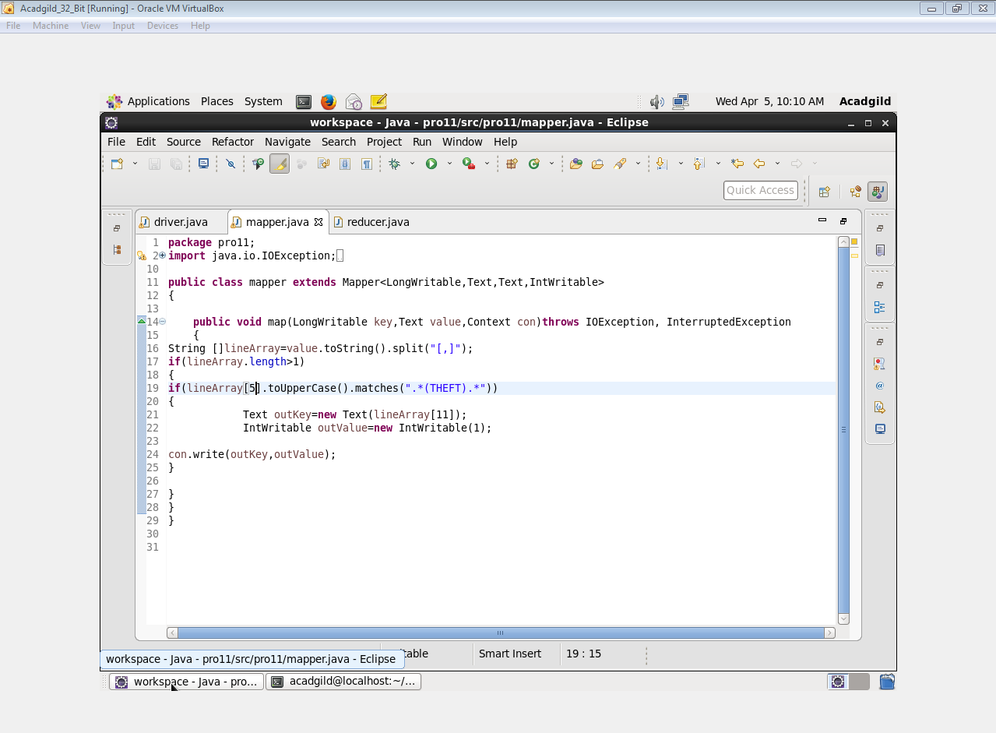

**REDUCER**



**OUTPUT**

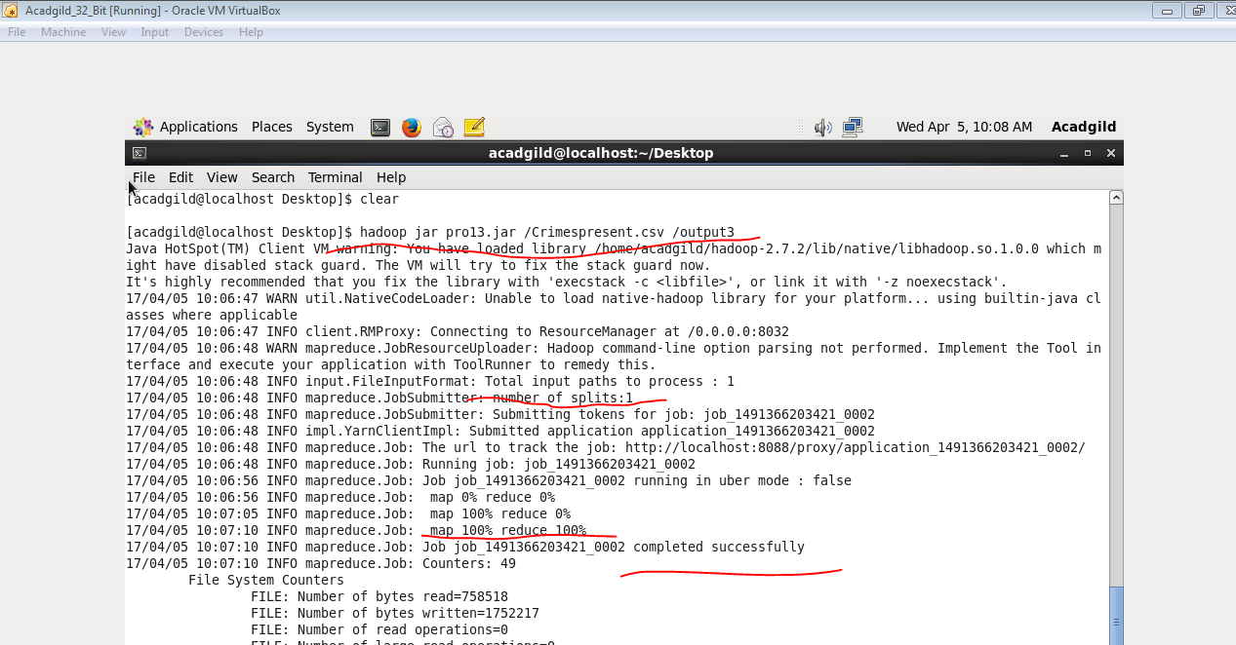

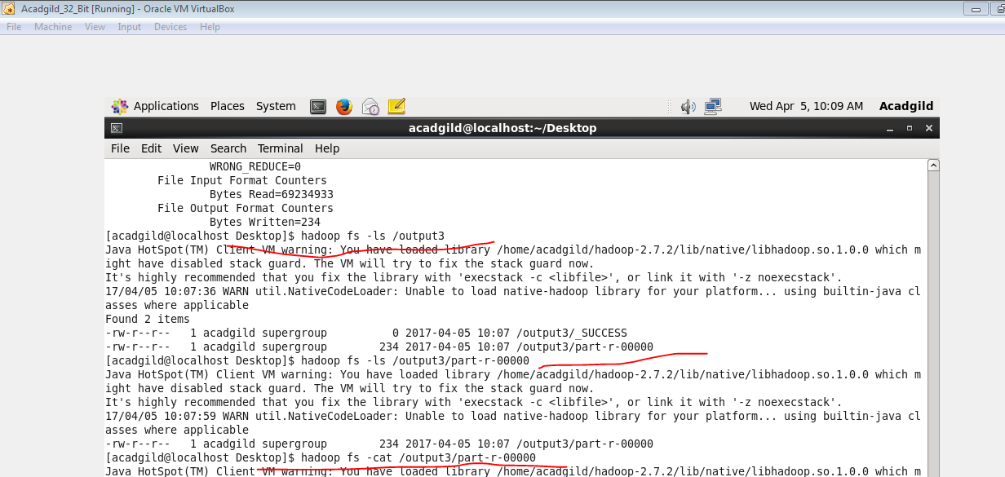

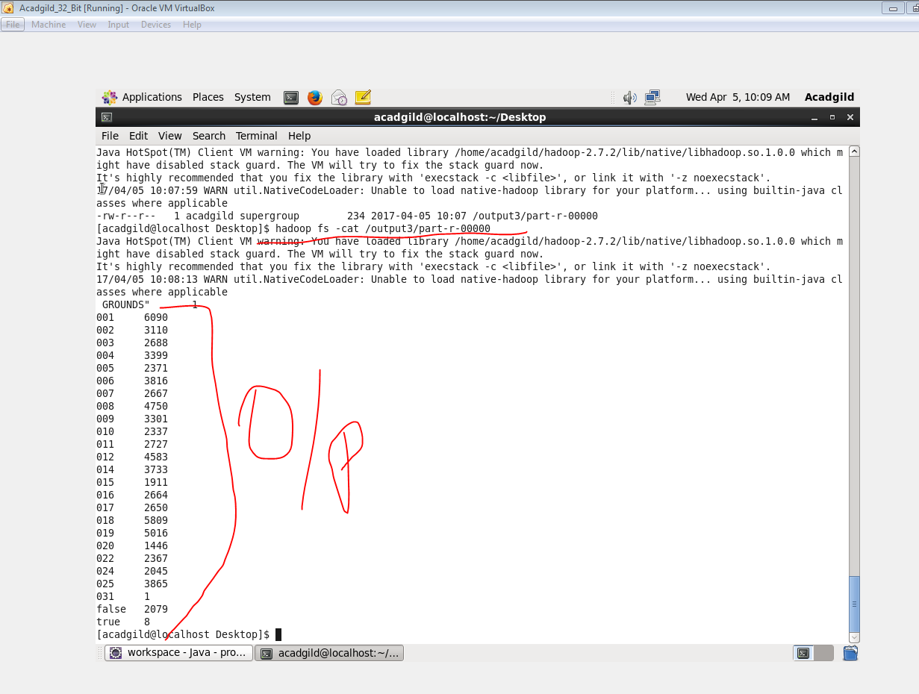

1. **Write a mapreduce and pig program to calculate the number of arrests done between October 2014 and October 2015.**

**CODE**

**DRIVER**



**MAPPER**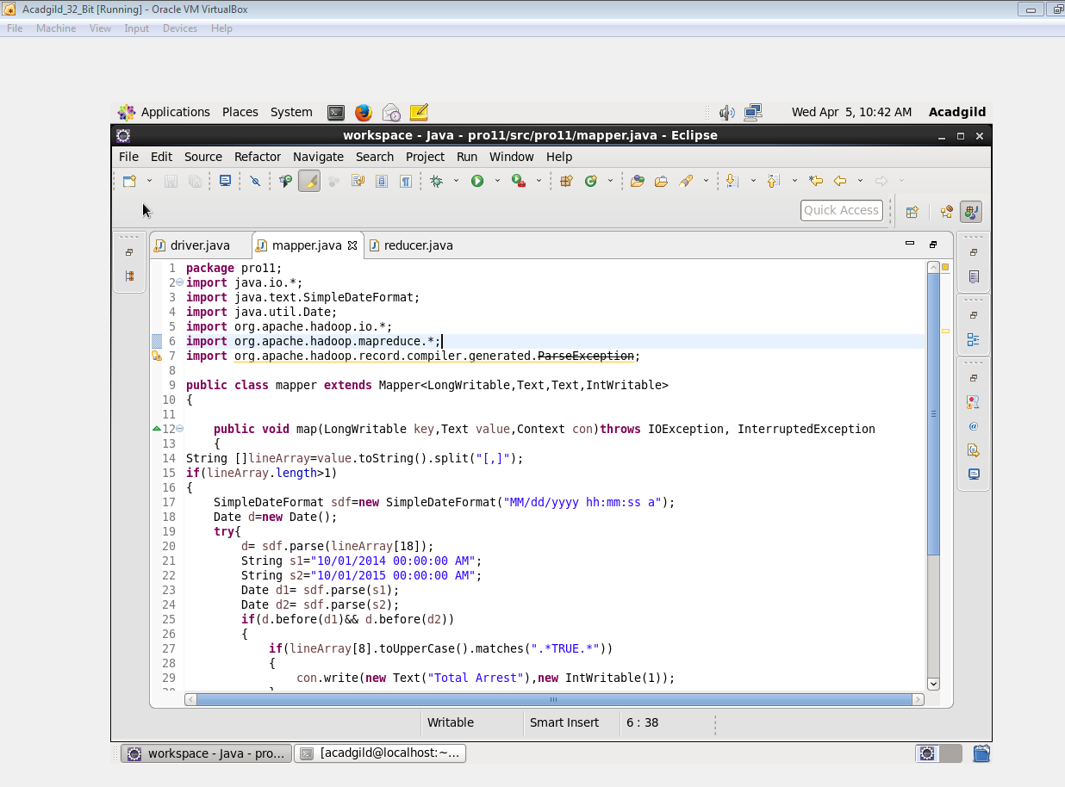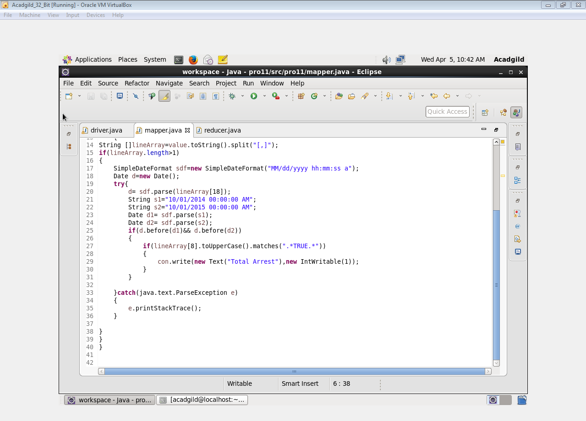

**REDUCER**



**OUTPUT**

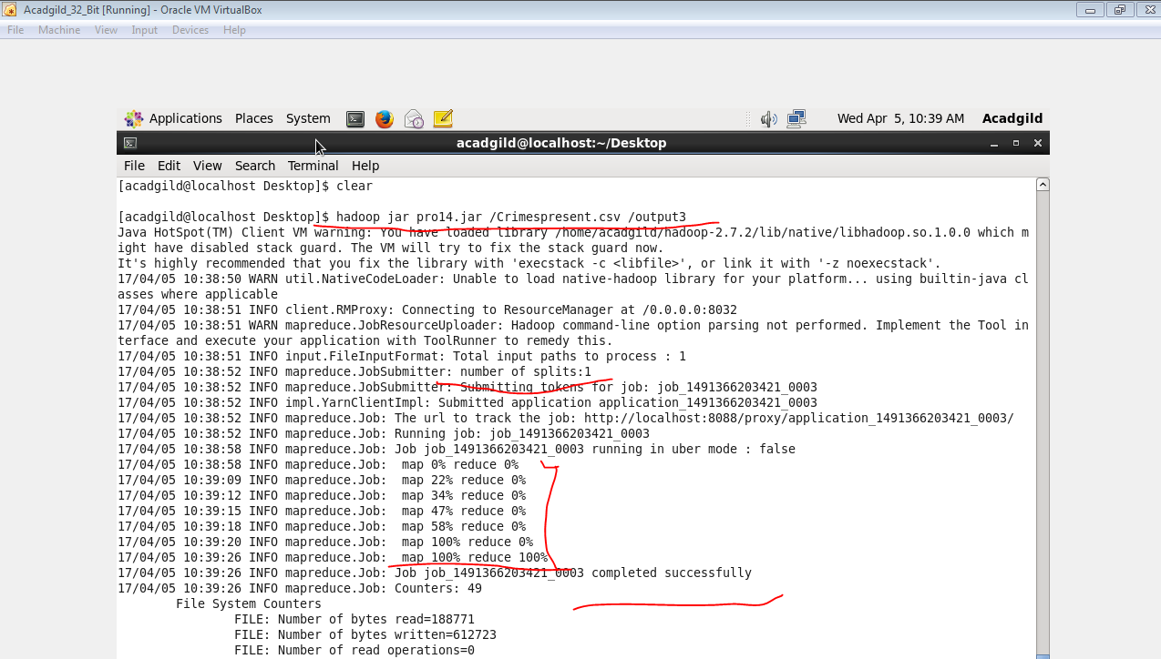

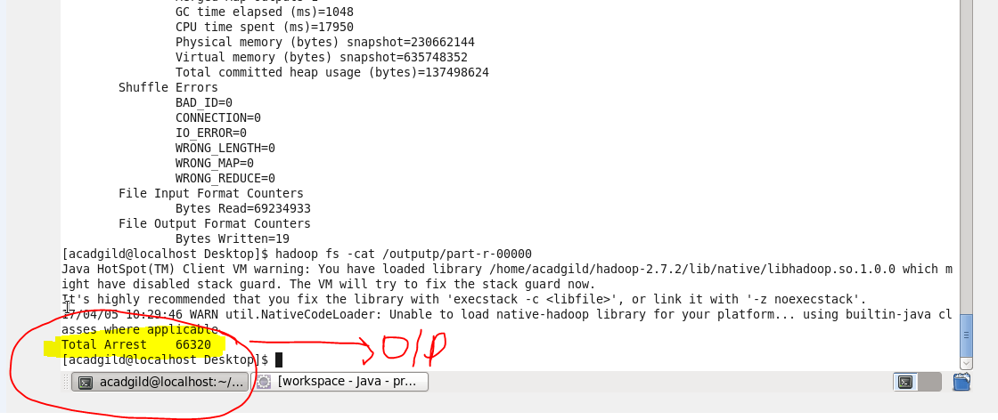

***BY PIG***

1. **Write a mapreduce and pig program to calculate the number of cases investigated under each FBI code**

**COMMANDS**

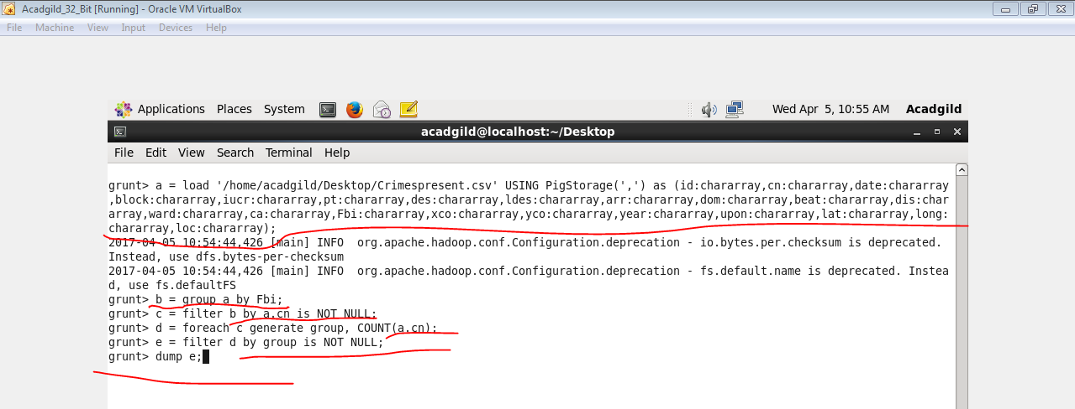

**OUTPUT**

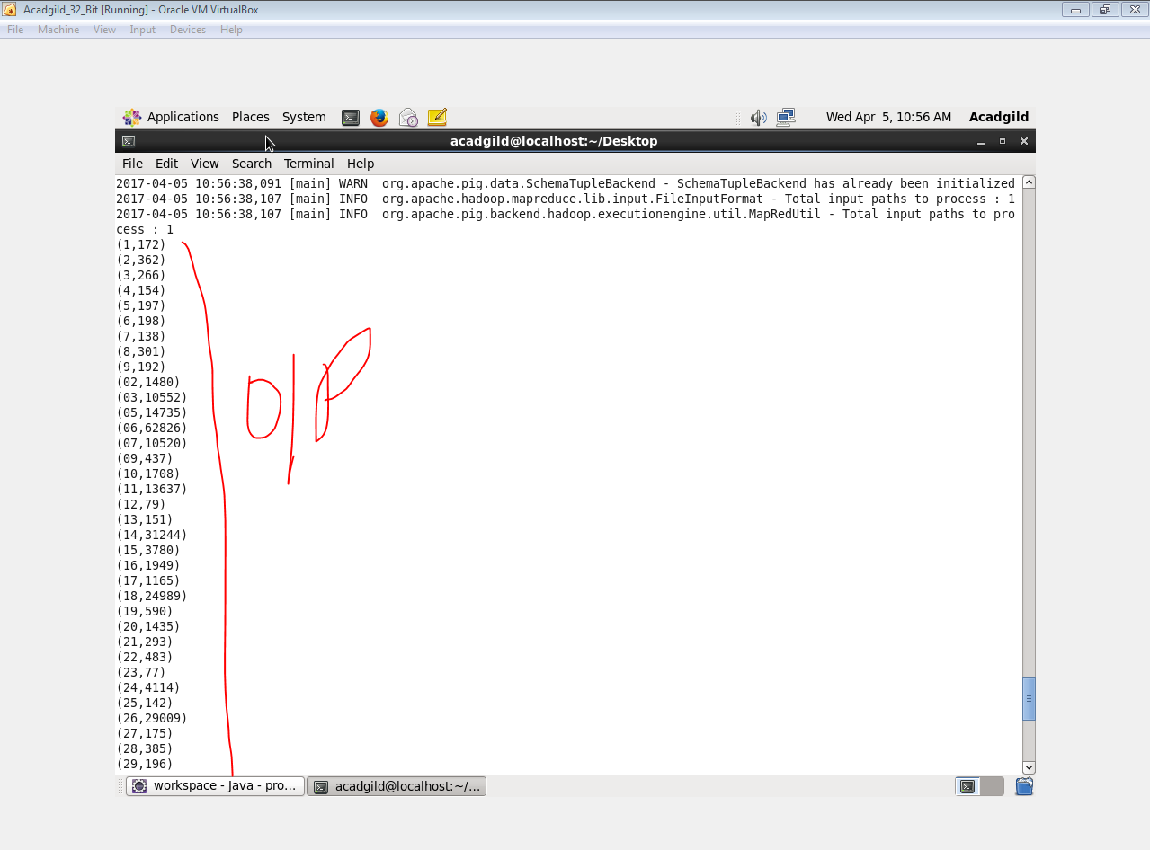

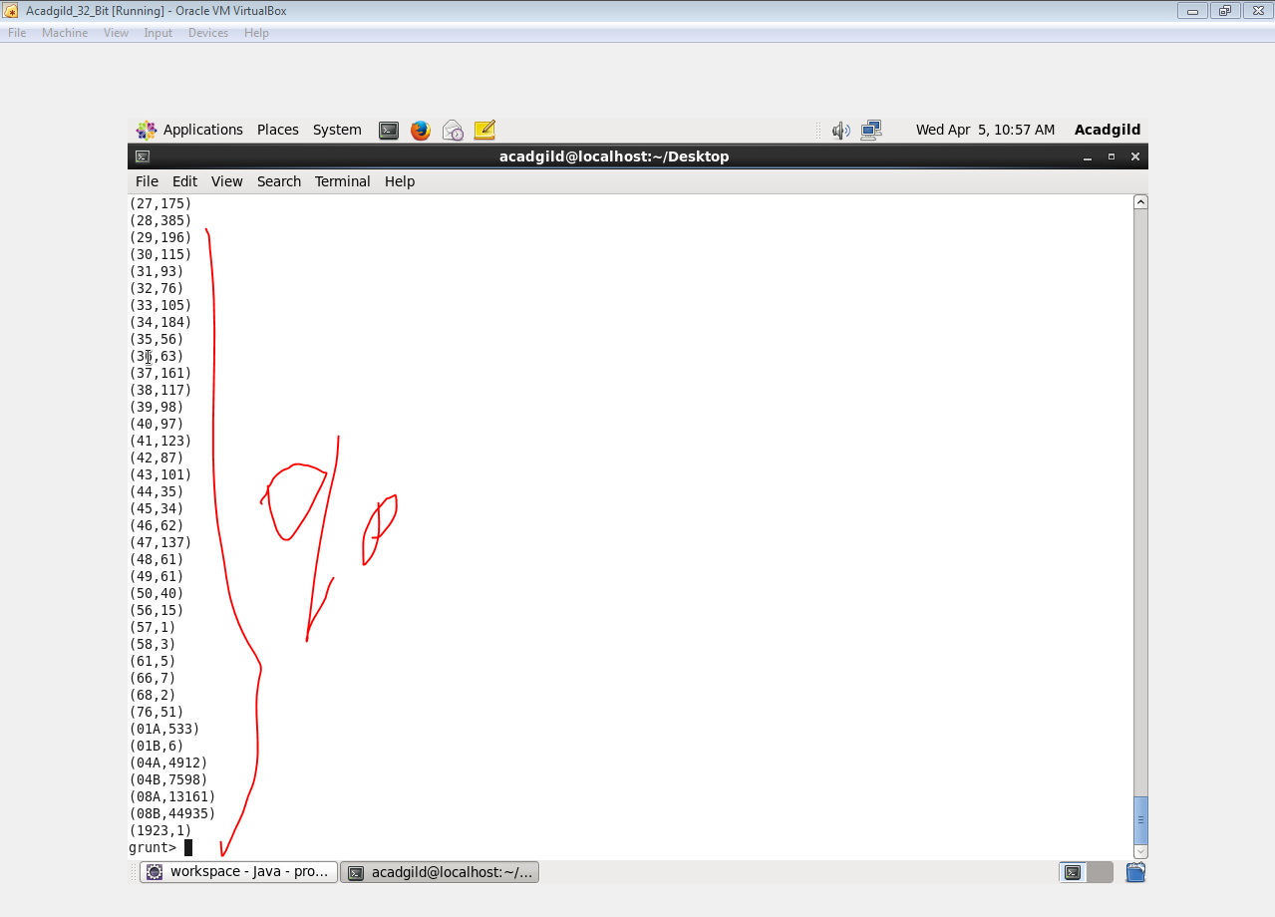

1. **Write a mapreduce and pig program to calculate the number of cases investigated under FBI code32.**

**COMMANDS**

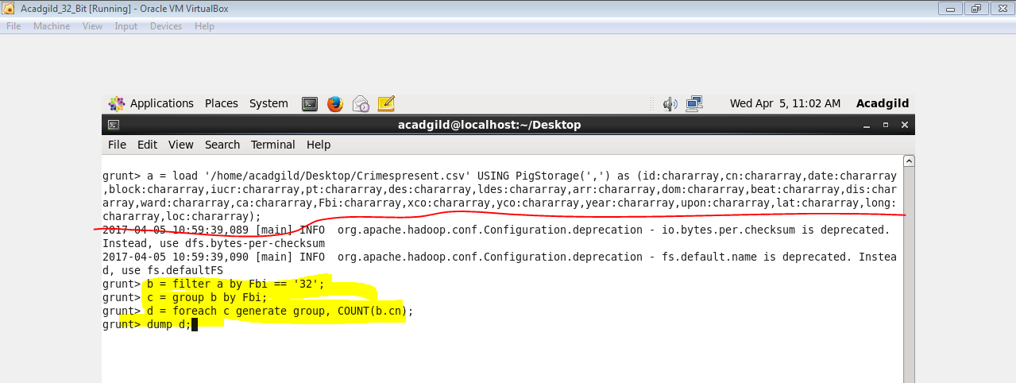

**OUTPUT**

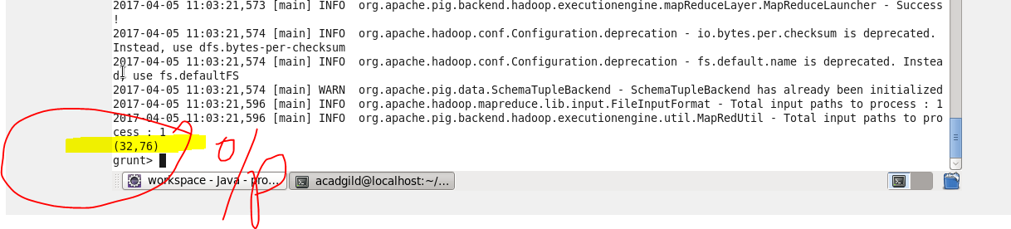

1. **Write a mapreduce and pig program to calculate the number of arrests in theft district wise.**

**COMMANDS**

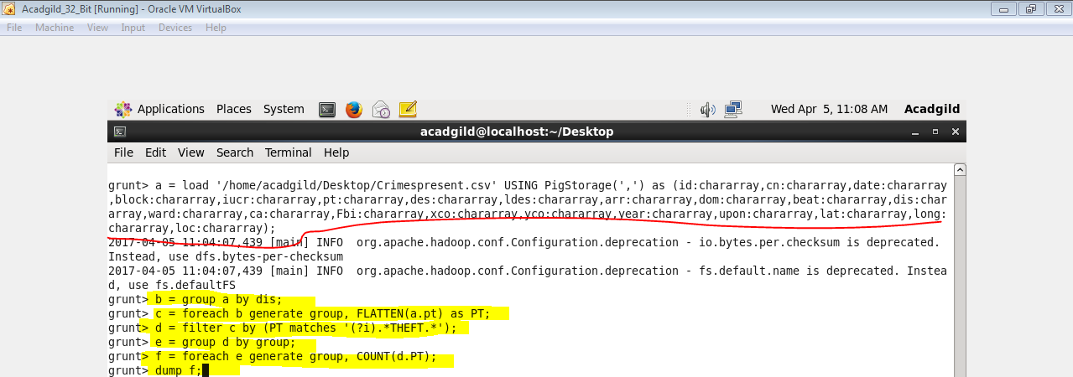

**OUTPUT**

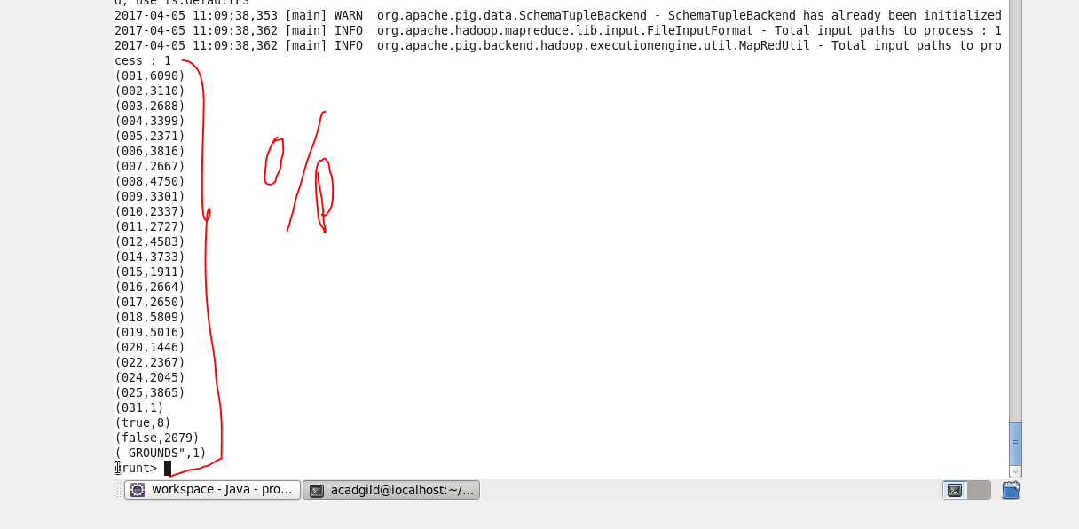

1. **Write a mapreduce and pig program to calculate the number of arrests done between October 2014 and October 2015.**

**COMMANDS**

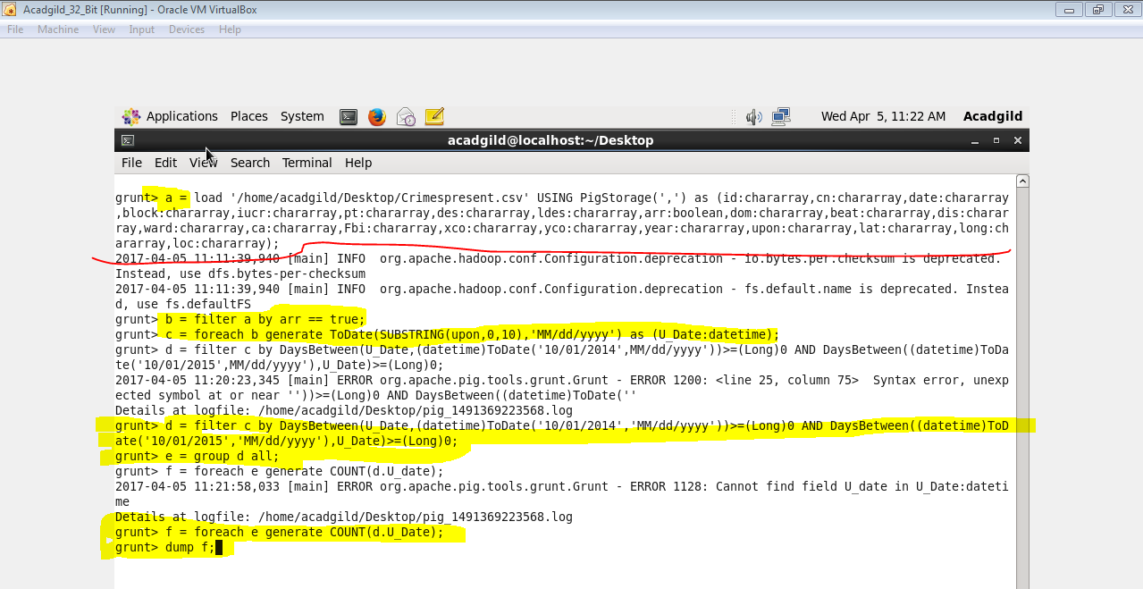

**OUTPUT**

