**I.Write a mapreduce program to remove commas present inside the double quotes.**

**CODE**

**DRIVER**

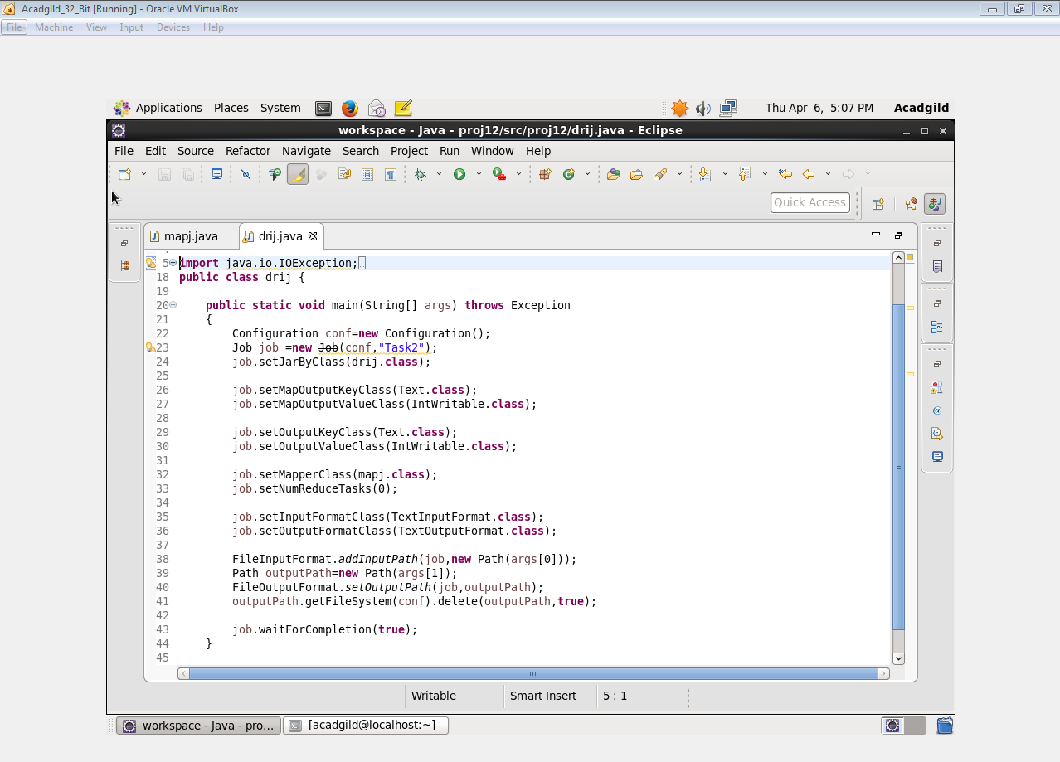

**MAPPER**

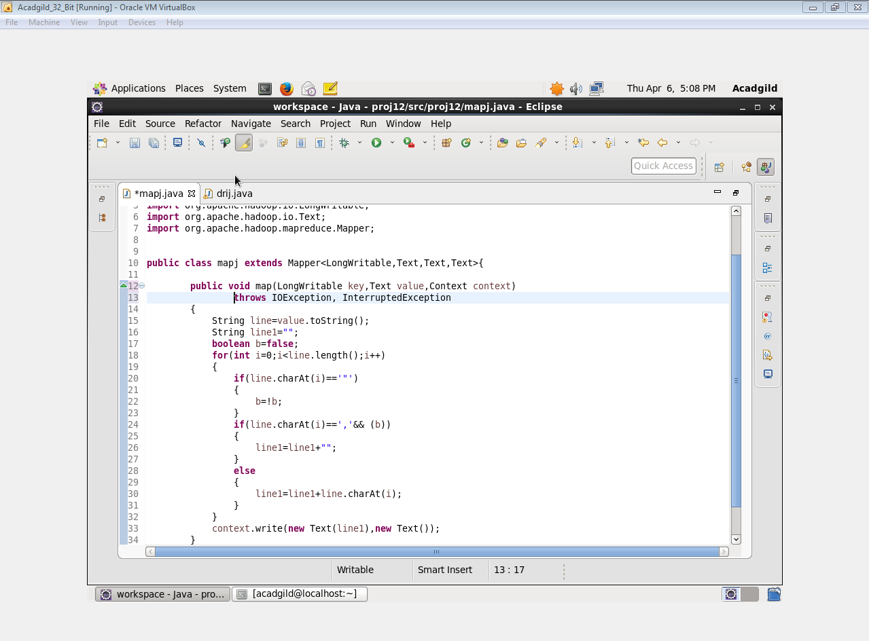

**COMMANDS**

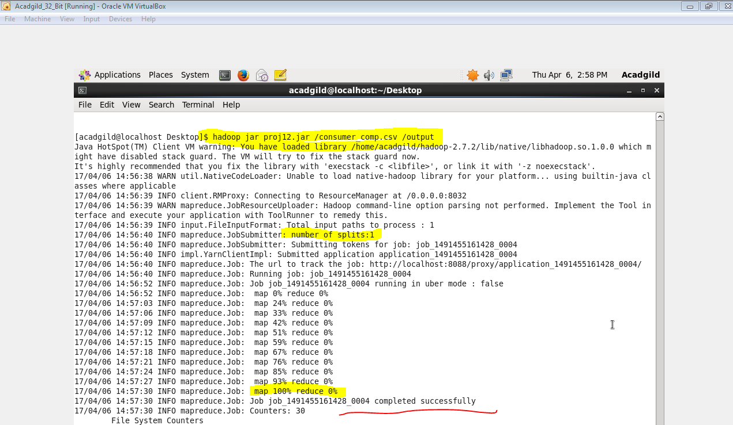

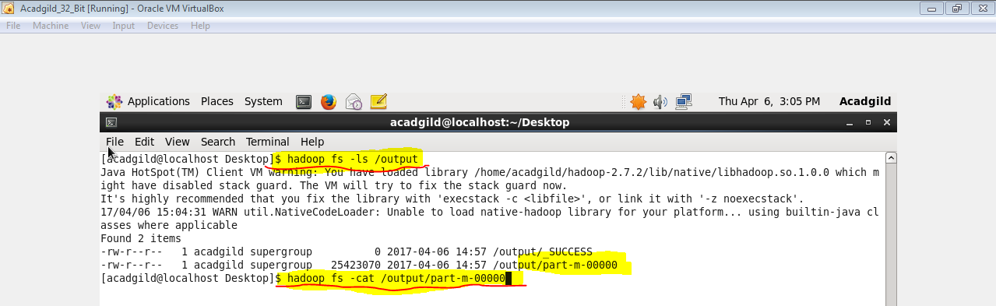

**OUTPUT**

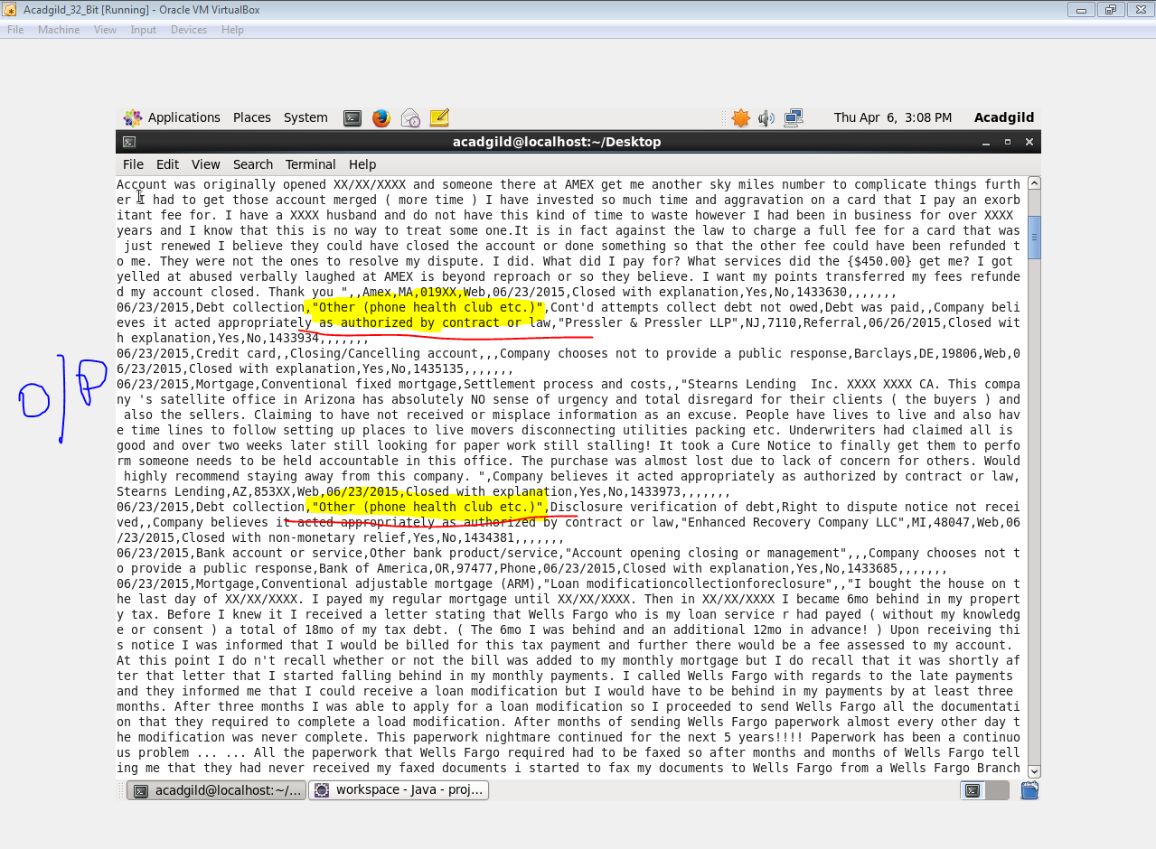

**GET COMMAND TO USE FILE IN PIG**

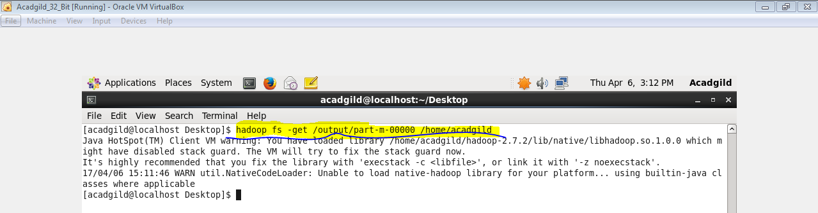

**II.**

1. **Write a pig script to find no of complaints which got timely response**

**COMMANDS**

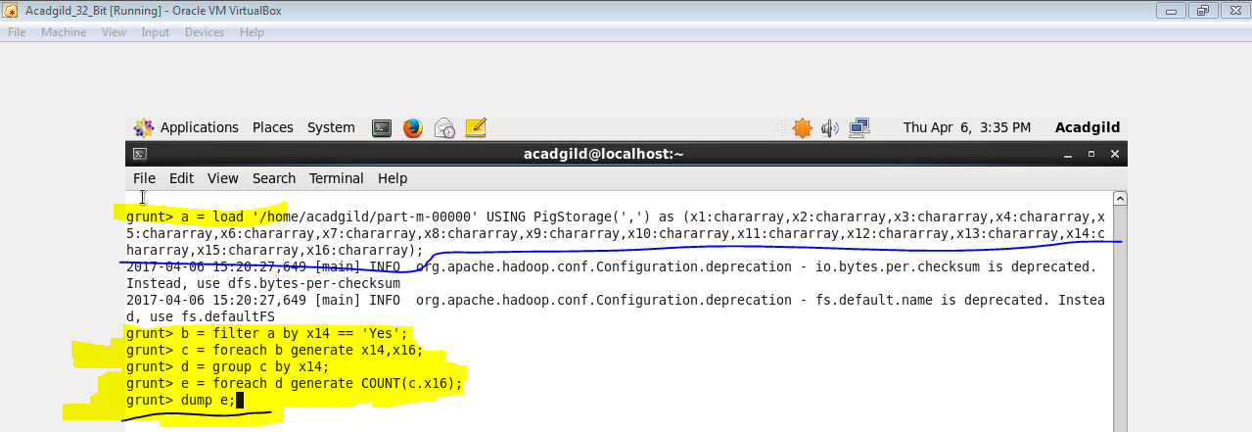

**OUTPUT**

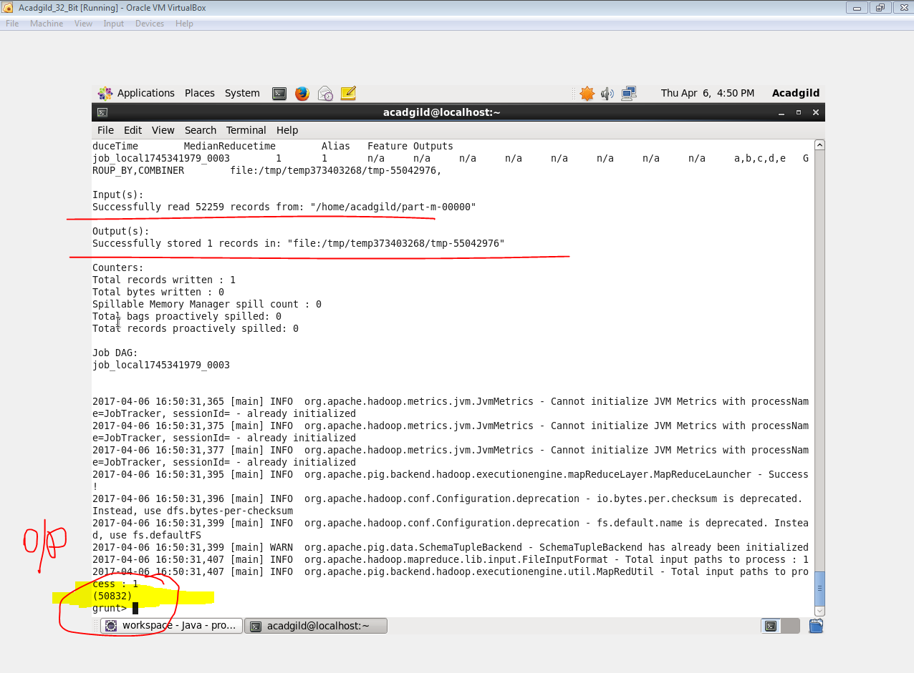

1. **Write a pig script to find no of complaints where consumer forum forwarded the complaint same day they received to respective company**

**COMMANDS**

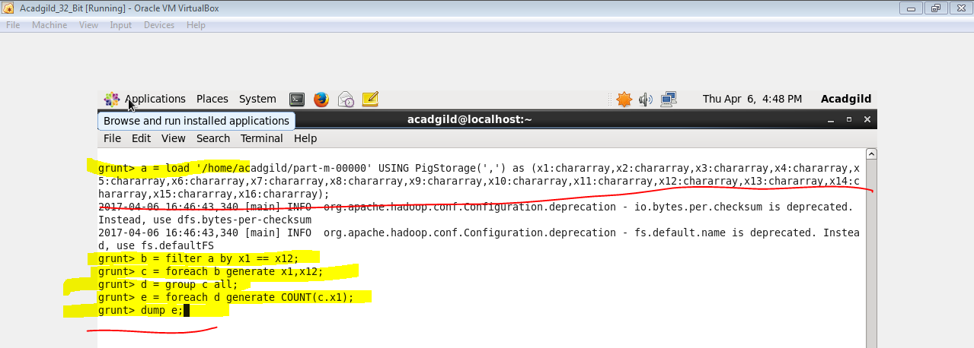

**OUTPUT**

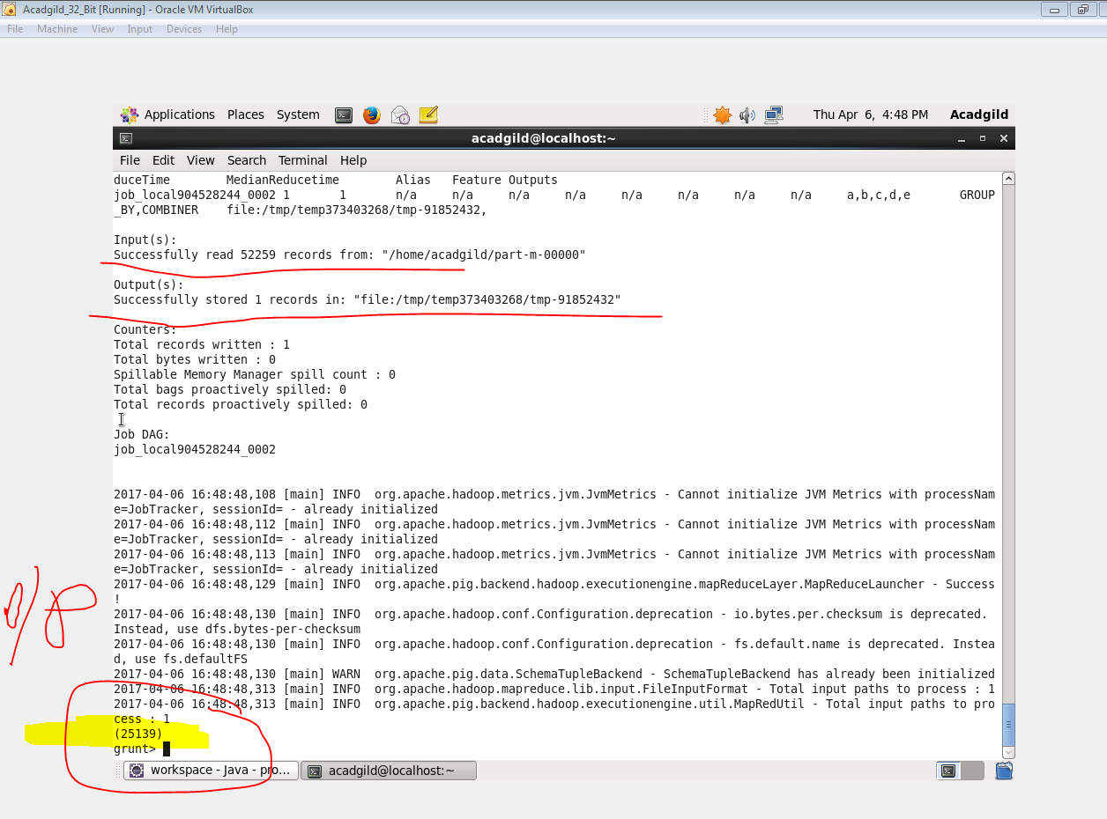

1. **Write a pig script to find list of companies topping in complaint chart (companies with maximum number of complaints)**

**COMMANDS**

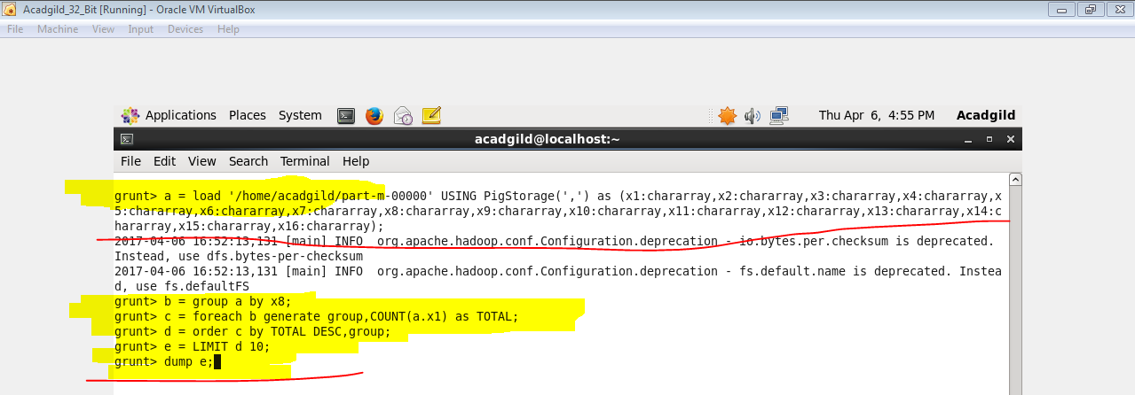

**OUTPUT**

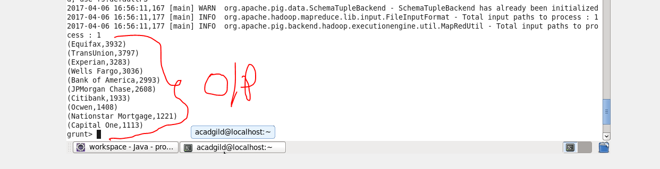

1. **Write a pig script to find no of complaints filed with product type has "Debt collection" for the year 2015**

**COMMANDS**

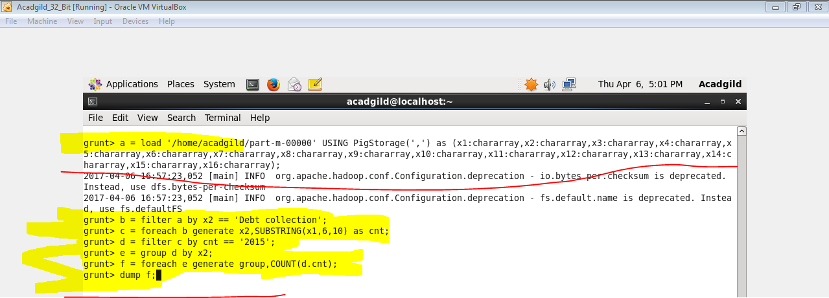

**OUTPUT**

