IBM SKILLSBUILD NATIONAL CYBERSECURITY BOOTCAMP
BharatCares (CSRBOX Group) in collaboration with IBM
PROJECT REPORT
Automated Web Scanner
A Python tool to audit websites for secure headers and CORS misconfiguration

SUBMITTED BY | Neha Khatri
COURSE | BCA, 2nd Year (3rd Semester)
COLLEGE | Vision College of Commerce
BOOTCAMP | IBM SkillsBuild National Cybersecurity Bootcamp (Online, October 2026)
LANGUAGE | Python 3 (standard library only)
MAIN FILE | Neha_AutomatedWebScanner.py
DATE | 21 October 2026

Abstract
This project presents the Automated Web Scanner, a command-line tool written in Python that audits a website’s security headers and its CORS setting. The tool asks for permission, sends a single normal GET request, checks five important security headers and the Access-Control-Allow-Origin header, and prints a report using PASS, FAIL and WARN labels with a score out of 6. It uses only Python’s standard library, so nothing needs to be installed. Tested on three websites, it scored a well-secured site at 6/6 and weakly protected sites at 1/6 and 0/6, showing that it separates strong and weak configurations correctly.

Contents
01 Introduction  02 Objectives  03 Tools and Technologies  04 How the Scanner Works  05 Security Checks Performed  06 Safety and Ethical Measures | 07 Implementation Overview  08 Testing and Results  09 Limitations  10 Future Scope  11 Conclusion  12 References

1. Introduction
When a browser opens a website, the website’s server sends back the page along with a set of headers. Some of these headers are security instructions that tell the browser how to behave safely, for example whether the page may be shown inside another site’s frame or whether only encrypted HTTPS connections should be used. If a site leaves these headers out, it becomes easier for attackers to carry out attacks such as clickjacking or cross-site scripting.
The Automated Web Scanner is a small command-line program that checks a website for these important security headers and for a risky CORS setting, and then prints a clear report with a score. It was built as the project for the IBM SkillsBuild National Cybersecurity Bootcamp.

2. Objectives
- To build a simple, safe tool that audits a website’s security headers.
- To detect a permissive CORS setting that allows every website to read responses.
- To present the results in a report that a beginner can understand, with a score out of 6.
- To follow responsible practice: ask for permission, send only one normal request and never attack the target.
- To keep the project lightweight, using only Python’s standard library with nothing extra to install.

3. Tools and Technologies
TOOL | USE IN THE PROJECT
Python 3 | Programming language used for the whole scanner
urllib.request | Sends the single GET request and builds a custom opener
urllib.parse | Splits and validates the website address
urllib.error | Handles HTTP and connection errors
sys | Allows the program to exit cleanly when cancelled
VS Code with GitHub Copilot | Editor and AI assistant used to write the code from prompts
GitHub | Hosting the project repository

Zero dependencies
No external packages are used, so the project needs no installation step and works on any computer that has Python 3.

4. How the Scanner Works
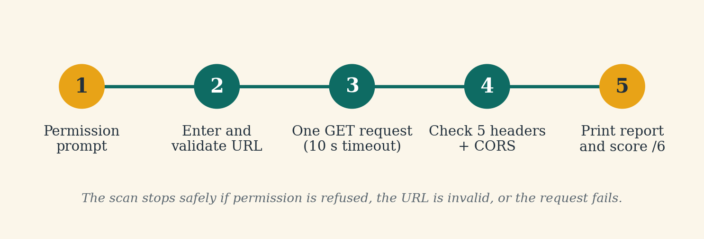
Figure 1: Workflow of the Automated Web Scanner
- The program asks: “Do you have permission to scan this site? (yes/no)”. If the answer is not yes, it stops.
- The user enters a website address. If it has no http:// or https://, the program adds https:// automatically.
- The address is validated. It must start with http or https and contain a valid hostname.
- The program sends one normal GET request with a 10-second timeout. Redirects are deliberately not followed.
- The response headers are read, and each required security header is checked for presence.
- The Access-Control-Allow-Origin header is checked for the value * (any origin).
- A report is printed on screen with PASS, FAIL or WARN for each check and a final score out of 6.

5. Security Checks Performed
CHECK | PURPOSE | RESULT
Content-Security-Policy | Limits which sources a page may load scripts and content from; helps reduce cross-site scripting | PASS if present, FAIL if missing
X-Frame-Options | Stops the page from being shown inside another site’s frame; protects against clickjacking | PASS if present, FAIL if missing
Strict-Transport-Security | Tells the browser to use HTTPS only for this site | PASS if present, FAIL if missing
X-Content-Type-Options | Prevents the browser from guessing file types (MIME sniffing) | PASS if present, FAIL if missing
Referrer-Policy | Controls how much page address information is shared with other sites | PASS if present, FAIL if missing
Access-Control-Allow-Origin (CORS) | Shows which other websites may read responses from this site | WARN if the value is *, otherwise PASS

Scoring
Each PASS counts as 1 point. FAIL and WARN count as 0. The maximum score is 6.

6. Safety and Ethical Measures
- Permission prompt: The scanner asks for confirmation before every scan and stops if permission is not confirmed.
- Single request: Only one normal GET request is sent per run, like a browser opening a page.
- No redirect following: Redirects are disabled so that the scanner never makes a second request.
- Timeout: Requests give up after 10 seconds so the program never hangs.
- Passive only: The tool does not crawl, brute-force, inject data or attempt any attack.
- Responsible use: Test only websites that you own or that are intended for testing.

7. Implementation Overview
All of the code is in one file, Neha_AutomatedWebScanner.py, split into small functions:
PART OF THE CODE | WHAT IT DOES
NoRedirectHandler | A small class that blocks redirects so only one request is made
get_website_url() | Asks for permission, takes the address, adds https:// if needed and validates it
fetch_headers() | Sends the single GET request with a 10-second timeout and returns the status code and headers; prints friendly messages on errors
check_headers() | Checks the five security headers and the CORS header and records PASS, FAIL or WARN
print_report() | Counts the passes, calculates the score and prints the report
main() | Runs the steps in order and stops safely if any step cannot continue

Command to run the scanner:
$ python Neha_AutomatedWebScanner.py

8. Testing and Results
The scanner was tested on three websites. The results are shown below.
WEBSITE | SCORE | OBSERVATION
https://github.com | 6/6 | All five security headers present and no wildcard CORS; a well-secured site
https://example.com | 1/6 | None of the five security headers present; passes only the CORS check
https://httpbin.org | 0/6 | No security headers; CORS allows all origins (*), so a WARN was shown

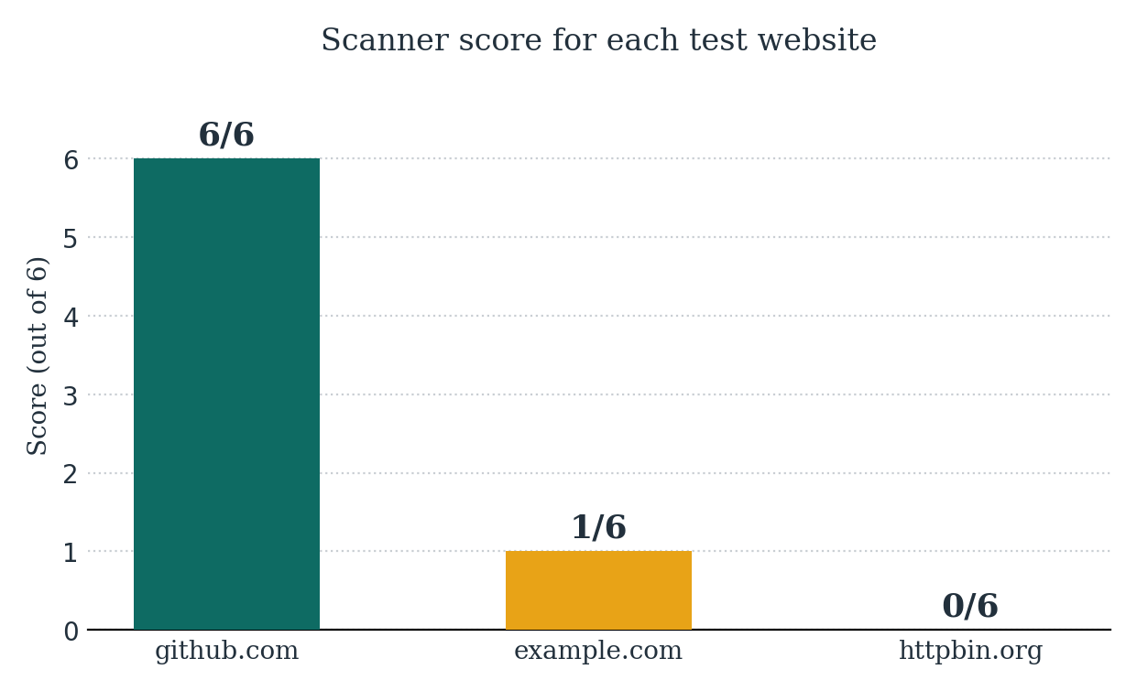
Figure 2: Scores obtained on the three test websites
Sample output for https://github.com:
Automated Web Scanner Report
---------------------------
Website: https://github.com
HTTP status: 200

Header checks:
- Content-Security-Policy: PASS
- X-Frame-Options: PASS
- Strict-Transport-Security: PASS
- X-Content-Type-Options: PASS
- Referrer-Policy: PASS
- Access-Control-Allow-Origin: PASS

Score: 6/6

Key findings
The scanner told a well-protected site (6/6) apart from weakly protected ones (1/6 and 0/6). It also separated a missing header (FAIL), a present header (PASS) and a risky setting (WARN) correctly.

- The WARN for httpbin.org is expected: allowing all origins is intentional for a public testing service, but it would be a concern for a site that handles private data.
- When a test site was slow and did not respond, the scanner timed out after 10 seconds and showed a clear message instead of crashing, which confirmed that the error handling works.

9. Limitations
- The scanner checks response headers only. It does not find vulnerabilities inside a page’s content.
- Redirects are not followed, so a site that redirects will show the headers of the redirect response (for example status 301).
- It scans one website per run.
- It checks whether a header is present but does not judge whether its value is strong enough.
- The report is printed on screen and is not saved to a file.

10. Future Scope
- Colored output for easier reading.
- An option to save the report to a file.
- Support for scanning a user-provided list of sites.
- A carefully limited option to follow redirects.
- Checking the strength of header values, not only their presence.

11. Conclusion
The Automated Web Scanner shows how a small, safe Python script can audit a website’s basic security configuration. It uses only the standard library, sends a single normal request, asks for permission first and reports the results clearly with PASS, FAIL and WARN labels and a score out of 6. Testing on websites with different levels of protection gave the expected results. The project gave practical experience with HTTP headers, secure coding practice, error handling and responsible security testing, and it can be extended with the improvements listed above.

12. References
- IBM SkillsBuild National Cybersecurity Bootcamp, BharatCares (CSRBOX Group) in collaboration with IBM, October 2026.
- OWASP Secure Headers Project (owasp.org/www-project-secure-headers).
- MDN Web Docs: HTTP headers and Cross-Origin Resource Sharing (developer.mozilla.org).
- Python documentation: urllib (docs.python.org/3/library/urllib.html).

