Analysis of Venues for Corporate Event in Milan and for trips in Milan and Como in Italy

Table of contents
Sr.No | Component | Page No
A. | Introduction | 3
B. | Data | 4
C. | Methodology & Analysis | 5-14
D. | Results | 15
E. | Discussion | 16
F. | Conclusion | 17
G. | References | 18

A. Introduction

A.1. Description & Discussion of the Background

Milan is a city in northern Italy, capital of Lombardy, and the second-most populous city in Italy after Rome, with the city proper having a population of 1,395,274 while its metropolitan city has a population of 3,259,835. The wider Milan metropolitan area, known as Greater Milan is the largest metropolitan area in Italy and the 54th largest in the world. Milan is considered a leading alpha global city with strengths in the the art, commerce, design, education, entertainment, fashion, finance, healthcare, media, services, research and tourism fields. The city has been recognized as one of the world's four fashion capitals.

Como is a city and commune in Lombardy, Italy. Its proximity to Lake Como, Bellagio and to the Alps has made Como a tourist destination, and the city contains numerous works of art, churches, gardens, museums, theatres, parks and palaces.
A multinational company based in Milan, Italy (say XYZ) is currently organizing a corporate event and has invited business executives from its offices spread all over the world for a 5 day corporate program. The company has to put a good program, including a hotel of residence, event space and nearby venues in the Milan Area as the company is located there and also some more restaurants, shopping malls and fashion stores in some other areas spread over larger radius within the city and the company also intends to offer a one day tour to executives to the city of Como, Italy.

Now, the company’s purpose is to make a list of such places in Milan. The executives will be living in Milan and the city can also be visited in the evenings after work. The company chooses to take executives for a visit to nearby venues in the Milan area after work. The company also intends to offer a complete one day tour to the executives for visiting the city of Como (approx 50 km from Milan) in Italy on the 6th day(being Saturday) at the end of the week.

We can use data science and obtain results for some hotels, event space and nearby venues in the Milan Area as the company is located there and also some more restaurants, shopping malls and fashion stores in some other areas spread over larger radius within the city. Similarly, we can also find out each neighborhood in Como with the top 10 common venues so that the company can choose the neighborhoods as per the interested venues/maximum no of venues in a neighborhood.

When we consider all these problems, we can create a map visualizing hotels, event space & nearby venues in Milan Area and also another map to visualize hotels, fashion stores, shopping malls, restaurants spread over larger radius within the city of Milan. We can also create a map with clusters of neighborhoods in Como, Italy.

B. Data Description

Based on definition of our problem, the focus is to find the following data.
- Hotels, event space and nearby venues in the Milan Area of the city(within radius of 500 meters) and shopping malls, fashion stores and restaurants spread over larger radius in the city of Milan, Italy.
- Top 10 Common venues of each neighborhood in Como, Italy.
The data can be listed as below:
- I found the data of the first, second and third level Administrative Divisions of the entire Country of Italy from http://www.geonames.org along with the location data. I cleaned the data and grouped it from Country to State and then to City of Milan and Como. In the project, Borough represents the City and Neighborhoods represents the places in the city.
- The json file has the coordinates and data of the city of Milan and Como. I have cleaned it to obtain the required data for this project for the respective cities.
- I used it to create a map of places in Milan and Como.
- I have used Foursquare API to run the queries for hotels, event space and nearby venues in the Milan Area as the company is located there, also some more restaurants, shopping malls and fashion stores in some other areas spread over larger radius within the city. I have also used it to find top 10 most common venues for each neighborhood for the city of Como in Italy.

C. Methodology & Analysis

In this project, I have focused on finding out hotels, event space and nearby venues in the Milan Area as the company is located there and also some more restaurants, shopping malls and fashion stores in some other areas spread over larger radius within the city for the corporate event (5 day program)to be organized by the Company for business executives.

I have also found out top 10 common venues for each neighborhood of Como as the company intends to take the executives for a one-day tour to the city of Como.

In first step, I have collected the required **data: hotels, event space and nearby venues such as shopping stores, fashion stores, restaurants, monuments, cafes etc within a radius of 500 meters from the Milan Neighborhood in the city and also some other areas to have more options. I have also identified common venues for each neighborhood of Como.

Second step in our analysis is calculation and exploration of categories of venues in the Milan Area and also venues in the Como City - I have used **bar charts** to identify the count of each category of venue in the Milan Area and also venues in each neighborhood in the Como city.

In third and final step, I have focused on interested areas of Milan and top 10 common venues for each neighborhood as **clusters of locations in Como City. I have presented map of all such locations for the Milan Area and also other areas spread over larger radius in the City. I have created a separate map with clusters(using **k-means clustering**) of neighborhoods with top 10 common venues in Como city. The above has been done to identify venues/general neighborhoods / addresses which should be of interest to the company for choosing venue locations in Milan and Como.

1. Description and analysis of information of the Milano City(in Milan Area and other areas spread over larger radius
The tabular data mentioned below has the main components Postal Code, Neighborhood, Latitude and Longitude information of the Borough- Milano City.

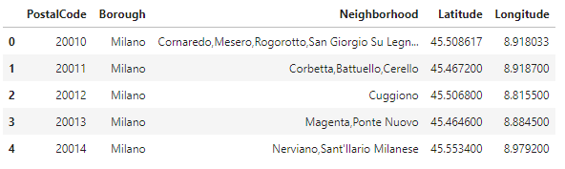
I used python folium library to visualize geographic details of Milano and its neighborhoods on a map and I used latitude and longitude values to get the visual as below:
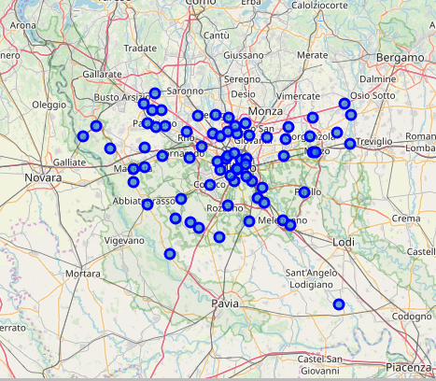

I utilized the Foursquare API to explore the hotels, event space and nearby venues in the Milan Area of the city. I restricted the limit to 100 venues and the radius 500 meters for the query. Here is the list of hotels and event space data which are in the Milan Area (20121) of the city near the company. I have identified 9 hotels and 1 event space in the Milan Area with postal code 20121.The company can choose the hotels and event space from the below data.

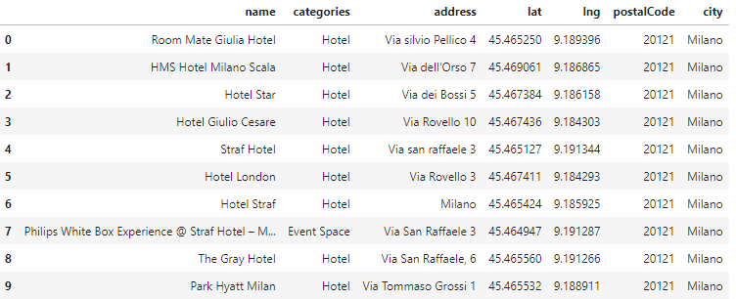
Here is also the list of (result of head query in Python)5 nearby Venues with name, category, latitude ,longitude and address data in the Milan Area within a radius of 500 meters.
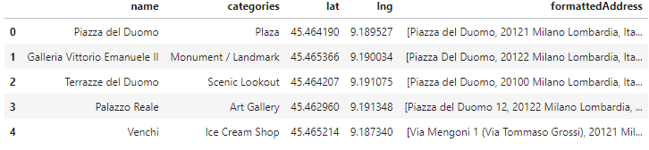
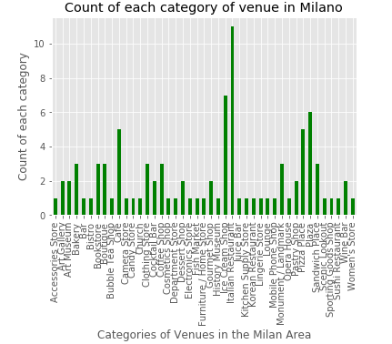

Above is the bar graph, showing the count of each unique category of venue in the Milano Area of the city. The company can choose from 93 venues available for a short trip in the evenings within a radius of 500 meters from the Milan Area in the city. There are 43 unique categories of venues like Italian Restaurants, Ice Cream Shops, Plaza, Cafe and Pizza Place with the respective highest counts. Venues also include some of the Art Galleries, Art Museums, Monuments, Cosmetics Store, Boutiques(which are also popular in the City) and many others that can be viewed from the above graph.

Visualizing all the venues that fall within the radius of 500 meters from the Milan Area in a folium map.
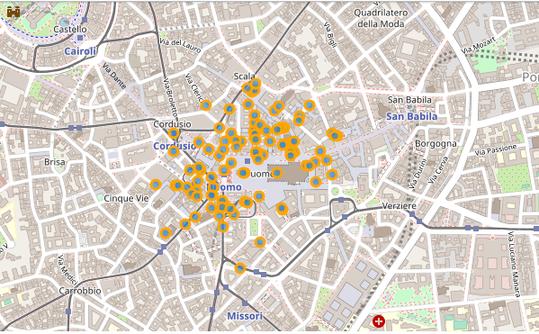
Since, the venues are very close to each other, they can be easily visited in the Milan Area.
Now, lets view the result of merged data of hotels(all hotels within 500 meters radius of the area) with restaurants, shopping malls and fashion stores obtained using specific search queries in other areas of the Milan City spread over larger radius(different limit and radius chosen for each specific query) within the city with no specific neighborhood and using location data of the Milan City, to have more venue options for the company to choose from. We have used hotels data of the Milan Area only as we are interested in hotels in that area only.
The result of the merged data(last 5 rows is as follows):
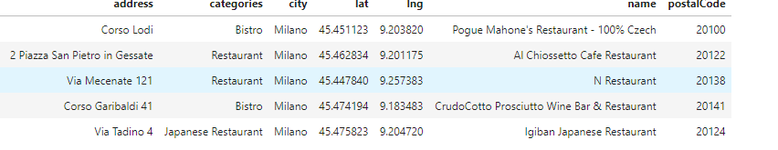

Here is the bar graph of the merged data with the count of each unique category of places in the
Milan City spread over larger radius.

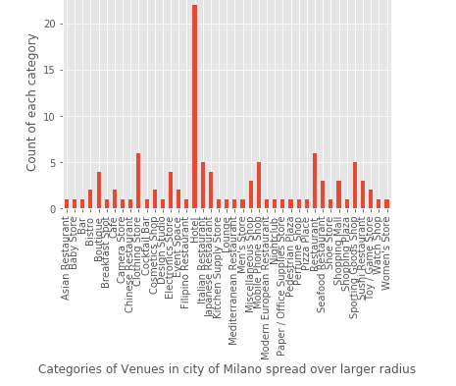

The company can choose from the 41 categories of places/venues in the city of Milano spread over larger radius for any specific type of hotel, restaurants, shopping malls and fashion stores. From the above graph, we can see that hotels(as they are already chosen from the filtered category)have the highest count, followed by clothing stores, mobile phone shop, restaurants, sporting goods shop and others.

Visualizing merged data of hotels, shopping malls, restaurants and fashion stores on a folium map.
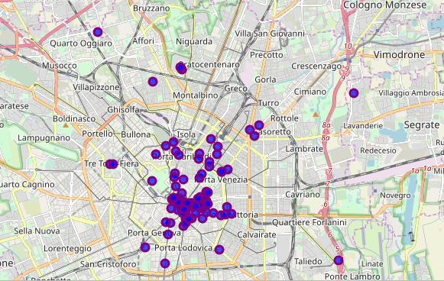

The company can choose from any one of the 23 hotels,31 Restaurants,34 fashion stores and 18 shopping malls/places for any specific type of category of location spread over larger radius in the city of Milano.

2. Description and analysis of information of the Como City: The tabular data mentioned below has the main components Postal Code, Neighborhood, Latitude and Longitude information of the Borough- Como City.

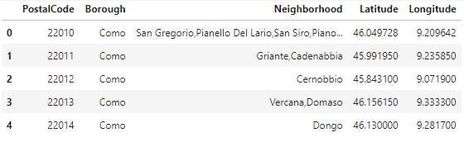

I have python folium library to visualize geographic details of Como and its neighborhoods on a map. I used latitude and longitude values to get the visual as below:

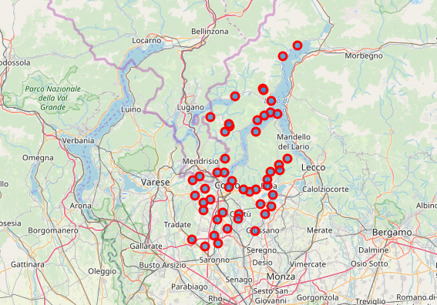

For the nearby venues query for the city of Como, 370 venues were returned by Foursquare. Here is a table of neighborhoods and venues( first 5 rows with some neighborhoods and venues).
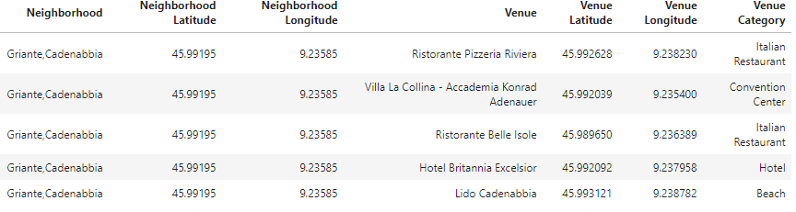

The result of first 5 rows of Neighborhoods and Venue data(number and category) in Como grouped by neighborhoods is as follows.
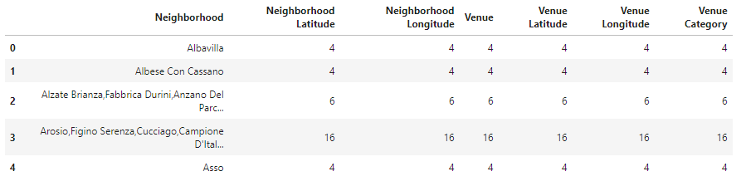

The result of bar graph showing number of venues in Como for each neighborhood is as follows:
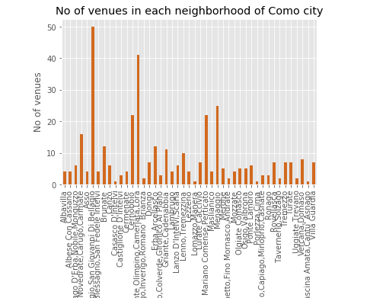

We can see in the above mentioned graph that the neighborhood having the highest no of venues are Bellagio, San Giovanni di Bellagio with 50 venues, Como-Lora group(written in short) with 41 venues, Mennaggio with 25 venues, Mariano Comense, Perticato with 22 venues and Cernobbio with 22 venues followed by others.
There are 45 neighborhoods in Como with 97 unique categories. Below is the result of first five rows of the query showing neighborhood for each unique category. Due to space constraints here, it is not possible to show all of the 97 unique categories. Hence, some of them are as follows:
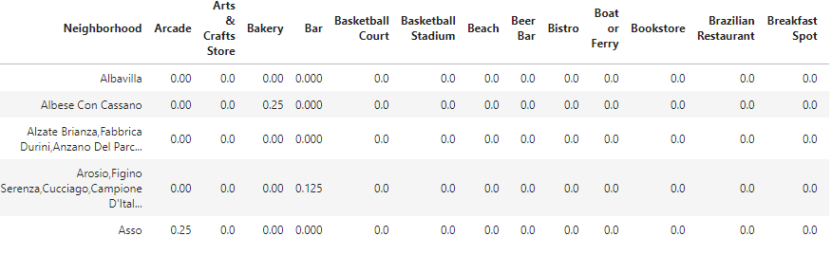
We have some common venue categories in neighborhoods. For this reason, I have used unsupervised learning K-means algorithm to cluster the neighborhoods. K-Means algorithm is one of the most common cluster methods of unsupervised learning. Neighborhoods in Como are grouped into 5 clusters (k=5).
I created a table which shows list of top 10 venue categoies for each neighborhood in Como. Due to space constraint, the first 5 rows are shown and the data is shown in two different tables:
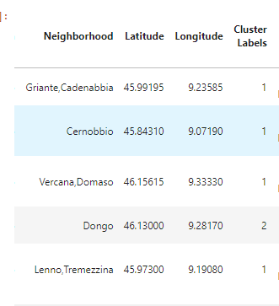

Top 10 common venues in Como for the neighborhoods with cluster labels mentioned in the above table:
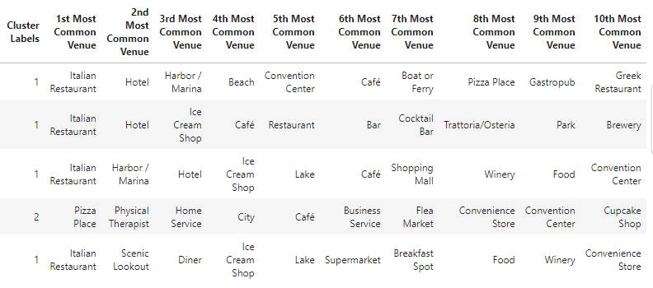
We can visualize the result of neighborhoods of Como grouped into five clusters(based on common venue categories) represented in five different colors in the folium map as follows:
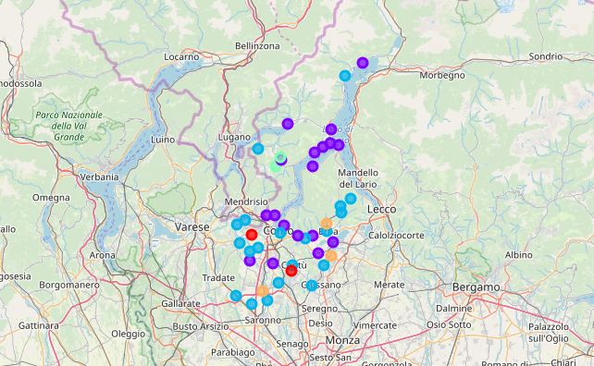

D. Results

The above analysis show that for the corporate event(5 day program),the company can choose from the any of the 9 hotels and 1 event space in the Milan Area nearby the Company location in the city and also several nearby venues available for a short trip in the evenings within a radius of 500 meters from the Milan Area to various places in the city. There are 93 venues with 43 unique categories like Italian Restaurants,Ice Cream Shops, Plaza, Cafe and Pizza Place with the respective highest counts. Venues also include some of the Art Galleries, Art Museums, Monuments, Cosmetics Store, Boutiques(which are also popular in the City) and many others.

The company for any specific type of category of location can also choose from any one of the 23 hotels,31 Restaurants,34 fashion stores and 18 shopping malls/places with 41 unique categories spread over larger(different for each venue)radius in the city of Milano to have some more options of venues.

There are 45 neighborhoods in Como with 370 venues and 97 unique categories of venues. Top 5 neighborhoods with highest no of venues are Bellagio,San Giovanni di Bellagio with 50 venues, Como-Lora(big set of neighborhoods mentioned in short) with 41 venues, Mennaggio with 25 venues,Mariano Comense,Perticato with 22 venues and Cernobbio with 22 venues followed by other venues. Then, top 10 common venues for each neighborhood in Como are also identified and grouped into 5 clusters. Likewise, the company can also choose the neighborhoods in Como as per the top 10 common interested venues/maximum no of venues in a neighborhood and plan a one day tour to the city of Como for the executives.

I used the K-means algorithm as part of this clustering study for the dataset.

I have ended the study by visualizing the data of the locations in the Milan Area on one map and data spread over larger radius of the city in another map. Data of the Como city is also visualized in a separate map with clusters (using **k-means clustering**) of neighborhoods (with top 10 common venues) in the city to identify neighborhoods which should be of interest to the company for choosing venue locations.

E. Discussion

I have just used one of the ways to suggest various venues, location and their categories for the city of Milan and Como.

It is possible that a location may or may not be suitable for any reasons which may be subject to further analysis.

In order to avoid confusion, I would like to clearly state that there are different Milan Neighborhoods/Areas in the Milan City in the dataset I have obtained. They can be differentiated from each other by checking the postal code and also complete address can be easily identified as mentioned above for any interested venue. I would also like to mention that data returned by Foursquare may vary slightly depending on the time of the day it is run.

As Milan and Como are big cities, there is a complexity and very different approaches can be tried in clustering and classification studies. Moreover, it is obvious that not every classification method can yield the same high quality results for the city.

I used the K-means algorithm as part of this clustering study for the dataset I have obtained. One can also choose to do a more detailed study and the details of the neighborhood or street can also be drilled.

I have ended the study by visualizing the data of the locations in the Milan Area on one map and data spread over larger radius of the city in another map. Data of the Como city is also visualized in a separate map with clusters (using **k-means clustering**) of neighborhoods with top 10 common venues in the city.

F. Conclusion
Purpose of this project was to identify hotels and event space (9 hotels and 1 event space are identified) in the areas close to the company location in the Milan Area of the Milan city for the corporate event and also nearby venues(93 venues are identified with 43 unique categories of venues) that can be visited in the evenings after work within a radius of 500 meters from the Area. I have also identified 31 restaurants, 18 shopping malls and 34 fashion stores not specific to any neighborhood and spread over a larger radius in the city to give the company few more options of the same.
I have also identified 45 neighborhoods in Como with 370 venues and 97 unique categories of venues. Top 5 neighborhoods with highest no of venues are also identified. Then, top 10 common venues for each neighborhood in Como are also identified.
The company can accordingly choose neighborhoods as per the interested venues/maximum no of venues in a neighborhood for one day tour of executives to the Como city.
Final decision for choosing optimal venue locations will be made by the company based on specific characteristics of neighborhoods and locations in city of Milan and Como, taking into consideration additional factors like attractiveness of each location in terms of event for executives, tourist place and opening & closing times for visit.
Several other companies can use similar data analysis types for any type of event/tourist package that they are interested in organizing.

G. References:
- [1] Milan and Como City data— Wikipedia
- [2] All Administrative Divisions of Italy- www.geonames.org
- [3] Foursquare API
- [4]Folium maps

