**PHARMACY MANAGEMENT SYSTEM - Report**

**Manasi Jadhav (2018140025)**

**Shreya Jain (2018140027)**

**Neha Kolambe (2018140030)**

**Screenshots:**

**Index.php**

This is the login page. Here we have 4 options to get logged in.

1. Admin
2. Pharmacist
3. Cashier
4. Manager

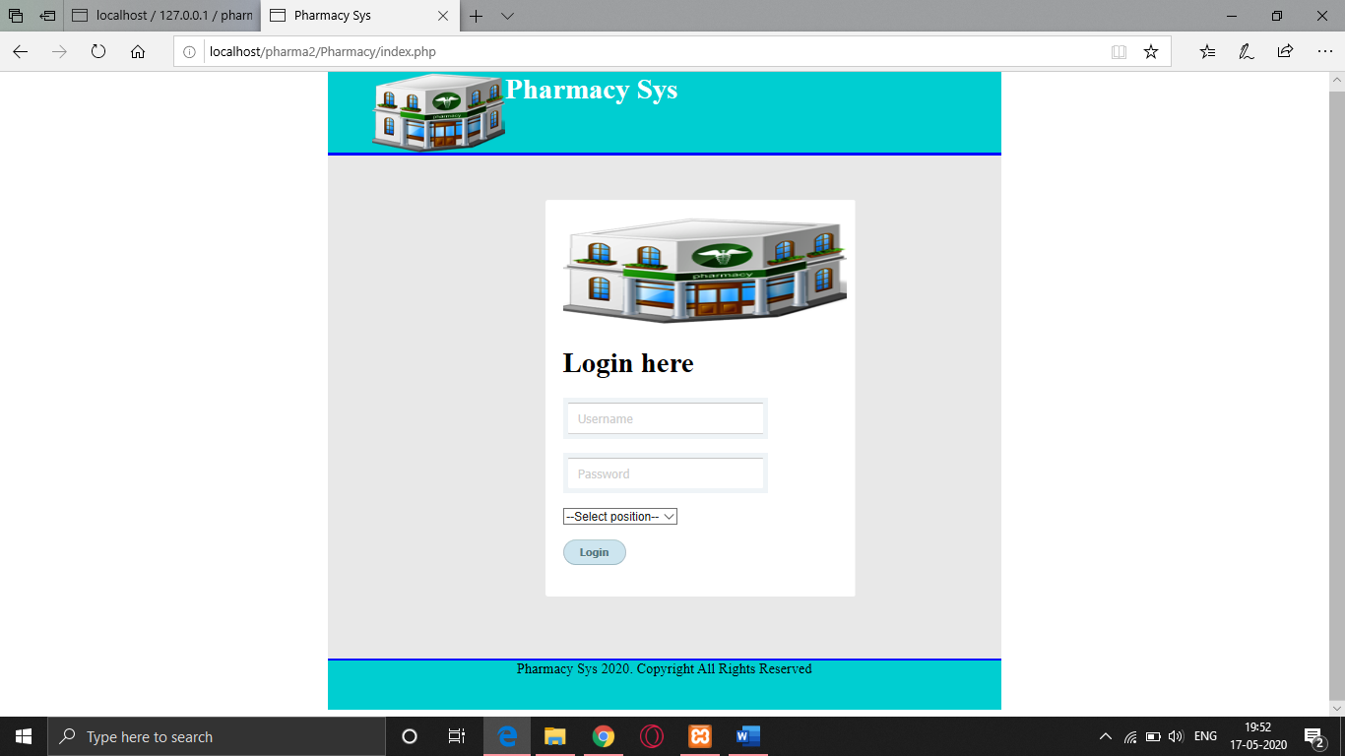

**Admin.php**

1. Pharmacist
2. Manager
3. Cashier

Kindly note, while updating in any part, the username should be unique so admin can fill the form to make changes but can change his/her username. If admin tries too, then admin gets the error.

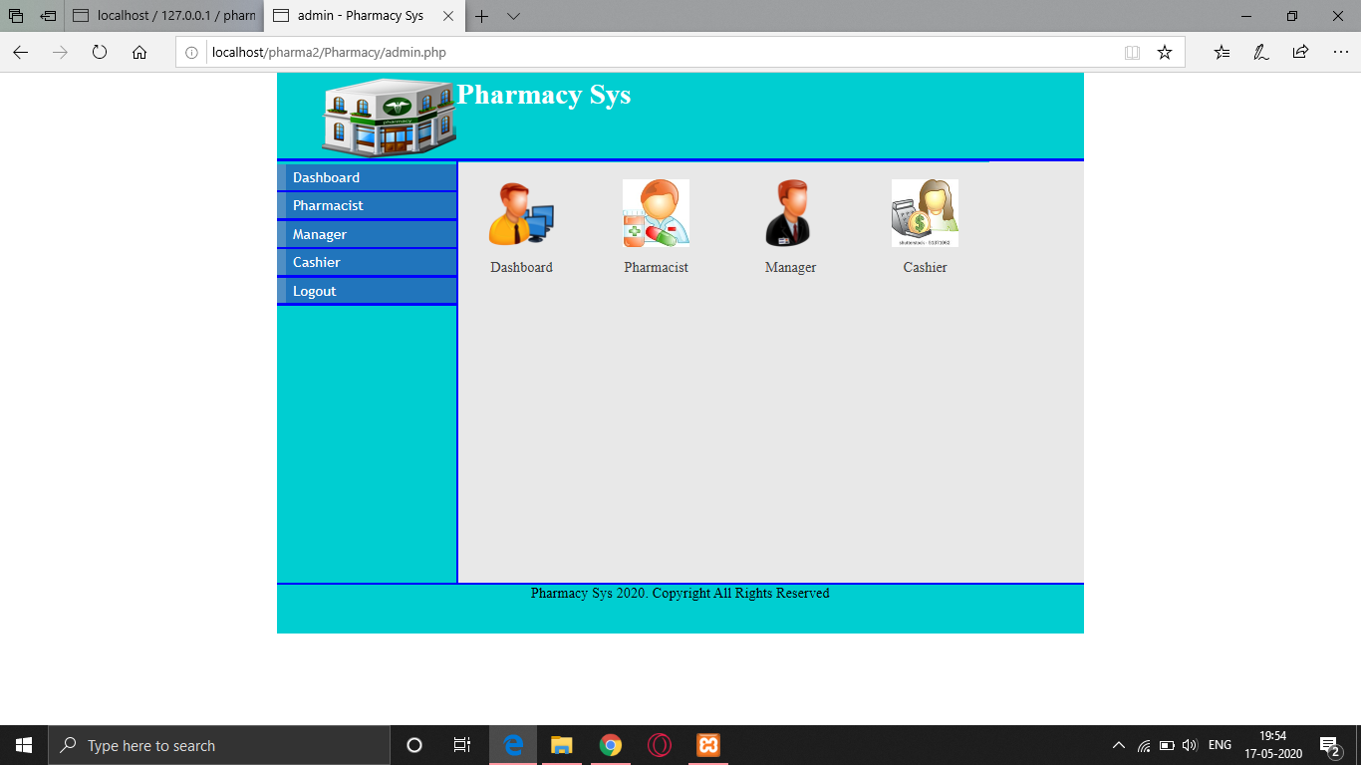

**Admin_pharmacist.php**

Admin can view, delete, add and update in the pharmacist’s table.

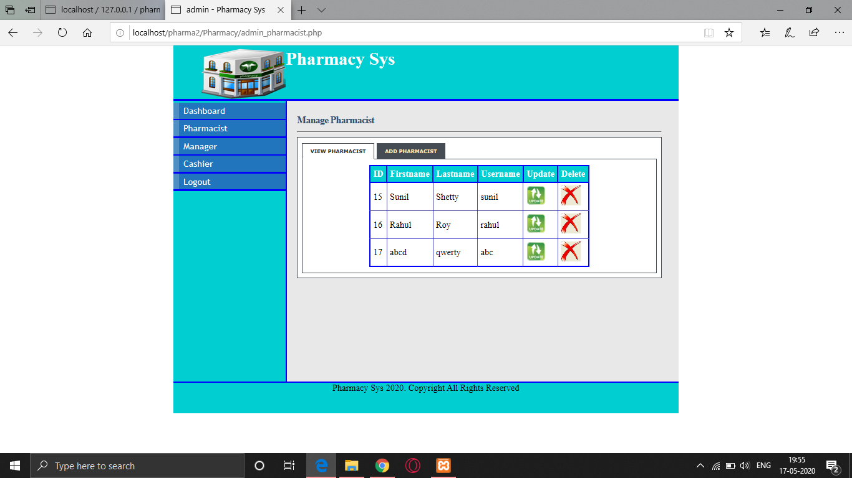

**Admin_manager.php**

Even in this, the admin can add, view, delete and update the manager details.

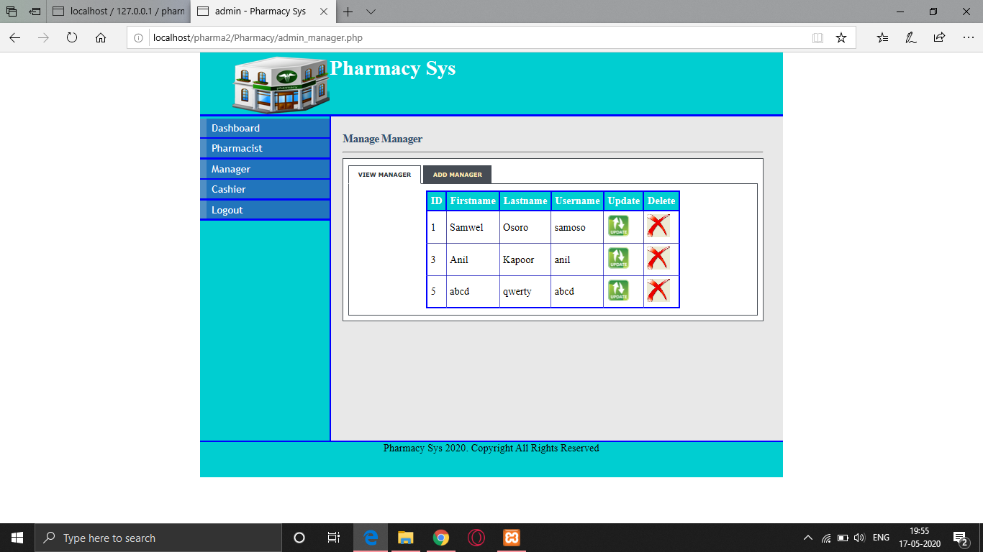

**Admin_cashier.php**

In this as well, the admin has the same options to add, delete, view and update the cashier's detail.

**Pharmacist.php**

1. Prescription
2. Stock

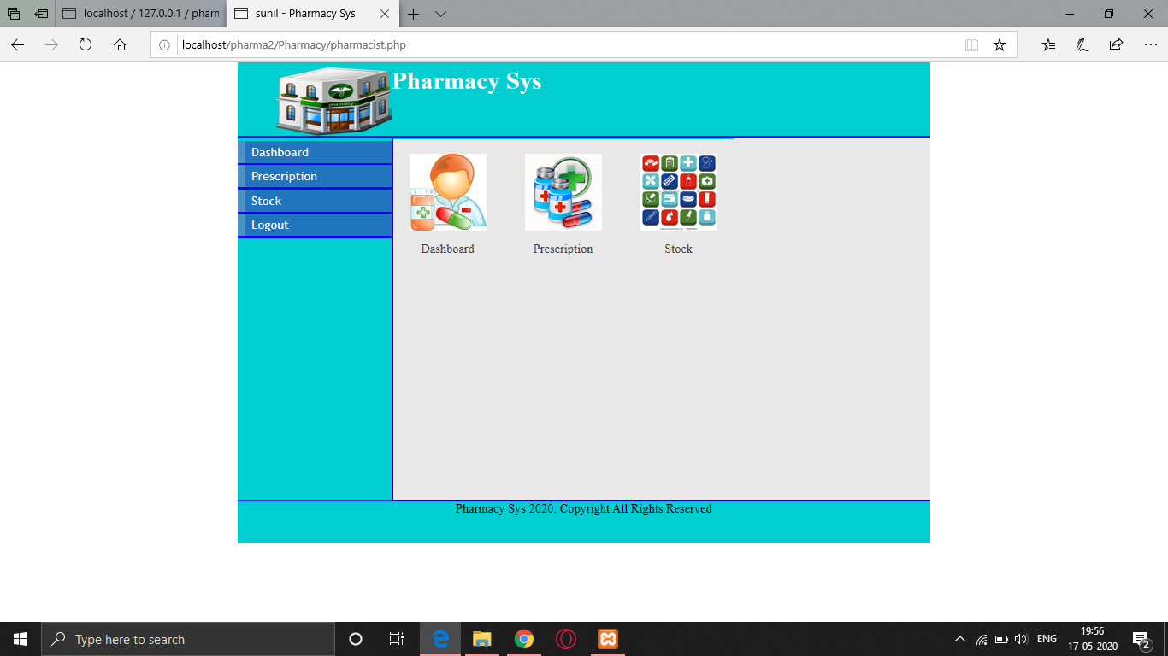

**Prescription.php**

He has the option to delete, view and add prescriptions.

While adding a new prescription, He has to fill the form and before clicking on the submit button he/she gets the table to confirm the details before submitting. After clicking on the submit button, a new prescription gets added in the database. Also, here we have used triggers to get the current date and time added in the database for proper record.

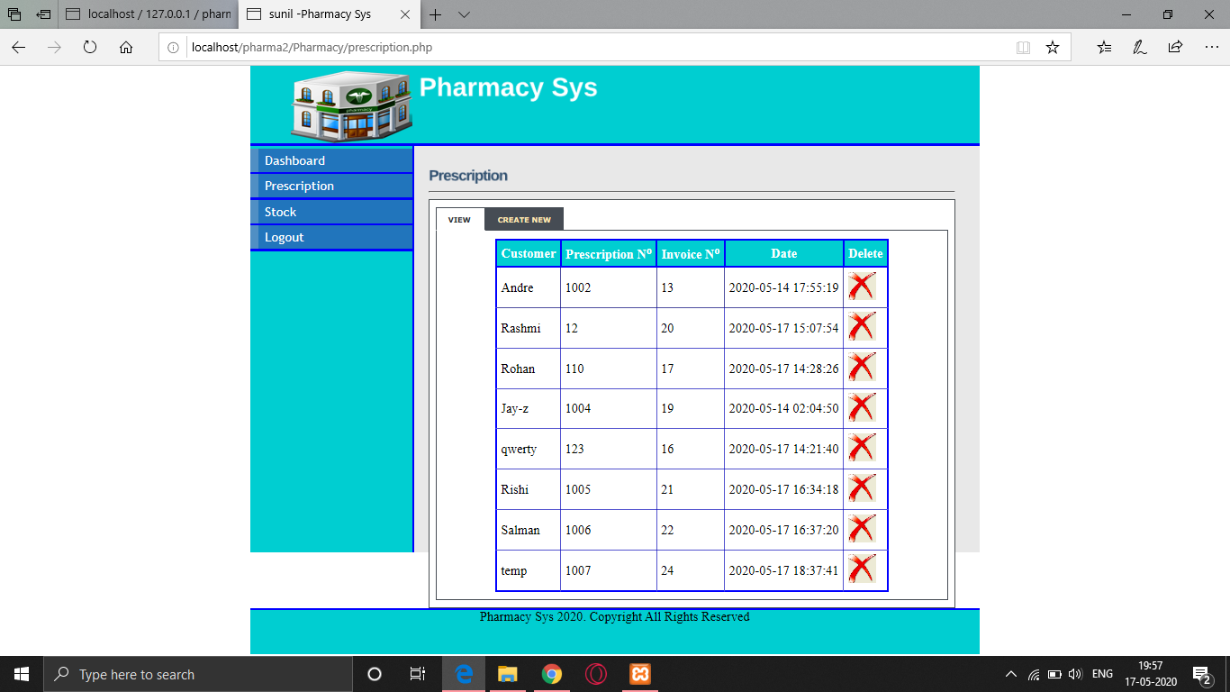

**stock_pharmacist.php**

Here, the pharmacists can delete, view and add the stock of medicine.

While adding, he has to fill the form and then click on the submit button. The stock gets added. Here, also we have used the triggers AFTER INSERT type to get the current date and time after inserting the data. Also, after inserting new stock, we get a new invoice added directly in the database because of foreiegn keys used. Also here, the invoice receipt gets printed and gets saved in receipt/docs/ by the name as its invoice id.

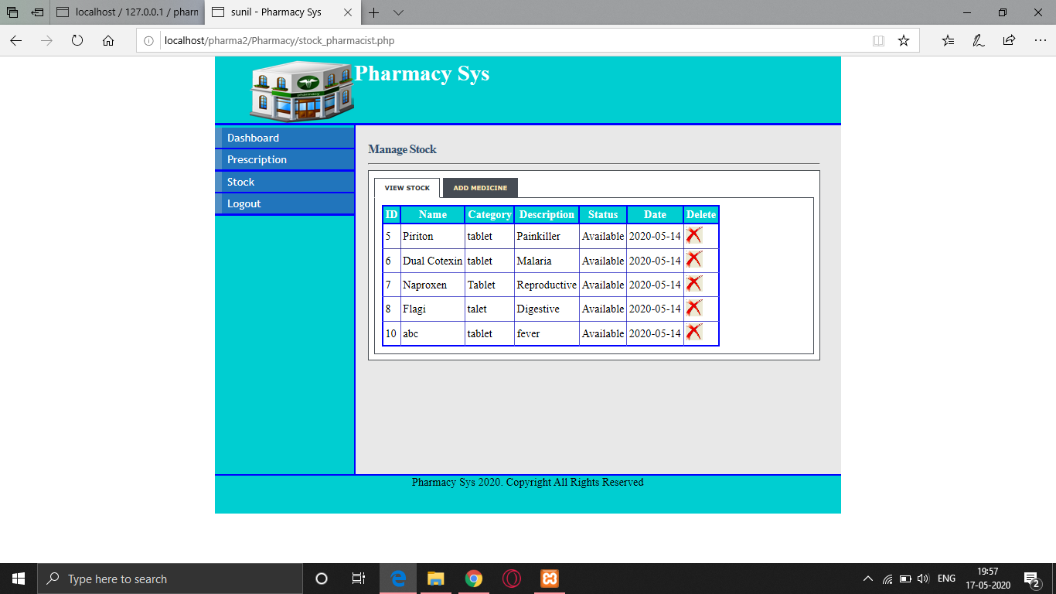

**Manager.php**

1. View Users
2. View Prescription
3. Manage Stocks

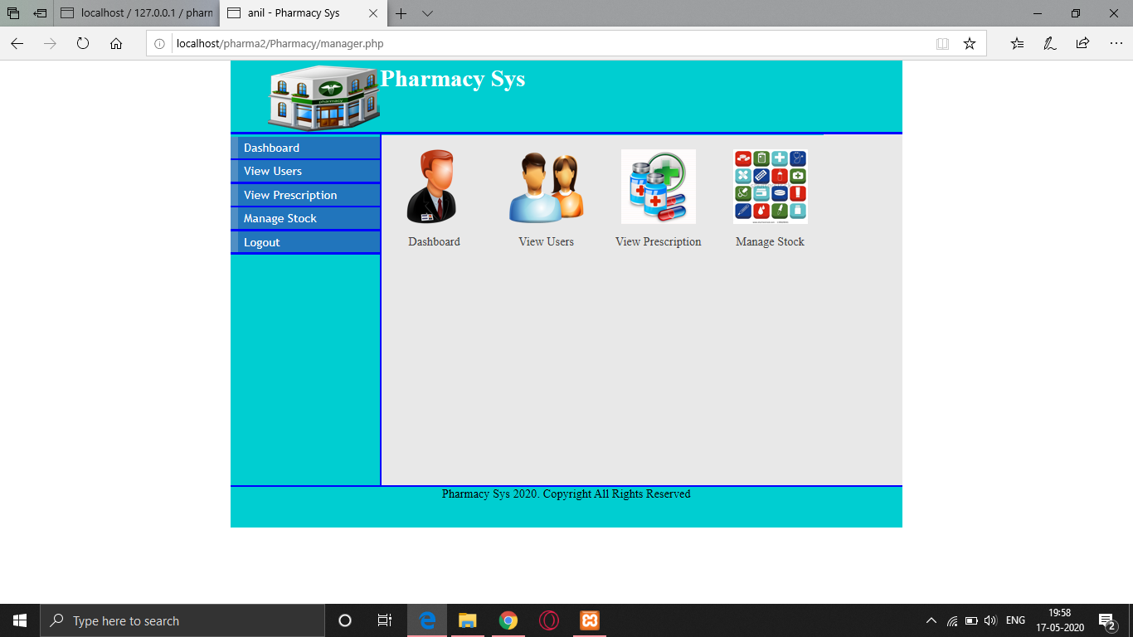

**View.php**

In this, Manager can see all the detailed information of pharmacists, cashiers and managers.

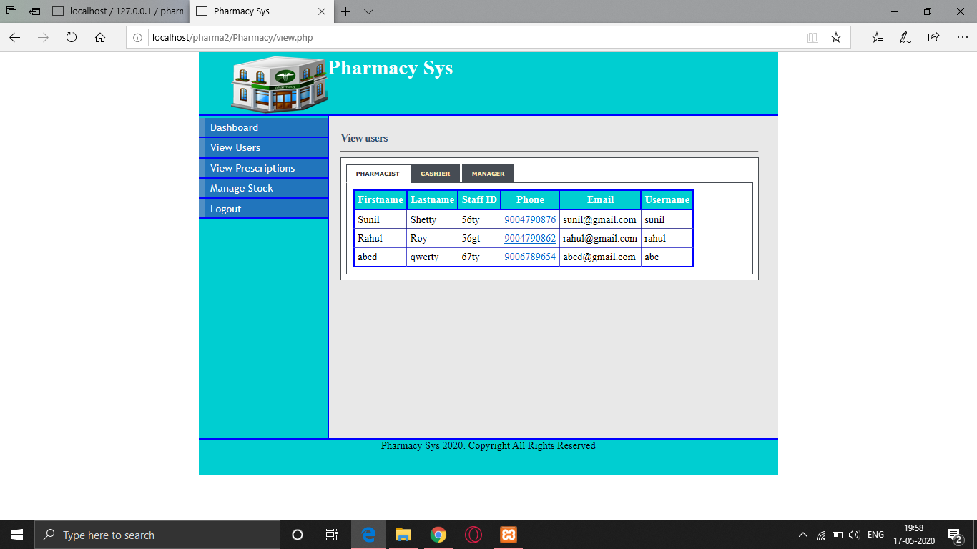

**View_prescription.php**

Here, Manager can view all the prescriptions with the name, it's id, date and time when the particular prescription was given.

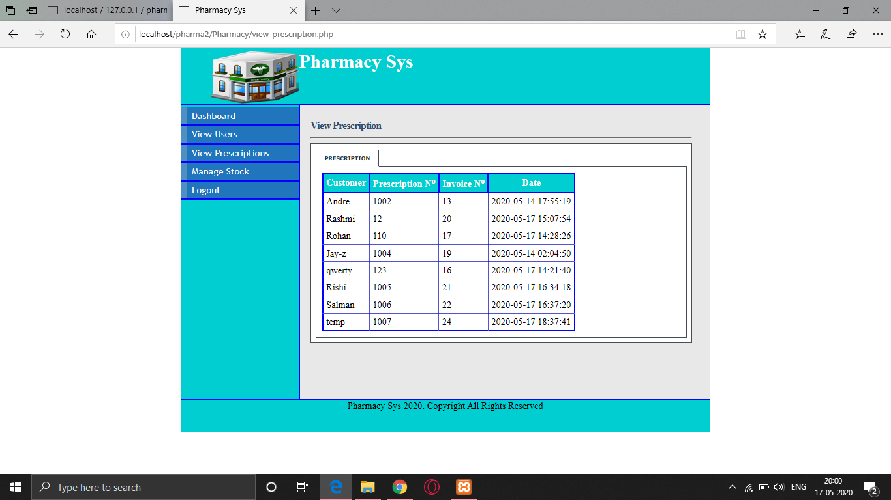

**Stock.php**

The manager can manage stocks. He can delete and add Stocks but can’t update as updates of stocks can only be done by Pharmacists.

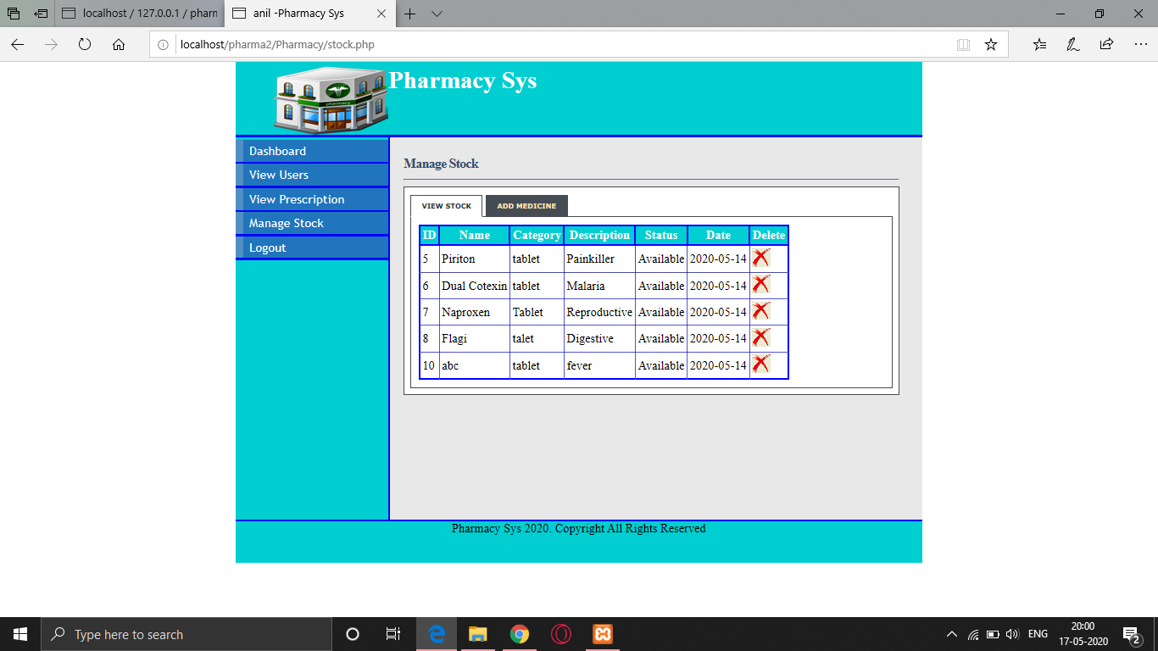

**Cashier.php**

He can only do Payments and generate receipts.

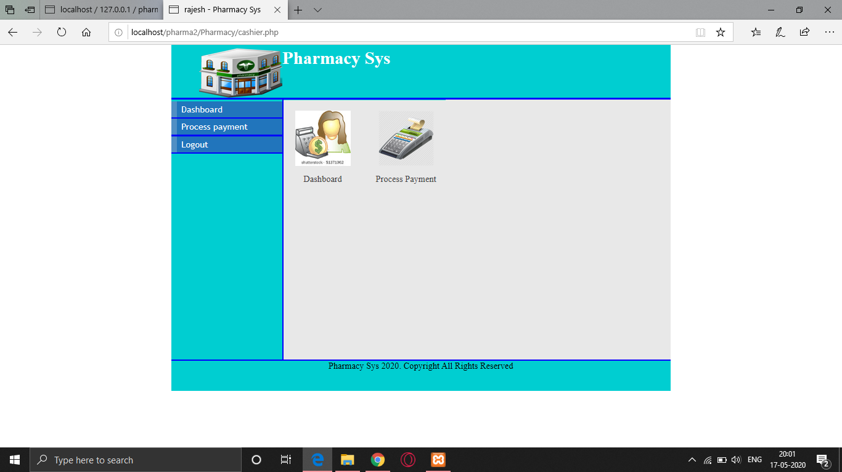

**Payment.php**

First he has to enter the invoice number of the patient. If the payment is remaining, the table gets generated the cashier comes to know the total price to pay of the patient by just giving invoice id. Then after adding all the details and clicking on the submit button, the record gets added to the receipt table in the database. Also the receipt in the form of pdf gets saved in receipt/printouts/ named as customer_name - receipt. Also the trigger is used to get a date on the receipt.

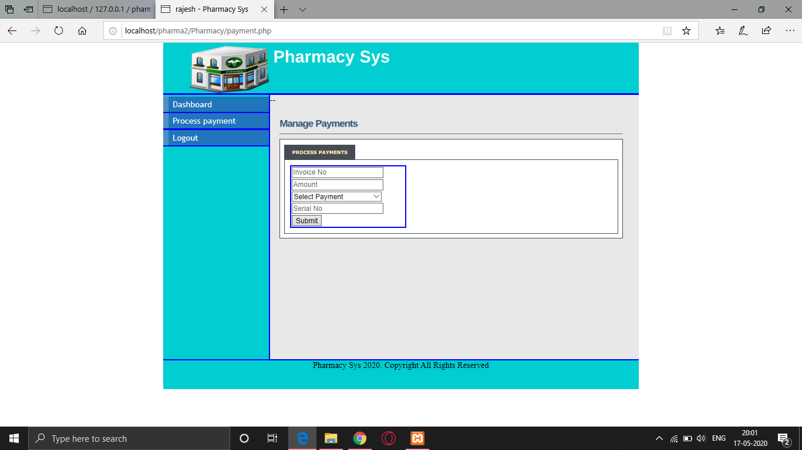

**Pharmacy database**

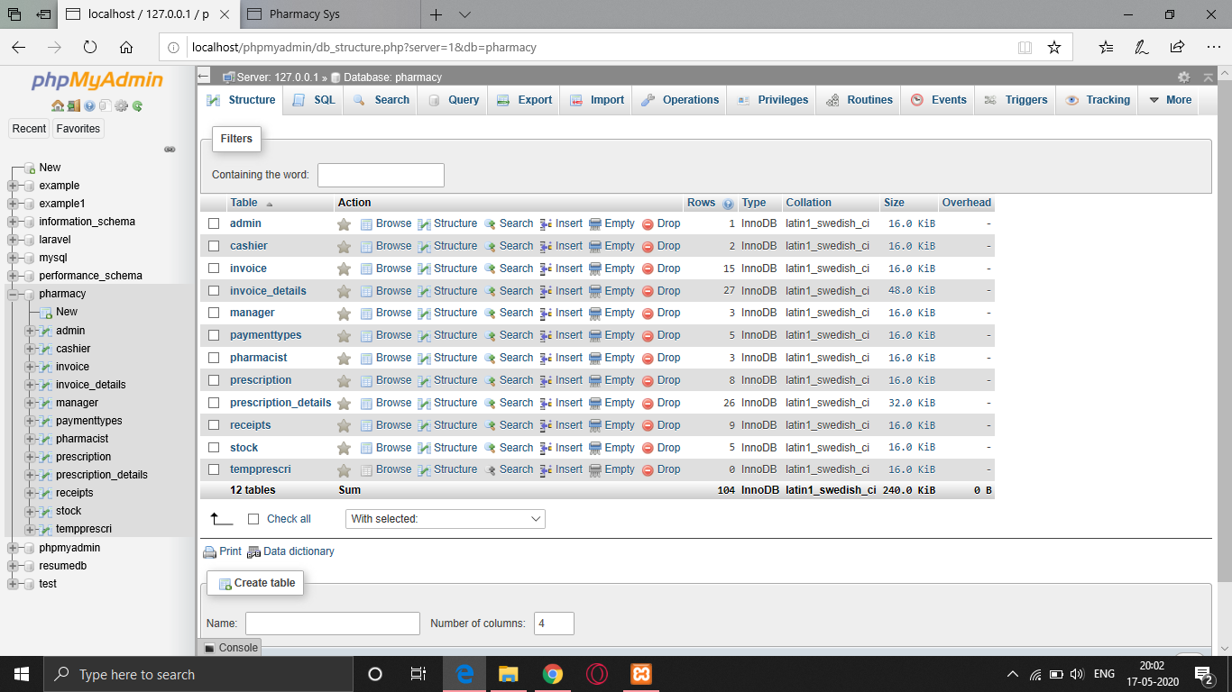

**Invoice.pdf (Pharmacist)**

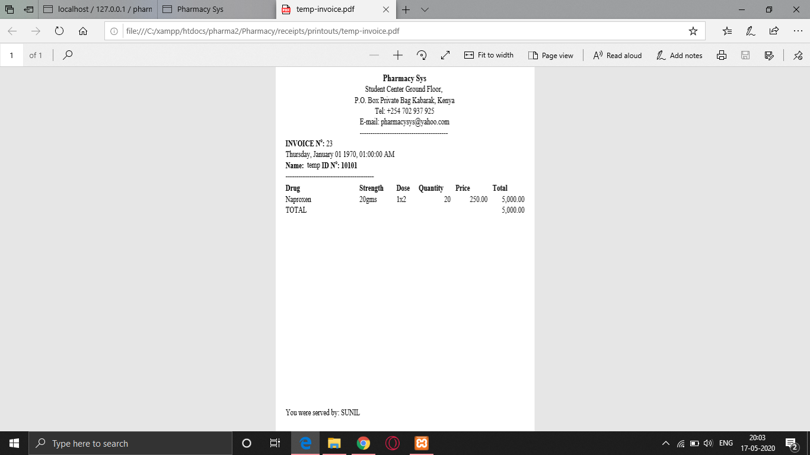

**Receipt.pdf (Cashier)**

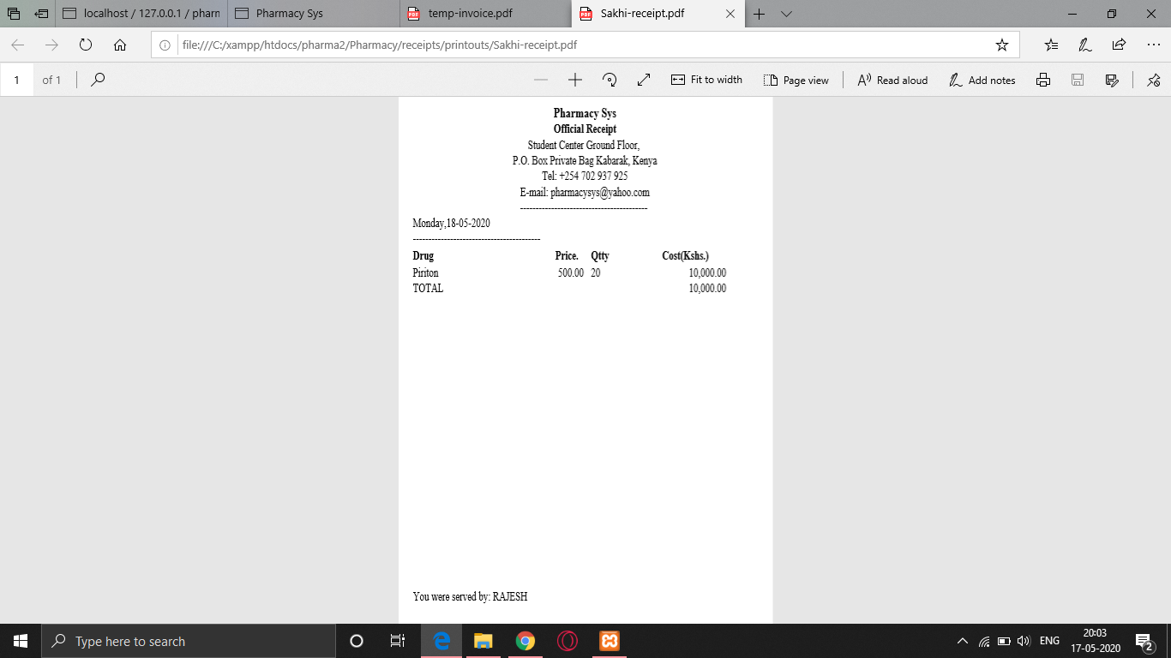

**Video Link:**

https://drive.google.com/file/d/1tls8POcMhjpnueyuqn5L9fN7zRQD_f1u/view?usp=sharing