- What is the type conversion in python,
- 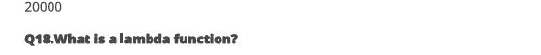
https://github.com/nehakumari131997/Study_pratical_neha/tree/asmita <- link

