**TITLE** - USING DATASET CLASSIFY CAT VS DOG IMAGE .

## **REQUIREMENTS**

* Google colab
* TensorFlow
* Numpy
* Matplotlib

**THEORY-**

Cat vs. Dog Image Classification

we will build a classifier model from scratch that is able to distinguish dogs from cats. We will follow these steps:

1. DATASET
2. GENERATORS
3. NORMALIZE
4. CREATE CNN MODEL
5. TRAINING AND TESTING
6. GRAPHICAL ANALYSIS
7. REDUCE OVERFITTING TECHNIQUES USED
8. IMAGE IMPORTING FOR CLASSIFICATION

**TensorFlow-**It is an open-source machine learninglibrary developed by google. TensorFlow is used to build and train deep learning models as it facilitates the creation of computational graphs and efficient execution on various hardware platforms. The article provides an comprehensive overview of tensorflow.

Generators – It is very useful to process large amount of data. It is used for dataset separate in batches.

Convolutional Neural Network (CNN)-It is an algorithm taking an image as input then assigning weights and biases to all the aspects of an image and thus differentiates one from the other.

Matplotlib -It is a popular data visualization library in Python. It's often used for creating static, interactive, and animated visualizations in Python. Matplotlib allows you to generate plots, histograms, bar charts, scatter plots, etc.

PROGRAM-

!mkdir -p ~/.kaggle

!cp kaggle.json ~/.kaggle/

!kaggle datasets download -d salader/dogs-vs-cats

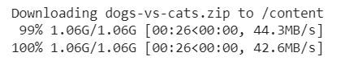

import zipfile

zip_ref = zipfile.ZipFile('/content/dogs-vs-cats.zip', 'r')

zip_ref.extractall('/content')

zip_ref.close()

import tensorflow as tf

from tensorflow import keras

from keras import Sequential

from keras.layers import Dense,Conv2D,MaxPooling2D,Flatten,BatchNormalization,Dropout

# generators

train_ds = keras.utils.image_dataset_from_directory(

    directory = '/content/train',

    labels='inferred',

    label_mode = 'int',

    batch_size=32,

    image_size=(256,256)

)

validation_ds = keras.utils.image_dataset_from_directory(

    directory = '/content/test',

    labels='inferred',

    label_mode = 'int',

    batch_size=32,

    image_size=(256,256)

)

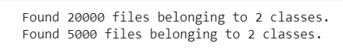

# Normalize

def process(image,label):

    image = tf.cast(image/255. ,tf.float32)

    return image,label

train_ds = train_ds.map(process)

validation_ds = validation_ds.map(process)

# create CNN model

model = Sequential()

model.add(Conv2D(32,kernel_size=(3,3),padding='valid',activation='relu',input_shape=(256,256,3)))

model.add(BatchNormalization())

model.add(MaxPooling2D(pool_size=(2,2),strides=2,padding='valid'))

model.add(Conv2D(64,kernel_size=(3,3),padding='valid',activation='relu'))

model.add(BatchNormalization())

model.add(MaxPooling2D(pool_size=(2,2),strides=2,padding='valid'))

model.add(Conv2D(128,kernel_size=(3,3),padding='valid',activation='relu'))

model.add(BatchNormalization())

model.add(MaxPooling2D(pool_size=(2,2),strides=2,padding='valid'))

model.add(Flatten())

model.add(Dense(128,activation='relu'))

model.add(Dropout(0.1))

model.add(Dense(64,activation='relu'))

model.add(Dropout(0.1))

model.add(Dense(1,activation='sigmoid'))

model.summary()

Model: "sequential_2"

_________________________________________________________________

Layer (type) Output Shape Param #

=================================================================

conv2d_4 (Conv2D) (None, 254, 254, 32) 896

batch_normalization (BatchN (None, 254, 254, 32) 128

ormalization)

max_pooling2d_3 (MaxPooling (None, 127, 127, 32) 0

2D)

conv2d_5 (Conv2D) (None, 125, 125, 64) 18496

batch_normalization_1 (Batc (None, 125, 125, 64) 256

hNormalization)

max_pooling2d_4 (MaxPooling (None, 62, 62, 64) 0

2D)

conv2d_6 (Conv2D) (None, 60, 60, 128) 73856

batch_normalization_2 (BatchNormalization} (None, 60, 60, 128) 512

max_pooling2d_5 (MaxPooling (None, 30, 30, 128) 0

2D)

flatten_1 (Flatten) (None, 115200) 0

dense_3 (Dense) (None, 128) 14745728

dropout (Dropout) (None, 128) 0

dense_4 (Dense) (None, 64) 8256

dropout_1 (Dropout) (None, 64) 0

dense_5 (Dense) (None, 1) 65

=================================================================

Total params: 14,848,193

Trainable params: 14,847,745

Non-trainable params: 448

_________________________________________________________________

model.compile(optimizer='adam',loss='binary_crossentropy',metrics=['accuracy'])

history = model.fit(train_ds,epochs=10,validation_data=validation_ds)

Epoch 1/10

625/625 [==============================] - 71s 112ms/step - loss: 1.2870 - accuracy: 0.6077 - val_loss: 0.6443 - val_accuracy: 0.6386

Epoch 2/10

625/625 [==============================] - 70s 112ms/step - loss: 0.5226 - accuracy: 0.7400 - val_loss: 0.5353 - val_accuracy: 0.7442

Epoch 3/10

625/625 [==============================] - 71s 113ms/step - loss: 0.4516 - accuracy: 0.7917 - val_loss: 0.4704 - val_accuracy: 0.7834

Epoch 4/10

625/625 [==============================] - 70s 111ms/step - loss: 0.3935 - accuracy: 0.8224 - val_loss: 0.7385 - val_accuracy: 0.6624

Epoch 5/10

625/625 [==============================] - 70s 111ms/step - loss: 0.3376 - accuracy: 0.8543 - val_loss: 0.5054 - val_accuracy: 0.7704

Epoch 6/10

625/625 [==============================] - 70s 112ms/step - loss: 0.2517 - accuracy: 0.8946 - val_loss: 0.8225 - val_accuracy: 0.7428

Epoch 7/10

625/625 [==============================] - 70s 112ms/step - loss: 0.1735 - accuracy: 0.9294 - val_loss: 0.5472 - val_accuracy: 0.7982

Epoch 8/10

625/625 [==============================] - 70s 111ms/step - loss: 0.1200 - accuracy: 0.9551 - val_loss: 0.6331 - val_accuracy: 0.8042

Epoch 9/10

625/625 [==============================] - 70s 111ms/step - loss: 0.0917 - accuracy: 0.9671 - val_loss: 0.6862 - val_accuracy: 0.8010

Epoch 10/10

625/625 [==============================] - 70s 111ms/step - loss: 0.0755 - accuracy: 0.9744 - val_loss: 0.7166 - val_accuracy: 0.8080

import matplotlib.pyplot as plt

plt.plot(history.history['accuracy'],color='red',label='train')

plt.plot(history.history['val_accuracy'],color='blue',label='validation')

plt.legend()

plt.show()

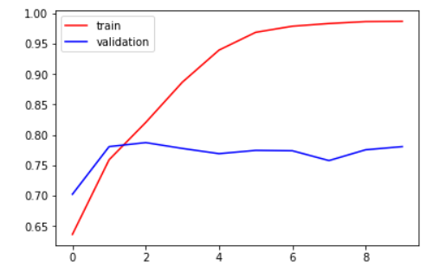

plt.plot(history.history['accuracy'],color='red',label='train')

plt.plot(history.history['val_accuracy'],color='blue',label='validation')

plt.legend()

plt.show()

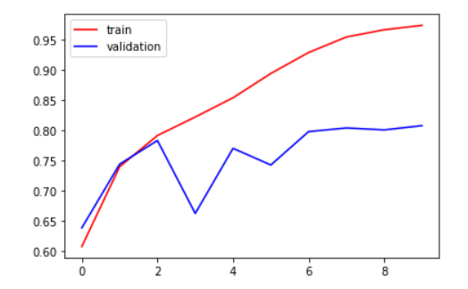

plt.plot(history.history['loss'],color='red',label='train')

plt.plot(history.history['val_loss'],color='blue',label='validation')

plt.legend()

plt.show()

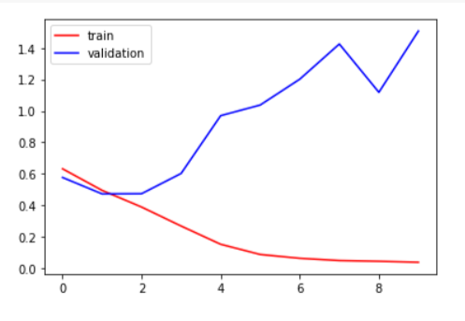

plt.plot(history.history['loss'],color='red',label='train')

plt.plot(history.history['val_loss'],color='blue',label='validation')

plt.legend()

plt.show()

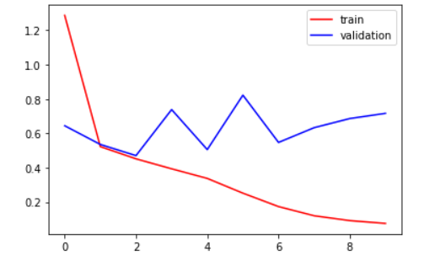

# ways to reduce overfitting

# Add more data

# Data Augmentation -> next video

# L1/L2 Regularizer

# Dropout

# Batch Norm

# Reduce complexity

import cv2

test_img = cv2.imread('/content/cat.jpg')

plt.imshow(test_img)

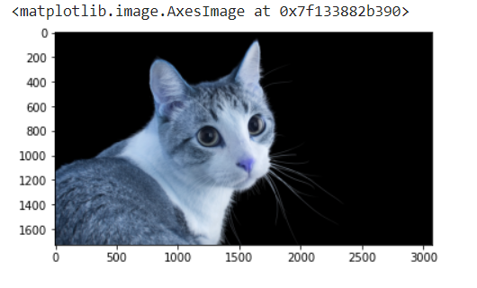

test_img.shape

(1728, 3072, 3)

test_img = cv2.resize(test_img,(256,256))

test_input = test_img.reshape((1,256,256,3))

model.predict(test_input)

array([[0.]], dtype=float32)

# Results

Include any relevant information about the model's performance, accuracy, and evaluation metrics.