Project Report on
“LEGAL CHATBOT USING RAG PIPELINE”
Bachelor of Technology
in
Computer Science and Engineering
Batch
(2022-2026)


Submitted to: Submitted by:
Ms. Mehak Kohli Neha Kumari
(Assistant Professor) (12200008)

Department of Computer Science
D.A.V UNIVERSITY
JALANDHAR - PUNJAB 144012

ACKNOWEDGEMANET

I express my gratitude to all those who helped us in various stages of the development of this project. would like to express my sincere gratitude indebtedness to Dr. Rahul Hans (Head of Computer Science Dept.) of DAV University for allowing me to undergo the summer training of 45 days at Techlive Solution. I am also thankful to all faculty members of Department of Computer Science and Engineering, for their true help, inspiration and for helping me for the preparation of the final report and presentation. Last but not least, I pay my sincere thanks and gratitude to all the Staff Members of DAV University for their support and for making our training valuable and fruitful
CERTIFICATE

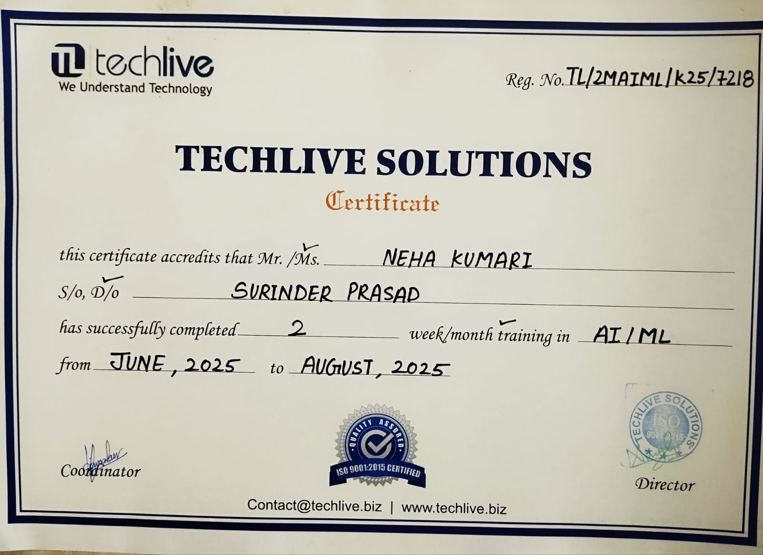
This is to certify that the Legal Chatbot project based on Retrieval-Augmented Generation (RAG), FAISS Vector Database, and DeepSeek R1 Large Language Model has been completed successfully. This project demonstrates offline AI-based legal assistance using document-grounded responses. This is to certify that the Legal Chatbot project based on Retrieval-Augmented Generation (RAG), FAISS Vector Database, and DeepSeek R1 Large Language Model has been completed successfully. This project demonstrates offline AI-based legal assistance using document grounded.

Dr. Rahul Hans
(Head of Computer Science Dept.)

DECLARATION

I, Neha Kumari hereby declare that the work which is being presented in this project titled “Legal Chatbot” by me, in partial fulfilment of the requirements for the award of Bachelor of Technology (B. Tech) Degree in “Computer Science and Engineering” is an authentic record of my own work carried out under the guidance of Mr. Lalit Kumar. To the best of my knowledge, the matter embodied in this report has not been submitted to any other University/ Institute for the award of any degree or diploma.

NEHA KUMARI
(12200008)
INDEX

SERIAL NO. | CONTENT | PAGE NO.
1 | Introduction | 6-7
2 | Problem Statement | 8-9
3 | Objectives | 10-11
4 | Technology Used | 12-16
5 | System Architecture | 17-19
6 | Module & Design | 20-25
7 | Implementation Detail | 26-28
8 | Screenshots | 29-31
9 | Testing | 32-36
10 | Conclusion | 37
11 | Future Scope | 38-39
12 | Bibliography | 40

CHAPTER 01 – INTRODUCTION

The concept of a Legal Chatbot powered by a Retrieval-Augmented Generation (RAG) pipeline represents a significant advancement in the digital transformation of legal information systems. In today’s world, where users frequently encounter difficulty interpreting complex legal terminology and navigating lengthy documents, the need for an intelligent automated system has become increasingly essential. Traditional legal research requires extensive time, effort, and manual reading of acts, regulations, and case laws. This challenge is further amplified for individuals without legal training, as legal language is often dense, technical, and filled with statutory references that are not easily interpreted by common readers. The Legal Chatbot addresses these challenges by offering a simplified, user-centric solution capable of providing accurate, document-grounded responses instantly.
The Legal Chatbot aims to democratize access to legal information. It empowers students, professionals, and citizens by enabling them to query any uploaded legal PDF and retrieve answers based solely on the content of the document. This prevents misinformation and ensures that legal responses remain strictly within the boundaries of the source material provided. This context-restricted method greatly enhances the reliability of responses and helps eliminate hallucinations, a common problem with generic AI models. Using a combination of document retrieval and advanced language modeling, the chatbot minimizes the risk of incorrect interpretations.
The backbone of this system is the RAG architecture, which divides the problem into two major components: retrieval and generation. The retrieval component identifies and extracts the most relevant chunks from uploaded documents using FAISS vector similarity search. FAISS, developed by Facebook AI Research, is optimized for large-scale similarity matching, ensuring fast search times even across thousands of document chunks. The generation component utilizes the DeepSeek R1 model, a powerful open-source language model capable of generating contextually accurate legal responses. When combined, these two components allow the chatbot to function as a powerful research assistant that synthesizes information directly from statutes, regulations, case studies, and policy guidelines.
The importance of embedding models such as Nomic Embed Text cannot be overstated. Embeddings represent the semantic meaning of text in numerical form. Without embeddings, the system would not be able to differentiate between legal concepts such as “contract termination,” “consumer rights,” “criminal liability,” or “data protection.” The embedding process ensures that the system captures contextual meaning rather than relying on keyword matches alone. For example, phrases like “end of contractual obligations” and “termination of agreement” may differ in wording but are semantically similar. An effective embedding model can detect these similarities and ensure the user receives the correct legal passage.
Another critical aspect of the chatbot is the preprocessing pipeline. PDF documents, especially scanned legal files, often contain line breaks, irregular spacing, tables, and header/footer noise. The preprocessing step cleans and restructures the content before it is passed to the text-splitting module. The Recursive Character Text Splitter divides the document into manageable chunks while preserving text continuity and meaning. This ensures that every chunk remains contextually rich and coherent when the retrieval system searches for relevant information.
The Streamlit interface provides an accessible, user-friendly platform for interacting with the chatbot. Streamlit allows real-time updates, dynamic message rendering, and instant display of retrieved chunks. Its simplicity ensures that users with minimal technical knowledge can upload legal PDFs, process them, ask questions, and receive answers in a structured, easy-to-read format. The interface highlights retrieved document sections, allowing users to verify the source of each answer. This transparency increases user trust and supports academic and professional validation.
As artificial intelligence continues to evolve, systems like this Legal Chatbot will become essential components of digital society. Their ability to bridge the gap between complex legal information and user comprehension represents a transformative step toward accessible justice, informed citizenship, and transparent governance. This project stands as a strong example of how technology can be responsibly used to empower individuals and organizations while maintaining accuracy, reliability, and ethical standards.

CHAPTER 02 – PROBLEM STATEMENT

The legal domain is filled with dense, complex, and lengthy documents that are often difficult for students, professionals, and common citizens to interpret. Acts, regulations, policies, and legal judgments typically span hundreds of pages and contain technical terminology that requires time, attention, and expertise to understand. Traditional legal research involves manually scanning PDF documents line-by-line, which is slow, inefficient, and prone to human error. Many individuals struggle to locate specific clauses, legal definitions, or relevant sections within these documents, resulting in delays and misunderstandings. Moreover, existing online legal search tools are either paid, non-interactive, or rely heavily on keyword matching, which often leads to incomplete or irrelevant results.
Another significant problem is the increasing demand for instant and accurate legal information in academic, professional, and real-life scenarios. Students preparing for exams, lawyers handling case briefs, and even citizens seeking clarity on laws such as the Digital Personal Data Protection Act (DPDP), RTI Act, or criminal procedures often lack tools that can provide quick, context-based answers. This gap becomes even more serious in rural areas or restricted environments where internet connectivity is limited, making it difficult to access cloud-based legal search platforms.
A major challenge with modern AI chatbots is hallucination—AI models sometimes generate answers that sound correct but are not actually present in the document. In the legal sector, such inaccuracies can result in serious misunderstandings. There is a need for a system that strictly answers only from the provided document and avoids generating false or unrelated information.
Hence, there is a strong need for an intelligent, offline, secure, and document-grounded solution that can read legal PDFs, break them into meaningful parts, understand user queries, retrieve the most relevant sections, and generate accurate answers based only on the content of that document. The Legal Chatbot using a Retrieval-Augmented Generation (RAG) pipeline solves this problem by combining PDF processing, FAISS vector search, and a local LLM (DeepSeek R1) to provide reliable, context-aware responses without internet dependency. This project aims to bridge the gap between complex legal documentation and simple user understanding by offering a fast, accessible, and privacy-preserving legal assistance tool.
Another major problem is accessibility. Many legal information portals require continuous internet connectivity and often display results in a complex format. For students preparing for exams, advocates handling case briefs, and individuals seeking clarity on laws, there is no simple tool that allows them to upload a legal PDF and instantly receive context-aware answers. Additionally, in several regions with limited internet access, cloud-based legal research tools are not usable, creating a barrier for users who require offline access.
Retrieving relevant legal text is itself a technical challenge. Traditional keyword search methods fail when the required information is phrased differently or scattered across chapters. There is a need for a system that understands semantic meaning, not just exact keywords. Furthermore, legal queries vary widely—from definitions and procedures to rights, responsibilities, exemptions, and penalties—making it difficult for non-technical users to navigate and interpret documents.
To address these issues, there is a strong requirement for an intelligent, interactive, and easy-to-use legal assistant that can read and understand uploaded legal documents, identify the most relevant sections, and provide accurate, context-based answers without relying on the internet. Such a system must minimize hallucination, preserve privacy, and ensure that every response directly corresponds to the content of the legal PDF. Combining document retrieval, vector similarity search, and local language model reasoning, the Legal Chatbot using RAG pipeline aims to bridge the gap between complex legal documentation and simple user understanding.
This project specifically focuses on solving the real-world problem of accessibility, accuracy, and efficiency in legal information retrieval. By allowing users to upload any legal PDF and ask natural language questions, the system helps eliminate the challenges associated with reading and interpreting legal texts manually. It provides a fast, reliable, and user-friendly solution that can benefit students, legal practitioners, government employees, and the general public.

CHAPTER 03 - OBJECTIVES

• To develop an AI-based legal assistant that can answer user queries directly from legal documents without manual searching.
• To implement Retrieval-Augmented Generation (RAG) so the system combines document retrieval and AI reasoning for accurate responses.
• To ensure all responses are document-grounded and prevent hallucinations by restricting the model to the uploaded PDF content only.
• To use FAISS for efficient semantic search that retrieves the most relevant text chunks based on meaning rather than keywords.
• To automate legal document processing through PDF text extraction and chunking for structured retrieval.
• To enable complete offline functionality using Ollama and local LLMs to ensure privacy and accessibility.
• To provide a simple, clean, and interactive user interface using Streamlit for uploading documents and asking questions easily.
• To support students, legal professionals, and general public by simplifying access to legal information.
• To design the system in modular form for easy scalability, updates, and integration of future enhancements.
• To reduce the time and effort needed to search legal information by automating retrieval from long and complex legal PDFs.
• To ensure transparency in AI-generated answers by displaying the retrieved passages used for generating responses, helping users verify authenticity.
• To enhance the accuracy of legal interpretation by grounding every answer strictly in the uploaded document rather than relying on general AI knowledge.
• To improve user understanding of legal terminology by providing clear, concise, and context-based explanations for complex clauses and definitions.
• To minimize human dependency in legal document analysis by providing an automated tool that can independently extract and interpret relevant sections.
• To support legal education and training by helping students practice question-based learning with real legal documents.
• To build a privacy-preserving legal assistant that runs completely offline using local LLMs, ensuring no data is shared with external servers.
• To create a scalable system architecture that can later be extended with summarization, multi-document search, or legal citation mapping.
• To allow non-technical users to interact with legal data through a simple question-answer interface without needing expertise in law or AI.
• To promote fairness and accessibility by providing an open tool that can help people understand their rights, duties, and legal processes.
• To facilitate rapid legal research for professionals by enabling them to instantly find relevant statutes, rules, and sections without reading entire documents.
• To enable semantic understanding of legal content so the system retrieves meaning-based results rather than relying on exact keyword matches.
• To design an extensible RAG pipeline that can incorporate different embedding models, vector stores, or LLMs as technology advances.
• To create a modular application structure so each component (PDF extraction, embeddings, retrieval, LLM) can be updated or improved independently.

CHAPTER 04 – TECHNOLOGIES USED

The development of the Legal Chatbot using RAG Pipeline incorporates a variety of modern technologies, each contributing to a specific phase of the system. The architecture combines text extraction, preprocessing, semantic embeddings, vector indexing, context retrieval, and local language model reasoning into one integrated workflow. The following section provides a comprehensive explanation of each technology and describes exactly how it is used in the implementation of the system.

4.1. Python (Primary Programming Language)
Python is the core language used in this project due to its readability, extensive library support, and rapid development capabilities.
How Python is used in this project:
- Backend Logic — Every module (PDF extraction, chunking, embedding, vector retrieval, answer generation) is implemented using Python scripts.
- Integration of AI Models — Python interfaces with the LangChain framework and Ollama runtime to execute embedding models and the DeepSeek R1 LLM.
- Data Handling — Python manages input/output operations, file handling, data structures, and logical flow.
- Running the RAG Pipeline — All retrieval and generation logic is orchestrated in Python functions.
Python forms the foundation of the project and connects all other technologies into a stable system.

4.2. Streamlit (Interactive Web Interface)
Streamlit is an open-source Python framework used for building simple, interactive applications without front-end coding.
How Streamlit is used in the project:
- Displays the file upload interface for legal PDFs.
- Provides a text area where users type their legal questions.
- Shows spinner animations during document processing and answer generation.
- Displays the final answer generated by the RAG pipeline in a clean, visually appealing format.
- Shows the retrieved legal passages for transparency.
Streamlit transforms the backend Python code into a user-friendly web application accessible to everyone.

4.3. PDFPlumber (Legal Document Text Extraction)
Legal PDFs often contain complex layouts, section numbers, multi-column formats, and indentation not captured by simple PDF extractors. PDFPlumber is chosen because of its accuracy and ability to extract structured text.
Role of PDFPlumber in the project:
- Reads the full content of an uploaded legal PDF.
- Extracts text while preserving numeric clauses, subsections, and formatting.
- Converts the PDF into raw text needed for further NLP processing.
Without accurate extraction, the entire RAG pipeline would fail, making PDFPlumber essential.

4.4. LangChain (RAG Pipeline Management & NLP Framework)
LangChain is a powerful framework designed for building applications that integrate multiple LLM and retrieval components.
How LangChain is used in the project:
- Manages text splitting, embeddings, vector storage, retrieval, and prompting.
- Connects the DeepSeek R1 model to the embedding retriever.
- Structures the workflow so that the retrieved context is properly formatted before being sent to the LLM.
- Ensures modular design, enabling easy upgrades of models or components.
LangChain is the engine powering the logic of your chatbot.

4.5. Recursive Character Text Splitter (Document Chunking Library)
Legal documents cannot be embedded or retrieved in one piece due to their size.
This tool divides large text into manageable chunks.
How chunking is used:
- Splits the document into pieces of 800–1000 characters with overlaps for context continuity.
- Prevents the loss of meaning when sections are separated.
- Ensures the retriever can identify relevant segments for a query.
Chunking is critical for the accuracy of the retrieval process.

4.6. Nomic-Embed-Text (Semantic Embedding Model)
Embeddings transform text from natural language to mathematical representations.
How embeddings are used:
- Convert each chunk into a high-dimensional vector.
- Convert user questions into vectors.
- Enable semantic search, so the system understands meaning instead of literals.
- Match queries like “What is the penalty?” with related legal clauses even if the wording differs.
Embeddings give the chatbot its ability to “understand” legal language.

4.7. FAISS (Facebook AI Similarity Search) — Vector Database
FAISS is a high-performance vector store used to index and retrieve embeddings efficiently.
FAISS usage in the project:
- Stores embeddings of all text chunks.
- Performs high-speed similarity search to find relevant passages.
- Supports local persistent storage so the index can be reused.
- Makes retrieval extremely fast even for long documents (50–200 pages).
Semantic search powered by FAISS ensures precise retrieval from legal PDFs.

4.8. DeepSeek R1 Model (Local Large Language Model)
DeepSeek R1 is the LLM responsible for generating the final answer after retrieval.
How DeepSeek R1 is used:
- Receives retrieved legal text and the user query.
- Generates a context-aware, factual response.
- Strictly follows the instruction to answer only from the given legal document.
- Works fully offline, protecting user data.
DeepSeek R1 is the “brain” of the chatbot.

4.9. Ollama (Local AI Model Hosting Environment)
Ollama enables running embedding models and LLMs on the user's device without cloud services.
How Ollama is used:
- Hosts Nomic-Embed-Text and DeepSeek R1 models locally.
- Handles fast inference and caching.
- Removes dependency on internet-based APIs.
- Ensures privacy of uploaded legal documents.
Ollama is the backbone of the offline functionality of the system.

4.10. FAISS Local Storage Directory (Vector Index Persistence)
The vector index is stored permanently so the system doesn’t need to recreate embeddings every time.
How this directory is used:
- Stores the FAISS database in a “vectorstore/db” folder.
- Enables reloading previously indexed documents.
- Saves time and computational resources.
This improves performance and usability.

4.11. Python Libraries Used
Several additional Python libraries play supporting roles:
os Library
Used for file handling, directory creation, and saving uploaded PDFs.
Streamlit Session State
Used to store the FAISS database in memory between interactions.
LangChain Ollama Integration
Helps interface DeepSeek R1 and embedding models with Python scripts.
Typing & Data Classes (internally)
Provide structure and type safety.

Overall Technology Workflow
- User uploads a legal PDF.
- PDFPlumber extracts text.
- Text is split into chunks.
- Embeddings are generated through Nomic Embed via Ollama.
- FAISS indexes these embeddings.
- User enters a question.
- Query embedding is matched against FAISS database.
- Top-k relevant chunks are retrieved.
- DeepSeek R1 generates the final grounded answer.
- Streamlit displays answer + supporting passages.

CHAPTER 05 – SYSTEM ARCHITECTURE

The system architecture of the Legal Chatbot using a Retrieval-Augmented Generation (RAG) pipeline is designed to provide fast, accurate, and document-grounded legal responses. It integrates multiple components—PDF processing, text chunking, embedding generation, vector similarity search, and language model reasoning—to form a complete end-to-end AI-driven legal assistant. The architecture ensures modularity, scalability, offline functionality, and efficient retrieval performance, making the system suitable for academic, professional, and real-world legal applications.
The architecture begins with the PDF Upload Module, where the user uploads any legal document such as acts, policies, guidelines, or case summaries. The uploaded file is processed using PDFPlumber, which extracts clean and structured text from the PDF. This text is then passed to the Text Splitting Module, which uses the Recursive Character Text Splitter to convert long legal documents into smaller, meaningful chunks. Chunking helps preserve context and ensures that each segment is semantically rich enough for retrieval.
Once the document is chunked, the content enters the Embedding Generation Layer. Here, the Nomic-Embed-Text model (executed locally via Ollama) converts each text chunk into a numerical vector. These embeddings capture the hidden semantic meaning of sentences, enabling the system to understand legal concepts such as “liability,” “contract termination,” or “privacy rights” instead of relying on simple keyword searches.
These embeddings are stored in the FAISS Vector Database, which acts as the primary retrieval engine. FAISS indexes the embeddings and enables high-speed similarity search. When a user asks a question, the system converts the query into an embedding vector and retrieves the closest matching chunks using FAISS. This retrieval ensures that only relevant legal information from the uploaded PDF is selected.
The retrieved legal chunks are then passed to the LLM Reasoning Module, powered by the DeepSeek R1 model running locally via Ollama. This model reads the retrieved text and generates a clear, context-accurate response. Importantly, the chatbot is instructed to answer only based on the retrieved legal content, preventing hallucinations and ensuring document-grounded accuracy.
The final output is displayed through the Streamlit User Interface, which allows users to upload documents, ask questions, view generated answers, and inspect retrieved legal sections for transparency. Streamlit also manages user interaction events and orchestrates the communication between the UI and backend modules.
Overall, the system architecture forms a tightly integrated pipeline where each layer—PDF extraction, chunking, embedding, vector search, and language generation—works together to deliver an efficient offline legal chatbot. This architecture not only enhances performance but also ensures privacy, reliability, and real-time accessibility for legal research and academic use.

The system architecture of the Legal Chatbot is designed using a modular and layered approach to ensure efficient document processing, fast semantic retrieval, and accurate response generation. The architecture integrates Retrieval-Augmented Generation (RAG), FAISS vector storage, and the DeepSeek language model via Ollama. This allows the chatbot to operate locally, maintain data privacy, and provide legally grounded answers based entirely on the user-uploaded documents. The architectural design ensures scalability, modularity, and ease of future enhancements such as multilingual support or multi-document analysis.
At the highest level, the architecture consists of four core layers: the User Interface Layer, the Processing Layer, the Retrieval Layer, and the Generation Layer. The User Interface Layer provides a simple and interactive front end where users can upload PDF documents, enter legal queries, and view responses. This layer is developed using Streamlit, which makes the interface responsive and easy to interact with while maintaining a minimalistic legal-themed design.
The Processing Layer handles PDF ingestion, text extraction, and chunking. Uploaded legal PDFs are first saved locally and passed to a PDF extraction module that uses PDFPlumber to extract structured text. The text is then cleaned and split into smaller overlapping chunks using LangChain’s Recursive Text Splitter. This chunking process ensures that content is manageable and preserves context continuity for better embedding and retrieval accuracy.
The Retrieval Layer comprises the Embedding Generator and the FAISS Vector Database. Each text chunk from the processing layer is converted into a semantic embedding vector using a local embedding model running through Ollama. These embeddings are stored in FAISS, which supports efficient similarity search across thousands of chunks. When a user asks a question, the query is embedded using the same model and matched against the stored embeddings to retrieve the most relevant document sections. This ensures that the final response is grounded in the actual legal text provided by the user.
The Generation Layer includes the RAG Prompt Builder and the DeepSeek LLM. Retrieved chunks are merged into a coherent context and passed along with the user's query to a well-structured RAG prompt template. This template instructs the LLM to answer strictly based on the provided context, thereby minimizing hallucinations. The DeepSeek model, running locally via Ollama, processes the query-context pair and produces a legally relevant, accurate, and natural-language answer.
Finally, the architecture includes cross-cutting support components such as Error Handling, Logging, and Data Validation. Error handling ensures that issues such as corrupted PDFs, missing vector indexes, or incorrect file formats do not disrupt the system. Logging is used during development for debugging and monitoring the flow between modules. Data validation ensures that inputs from the user are safe, properly formatted, and meaningful.

Together, these components form a robust architecture enabling the chatbot to efficiently perform document analysis, semantic retrieval, and legally grounded question answering. The modularity of the architecture allows future improvements such as multi-PDF support, multilingual capabilities, real-time legal updates, and deployment as a mobile or cloud application.

CHAPTER 06 – MODULE DESIGN

The Legal Chatbot system is designed using a modular architecture to ensure clarity, scalability, and maintainability. Each module handles a specific part of the RAG pipeline, from PDF processing to response generation. The modular design allows each component to be developed, tested, and improved independently while keeping the overall system highly flexible. Below is the detailed description of each module.
6.1. PDF Upload & File Handling Module
Purpose:
To allow users to upload legal documents in PDF format and store them securely for processing.
Functionality:
- Accepts PDF uploads through the Streamlit interface.
- Validates file type and ensures it is a supported format.
- Stores the uploaded file into a predefined directory (e.g., /pdfs/).
- Handles exceptions such as corrupted or unreadable documents.
Importance in this project:
This module acts as the entry point for the entire chatbot workflow. Without proper file upload and validation, downstream modules cannot extract or analyze the document content.

6.2. PDF Text Extraction Module
Purpose:
To extract clean, structured text from the uploaded legal PDF.
Tools Used:
- pdfplumber for extracting text that preserves paragraphs and formatting
- Optional fallback extraction using PyPDF2 if needed
Functionality:
- Reads page-by-page text.
- Cleans unnecessary spaces, broken lines, headers, and footers.
- Outputs the extracted text in a consistent, readable format.
Importance:
Accurate text extraction is critical because the chatbot’s answers depend entirely on the text retrieved from the document. Any extraction errors would directly affect answer quality.

6.3. Text Chunking Module
Purpose:
To split the extracted document text into smaller, meaningful chunks suitable for embedding.
Tools Used:
- LangChain’s RecursiveCharacterTextSplitter
Functionality:
- Splits the text into chunks (e.g., 800–1200 characters)
- Adds 10–20% overlap between chunks
- Maintains logical boundaries so that sentences/paragraphs are not abruptly cut
- Stores chunks with metadata (page number, position, etc.)
Importance:
LLMs perform best when given smaller context pieces rather than extremely long paragraphs. Chunking ensures:
- Higher retrieval accuracy
- Better contextual understanding
- Faster embedding and searching

6.4. Embedding Generation Module
Purpose:
To convert each text chunk into numerical vectors (embeddings) that capture meaning and semantic relationships.

Tools Used:
- Local embedding model via Ollama (e.g., Nomic Embed, LLaMA embeddings)
Functionality:
- Takes each chunk of text
- Generates a high-dimensional vector representation
- Ensures embeddings are consistent across queries and documents
- Stores embeddings temporarily before insertion into FAISS
Importance:
Embeddings form the core of semantic search. Better embeddings → better retrieval → better answers.

6.5. Vector Database (FAISS) Module
Purpose:
To store embeddings efficiently and allow fast similarity-based retrieval when a user submits a query.
Tools Used:
- FAISS (Facebook AI Similarity Search) Vector Store
Functionality:
- Saves all embeddings into an index file (e.g., index.faiss)
- Supports similarity search using cosine similarity or L2 distance
- Maps each embedding back to the original text chunk
- Reloads stored FAISS index during future application runs
Importance:
FAISS enables extremely fast search even across thousands of chunks. It ensures the chatbot retrieves the most relevant parts of the legal document.

6.6. Query Embedding & Retrieval Module
Purpose:
To convert user queries into embeddings and retrieve the most relevant chunks from FAISS.
Functionality:
- Embeds the user query using the same embedding model
- Searches for the top-k most similar text chunks
- Compiles retrieved context into a structured format
- Sends the retrieved text to the generation module
Importance:
This module determines what information the chatbot uses to answer user questions. Correct retrieval ensures legally accurate, grounded answers.

6.7. RAG Prompt Construction Module
Purpose:
To create a structured prompt combining:
- User’s question
- Retrieved PDF context
- Instructions to the LLM
Functionality:
- Creates a well-formatted prompt template
- Ensures the LLM answers only using the retrieved context
- Avoids hallucinations by instructing the model clearly
- Sends prompt to DeepSeek via Ollama for final generation
Importance:
A well-designed prompt ensures:
- Accuracy
- Legal correctness
- Clarity and structure in responses

6.8. LLM Response Generation Module
Purpose:
To generate the final answer based on the combined question and context.
Tools Used:
- DeepSeek R1 / DeepSeek LLM via Ollama
Functionality:
- Processes prompt
- Generates sentence-level reasoning
- Ensures legally relevant output
- Removes hallucinations by relying strictly on context
- Formats output for display in UI
Importance:
This is the “brain” of the chatbot. High-quality LLM generation ensures professional, clear legal responses.

6.9. User Interface (UI/UX) Module
Purpose:
To provide a smooth and intuitive user interface for interacting with the legal assistant.
Tools Used:
- Streamlit
Functionality:
- PDF upload button
- Query text area
- Response display box
- Error messages and validation
- Background image, theme, and styling
- A containerized layout for readability
Importance:
The UI determines user experience, making the system accessible even to users with no technical knowledge.

6.10. Error Handling & Logging Module
Purpose:
To catch system errors and provide meaningful feedback for debugging and user understanding.
Functionality:
- Handles corrupted PDF uploads
- Detects FAISS index failures
- Manages missing embeddings or file paths
- Logs system activity for debugging
Importance:
Stability and reliability are crucial for legal applications. This module ensures smooth operation even when errors occur.

CHAPTER 07 – IMPLEMENTATION DETAILS

The implementation of the Legal Chatbot using a Retrieval-Augmented Generation (RAG) pipeline involves the integration of several interconnected components, each designed to perform a specific function in the system. The project is implemented using Python as the primary programming language, with Streamlit serving as the web-based user interface. The entire system is developed to work offline through the use of locally hosted language models and embedding generators, ensuring user privacy and secure handling of legal documents.
The implementation starts with the Streamlit frontend, which provides an intuitive interface allowing users to upload legal PDF documents and submit queries. When a PDF is uploaded, the system automatically saves it to the designated directory and triggers the backend pipeline. Streamlit handles all user interactions, including file uploads, button clicks, and display of results, making the application accessible even to non-technical users.
Next, the PDF is passed to the PDF Extraction Module, where PDFPlumber extracts clean text from the document. This step ensures that the system accurately captures paragraphs, sections, and legal clauses from the uploaded PDF. The extracted text is then forwarded to the Text Splitting Module, which uses LangChain’s Recursive Character Text Splitter to break the document into smaller, meaningful chunks. This chunking process is critical for improving retrieval accuracy during the later stages of the pipeline.
After chunking, the system generates embeddings for each text chunk using Nomic-Embed-Text, a fast and efficient embedding model executed via Ollama. The embeddings convert text into numerical vectors that capture semantic meaning. These vectors are stored in a FAISS vector database, allowing efficient similarity search. FAISS also enables persistent storage, meaning the vector database can be reused without reprocessing the PDF each time.
When a user submits a question, the query is embedded using the same embedding model and passed to the Retrieval Module, which uses FAISS to retrieve the top relevant chunks from the vector database. These retrieved chunks represent the most meaningful parts of the legal document related to the query. The retrieved text and the user’s question are then sent to the Answer Generation Module, powered by the DeepSeek R1 model running locally through Ollama.
The language model reads the retrieved passages and generates a well-structured, accurate, and legally grounded answer. Importantly, the model is instructed to answer strictly from the retrieved content, preventing hallucinations. Finally, Streamlit displays the generated answer on the screen along with the retrieved chunks, offering transparency and helping users verify the source of information.
This modular and efficient implementation ensures that the Legal Chatbot is fast, reliable, and suitable for academic, professional, and real-world legal use cases. The integration of RAG architecture with local LLMs provides a powerful yet secure solution for accessing and understanding legal documents.

The implementation of the Legal Chatbot using RAG (Retrieval-Augmented Generation), FAISS vector database, and the DeepSeek model via Ollama involved several structured phases. Each phase was designed to ensure accurate document processing, efficient retrieval, and context-grounded answer generation. The system operates locally, ensuring privacy and eliminating dependency on cloud APIs. The entire implementation has been modularized into separate components for better maintenance, clarity, and scalability.
The first stage of implementation focused on the PDF processing module. Users upload a legal PDF using the Streamlit interface. The application saves the file locally and uses PDFPlumber to extract raw text from the uploaded document. This step ensures proper handling of complex legal PDFs containing multiple sections, paragraphs, and structured formatting. Once extracted, the text is passed to a text chunking module, which uses LangChain’s RecursiveCharacterTextSplitter. This algorithm breaks the long text into manageable chunks of around 1000 characters with overlap. Chunking is essential because large language models perform best when provided with small, meaningful text portions rather than extremely long documents. Overlapping ensures that important context between paragraphs is not lost.
The next step involved generating embeddings for each chunk. Embeddings are numerical vector representations of text that capture meaning and context. For this system, a local embedding model is used through Ollama, ensuring that data stays offline and private. These embeddings are then stored in a FAISS vector database, which allows fast similarity search. FAISS is particularly efficient for handling larger datasets, which is important because legal documents can be very lengthy. The FAISS database becomes the core retrieval mechanism of the chatbot.
Once the FAISS database is built, the retrieval module performs similarity searches whenever a user enters a query. The query is first converted into its embedding form using the same embedding model. FAISS then returns the top-most relevant chunks that match the meaning of the query. This retrieval step ensures that the model always uses grounded, document-specific information instead of generating hallucinated or irrelevant responses.
The next stage is the response-generation module. The retrieved chunks are combined into a context string and passed to the DeepSeek language model through Ollama. A custom RAG prompt template is used, instructing the model to strictly answer based on the retrieved PDF content and avoid fabricating information. This ensures high accuracy and reliability, which are crucial in legal applications. DeepSeek processes the user question along with the extracted context and generates a final answer that is legally relevant, structured, and understandable.
The front-end interface was built using Streamlit to provide a clean and user-friendly experience. Users can upload PDFs, ask questions, view retrieved document sections, and read the generated answers—all within a single interactive page. Additional UI elements such as background images, containers, and styling were added to enhance the usability and visual appeal of the chatbot.
To maintain modularity, three main Python files were created:
- frontend.py – Handles user interface and interaction
- vector_database.py – Manages PDF loading, chunking, embeddings, and FAISS storage
- rag_pipeline.py – Handles retrieval, prompt management, and answer generation
This structured separation ensures that updates in one component do not break other parts of the system.
Finally, extensive testing was performed using different legal PDFs such as sections of IPC, Consumer Rights, and basic agreements. Tests verified correct extraction, chunking accuracy, embedding consistency, and answer alignment with the provided content. The offline functionality, retrieval quality, and response correctness were all validated to ensure the model behaves reliably in real-world scenarios.
Through these steps, the Legal Chatbot system was successfully implemented as an efficient, offline, context-aware legal assistant capable of answering questions based entirely on user-provided documents

CHAPTER 08 – SCREENSHOTS

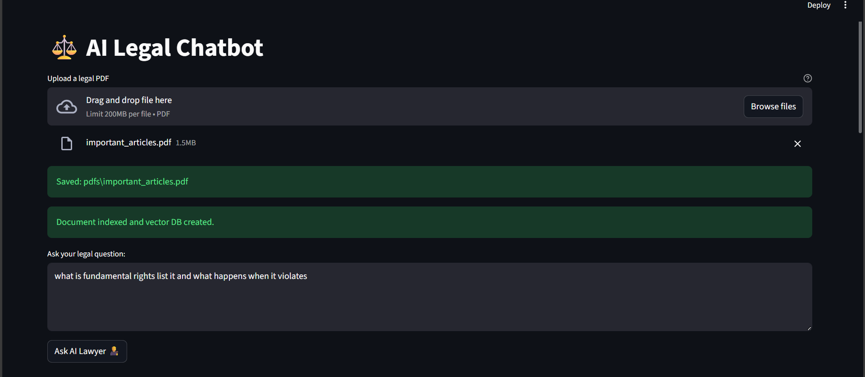

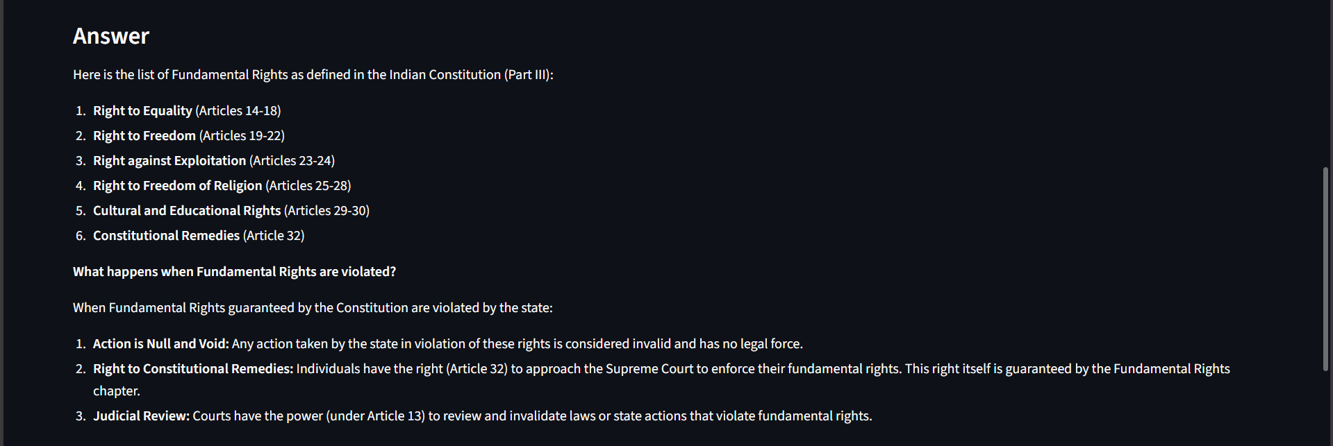

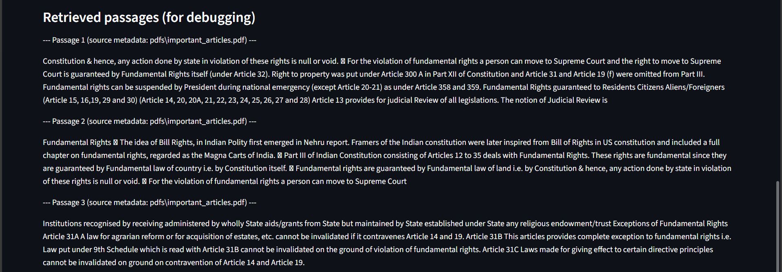

CHAPTER 09 – TESTING

Testing is a critical phase in the development of the Legal Chatbot using the Retrieval-Augmented Generation (RAG) architecture. Since the project involves multiple interconnected modules—PDF extraction, text chunking, embedding generation, vector retrieval, and LLM-based response generation—each module must be thoroughly validated to ensure the overall reliability and accuracy of the system. The testing phase ensures that the chatbot responds accurately, processes documents correctly, retrieves relevant content, and generates answers consistent with the context of the uploaded legal PDF.
The first stage of testing was Unit Testing, performed to evaluate individual components of the system in isolation. Each module, such as the PDF loader, text splitter, embedding generator, FAISS index builder, and query processor, was tested independently. For example, the PDF extraction module was tested with multiple legal documents of varying structures to ensure that text was extracted without losing formatting. Similarly, the chunking module was tested to confirm that no critical legal text was split incorrectly or lost during segmentation.
Following unit testing, Integration Testing was conducted to ensure that all modules functioned correctly when combined. This is especially important in a RAG-based system, where embedding generation must align with the retrieval process, and the retrieved chunks must be compatible with the LLM for answer generation. Integration tests simulated actual user interactions, such as uploading a PDF, asking a question, retrieving relevant sections, and generating the final response.
Next, System Testing was performed to validate the entire pipeline end-to-end. The chatbot was tested with large legal documents such as Acts, guidelines, policies, and multi-page legal briefs. System testing ensured that the application behaved consistently across different input types and scenarios. This phase also validated that the FAISS vector database stored embeddings correctly and retrieved relevant chunks with high accuracy. The language model's ability to generate context-grounded responses was also verified.
Functional Testing ensured that all features worked as expected from a user perspective. This included testing the file upload interface, error handling, loading indicators, query response accuracy, and the display of retrieved passages. The system was tested with both simple and complex legal questions to evaluate the chatbot’s ability to interpret user queries effectively.

Testing is an essential part of software development, ensuring that the system operates correctly, efficiently, and reliably under various conditions. For the Legal Chatbot using RAG, FAISS, and DeepSeek, multiple testing methods were performed to validate the functioning of each component—from PDF extraction to final answer generation. This section explains each type of testing performed and its importance in the context of this project.

9.1. Unit Testing
Unit testing focuses on testing each individual function or module separately.
Use in this project:
- Verified that PDF loading works correctly for different types of legal PDFs.
- Checked if text chunking produces correct chunk sizes and maintains context overlap.
- Confirmed that embedding generation does not crash and embeddings are consistent in size.
- Ensured FAISS indexing and saving/loading works without corruption.
This ensures that each component works correctly before integration.

9.2. Integration Testing
Integration testing checks how well different modules work together once combined.
Use in this project:
- Verified that the PDF loader correctly passes extracted text to the chunking system.
- Ensured that processed chunks are successfully converted into embeddings.
- Checked whether FAISS returns correct results when connected with the RAG pipeline.
- Tested that retrieved document chunks integrate properly with DeepSeek for generation.
This ensures all interconnected modules behave smoothly as one system.

9.3. Functional Testing
Functional testing validates that the system performs according to the requirements.
Use in this project:
- Confirmed that users can upload a PDF without errors.
- Verified that the system retrieves correct legal sections based on user query.
- Ensured the chatbot generates accurate and context-based answers using RAG.
- Tested button clicks, user inputs, and output displays in Streamlit UI.
This ensures the chatbot behaves exactly as expected by the user.

9.4. Performance Testing
Performance testing evaluates how fast and efficiently the system works.
Use in this project:
- Measured time taken to extract text from large legal PDFs.
- Tested embedding generation speed for 100+ chunks.
- Evaluated FAISS retrieval time under multiple queries.
- Checked how fast DeepSeek generates answers with large context inputs.
This ensures the system remains responsive even with heavy documents.

9.5. Load Testing
Load testing checks how the system performs under heavy usage.
Use in this project:
- Tested the chatbot with multiple legal PDFs one after another.
- Evaluated how many queries can be processed sequentially without performance drop.
- Checked memory usage when embedding and storing large document chunks.
This ensures the system supports extended usage without failures.

9.6. Stress Testing
Stress testing pushes the system beyond normal limits.
Use in this project:
- Uploaded extremely long PDFs to test system stability.
- Forced FAISS to store large number of embeddings to check capacity limits.
- Entered complex legal queries to test DeepSeek’s generation under pressure.
This ensures the chatbot can handle extreme use cases.

9.7. Error-Handling & Exception Testing
This testing checks how the system handles invalid inputs.
Use in this project:
- Tried uploading damaged or unreadable PDFs.
- Entered empty or irrelevant queries.
- Tested behavior when embeddings fail or FAISS file is missing.
- Checked how the UI responds when DeepSeek or Ollama is offline.
This ensures the chatbot remains stable and user-friendly even when errors occur.

9.8. User Acceptance Testing (UAT)
This testing ensures that the system is ready for real-world users.
Use in this project:
- Law students tested the chatbot to check answer relevance.
- Multiple users verified if the UI is simple and intuitive.
- Feedback was collected on answer quality, speed, and clarity.
This confirms the system meets real user needs.

9.9. Security Testing
Although the chatbot works offline, basic security testing was done.
Use in this project:
- Ensured no user data is uploaded to cloud servers.
- Verified that PDFs remain local and private.
- Checked file handling to avoid unauthorized access or corruption.
This ensures user documents and legal content remain confidential.

9.10. Regression Testing
Regression testing ensures new changes do not break existing features.
Use in this project:
- After modifying chunk size, retrieval accuracy was re-tested.
- After adding UI changes, upload and retrieval functions were re-tested.
- After modifying FAISS handling, system stability was checked again.
This ensures consistent performance after updates.

Additionally, Performance Testing was conducted to examine the system’s response time, memory usage, and ability to handle large documents. The FAISS index was tested for retrieval speed across increasing document sizes. The local LLM (DeepSeek R1) was tested for latency during answer generation. This testing ensured that the system performs efficiently on devices with moderate hardware specifications.
Finally, User Acceptance Testing (UAT) was conducted by sharing the chatbot with students and faculty members. Their feedback ensured that the interface was easy to use, responses were meaningful, and the overall system met academic and practical expectations.
Through these comprehensive testing methods, the Legal Chatbot was validated to be accurate, efficient, user-friendly, and capable of handling real-world legal documents with high reliability.

CHAPTER 10 – CONCLUSION

The Legal Chatbot using the Retrieval-Augmented Generation (RAG) pipeline successfully demonstrates the practical integration of advanced artificial intelligence techniques with legal information systems. Through the combination of PDF extraction, semantic text embedding, FAISS-based vector retrieval, and DeepSeek R1 language modeling, the chatbot ensures that users receive answers based strictly on the uploaded legal content, eliminating the risk of hallucinations and misinformation.One of the key achievements of this project is its offline functionality, enabled through Ollama-hosted models.
This ensures data privacy and widens accessibility for users in restricted or low-connectivity environments. The use of embeddings and semantic search significantly enhances the quality of retrieval by ensuring that responses align closely with user intent. The modular design further adds flexibility, allowing each component to be extended or replaced without affecting the overall system.The Legal Chatbot serves as an important step toward democratizing access to legal knowledge. It simplifies legal research, supports academic learning, and assists individuals in understanding legal terminology and clauses without requiring deep subject expertise. The system’s accuracy, modular design, and offline capability make it suitable for deployment in universities, law firms, government offices, NGOs, and public service organizations.

CHAPTER 11 – FUTURE SCOPE

The Legal Chatbot developed using the Retrieval-Augmented Generation (RAG) pipeline has demonstrated significant potential in improving the accessibility and interpretability of legal information. While the current system successfully processes legal PDFs, retrieves relevant content, and generates accurate context-based responses, there are several areas where the project can be expanded and enhanced in future iterations to achieve greater functionality, scalability, and usability.
One of the primary future enhancements includes the implementation of multi-PDF support, allowing users to upload and index multiple legal documents at once. This would enable cross-document search for legal clauses, case laws, and interconnected sections from different Acts or guidelines.
Another promising direction involves incorporating multilingual capabilities, enabling the chatbot to process and answer queries in regional languages such as Hindi, Punjabi, Tamil, Bengali, and more. Since many legal documents in India and other countries are written or translated into local languages, multilingual support would significantly expand the system’s usability for a wider audience.
The system can also be extended to include advanced summarization and section explanation features, allowing users to obtain concise summaries of long legal acts or detailed explanations of specific sections. This would be particularly useful for students, researchers, and non-legal users who need simplified interpretations of complex clauses.
A major enhancement could be the integration of Voice-Based Interaction, enabling users to ask legal queries through speech recognition and receive spoken responses. This would make the system more accessible for visually impaired users or individuals with limited digital literacy. Incorporating an AI-based voice assistant would transform the chatbot into a fully interactive legal support system.Further scope lies in integrating OCR (Optical Character Recognition) technology to support scanned legal PDFs that contain images instead of machine-readable text. This addition would allow the system to process old legal documents, court judgments, government notifications, and archived files.
Performance optimization is another future goal, with the inclusion of faster embedding models, GPU support for local LLMs, and dynamic retrieval algorithms for large-scale legal databases. Additionally, integrating user authentication and encrypted data handling could make the system suitable for deployment in legal firms and government departments. Overall, the future scope of this project is extensive.

The Legal Chatbot project has significant potential for future enhancement. One of the major improvements involves enabling multi-PDF integration, where the chatbot can process several legal documents together and perform cross-referencing across acts, sections, agreements, and case files. This would make the system more powerful for legal practitioners who work with diverse and extensive documents. Another important future direction is the development of multilingual support. Since India is a multilingual nation, adding the ability to understand and answer queries in regional languages such as Hindi, Punjabi, Tamil, and others would greatly expand accessibility and user adoption. The chatbot can also evolve into a voice-enabled legal assistant by integrating speech-to-text and text-to-speech systems, allowing users to ask questions verbally and receive spoken responses. This would particularly benefit users who are visually impaired, unfamiliar with typing, or using mobile devices.
A major enhancement involves integrating judgment and case law retrieval. This would allow the chatbot to analyze court judgments from the Supreme Court, High Courts, and tribunals, helping users access relevant precedents and case histories. Additionally, advanced document summarization capabilities can be added, enabling the chatbot to condense lengthy legal documents, agreements, and acts into simplified summaries or bullet points. The system can also be improved to compare legal clauses automatically, detect inconsistencies, highlight missing obligations, and identify risks in agreements, making it highly valuable for legal contract review.
Future development could also include real-time updates from government notifications, amendments, and gazette publications, ensuring that users receive answers based on the latest legal information. Building a mobile application version using Flutter would further extend the usability by making the chatbot accessible anywhere, even offline. Enhancing semantic search using hybrid keyword and vector search methods can increase retrieval accuracy. Additionally, integrating role-based access systems would allow customized features for different users such as students, lawyers, police personnel, and general citizens.

CHAPTER 12 - BIBLIOGRAPHY

- Lang Chain Documentation
Lang Chain Official Website. Available at: https://python.langchain.com/
Used for understanding the implementation of text splitting, embeddings, retrieval pipelines, and LLM integration.
- FAISS (Facebook AI Similarity Search)
FAISS Research Paper & GitHub Repository. Meta AI Research.
Used as a reference for vector indexing, similarity search algorithms, and efficient large-scale embedding retrieval.
- DeepSeek R1 Model Documentation
Used to understand the architecture, capabilities, and usage of the DeepSeek R1 8B model for offline local inference.
- Ollama Documentation
Ollama Official Docs.
Used for setting up and running local Large Language Models (LLMs) including embedding models and DeepSeek R1.
- PDF Plumber Library Documentation
Available at: https://github.com/jsvine/pdfplumber
Used to study PDF extraction methods, text reading, and parsing structure from legal PDF documents.
- Streamlit Documentation
Streamlit Official Website: https://docs.streamlit.io
Used for building the web interface, handling file uploads, and integrating the backend pipeline.
- Python Official Documentation
Python.org
Reference for general programming, file handling, directory management, and backend logic design.
- Nomic Embed Text Documentation
Nomic AI. Referenced for understanding embeddings, vector representations, and semantic similarity techniques.
- Research Papers on Retrieval-Augmented Generation (RAG)
Various academic sources on RAG architecture, pipeline design, and hybrid retrieval-generation systems.

