**DATA ANALYSIS ON E- STORE**

**Project Author: Neha Kunwar Solanki**

**OBJECTIVE:**

In this project, we are working on E-commerce Data to get some information so that the information can be used for analytical purpose and decision making, useful for Maximizing Business Profit. Huge data sets will help Organizations to address potential customers in a meaningful way.

Dataset information that could be used for future decisions, improve customer engagement so that newly launch product information can be shared to them.

**SAMPLE DATA SETS FOR ANALYSIS:**

1. **Customer:**

|  |  |  |  |  |
| --- | --- | --- | --- | --- |
| Customer_id | First name | last name | age | Address |
|  |  |  |  |  |
|  |  |  |  |  |

**2. Transaction:**

|  |  |  |  |  |  |  |  |
| --- | --- | --- | --- | --- | --- | --- | --- |
| Date | uid | amount | category | product | city | state | Payment |
|  |  |  |  |  |  |  |  |
|  |  |  |  |  |  |  |  |

**PROJECT DESCRIPTION -**

We are provided with certain use-cases to get the required data. For all the use-cases we will be using a Map-reduce approach. The Map Reduce Approach totally works on Key-Value pair as Input and Output. There will be a Driver Class, Mapper Class and a Reducer Class.

**TECHNOLOGY USED:**

* Apache Hadoop
* Map-Reduce Programming in java.

**SOFTWARE USED:**

* Eclipse IDE
* Oracle Virtual Machine
* Ubuntu
* JDK 1.7

**USE CASES**

**1. Categorization of customer based on Amount Scenario:**

The system keeps track of different customer’s information by their unique code. Whenever user purchases a product of a particular price or within range of amount than at time the user will provide with similar type of product within the same range.

* **Find all the transaction where amt>160**

**Validation Constraints: yes**

**Output: Using Custom input**

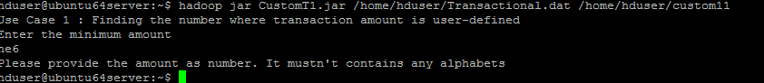

**2. Customer transaction information**

In this use case, we are finding all the transaction where amount is more than 170 and less than 200 paid by customer. So that we come to know about the specific amount or more than that is paid by customer for purchasing and new product and services in same rang can be shared to them.

* **Count all the transaction where amount is between 175 to 200**

**Validation Constraints: yes**

**Output: Using Custom input**

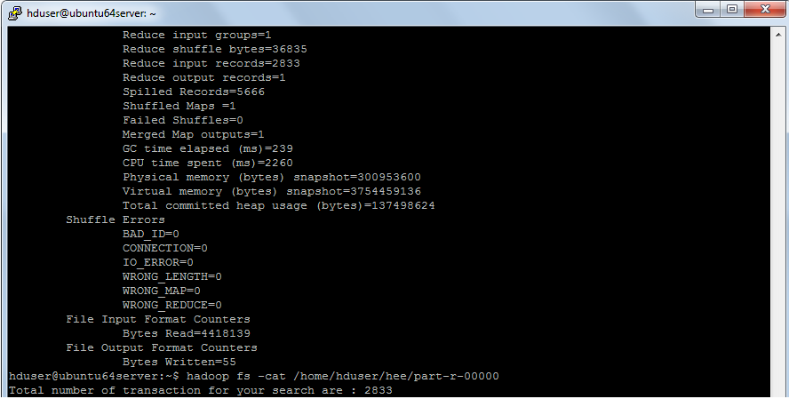

**3. Overall Transaction counting for each user:**

In this use case, we will fetch a Customer Overall Transactional report against each customer ID, Counting will be done for the no. of transactions. Also for each customer, all the transaction amount is added. Finally we will display the count and total transaction amount for every customer.

* **Calculate the total sum and total count of all the transaction for each user id**

**Output:** **Using Custom input& Validation Constraints**

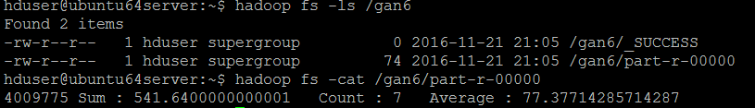

**4. Calculate the average transaction value for each user id**

In this case we will fetch the transaction amount data of each user and get the average of all transaction as per individual user id. Average rating for each user can be done periodically for analysis. Average transaction only decides weekly, monthly and yearly product services.

* **Calculate the total sum and total count of all the transaction for each user id**

**Validation Constraints: Yes**

**Output**: **Using Custom input**



**5. Division of single file into multiple files**

In this use case dataset is divided into multiple sub file according to product category. As a developers, fetching data from two table and divide them according to product category. For example how many customer has used credit card for as a payment mode, How many customer took offer on products so that when season comes for discount we can inform those customer about discount offer.

* **Divide the file into 12 files, each file containing each month of data. For eg. file 1 should contain data of January txn, file 2 should contain data of feb txn.**

**Validation Constraints: Yes**

**Output:** **Using Custom input**

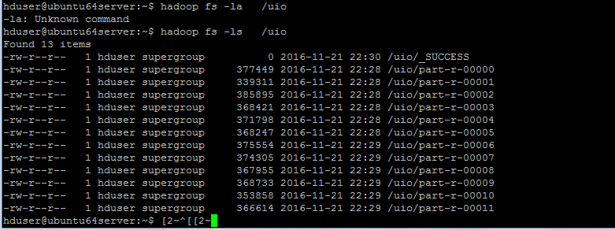

**6. The profession of user who has spent the maximum amount**

In this use case we are given a task to find the name of profession from customer dataset to find maximum amount. Next new products marketing starts from him by giving discount of 20% on purchasing

* + - **Find the profession of user who has spent the maximum amount**

**Validation Constraints: Yes**

**Output**: **Using Custom input**



### 7. New Product and Services:

In this use case, we are finding three top spenders report to whom organization can offer new launching Services like yoga products, gym products, Air sports, life jackets etc.

* **Find the name of top 3 spenders.**

**Validation Constraints: Yes**

**Output: Using Custom input**



### 8. Retaining Customers: ****Customer lifetime value****

### **In this use case, searching particular customer who has made highest transaction so that we can analyze number of unique purchase mode, average price of products, average price or orders And number of days and session leading to a transaction.**

* + - **Find the profession of user who has spend the maximum amount**

**Validation Constraints: Yes**

**Output**: **Using Custom input**



**9. Special rewards: Extra point Events**

In this use case, fetching all customer information in July month to give them offer like Extra point events. An extra point’s event is a great way to boost program engagement and encourage shoppers to spend points

* **Find the user who has spent the max amount in July month**

**Output: Using Custom input**



**CONCLUSION:** Analysis done on relevant very large sets of data for Statistical analysis, data mining, predictive analytics, and text mining. And we built a summary table to aggregate the detail at a monthly level transaction, a table to aggregate the detail at a year-to-date level, and a final summary table for the division level.