**E-Commerce Project Using PIG PROGRAMMING**

1. Below is the Program to find the number of customers whose Transaction amount is >160.

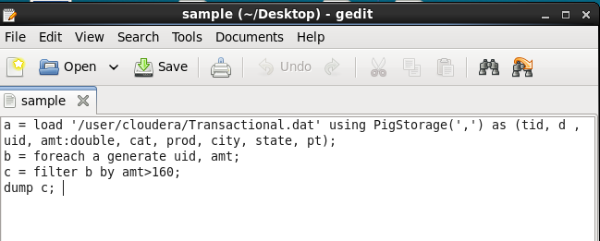

**Output**

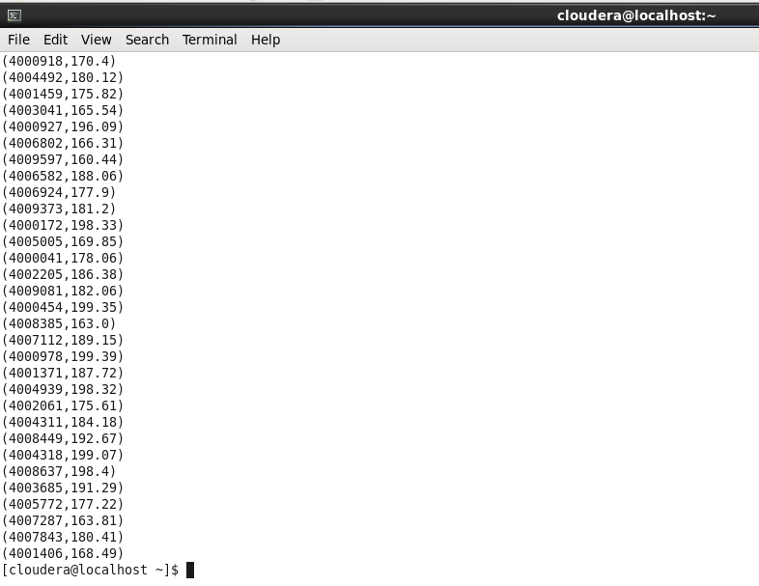

1. Below is the Program to find the number of customers whose Transaction amount is >175 and <200.

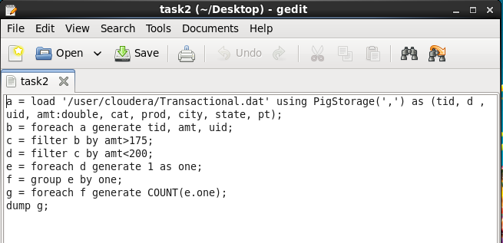

Output

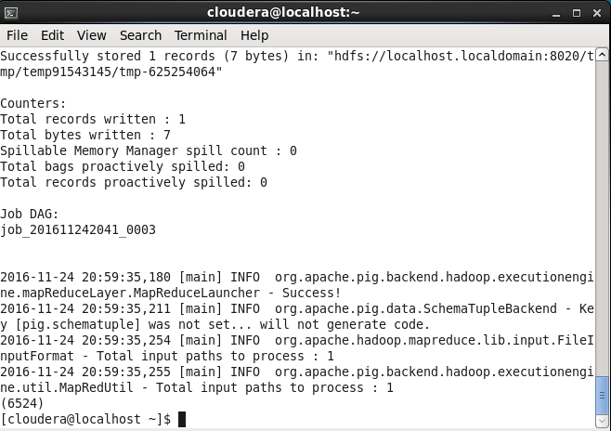

1. Below is the program to calculate the Total Sum against each customer

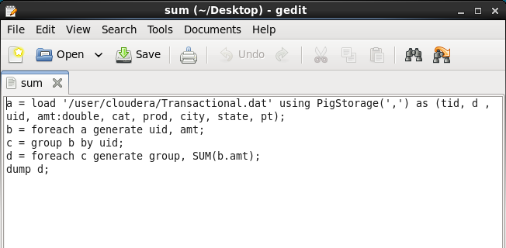

**Output –**

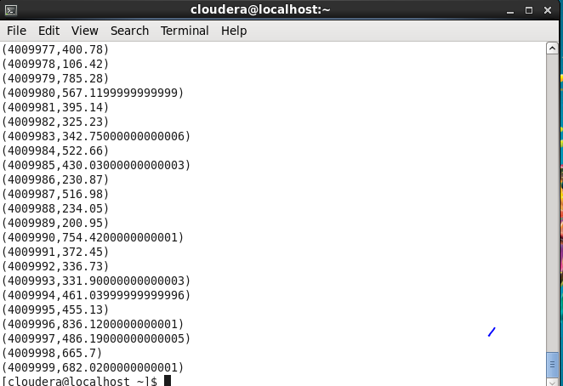

1. Below is the Program to calculate the Average Transaction amount against each customer ID.

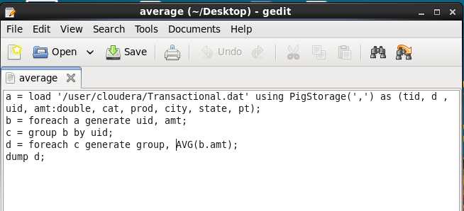

Output-

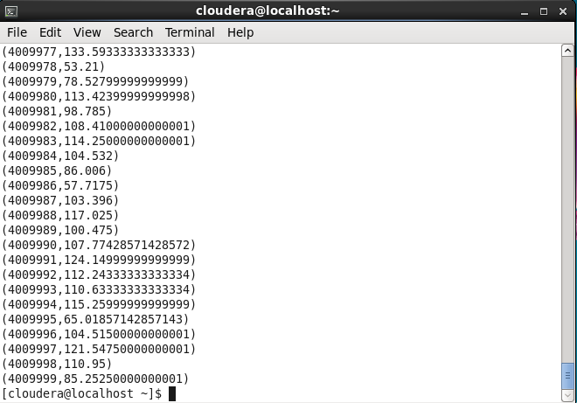

1. Below is the Program to find the number of transactions done by each customer.

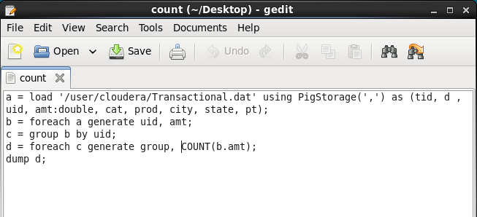

Output-

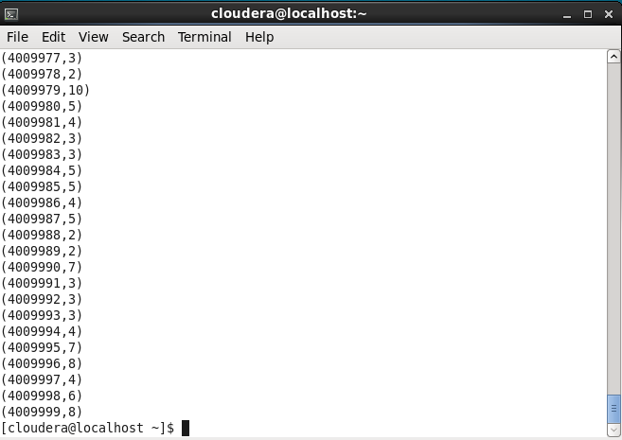

1. Below is the Program to find the Top 3 customers with maximum transaction amount.

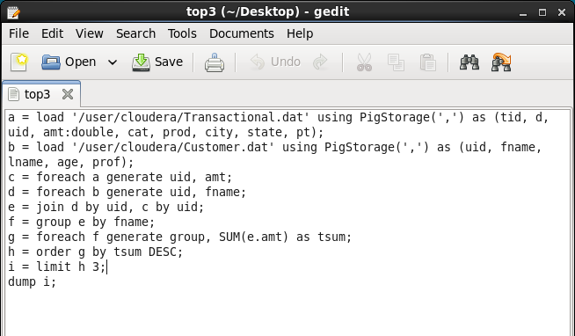

Output-

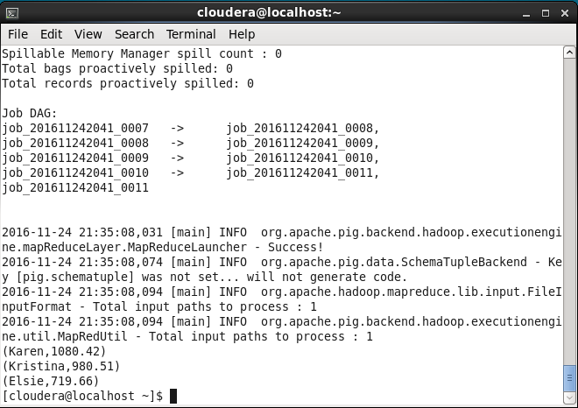

1. Below is the program to find the total Sales amount for each month.

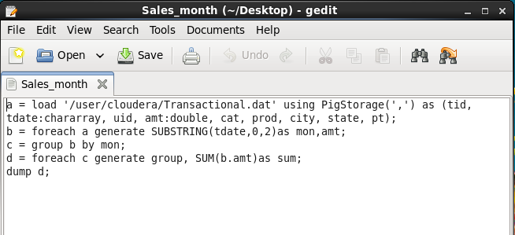

Output

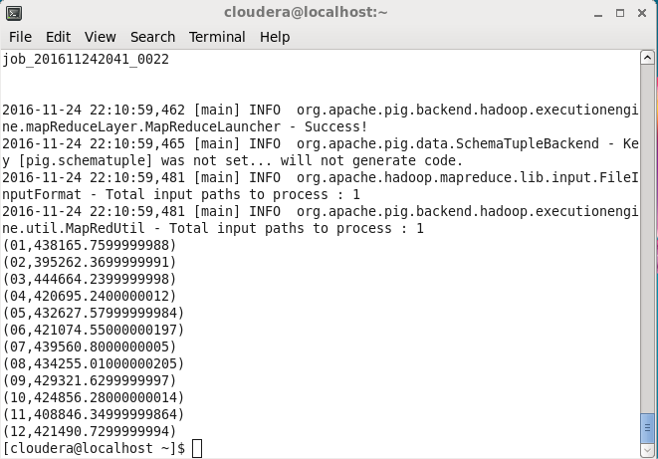

1. Below is the Program to divide the data according to month in 12 different files.

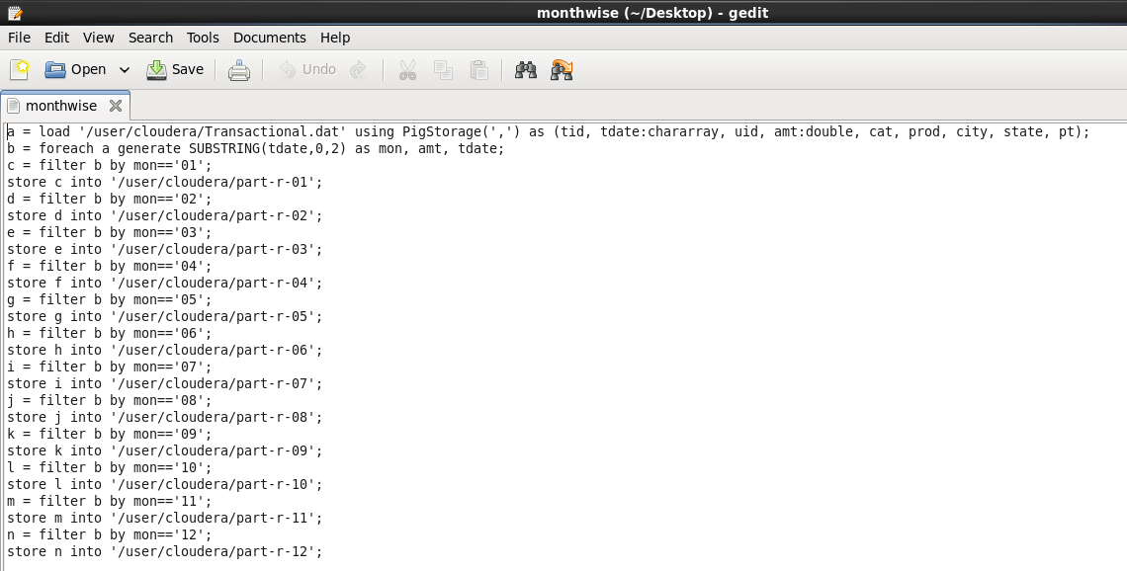

Output –

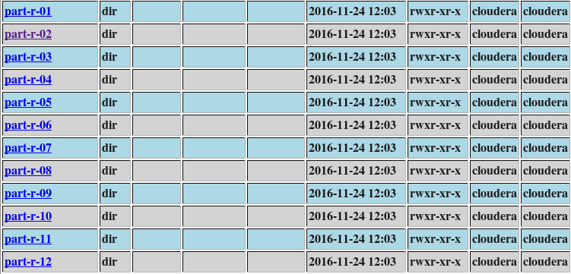

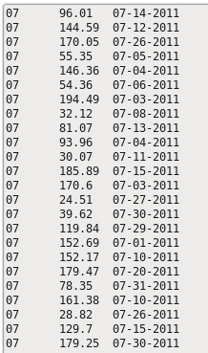

9. To find the name of customer with maximum Transaction amount.

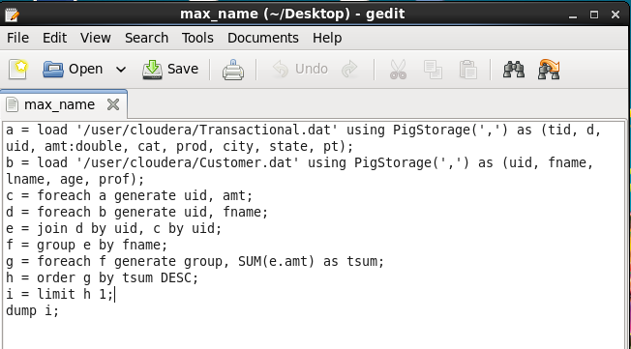

Output-

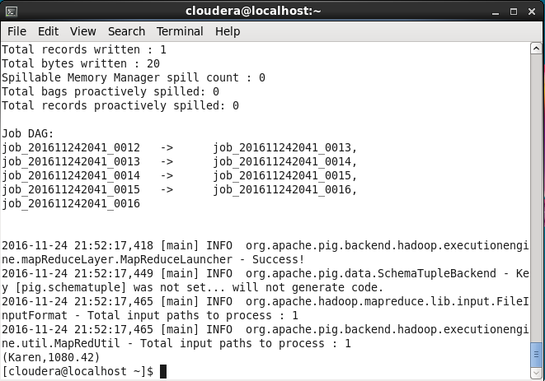

10. To display the customer Name with maximum transaction amount in July Month.

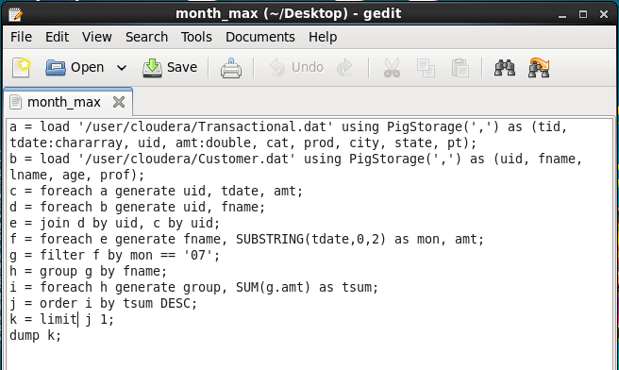

Output-

