title: “LAB 2” author: “Nehal Ur Rahman” date: “2023-01-24” output: word_document

#NAME: NEHAL UR RAHMAN #STUDENT ID: 991691259

##Introduction #In Lab 2 We will be analyzing a College dataset and performing various functions to understand the variables. We will also be creating a new variable and provide visualizations.

#Import  
#Here we are going to load and read all variables with its values from the college1 dataset.  
college <- read.csv("college1.csv")  
head(college)

## X Private Apps Accept Enroll Top10perc Top25perc  
## 1 Abilene Christian University Yes 1660 1232 721 23 52  
## 2 Adelphi University Yes 2186 1924 512 16 29  
## 3 Adrian College Yes 1428 1097 336 22 50  
## 4 Agnes Scott College Yes 417 349 137 60 89  
## 5 Alaska Pacific University Yes 193 146 55 16 44  
## 6 Albertson College Yes 587 479 158 38 62  
## F.Undergrad P.Undergrad Outstate Room.Board Books Personal PhD Terminal  
## 1 2885 537 7440 3300 450 2200 70 78  
## 2 2683 1227 12280 6450 750 1500 29 30  
## 3 1036 99 11250 3750 400 1165 53 66  
## 4 510 63 12960 5450 450 875 92 97  
## 5 249 869 7560 4120 800 1500 76 72  
## 6 678 41 13500 3335 500 675 67 73  
## S.F.Ratio perc.alumni Expend Grad.Rate  
## 1 18.1 12 7041 60  
## 2 12.2 16 10527 56  
## 3 12.9 30 8735 54  
## 4 7.7 37 19016 59  
## 5 11.9 2 10922 15  
## 6 9.4 11 9727 55

#The fix function is used to fix the 1st column and not store it as data as they are just labels  
fix(college)

#Here we fix the dataset by adding a column called row.names which records the name of all the universities  
row.names(college) = college[,1]  
fix(college)

#Using the function given below we delete the 1st column in the college dataset as it is not required in our analysis.  
college = college[,-1]  
fix(college)

#The as.factor function converts the character variable(Private) to vector with numerical values  
college$Private<-as.factor(college$Private)

###Question 1

#First we create a variable by using the function rep() which replicates the college with 777 number of rows with a value of "No"   
Elite <- rep("No",nrow(college))  
#Now we record the values as "Yes" in the Elite column with a condition that the proportion of students coming from the top 10% of their high school exceeds 50%.   
Elite[college$Top10perc >50] <- "Yes"  
#The as.factor function displays the variable(Elite) as vector with levels(Yes & No)  
Elite <- as.factor(Elite)  
#Now we create a dataframe with college and elite  
college <- data.frame(college , Elite)  
TotalEliteSchools <- length(college$Elite[college$Elite=="Yes"])  
#We then calculate the total number of Elite colleges and display the number.   
message("The total number of Elite Schools are : ", TotalEliteSchools)

## The total number of Elite Schools are : 78

###Question 2

#The summary function is used here to get details of the Elite column  
summary(college$Elite)

## No Yes   
## 699 78

#A side by side boxplot of Outstate Vs Elite is created using plot function  
plot(college$Outstate ~ college$Elite, col = c("violet", "orange"), xlab="ELITE",ylab="OUTSTATE", main = "Outstate vs Elite", border = "black")

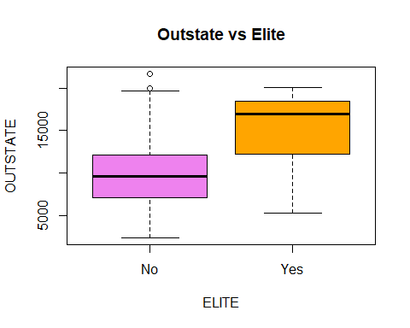 #Boxplot: From the boxplot we can see that the number of Elite colleges are more in the Outstate.

###Question 3

#The hist() function is used here to produce histograms with variable number of bins for 3 of the quantitative variables like Top10perc, Top25perc and Grad.Rate.  
#breaks = 6 & 8 is assigned first which gives lesser number of bins  
#breaks = 12 is assigned next to get more number of bins.   
  
#The par() function divides the frame into the required number to display the histograms within one window.  
par(mfcol=c(2,3))  
  
hist(college$Top10perc, col = "blue",breaks=8, xlab = "Top 10%", ylab = "Value", main="Students from Top 10% of H.S")  
hist(college$Top10perc, col = "green",breaks=12, xlab = "Top 10%", ylab = "Value", main="Students from Top 10% of H.S")  
  
hist(college$Top25perc, col = "blue",breaks= 6, xlab = "Top 25%", ylab = "Value", main="Students from Top 25% of H.S")  
hist(college$Top25perc, col = "green",breaks=12, xlab = "Top 25%", ylab = "Value", main="Students from Top 25% of H.S")  
  
hist(college$Grad.Rate, col = "blue",breaks=6, xlab = "Graduation rate", ylab = "Value", main="College Graduation Rate")  
hist(college$Grad.Rate, col = "green",breaks=12, xlab = "Graduation rate", ylab = "Value", main="College Graduation Rate")

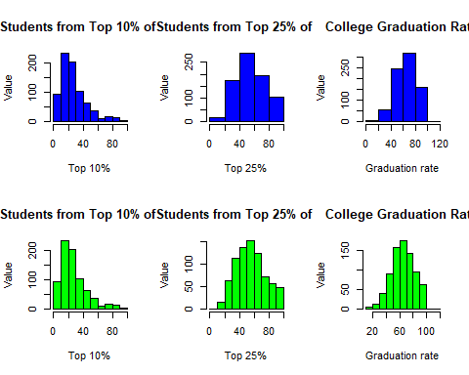 #The histogram for the 3 variables: Top10perc, Top25perc and Grad.Rate have been displayed with different number of bins.