**SERVER SIDE COMMUNICATION**

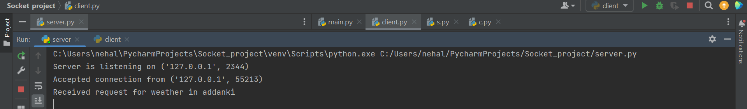

**CLIENT SIDE COMMUNICATION**

