1.A program to print hello world

<https://www.programiz.com/online-compiler/0wjO31Z26THFz>

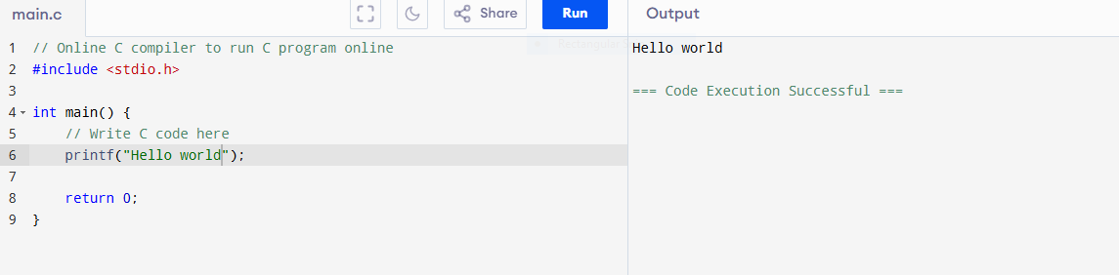

2. A program for basic Introduction.

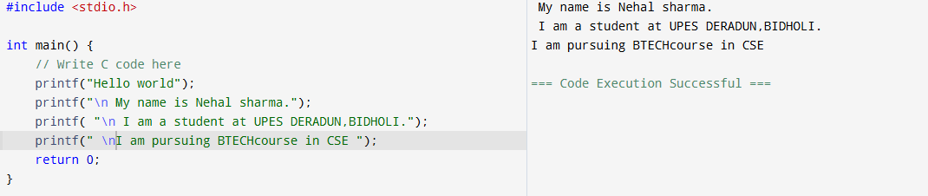

<https://www.programiz.com/online-compiler/77Dp1zIv1OllF>

. A program to to calculate basIc calculation i.e Simple calculator

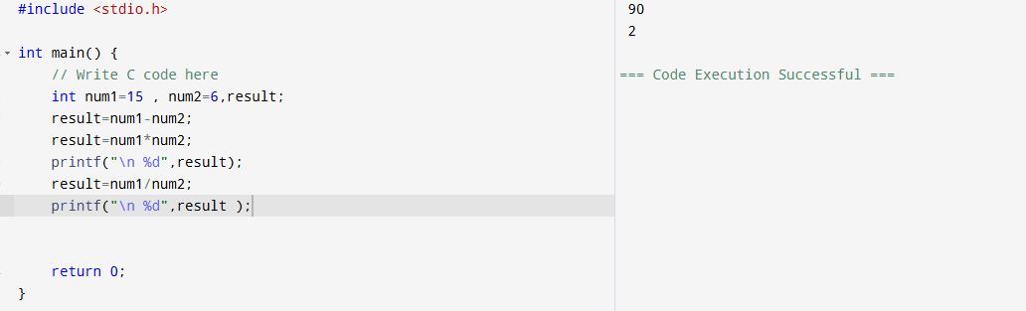

<https://www.programiz.com/online-compiler/28MgZKmgnDnAx>

to calculate si

